In the paper Conflict and Peace Building, I had given a Project on Structural and Direct Violence. Students had to differentiate between the two concepts giving suitable examples.

Regards,

Dr. Rachna Kumari Prasad

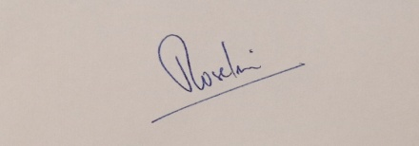

Verified.