In the paper Public Opinion and Survey Research I had asked students to prepare a project on structured questionnaire. We had discussed it in the class and also focused on how to make a good structured questionnaire for random asking of questions.

Regards,

Dr. Rachna Kumari Prasad

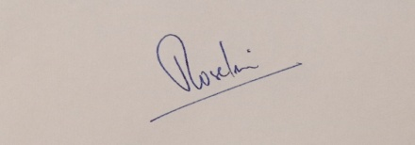

Verified.