SMALL SCALE INDUSTRIES

NAME-HARSMRITI KAUR

SUBJECT-ECONOMICS (SEC)

CROUSE-BA(PROGM)

ROLL NO-308

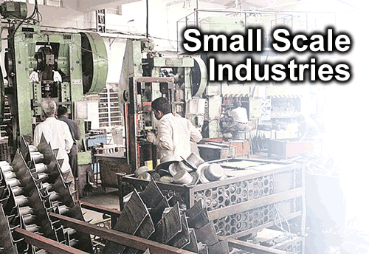

INTRODUCTION

Small scale industries is an industrial undertaking in which the investment is fixed assests in plant and machinery whether held on ownership terms or on lease or hire purachase does not exceed rs.1crore . However,this investment limit is varied by the government from time to time. Enterprenereuns in small scale sector are normally not required to obtain a license either from the center government or the state government for setting up units in any part of the country . Its registration with the state director or commissioner of industries or DIC’s make the unit eligible for availing different types of government assistance like financial assistance medium and long terms loans from state financial corporatons and other commercial bank .The Small Scale Industries Sector hold the key to economic prosperity of the indian economy characterized by abundant labour supply unemployment and under employment scarcity of finance growing modern large industries providing scope for development of ancillary industries and so on . the small scale industries has grown phenominemt during last six decades and has acquired a very prominent place in the socio – economics development in the country.

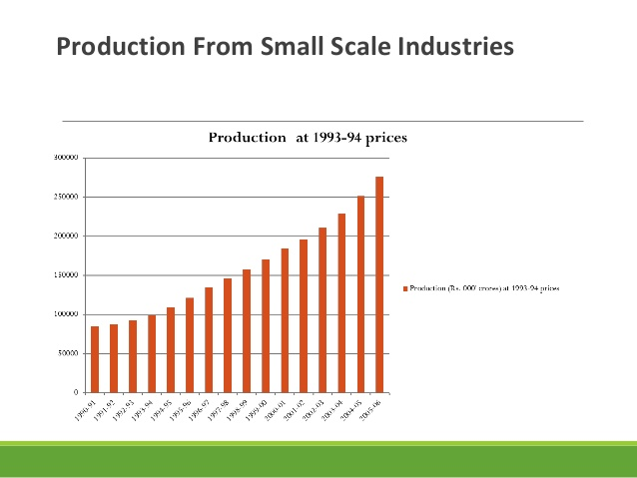

* It contributes almost 40%of the gross industries value added in the indian economy
* It has been estimated that a million rs of investment In fixed assets in the small scale sector produces 4.62 million

REVIEW OF LITRATURE

* Aarti Deveshwar (2006) The Small scale Industries sector has emerged as a vibrant and dynamic sector of Indian economy which contributes nearly 40% of the total industrial production and over 34% of the national exports. At present this sector is providing employment to over 250 lakhs people. It also acts as a nursery for promoting entrepreneurial talent and as a catalyze of industrial growth through a wide network of more than three million units in the country, according for about 95% of the total industrial units in the country.
* Aremu, Mukaila Ayanda (2011)Sustainable development is recognized as an essential requirement for achieving economic goals without degrading the environment, major problems arise in implementing the concept of sustainabilitySpecifically, governments, consumers, and enterprises contribute and play crucial roles in reaching sustainable development. As a result, if goals of sustainability are to be achieved, small and medium-sized enterprises must be reformed to minimize their negative ecological and social impacts (Gladwin, 1992)
* Ashok Sharma and kumar (2011), the main aim of this article is to examine the effect of Working Capital on profitability of Indian firms. The finding of researcher shows significantly depart from the various international markets. The result show that Working Capital Management and profitability in positively correlated in Indian companies Research also shows that the inventory of number of day and number of days account. Payment is negatively whereas number of days accounts receivable and cash conversion period a positive relationship with corporate profitability.
* Beydokhti Abbas Taleb (2007), author clearly said in his literature that The Small Scale Industry (SSI) sector is a key of economic growth and contributes substantially to India‟s total industrial production; export and employment generation. As a result, 3.6 million SSI units in the country produce over 8000 items and provide employment to about million people. Small Scale Industry unit have weak capital base of their own because they are mostly organize on proprietary or partnership basis and are usually of very small in size. They are poorly placed in the matter of capital formation. It is the fact the success or failure of an enterprises to a large extent depend upon the effectiveness with which financial resource of the firms applied and managed there is positive relationship between a firm‟s growth and working capital needs.

CHARATERISTICS OF SSIs

* Capital investment is small and most of them have small number of workers .
* Generally owned by a single or the most two persons and engaged in products of small goods.
* Most of them are family owned industries.
* Workers are not well recognize and they may do difference types of works as neend arises.
* Funded by owner’s saving or short-terms loans.
* Small-scale industrial activity is mainly dependent on owner’s entrepreneurship.
* Exploitation of natural resources and human resources
* Generally management and organization are very poor or non existent in SSIs
* Incidents of early closure are of highest order
* Profits margins are less due to competition
* Innovation and risk bearing are high in SSIs
* Faces cut throat competition
* Few of them many grow as medium scale industries.

RESEARCH DESIGN

Small-scale industries (SSI) play a very vital role in the countiy's economy despite the phenomenal growth in the large-scale sector. In fact, the small-scale sector is playing a vital role in the growth of national economies the world over and is considered to be the engine of growth in most countries. The emphasis on Small-Scale Industries has always been an integral part of the Indian Industrial strategy, more so after the Second Five Year Plan. It was envisaged that Small-Scale Industries would play an important role as producer of consumer goods and absorber of surplus labour thereby addressing to the problems of poverty and unemployment. The Government created the Ministry of Small Scale Industries and Agro and Rural Industries (SSI&ARl) in October, 1999 as the nodal Ministry for formulation of policy and co-ordination of Central assistance relating to promotion and development of the small scale industries in India. The Ministry of Small Scale Industries and Agro and Rural Industries (SSI&ARI) was bifurcated into two separate Ministries, namely, Ministry of Small Scale Industries and Ministry of Agro and Rural Industries in September.

DATA TABLE

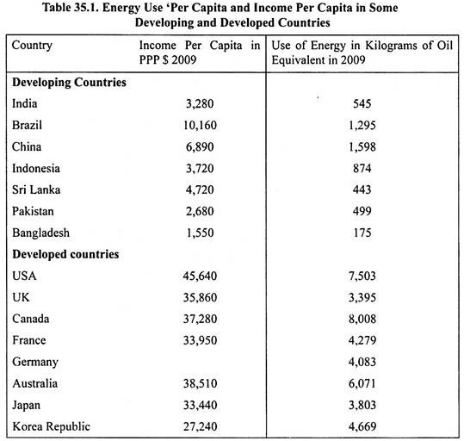

CONCLUSION

Effective management equires leadership plus administration skills in planning organizing direction and controlling the entre business operation because of limited financial resourses and inability to hire professional managerial personnel small scale unit lack specialization in the execution of various function of management . the majority of small scale unit are highly personal in nature i.e the single man show . it is very difficult to take quick decision in all respect **and implementing these decision promptly since the sole proprientor in neither a production oriented engineer nor sales oriented merchant . he has no time to look after other function . moreover the majority of sole proprietors are illiterate or have low level of education and lack managerial skill.**

**They also do not possess the qualities like motivation , sense of commitment and business morality. Consequently the small-scale units suffer from dearth of efficient management and poor managerial skill resulting in sickness of units**

**SUMMARY**

**India has a good potential to become a Superpower in the service sector particularly information technology enabled services. India has already captured 25% of world exports. However they face challenges due to competition by way of cheap imports from other countries due to removal of quantitave restrictions on import and lowering of traiffs. Due to this there is stiff completion for both small and big enterprises in both demostic and export market.**

QUATIONNAIRE

1. Name of the Industry (Unit) :GROSRY BOUNTY

2. Address : (a) Regd. Office : NEW DELHI

(b) Head Office :NEW DEHI

(c) Factory :NEW DELHI

(d) Registration : No. (If registered with the Directorate of Industries) .ABC 1234

3. Whether your product(s) is/are reserved for manufacturing by the small-scale industries ? :

Yes/No =NO

4. Nature if the Production :

(a) Continuous (b) Seasonal

= continuous

5. Number of working days : 6

6. How your finished products are sold ?

1. Wholesale (b) Retail (c) Contractual (d) By appropriate Agent

=contractual

7. who are your buyers ?

(a) Government (b) Large/Medium Scale Industries (c) Individual consumers (d) Any other category

=individual consumers