A PROJECT REPORT
ON
IMPACT OF SOICIAL MEDIA MARKETING

BY
ARSHDEEP KAUR THAPER
(BA. PROGRAMME) (2018-2019)

IN PARTIAL FULFILLMENT OF
Bachelor of Arts
Mata Sundari College for Women
Delhi University


ARSHDEEP KAUR THAPER
BAP/17/321
SEMESTER-4TH

Study of impact of social media marketing on consumer preferences.

STUDENT DECLARATION
I, Ms ARSHDEEP KAUR THAPER hereby declare that this project is the record of authentic work carried out by me during the academic year 2018-2019 and has not been submitted to any other university or institute towards the award of any degree.

SIGNATURE

ARSHDEEP KAUR THAPER

CERTIFICATE FROM THE INSTITUTE GUIDE
This is to certify that Ms ARSHDEEP KAUR THAPER of Mata Sundari College has successfully completed the project work in partial fulfilment of requirement for the award of Bachelor of Arts prescribed by Mata Sundari College Delhi University.
This project is the record of authentic work carried out during the academic year 2018-2019

MS. SAKSHI JINDAL
PROJECT GUIDE

PREFACE
The experience which I got by doing this project was essential to my future, for me and I achieved a better knowledge about Social media marketing. The information in this project being submitted contains detailed analysis of the research undertaken.
The research provides an opportunity to me to devote my skills, knowledge and competencies during our knowledge gathering sessions of marketing management.
The research is on the topic “Social Media Marketing”.

ACKNOWLEDGEMENT
“Knowledge is an experience gained in life, it is the choicest possession. Which should not be shelved but should be happily shared with others. It is the supreme art of the teacher to awaken joy in creative expression and knowledge”. The success of any project is the result of hard work and endeavour of not one but many people and this project is no different. I take this as a prospect to a vow that it was an achievement to have succeeded in my final project. This would not have been possible without the guidance of Ms SAKSHI JINDAL.

INDEX

No. Particular

1) CHAPTER 1-
a) INTRODUCTION

2) CHAPTER 2-
a) OBJECTIVE
b) SCOPE
c) RESEARCH METHODOLOGY

3) CHAPTER 3-

a) DATA ANALYSIS
a)COMPANY PROFILE
b)ANALYSIS
c)INTERPRETATION

4) CHAPTER 4-
a) CONCLUSION
b) RECOMMENDATION
c) REFERNCES
5) QUESTIONNAIRE

CHAPTER 1

INTRODUCTION

CHAPTER-1

Introduction To Social Media Marketing
Social media marketing refers to the process of gaining website traffic or attention through social media sites.
Social media marketing programs usually centre on efforts to create content that attracts attention and encourages readers to share it with their social network. The resulting electronics word of mouth (eWoM) refers to any statement consumers share via the internet (e.g. web sites, social networks, instant message, news feeds) about an event, product service, brand or company. When the underlying message spreads from user to user and presumably resonates because it appears to come from a trusted third party source as opposed to the brand or company itself , this form of marketing results in ‘earned media’ rather than ‘paid media’.
Social networking websites allow individuals to interact with one another and build relationship. When companies join the social channels, consumers can interact with them. That interaction feels personal to users because of their previous experience with social networking site interaction.
Social networking sites and blogs allow individual followers to “re tweet” or “repost” comments made by the product being promoted. By repeating the message, all of the users connections are able to see the message, therefore reaching more people. Social networking sites act as word of mouth. Because the information about the product is being put out there and is getting repeated, more traffic is brought to the product company.
In 2009, bloggers had an enormous impact on fashion, affecting everything from print publishing to show brands market themselves online. There are thousands of style-related blogs on the web these days, and those dedicated to their craft have earned industry recognition. A number of unknowns earned recognition from Dolce& Gabbana, Burberry, Alexander Mc Queen and leading publications such as Vogue. They participated in fashion design collection collaborations and received front-row, international Fashion week seats next to some of the most notable figures in the couture world. A recent Financial Times article notes that being a style bloggers is a perfectly respectable career for someone in the fashion industry. The social web has removed the gatekeepers of an industry that was notoriously hard to penetrate and build a name in. These sites have succeeded because of the quality of their content. While each is unique, they’ve built a cult following around their areas of expertise and passion.
Trough social networking sites, companies can interact with individual followers. This personal interaction can instil a feeling of loyalty into followers and potential customers. Also, by choosing whom to follow on these sites, products can reach a very narrow target audience.

CHAPTER-2
-OBJECTIVE TO STUDY
-SCOPE
-RESEARCH METHODOLOGY

CHAPTER-2

OBJECTIVE TO STUDY
1. To analyse the effective communication strategy through social networking sites.
2.To understand the social media fundamental concepts and social media etiquettes. It refers that how to use the concepts and etiquette of social media in marketing. These concepts are helpful in effective marketing as they direct path in which social media marketing has to be done.
3. Another objective of the study is to understand the social media strategy which is used in marketing. It helps to know the various ideas and techniques used in social media marketing. The strategy helps in understanding the market more effectively.
4. To study the effectiveness of brand communication through social l-networking sites from its users and communicators.
5. To find the impact of interaction through these communication among users (with reference to Facebook, Twitter and Orkut).

SCOPE
Social media is defined as “a group of Internet-based applications that build on the ideological and technological foundations of web2.0 and that allow the creation and exchange OD user generated content.” Furthermore the New Zealand Government of Internal Affairs describes it as “a set of online technologies, sites and practices which are used to share opinions, experiences and perspectives. Fundamentally it is about conversation. In contrast with traditional media, the nature of social media is to be highly interactive.”
Moreover, the term social media is described an online tools that let people to interact and communicate with each other. This has become a standard word for online and cultural and it has a dominant ways for individual to engage on the internet. By using social media individuals became more closely and strongly connected than ever before.

SOCIAL MEDIA AS PUBLIC UTILITY
Applying the term public utility to social media implies that social media websites are public necessities and consequently should be regulated by the government. While social media is not as essential for survival as traditional public utilities such as electricity, water and natural gas, many people believe it has become vital for living in an interconnected world and without it, living a successful life would be difficult, Therefore, many people believe that social media has reached utility status and should be treated as a public utility. However others believe that this is not true because social media is constantly revolutionizing and giving such platforms “utility status” would result in government regulation, which would consequently hinder innovation. Over the past decade many have debated and questioned whether or not “Internet service providers should be considered essential facilities or natural monopolies and regulated as public utilities.”

INDIVIDUAL LEVEL
On the individual level, advocates of social as a public utility believe that Internet presence using social media websites is imperative in order to adequately take part in the 21st century as an individual and consequently, these sites are public utilities and need to be regulated. Specifically, social media researcher Danah Boyd has argued that the social media site Facebook is obtaining public utility characteristics and due to such characteristics she concludes that regulation will eventually take place in future. She asserts “Facebook may not be at the scale of the internet (or the internet at the scale of electricity) but that doesn’t mean that it is not angling to be a utility or quickly becoming one.”

SOCIAL MEDIA TRENDS

Opponents of this theory claim that social media websites are not public utilities because new social media websites continually come into existence and replace that old. Such evolution does not happen with common public utilities like water, electricity, and natural gas.

RESEARCH METHODOLOGY
Research Methodology is the systematic, theoretical analysis of the methods applied to a field of study, or the theoretical analysis of the body of methods and principles associated with a branch of knowledge. It typically encompasses such as paradigm theoretical model, phases and quantitative techniques.
We also understand how to advertise by using social networking sites like Facebook, Twitter, etc. . Case study analysis helps in understanding how to advertise through social media. Advertising is the most important part in marketing i.e., to sell any product or organize any event the main part is to advertise it. SO social media marketing plays a major role in advertisement.
Case studies such as “America’s Got Talent YouTube submission” , “ Nike Make it Count” , “Clip In Touch” are done to understand the marketing strategies and its concepts. Various techniques are used by these companies to promote their products and events. These companies have used various social networking sites as a sources for marketing.
The study of social media marketing, since not being a related to particular company, has been conducted through secondary data.
Secondary data is data collected by someone other than the user. Common sources of secondary data for social science includes
-censuses
-organizational records
-Data collected through qualitative methodologies or qualitative research.
Secondary data analysis saves time that would otherwise be spent collecting data and particularly in the case of quantitative data provides larger and higher-quality database that would be unfeasible for any individual researcher to collect on their own. In addition, analysis of social and economic change considers secondary data essential. Since it is impossible to conduct a new survey that can adequately capture past change and developments.
The data collected by a person is already been collected and used by some other individual. It can be said as the re-usage of the data being collected. No questionnaires, etc. are involved in this as the person seeks the information which is already present to him .
Secondary data refers to the data , which is not newly generated but rather obtained from
-Public sources
-unpublished sources i.e. information about the performance of the company.
Secondary research uses outside information assembled by government agencies, industry and trade associations, labour unions, media sources, chambers of commerce, and so on.

Methods of data collection
The survey method helped to identify the reach of the brand among its target audience, ways of impact, usage of these social networking sites and access to these form of communication. And the content analysis is another method used to analyse the communication strategy of different social networking sites with certain parameters among top three Indian social networking sites which are tabulated with results.
Research design
This research study adopted survey and content analysis in order to find the effectiveness and the impact of communication in branding any product or the service among the target market through social networking sites like Face book, Twitter and Orkut.
Survey
Survey was conducted randomly among Face book, Twitter and Orkut user community, by sending questionnaire through online to collect the individual opinion from the respondents.
Sampling
Non probability sampling technique is used to collect the opinion from the online respondents. The total population is social networking user community, but to collect the effective data the sampling is constrained to the target population like young adults, graduates within the age of 16 years to 30 years. The sampling size is 50.
Content analysis
In content analysis, the following three popular social networking sites were selected to find the effective brand communication among its users (Facebook, Twitter and Orkut).
Parameters and units of analysis
- Target group: category of audience visiting these sites
.2. Types of advertisements: what are the types of brand communication followed by them?
3. Ads placement: how do these sites place their ad in their pages?
4. Communication strategy: kinds of brand promotion used by them.
5. Visual appealing factors: regarding the appearance of these sites
.6. User Interaction: kinds of participation with the brand.
7. Accessibility: how legibly they present themselves.
8. User interest: the forms of expectations from users in these sites
.9. Customization: the factors that the users could create by themselves.

CHAPTER-3

DATA ANALYSIS

-COMPANY PROFILE
- ANALYSIS
-INTERPRETATION

WHAT IS SOCIAL MEDIA MARKETING?
Social media marketing is the use of social media platforms and websites to promote a product or service. Although the terms e-marketing and digital marketing are still dominant in academia, social media marketing is becoming more popular for both practitioners and researchers. Most social media platforms have built-in data analytics tools, which enable companies to track the progress, success, and engagement of ad campaigns. Companies address a range of stakeholders through social media marketing, including current and potential customers, current and potential employees, journalists, bloggers, and the general public. On a strategic level, social media marketing includes the management of a marketing campaign, governance, setting the scope (e.g. more active or passive use) and the establishment of a firm's desired social media "culture" and "tone."
When using social media marketing, firms can allow customers and Internet users to post user-generated content (e.g., online comments, product reviews, etc.), also known as "earned media," rather than use marketer-prepared advertising copy.
PLATFORMS
Social networking websites
Social networking websites allow individuals, businesses and other organizations to interact with one another and build relationships and communities online. When companies join these social channels, consumers can interact with them directly. That interaction can be more personal to users than traditional methods of outbound marketing and advertising. Social networking sites act as word of mouth or more precisely, e-word of mouth. The Internet's ability to reach billions across the globe has given online word of mouth a powerful voice and far reach. The ability to rapidly change buying patterns and product or service acquisition and activity to a growing number of consumers is defined as an influence network. Social networking sites and blogs allow followers to "retweet" or "repost" comments made by others about a product being promoted, which occurs quite frequently on some social media sites. By repeating the message, the user's connections are able to see the message, therefore reaching more people. Because the information about the product is being put out there and is getting repeated, more traffic is brought to the product/company.

Social networking websites are based on building virtual communities that allow consumers to express their needs, wants and values, online. Social media marketing then connects these consumers and audiences to businesses that share the same needs, wants, and values. Through social networking sites, companies can keep in touch with individual followers. This personal interaction can instil a feeling of loyalty into followers and potential customers. Also, by choosing whom to follow on these sites, products can reach a very narrow target audience. Social networking sites also include much information about what products and services prospective clients might be interested in. Through the use of new semantic analysis technologies, marketers can detect buying signals, such as content shared by people and questions posted online. An understanding of buying signals can help sales people target relevant prospects and marketers run micro-targeted campaigns.
In 2014, over 80% of business executives identified social media as an integral part of their business. Business retailers have seen 133% increases in their revenues from social media marketing.
Mobile phones
More than three billion people in the world are active on the Internet. Over the years, the Internet has continually gained more and more users, jumping from 738 million in 2000 all the way to 3.2 billion in 2015. Roughly 81% of the current population in the United States has some type of social media profile that they engage with frequently. Mobile phone usage is beneficial for social media marketing because mobile phones have social networking capabilities, allowing individuals immediate web browsing and access to social networking sites. Mobile phones have grown at a rapid rate, fundamentally altering the path-to-purchase process by allowing consumers to easily obtain pricing and product information in real time and allowing companies to constantly remind and update their followers. Many companies are now putting QR (Quick Response) codes along with products for individuals to access the company website or online services with their smart phones. Retailers use QR codes to facilitate consumer interaction with brands by linking the code to brand websites, promotions, product information, or any other mobile-enabled content. In addition, Real-time bidding use in the mobile advertising industry is high and rising because of its value for on-the-go web browsing. In 2012, Nexage, a provider of real time bidding in mobile advertising, reported a 37% increase in revenue each month. Adfonic, another mobile advertisement publishing platform, reported an increase of 22 billion ad requests that same year.
Mobile devices have become increasingly popular, where 5.7 billion people are using them worldwide, and this has played a role in the way consumers interact with media and has many further implications for TV ratings, advertising, mobile commerce and more. Mobile media consumption such as mobile audio streaming or mobile video are on the rise – in the United States, more than 100 million users are projected to access online video content via mobile device. Mobile video revenue consists of pay-per-view downloads, advertising, and subscriptions. As of 2013, worldwide mobile phone Internet user penetration was 73.4%. In 2017, figures suggest that more than 90% of Internet users will access online content through their phones.
Implications on traditional advertising
Minimizing use
Traditional advertising techniques include print and television advertising. The Internet has already overtaken television as the largest advertising market. Web sites often include the banner or pop-up ads. Social networking sites don't always have ads. In exchange, products have entire pages and are able to interact with users. Television commercials often end with a spokesperson asking viewers to check out the product website for more information. While briefly popular, print ads included QR codes on them. These QR codes can be scanned by cell phones and computers, sending viewers to the product website. Advertising is beginning to move viewers from the traditional outlets to the electronic ones.
While traditional media, like newspapers and television advertising, are largely overshadowed by the rise of social media marketing, there is still a place for traditional marketing. For example, with newspapers, readership over the years has shown a decline. However, readership with newspapers is still fiercely loyal to print-only media. 51% of newspaper readers only read the newspaper in its print form, making well-placed ads valuable.
Leaks
The Internet and social networking leaks are one of the issues facing traditional advertising. Video and print ads are often leaked to the world via the Internet earlier than they are scheduled to premiere. Social networking sites allow those leaks to go viral, and be seen by many users more quickly. The time difference is also a problem facing traditional advertisers. When social events occur and are broadcast on television, there is often a time delay between airings on the east coast and west coast of the United States. Social networking sites have become a hub of comment and interaction concerning the event. This allows individuals watching the event on the west coast (time-delayed) to know the outcome before it airs. The 2011 Grammy Awards highlighted this problem. Viewers on the west coast learned who won different awards based on comments made on social networking sites by individuals watching live on the east coast. Since viewers knew who won already, many tuned out and ratings were lower. All the advertisement and promotion put into the event was lost because viewers didn't have a reason to watch.
Mishaps
Social media marketing provides organizations with a way to connect with their customers. However, organizations must protect their information as well as closely watch comments and concerns on the social media they use. A flash poll done on 1225 IT executives from 33 countries revealed that social media mishaps caused organizations a combined $4.3 million in damages in 2010. The top three social media incidents an organization faced during the previous year included employees sharing too much information in public forums, loss or exposure of confidential information, and increased exposure to litigation. Due to the viral nature of the Internet, a mistake by a single employee has in some cases shown to result in devastating consequences for organizations. An example of a social media mishap includes designer Kenneth Cole's Twitter mishap in 2011. When Kenneth Cole tweeted, "Millions are in uproar in #Cairo. Rumor has they heard our new spring collection is now available online at [Kenneth Cole's website]".This reference to the 2011 Egyptian revolution drew an objection from the public; it was widely objected to on the Internet. Kenneth Cole realized his mistake shortly after and responded with a statement apologizing for the tweet.
In 2012 during Hurricane Sandy, Gap sent out a tweet to its followers telling them to stay safe but encouraged them to shop online and offered free shipping. The tweet was deemed insensitive, and Gap eventually took it down and apologized. Numerous additional online marketing mishap examples exist. Examples include a YouTube video of a Domino's Pizza employee violating health code standards, which went viral on the Internet and later resulted in felony charges against two employees. A Twitter hash tag posted by McDonald's in 2012 attracting attention due to numerous complaints and negative events customers experienced at the chain store; and a 2011 tweet posted by a Chrysler Group employee that no one in Detroit knows how to drive. When the Link REIT opened a Facebook page to recommend old-style restaurants, the page was flooded by furious comments criticizing the REIT for having forced a lot of restaurants and stores to shut down; it had to terminate its campaign early amid further deterioration of its corporate image.
In 2018, Max Factor, MAC and other beauty brands were forced to rush to disassociate themselves from Kuwaiti beauty blogger and Integral 'influencer' Sondos Alqattan after she criticised government moves to improve conditions for domestic workers.
Ethics
The code of ethics that is affiliated with traditional marketing can also be applied to social media. However, with social media being so personal and international, there is another list of complications and challenges that come along with being ethical online. With the invention of social media, the marketer no longer has to focus solely on the basic demographics and psychographics given from television and magazines, but now they can see what consumers like to hear from advertisers, how they engage online, and what their needs and wants are. The general concept of being ethical while marking on social network sites is to be honest with the intentions of the campaign, avoid false advertising, be aware of user privacy conditions (which means not using consumers' private information for gain), respect the dignity of persons in the shared online community, and claim responsibility for any mistakes or mishaps that are results of your marketing campaign. Most social network marketers use websites like Facebook and MySpace to try to drive traffic to another website. While it is ethical to use social networking websites to spread a message to people who are genuinely interested, many people game the system with auto-friend adding programs and spam messages and bulletins. Social networking websites are becoming wise to these practices, however, and are effectively weeding out and banning offenders.
In addition, social media platforms have become extremely aware of their users and collect information about their viewers to connect with them in various ways. Social-networking website Facebook Inc. is quietly working on a new advertising system that would let marketers target users with ads based on the massive amounts of information people reveal on the site about themselves. This may be an unethical or ethical feature to some individuals. Some people may react negatively because they believe it is an invasion of privacy. On the other hand, some individuals may enjoy this feature because their social network recognizes their interests and sends them particular advertisements pertaining to those interests. Consumers like to network with people who have interests and desires that are similar to their own. Individuals who agree to have their social media profile public, should be aware that advertisers have the ability to take information that interests them to be able to send them information and advertisements to boost their sales. Managers invest in social media to foster relationships and interact with customers. This is an ethical way for managers to send messages about their advertisements and products to their consumers.
Since social media marketing first came to be, strategists and markets have been getting smarter and more careful with the way they go about collecting information and distributing advertisements. With the presence of data collecting companies, there is no longer a need to target specific audiences. This can be seen as a large ethical gray area. For many users, this is a breach of privacy, but there are no laws that prevent these companies from using the information provided on their websites. Companies like Equifax, Inc., Trans Union Corp, and LexisNexis Group thrive on collecting and sharing personal information of social media users. In 2012, Facebook purchased information from 70 million households from a third party company called Datalogix. Facebook later revealed that they purchased the information in order to create a more efficient advertising service.
Facebook had an estimated 144.27 million views in 2016, approximately 12.9 million per month. Despite this high volume of traffic, very little has been done to protect the millions of users who log on to Facebook and other social media platforms each month. President Barack Obama tried to work with the Federal Trade Commission (FTC) to attempt to regulate data mining. He proposed the Privacy Bill of Rights, which would protect the average user from having their private information downloaded and shared with third party companies. The proposed laws would give the consumer more control over what information companies can collect. President Obama was unable to pass most of these laws through congress, and it is unsure what President Trump will do with regards to social media marketing ethics.
Metrics
Web site reports
This involves tracking the volume of visits, leads, and customers to a website from the individual social channel. Google Analytics is a free tool that shows the behavior and other information, such as demographics and device type used, of website visitors from social networks. This and other commercial offers can aid marketers in choosing the most effective social networks and social media marketing activities.
Return on investment data
The end goal of any marketing effort is to generate sales. Although social media is a useful marketing tool, it is often difficult to quantify to what extent it is contributing to profit. ROI can be measured by comparing marketing analytic value to contact database or CRM and connect marketing efforts directly to sales activity.
Customer response rates
Several customers are turning towards social media to express their appreciation or frustration with brands, product or services. Therefore, marketers can measure the frequency of which customers are discussing their brand and judge how effective their SMM strategies are. In recent studies, 72% of people surveyed expressed that they expected a response to their complaints on Twitter within an hour.
Reach and virility
Popular social media such as Facebook, Twitter, LinkedIn, and other social networks can provide marketers with a hard number of how large their audience is nevertheless a large audience may not always translate into a large sales volumes. Therefore, an effective SMM cannot be measured by a large audience but rather by vigorous audience activity such as social shares, re-tweets etc.

Impact of social media marketing on a company
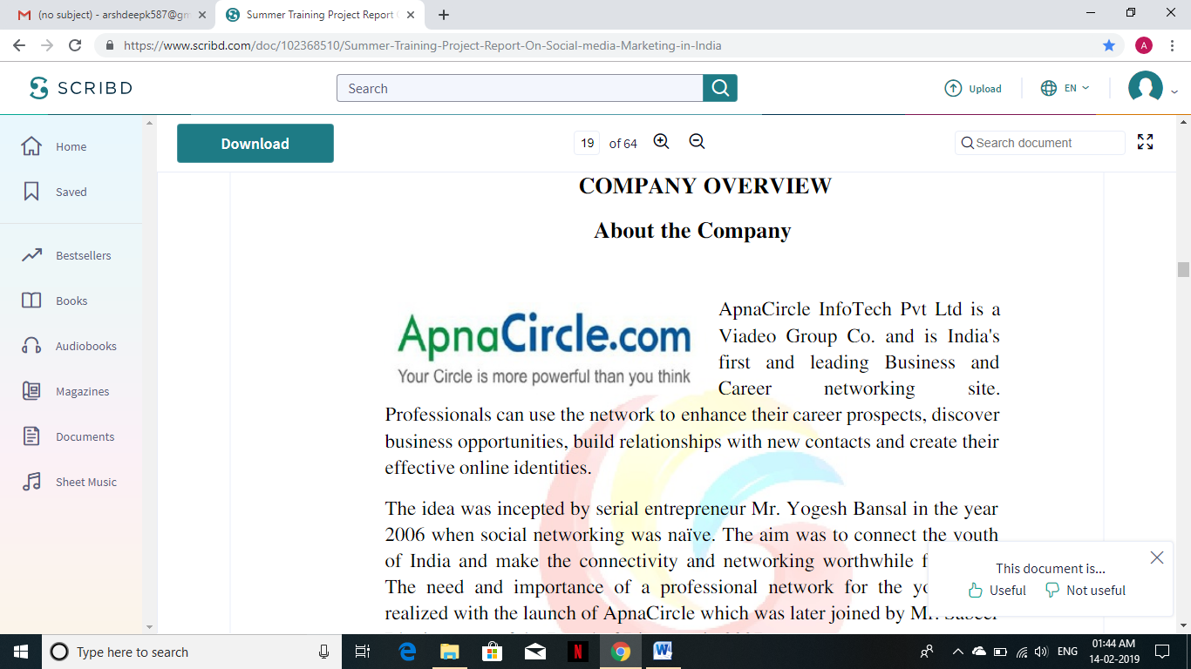 ApnaCircle InfoTech Pvt Ltd is video Group Co. and is India’s first and leading Business and Career networking site. Professionals can use the network to enhance their career prospects, discover business opportunities, build relationships with new contacts and create their effective online identities. The idea was incepted by serial entrepreneur Mr Yogesh Bansal in the year2006 when social networking was naïve. The aim was to connect the youth of India and make the connectivity and networking worthwhile for them. The need and importance of a professional network for the youth was realized with the launch of ApnaCircle which was later joined by Mr. Sabeer Bhatia as one of the Board of Directors in 2007.It was in the year 2009 that ApnaCircle merged with Video-Tianji, the leading professional networking sites of Europe and China, to form the leading Global entity which is in align with the 'Glo-cal' strategy of theirs. Also, ApnaCircle

Video - Tianji acquired Unyk, a Canadian social networking site to grow the Indian market organically. The idea was to give users a local network with a global reach. Continued organic growth coupled with an emerging markets acquisition strategy has taken the Video Group to a global number two position. Video depends on 3 revenue streams: premium membership, advertising, and services to recruiters, assuming that most professionals do business locally. With 4.5 million members, China is the most represented country. Since February 2010, Tianji is available in English allowing non-Chinese professionals to communicate and network in China. One report in2009 gave Video 1.8 million members in France, where it had a strong competitive effect on the alumni networks of the Grandes Écoles, France's top tier schools. The same study found a certain amount of linguistic barriers between the networks; with video being "too Franco-French" while LinkedIn was too Anglo-Saxon. Video is mainly focusing on Europe and emerging countries such as BRIC countries.

Key Offerings of ApnaCircle.com

•Active professional networking

•Individual/Corporate Branding

•Micro blogging

•Individual & Brand: Promotion and Advertisement

•Participation in Q and A sessions

•Discussions in Communities

•Participation in Industry Events

•Head hunting/Hiring

•Career opportunities

•Business and Career networking

Timeline

Jan 2012New office opens in Casablanca

Dec 2011Joint venture signed with Samoa Independent Media. New office opens in Moscow.

Nov 2011Acquisition of social, contact management app

Oct 201140 million members

Jun 2011Viadeo Group launches Video Graph API

May 2011New office opens in Daka

Dec 201035 million members

Jul 2010New office opens in San Francisco

May 2010, 30 million members

Oct 2009Acquisition of UNYK, smart address book

Jul 20098.5 million members

Apr 2009Third funding round raises €5 million

Jan 2009ApnaCircle, India‘s leading local professional social network, joins the Video Group

Nov 2008New office opens in Mexico City

Jul 2008Acquisition of ICTnet, a business-oriented community site

Dec 2007Tianji, the leading professional social network in China, joins the Video Group

Aug 2007Second funding round raises €5 million

Feb 2007Viaduc changes name to Video and opens offices in London, Madrid and Milan

Jan 20071 million member

May 2006Platform becomes available in six languages

Jun 2006First funding round raises €5 million

Jun 2004Dan Serfaty and Thierry Lunatilaunch Viaduc

About the Founder & CEO

Mr Yogesh Bansal is the Founder and CEO of ApnaCircle.com.He Completed his MBA from University of North Carolina in 1997.Apart from being a Serial Entrepreneur who founded several start-ups in USA and India he is a Great motivator to young minds. Prior to entering the role of an entrepreneur, he worked with McKesson Inc., a company developed IT applications for hospital automation in US. He Shifted to India in the year2006 and founded ApnaCircle.com-India‘s 1st Business & Career Networking site. Mr Yogesh Bansal is one of the Directors in theApnaCircle Video Tianjin group; He handles all operations of the company in India. Mr Yogesh Bansal has been lauded by many industry leaders’ and multiple publications for his visionary strategy, his ability to drive an entrepreneurial culture, and his warm-hearted and straight-talking approach.

Departments of the Company

-Administration

- IT

- Finance

- Marketing

- HR

Organization Vision

To be the most accepted and in vogue professional network in India. To evolve the processes of hiring, being hired and Business & Career networking.

Organization Culture

The Company Believes in an open system where one has ample opportunities to grow along with organization we believe in working as a group rather than an Individual towards the attainment of the goals

ApnaCircle.com Achievements

•Fast paced growth in a short span

•ApnaCircle is India‘s first and the world‘s second leading Business &Career networking site

•36 million subscribed users worldwide and 3 million subscribed users in India

•Mergers: Association with the biggest names from Europe and China

•A continuous effort towards success

•An attitude to remain grounded

Strategies developed and executed during the Project-Technical

1. Company PAGES for all the companies joining ApnaCircle.com so that they can let the jobseekers and new incoming network people to know about their company and its details without going on any other websites. Facebook also has this pages option and its very successful to commercialize and create awareness about the company, let it be a small or big company.

2. To increase the FONT SIZE (Personal UPDATE), of all the major part of the website and introduce more COLOURS (Search bar) on it, so that it can make the site look more attractive.

3. To give statistics of how many people have checked the profiles and visited their content

4. up gradation of Free SMS service.

5. In the reference format There is an option of Name which will be better if there is a drop down box from which people can choose the name in case they are not able to remember the exact name and they just know the1st letter of the name, it just makes the whole search lot more easier and gives more options for recommendation while going through the drop down box.

Promotional-

•YouTube-channel-By Maintaining and posting comments

•Social media marketing {Facebook, Twitter, Google+, LinkedIn, Quora, Yahoo etc.}

•App commercial {Blackberry}

•Insiders group.

•Recruiters interview.

•Promotion in Technical and Educational institutions- (Greater Noida, Faridabad, Gurgaon, Delhi).Visited more than 50 institutes during Internship.

•Convincing the faculties to open up account in ApnaCircle, so that students can connect them there.

•Participating in annual fest.

•Brand ambassador competition with rewards (business party, certificate) and measure (keyword tracking).

•JOB EVENT: Sponsored and hosted by ApnaCircle.com where all the interested people can look for job opportunities.http://hire.timesjobs.com/employer/jobfairs.html

•During college fest, sponsoring, hosting small workshops on online social media, or professional network by our own marketing team, with minimal cost.

•Recharge it now.com, creating application through it.

•Online forums (Wikipedia) and discussions which should have content of ApnaCircle.com

Analysis of social networking sites: A study on effective communication strategy in developing brand communication

Internet is the emerging information technology with the credibility of immediacy and fastness, thus, it brings globalization in every aspects of communication. Communication through internet is more specified, with effective interactive strategy among its users. In recent days, internet advertising has taken new forms which have more advantages over the traditional mediums like print media, television and radio. Marketing communication is becoming precise, personal, interesting, interactive and social. Different strategies of communication are followed in various social networking sites like Face book, Twitter and Orkut. They not only create impact over the audience but also make them interact with the marketing statistics created. People get attached to brand communication in social networking sites than usual banner and pop up ads. These networking sites bring more interactive communication with advertising. Social networking sites will become the primary arena for highly targeted marketing and advertising. Therefore, it is necessary to study the effectiveness of brand communication strategy followed in social networking sites which are mainly accessed by Indian users. This research attempts to find the effectiveness of brand communication strategy in promoting and advertising their brand in social networking sites. The effectiveness is determined with the help of survey from people who use these sites, and the content of three social networking sites is analysed.

COMPANY PROFILE

CASE-1

“America’s Got Talent” YouTube submission

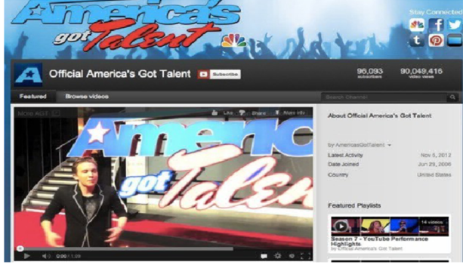

Why this is one of the best social media campaigns of 2012:

This campaign crosses online and offline participation in a way that makes sense. Videos are highly shareable, and when users see videos, they begin to build relationship with the subject of the video and might be more likely to follow along on the television show. Furthermore, opening up entries to all Americans (who have YouTube account or a way to share videos) ensures that the show is authentic and gives everyone a chance to complete.

INTERPRETATION

Social networking site “YouTube” has been used to promote a television show America’s Got Talent. People got a chance to participate just by uploading their video on YouTube and share it with whole world. So social media marketing played an important role in grand success of this show. Whole world got chance to see videos through YouTube.

CASE-2

NIKE#Makeitcount in 2012 (Twitter)

The goal of the campaign were to use the Nike brand to encourage and motivate people to “make it count” this year. The campaign focused on fitness and health and incorporating powerful photos, content and videos corresponding with the “make it count” message. The campaign was cross-channel (Instagram, YouTube, Twitter, Facebook) however the hash tag was the stickiest aspect of the program.

Here’s how the campaign was implemented on twitter:

The #Makeitcount was launched in January 2012, right around the time when people are checking in on their New Year’s resolution. The campaign features 11 athletes were pushing their boundaries and “making it count” was shared on social channels using the #Makeitcount hashtag. This content was shared virally, and users began sharing their own #Makeitcount experiences and how they were motivating and pushing themselves.

WHY THIS WAS ONE OF THE BEST SOCIAL MEDIA CAMPAIGNS OF 2012:

The campagin was in line- with Nike’s core messaging “Just Do It”. Choosing 11 athletes and leveraging their fans and followers amplified the message. The # Makeitcount hash tag was brilliantly crafted to be succinct to-the-point, relevant and easily shareable. Futhermore, the videos are highly engaging and motivational.

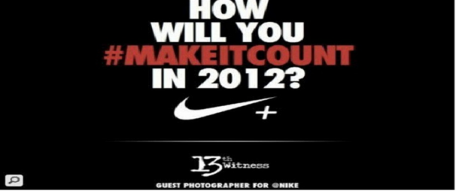

INTERPRETATION

In this case study of Nike, the company focused on creating awareness of physical fitness through social networking sites such as Twitter, YouTube, Facebook, various photos, videos were uploaded on social networking sites.

CASE 3

BRITISH MIDLAND INTERNATIONAL’S (BMI) PINTEREST LOTTERY

The goals of the campaign were to drive awareness to the newly created interest account for BMI and incentivize users to pin destination photos to BMI’S boards (thus creating a large amount of user-generated content)

Here’s how the campaign was implemented on interest:

Destination boards were created on BMI’s interest account. Each board contained exactly nine pins that each had a unique number on them (1-9). Each week, a number would be those at random. Everyone who had re-pinned the image that corresponded to that number was entered into the drawing. A winner was chosen at random, and the prize was a round-trip ticket from any BMI destination.

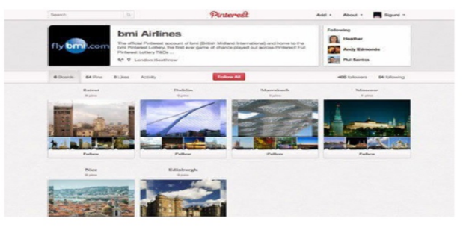

INTERPRETATION

The company BMI had launched a campaign interest account in which there was nine pins each having unique number. The winners were chosen at random through social networking sites. So social media marketing played important role for BMI. They gave updates to people through social networking sites.

CASE-4

MTV BLOC PARTY

MTV wanted to be more than just a TV channel, it wanted to connect with its target audience and build a community that the fans could associate strongly with. 76% of the youngsters state that live music events are important or extremely important to them and they would love to experiment with new genres of music and 95% place music as an important and central aspect of their lives

EXECUTION

A bloc (k) party is an established international concept, which is a celebration spread across an entire city block. India’s first ever MTV Bloc Party was set by the sea in Juhu, Mumbai. It was one big party at the centre, integrated with multiple party hubs across the block and music humping with 30 World Class DJ and indie bands, and all accessed through a single ticket; the cost of that one ticket was approximately Rs. 4,000 for 2 days. People stepped in the Bloc (k) that housed the longest party ever, and danced away the 2 days. To heighten the experience, MTV hosted a relaxed beer garden through the leisurely Saturday afternoon. This was followed by a high energy sun-down party. Post sundown, an immersive audio visual spectacle added to the musical experience using projection technology across the stage and venue to bring alive the essence of the celebration mood. The experience was heightened through interactive games, fun graffiti’s, and origami art and trash art installations. Radio taxi service was provided to fans to hop from one party hub to another. And yes it was all inclusive in that magical single ticket.

INTERPRETATION

A seamless party that integrated different sounds of Dance Music –electronic or beyond and also allowed the fans to interact with the artistes across multiple venues.

The idea was: one entry, multiple parties! With an incredible line up of DJs and an audio visual experience like never before, all that fans needed to do was to get an access with the single ticket to be part of Mumbai’s longest part. It was an idea with great potential.

With a target scale of reaching up to 5000-8000 people, a bloc party was the craziest but perhaps the best idea MTV could have come up with to meet its objective.

CASE-5

FIND YOUR BLISS-LG

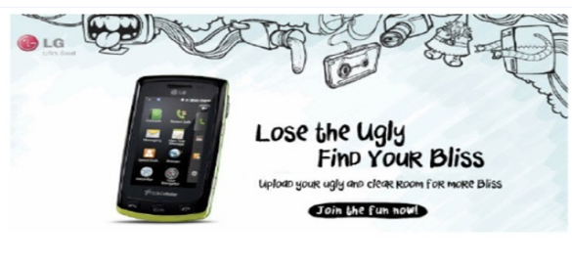

It was a community building campaign which drove over 80,000 targeted users to Facebook fan page.

It was published over 100 blogs and tweeted over 75 times in a span of 4 weeks.

This campaign generated over 7000 fans in just 4 weeks.

Social media marketing was done through Facebook which gained success in a very less time.

INTERPRETATION

It was a campaign launched by LG to build community. Social networking site Facebook was the sources through which marketing was done by the company. The company wanted to promote campaign in short period of time so they did social media marketing.

ROLE OF FACEBOOK IN S0CIAL MEDIA MARKETING



Facebook profiles are far more detailed than twitter accounts. They allow a product to provide videos, photos and longer descriptions. Videos can show when a product can be used as well as how to use it. These also can include testimonials as other followers can comment on the product pages for others to see. Facebook can link back to the products twitter page as well as send out event reminders. Facebook promotes a product in real-time and brings customers in.

As marketers see more value in social media marketing, advertise continue to increase sequential ad spend in social by 25%. Strategies to extend the reach with sponsored stories and acquire new fans with Facebook ads contribute to an uptick in spending across the site. The study attributes 84% of “engagement” or clicks to likes that link back to Facebook advertising. Today brands increase fan counts on average 9%monthly, increasing their fan base by two-times the amount annually.

The social network no longer supports social marketing and that it has become a traditional ad seller. Although Facebook promises it will better connect marketers to their customers, the social network shows 16% of each brand’s posts to its fans, the report said. Facebook has also done little to improve branded page formats and the tools marketers use to manage those pages.

Instead of supporting social marketing, the social has instead become a traditional ad seller. Although Facebook delivers as many as one-third of all display impressions online, fewer than 15% of Facebook ads use social data to reach more-relevant audiences. “Facebook’s static- image ad unit offers marketers less impact per impressions than marketers could achieve with the ads units other sites offer.

Facebook placed last in a list of 13 marketing channels by 395 marketers in the U.S., U.K. and Canada. Social sites including LinkedIn, Google plus and twitter all ranked above F Facebook did however achieve a score of 3.54 on a scale of 1 to5.

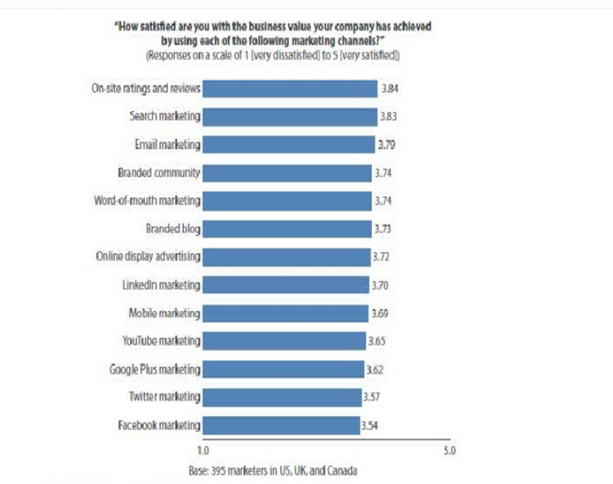
ROLE OF INSTAGRAM IN SOCIAL MEDIA MARKETING 
Instagram is free photo and video- sharing program and social network that was launched in October 2010. The service enables users to take a photo or video apply a digital filter to it and then share it with other instagram users they are connected to on the social network as well as on a variety of social networking services. Instagram debuted as a photo sharing network but implemented support for video on June 2013. As of June 2013, instagram had 130 million monthly active users.
71% of the world’s largest brand has adopted instagram, which now rivals the brand adoption of Google+ and pinterest making it fastest growing social network worldwide. The brand hash tag monitoring, multi-account monitoring, competitive monitoring and a complete social media snapshot.
This is a comprehensive view of activity that tracked brands across all social channels and put in context with their other social media activity. Instagram is a channel we’ve been tracking for some time. It’s an excellent channel for brands to repurpose their marketing content. Brand adoption has increased significantly, which has made it a great place for consumers to connect with those brands.
The top brand on instagram is mercedes-benz with more than 425,000 followers and more than 9 million engaged users. This might be surprising since instagram draws a younger crowd.
They are very strong all the way around. There is extreme interest in luxuary goods and brands on the network.
As activity increases so do followers, 57% of top brand marketers are now averaging at least one post per week, up from only 38%in Q3 of 2012. As a result, more than one third of top brands have, 10,000 followers and 19% enjoy audiences that exceed 100,000 followers.
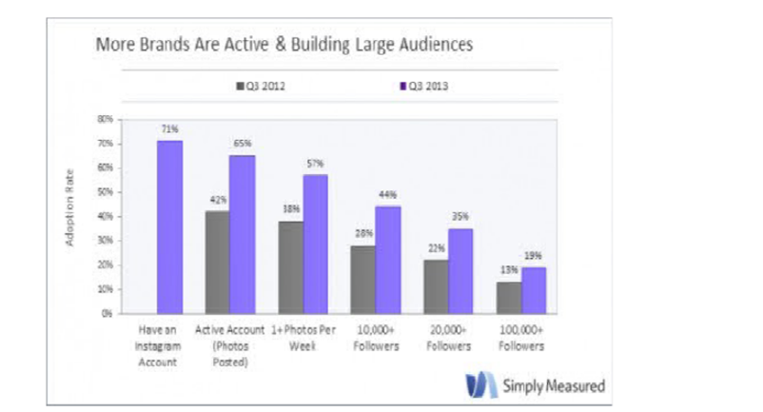
GOOGLE+

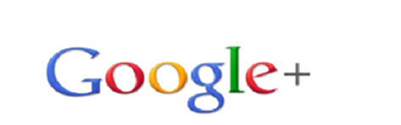
Google+ pronounced and sometimes written as Google plus is social networking and identity service that is owned and operated by Google Inc. Google has described Google+ as “social layer” that enhances many of its online properties, and that it is not simply a social networking website. It is the second largest social networking site in the world after Facebook. 540 million monthly active users are part of the identity service side, by interacting socially with Google’s enhanced properties like mail, +1 button. YouTube comments 300 million monthly active users are part of the social networking side by interacting with Google+ social networking steam itself.
Google+ mobile app was used by 30% of smartphone users between April- June 2014 making it the fourth most used app. Google + enhanced apps and mobile sites are used on 92%of USA smartphone.
Two main strengths of Google+ social are photography and its hangout feature. An update in October, 2014 focuses on these areas. Google+ has 1.5b photos uploaded each week.
ROLE OF YOUTUBE IN SOCIAL MEDIA


YouTube is a video-sharing website created by three former PayPal employees in February 2005 and owned by Google since ate 2006 on which users can upload view and share videos. The company is based in San Bruno, California and uses Adobe Flash video and HTML.5 technology to display a wide variety of users generated video content including movie clips, TV clips and music video as well as amateur content such as video blogging, short original videos and educational videos.
Most of the content on YouTube has been uploaded by individuals although media corporations including CBS the BBC, vivo, hulu and other organizations offer some of their material via the site as part of the YouTube partnership program. Unregistered users can watch video, while registered users can upload an unlimited number if videos. Videos considered to contain potentially offensive content are available only to registered users least 18 years old. YouTube, LLC was bought by Google for US $ 1.65 billion in November 2006 and now operates as a Google subsidiary.
ROLE OF TWITTER IN SOCIAL MEDIA MARKETING
. 

Twitter’s origin lie in a “daylong brain strong session” held by board members of the podcasting company odeo. Dorsey, then an undergraduate student at New York University, introduced the idea of an individual using an SMS service to communicate with a small group. The original project code name for the service was twitter an idea that Williams later ascribed to Noth Glass inspired by Flickr and the five-character length of American SMS short codes. The developers initially considered “10958”as a short code, but later changed it to “10404” for “ease of use and memorability”. Work on the project started on March 21, 2006, when Dorsey published the first Twitter message at 9:50 Pacific standard time (PST): “just setting up my twitter”. Dorsey has explained the origin of the “twitter” title: we came across the word “twitter” and it was just perfect. The definition was a short burst of inconsequential information and chirps from birds and that’s exactly what the product was.
The first Twitter prototype, developed by Dorsey and contractor Florian weber was used as internal service for odeo employees and the full version was introduced publicly on July 15 2006.
In October 2006 Biz Stone, Evan Williams ,Dorsey and other members of odeo, formed obvious corporation and acquired odeo, together with its assets including odeo.com and twitter.com from the investors and shareholders. Williams freed glass that was silent about his part in Twitters start up until 2011. Twitter spun off into its own company in April 2007. Williams provided insight into the ambiguity that defined this early period in a 2013 interview: with Twitter it wasn’t clear what it was. They called it a social network, they called it micro blogging but it was hard to define because it didn’t replace anything. There was this path of discovery with something like that, where overtime you figure out what it is. Twitter actually changed from what we thought it was in the beginning, which we described as status updates and a social utility. It is that in part but the insight we eventually came to was Twitter was really more of an information network than it is social network.

TABLES AND CHARTS
TABLE-1
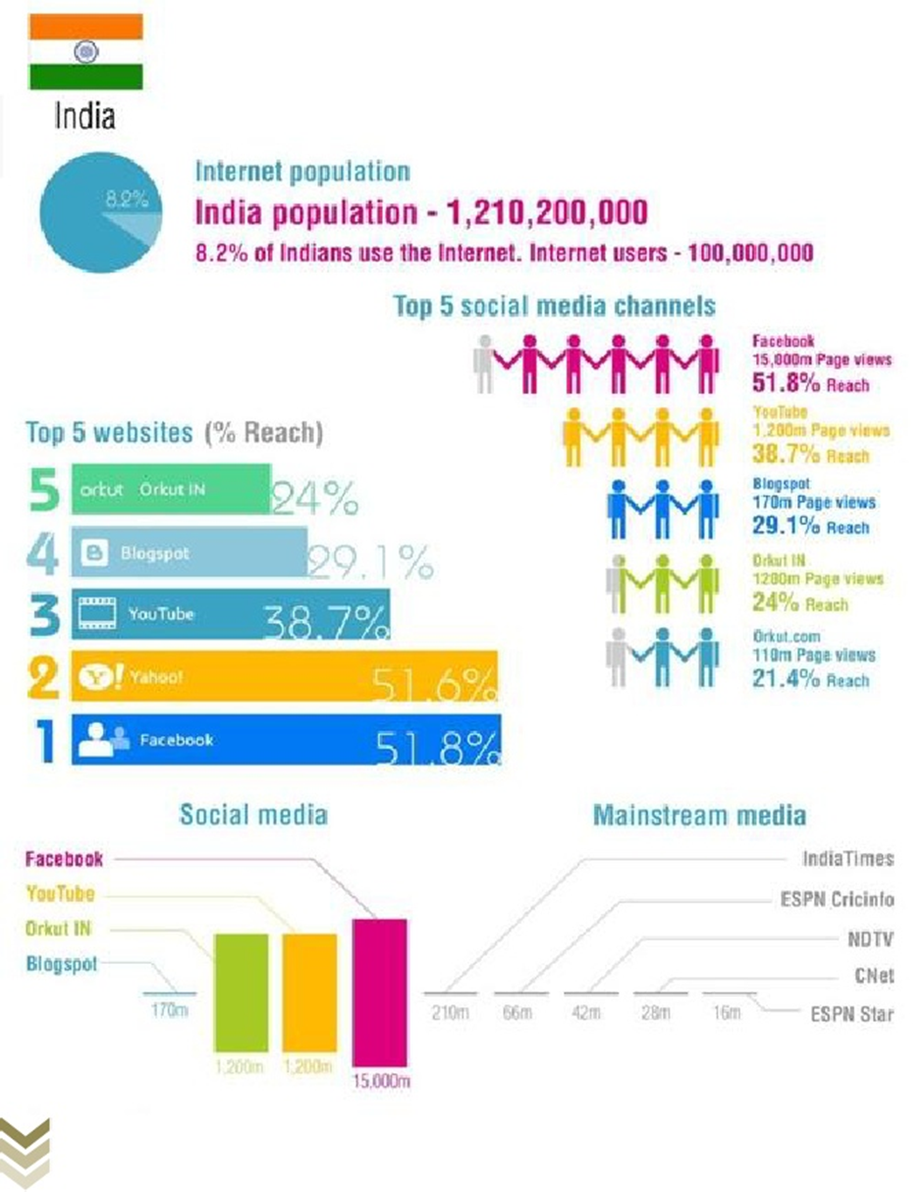
TABLE-2

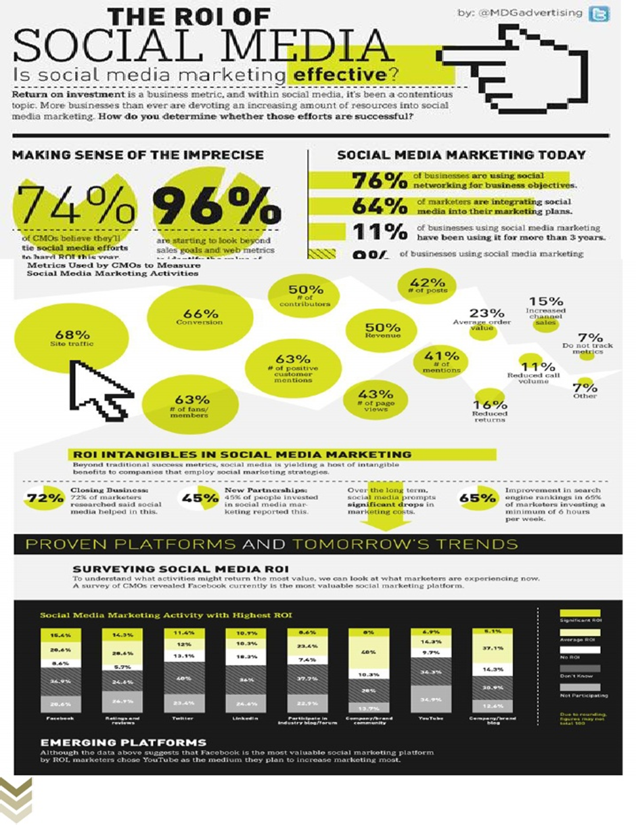

TABLE-3
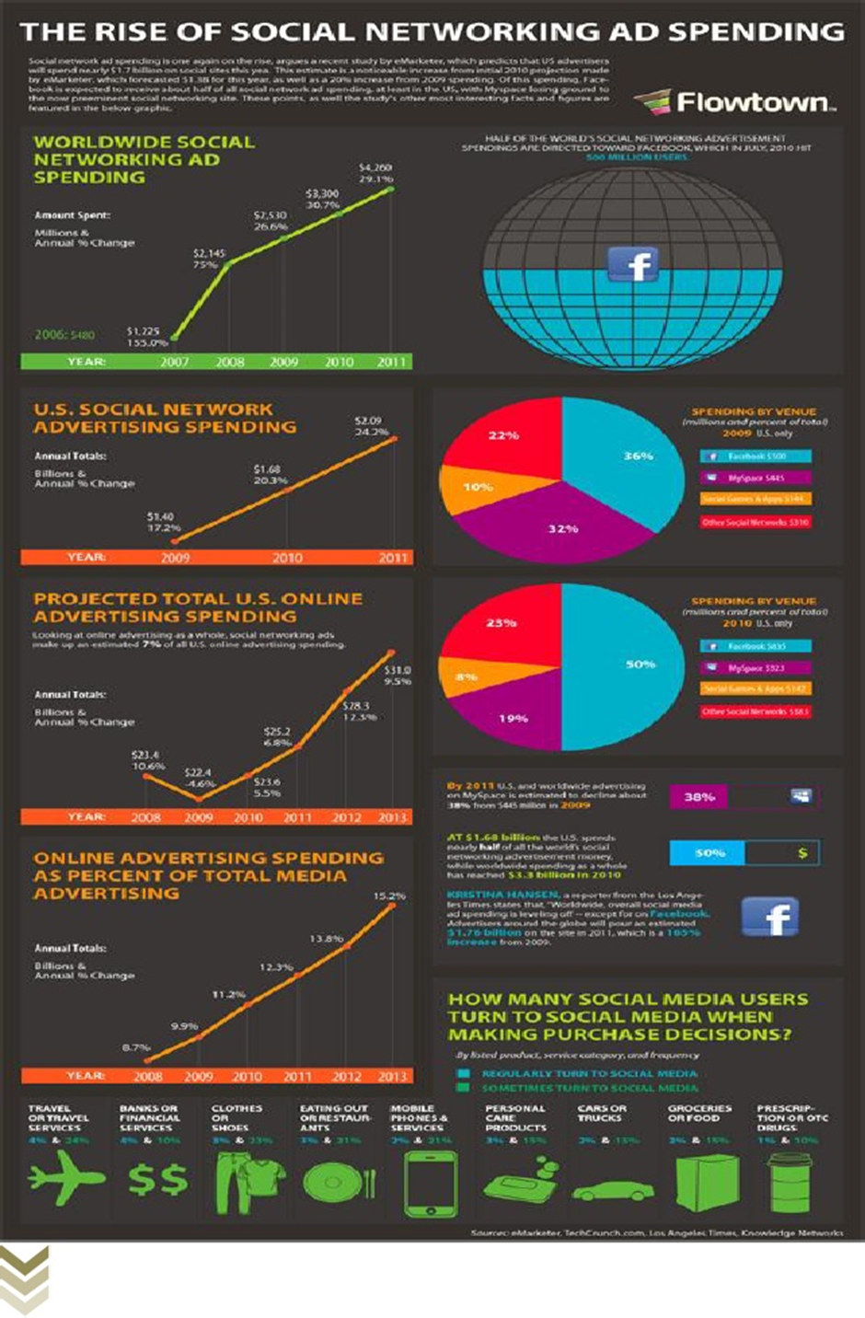

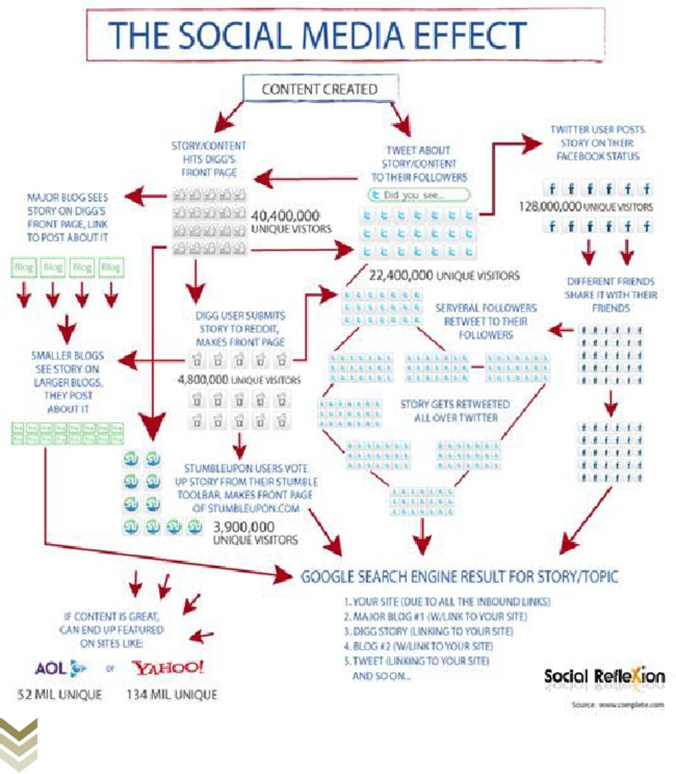

TABLE-4

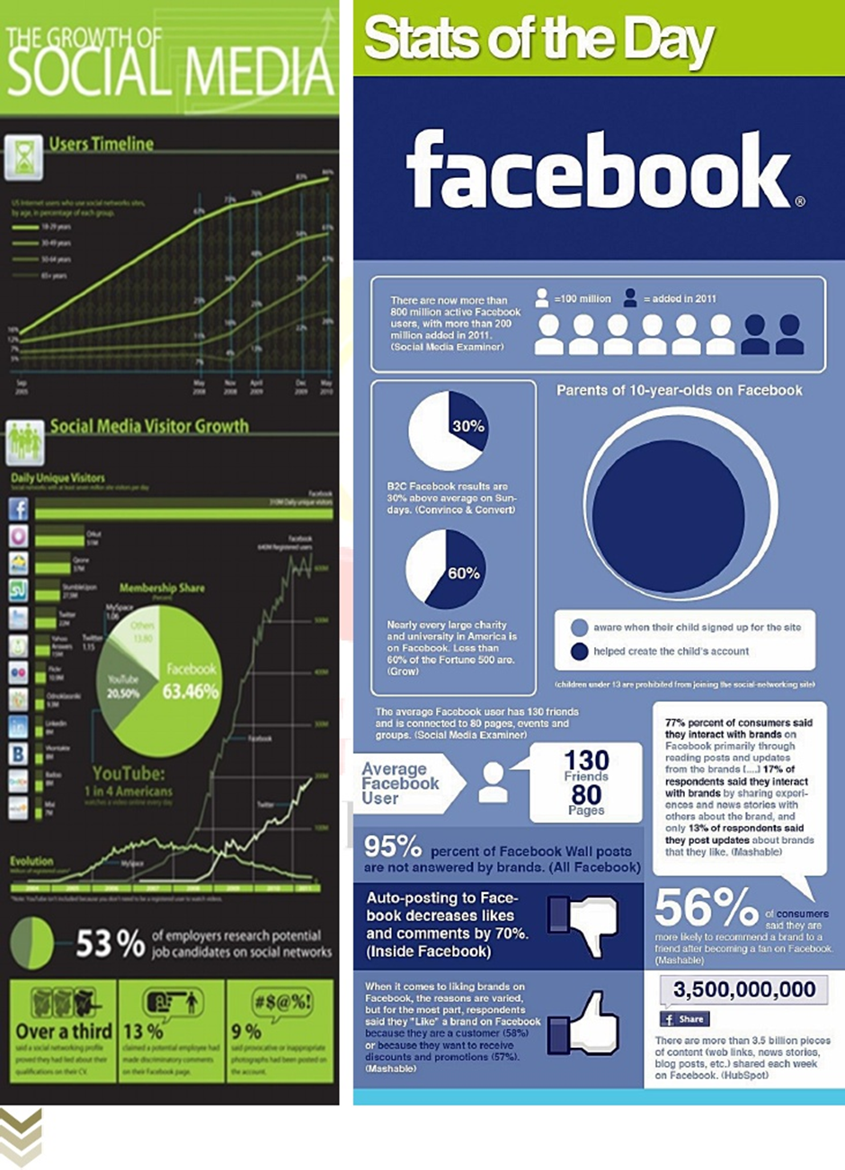

TABLE-6

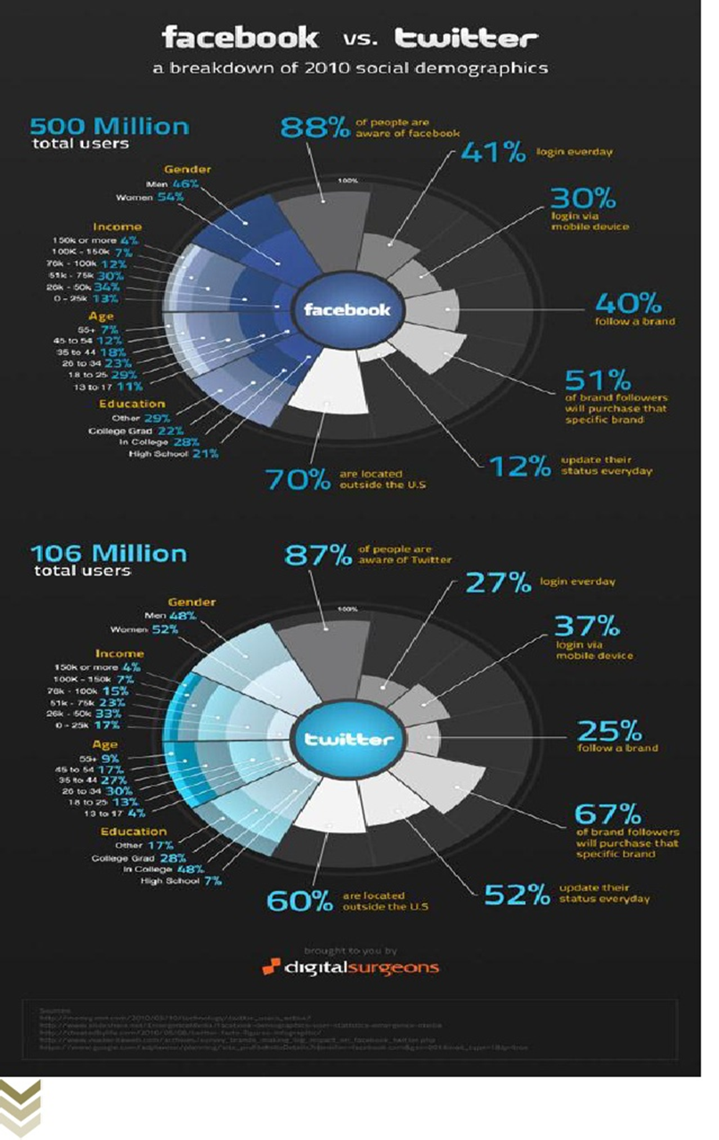

TABLE-7

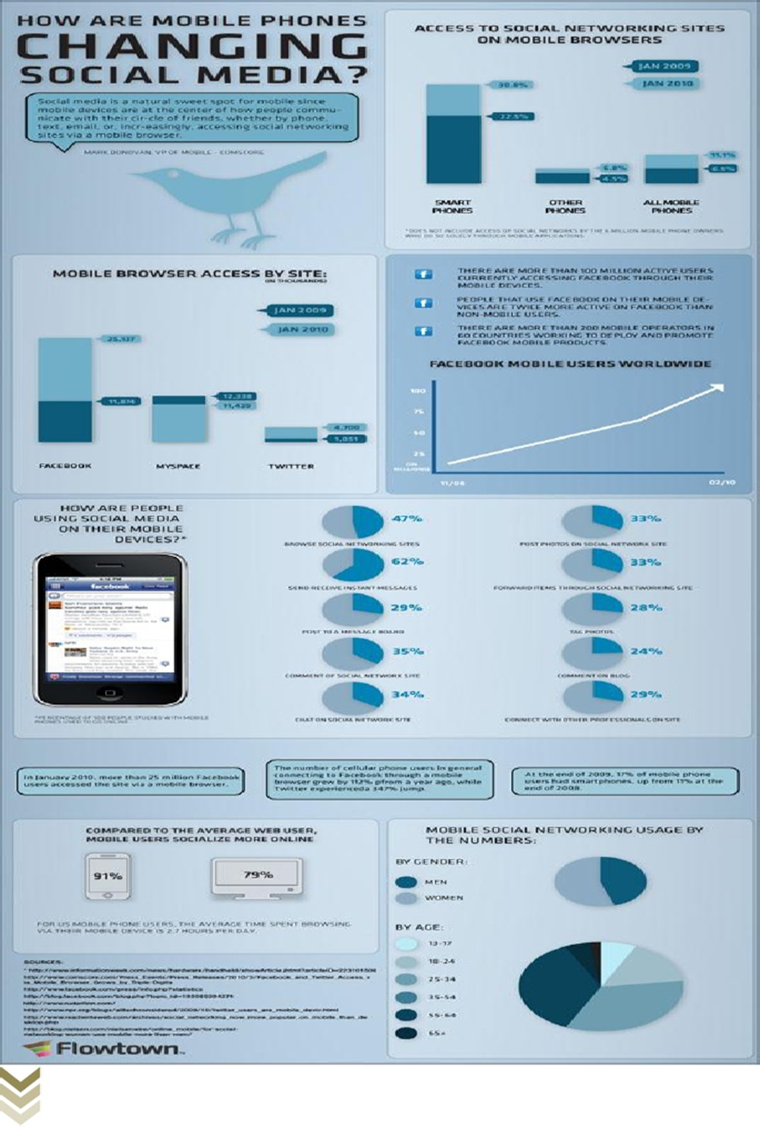

TABLE-8

TABLE-9

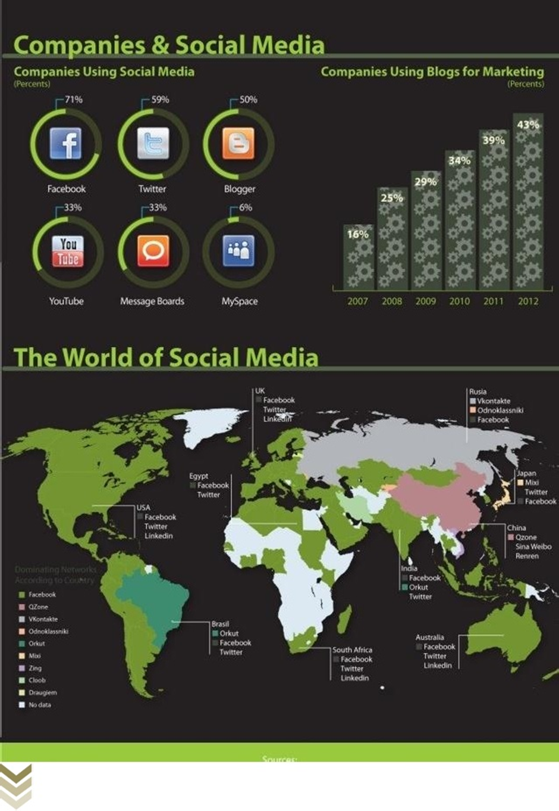

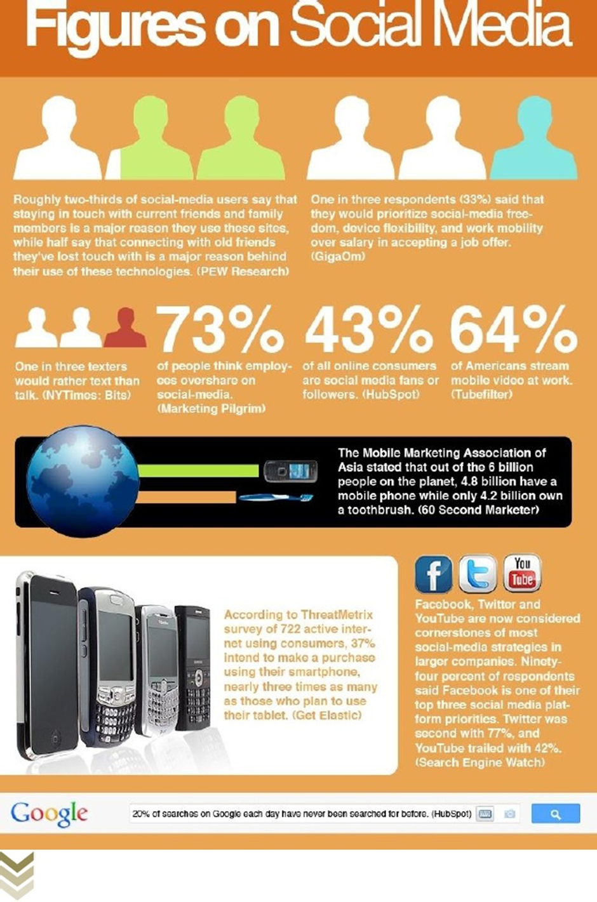

TABLE-10

DATA ANALYSIS

For research purposes, a survey was conducted using Google Forms. A Total of 60 people participated in the Survey. All the participants were in the age group 20-35 years of age –

Following are the result:

How many people are aware of social networking sites-

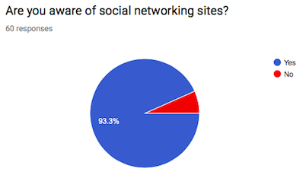

From this we can see that out of 60 people, 55 are aware of social networking sites and only 5 people are not aware about the social networking sites.

HOW OFTEN PROPLE USE INTERNET-

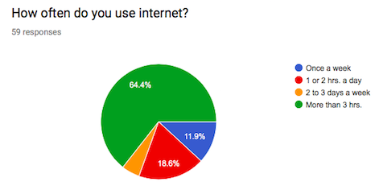

From this we can see that out of 59 people, 37 people use internet more than 3hrs, 6 people use internet once a week, 10 people use internet 1 or 2 hrs.’ a day and remaining 6 people use internet 2 to 3 days a week.

HOW OFTEN PEOPLE LOG IN THOSE SOCIAL SITES-

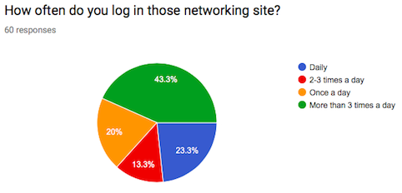

In this we can see that out of 60 people, 25 people use social sites more than 3 times in a day, 13 people use social sites daily, 12 people login once in a day and rest 10 login 2-3 times in a day.

HOW MANY SOCIAL NETWORKING SITES(SNS) DO PEOPLE USE-

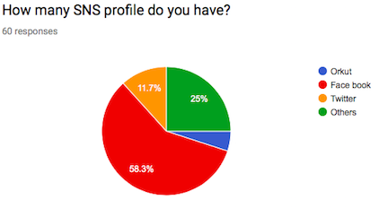

We can see from the survey of 60 people that, 34 people use Facebook, 6 people use twitter, 5 people use orkut and rest 15 people use other social networking sites which were not mentioned in the survey.

WHICH SOCIAL NETWORKING SITE COMMUNICATES ADS WELL-

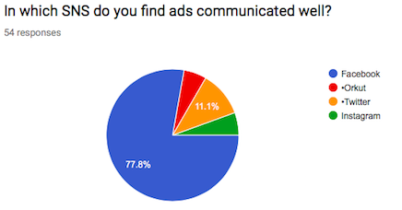

We can see from the survey of 54 people, 41 people find ads on Facebook well communicating, 5 people find ads on twitter well communicating, 4 people find ads on orkut attractive and remaining 4 find instagram more communicative.

WHAT KIND OF ADS DO PEOPLE COME ACROSS ON SOCIAL NETWORKING SITES-

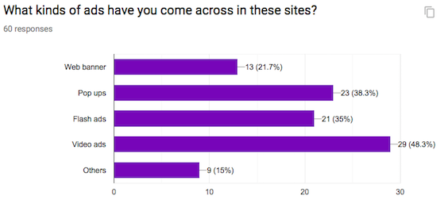

We can see that 60 people responded to the survey conducted, out of which 27 people responded that they come across video ads, 13 people come across pop-ups, 11 people come across flash ads, 6 people come across web banners and reaming 3 come across other forms of ads.

WHAT KIND OF BRAND COMMUNICATION DO PEOPLE FIND ATTRACTIVE-

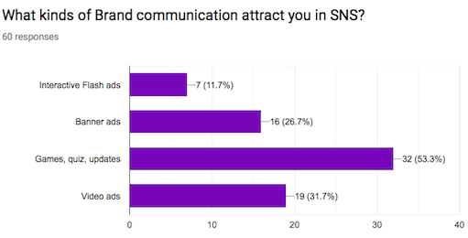

From the survey of 60 people, 31 of them find games, quiz and updates attractive as the mean of brand communication, 11 people find interactive video ads more attractive, 9 people find banners as better mean of communication and rest 9 find interactive flash ads attracts them.

DO THESE KINDS OF ADS MAKE IMPACT ON PEOPLE-

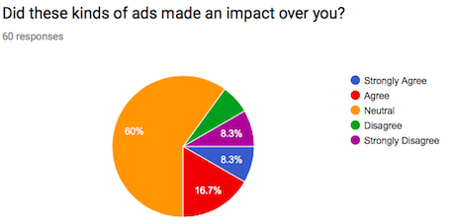

As we can see that out of 60 people surveyed, 36 people responded that these ads make neutral effect to them, 9 people agreed that these ads make good impact, 4 said these ads strongly affect people, 4 people strongly disagreed the statement and remaining 7 also disagreed to this.

CHAPTER-4
-CONCLUSION
-RECOMMENDDATION
-REFERENCES

CONCLUSION
Marketers have been confronted with the fact that their dominance in the marketplace is fading: push marketing, based on mass-media communication is becoming less efficient while substantial changes in the marketplace and development in the area of information and communication technologies have put the customer in control of the communication and marketing process. Increasing customer power goes hand in hand with decreasing trust in traditional marketing and in the diminishing effectiveness of long-established marketing approaches.
The present evolutionary stage of the internet widely known as web 2.0 has boosted customer power by presenting individual with a new generation of online applications, tools and networking opportunities commonly referred to as the social media.
Social media has changed the way we communicate and the way we do business. Word of marketing is being replaced by tweeting recommendation to friends and more and more customers are researching products online before purchasing.
So social media marketing plays a vital role in selling or advertising the products and events. But on other hand it has various drawbacks too such as it is time consuming process hacker’s threat is always there risk of negative comments etc.
Social media marketing can be done through various social networking sites such as Facebook, twitter. Orkut etc.
Case studies help in understanding detailed information, strategies and concepts about the topic. In this project various case studies have been used to know more about social media marketing. This helped to understand the concept and strategies which companies uses to promote their products. Case study on LG, NIKE, MTV, have been done in this project which helped to know more about social media marketing.

RECOMMENDATION
Social media marketing success doesn’t take place over night. It’s a cumulative process that produces success with persistent and consistent execution. Once you’ve developed your social media marketing strategy, success of your efforts is dependent on your execution.
- Spend time every day executing your social media strategy. If you’re not investing at a minimum the equitant of 25% of a full-time employee daily to execute your social media marketing strategy you likely will not get the result you need and expect.
- Develop a 3 month edition calendar now that you know who you want to reach and where you plan to find them, you need to develop an editorial calendar that identifies the content and messages you want to communicate over a 3 month period.
- Use the 10-4-1 rules your audience will quickly tune you out if all you talk about is YOU! While it’s entirely appropriate to share your blog posts and landing pages on social media you need to be helpful above all else. Post interesting content from other sources (trade, journals, business press etc.)
- Involve your sales team in your social media marketing while you’re focused on optimizing your company’s social media marketing channels, have your sales and management team amplify your efforts with their personal accounts.

REFERENCES

Borges B (2009). Marketing 2.0. Wheat mark, pp. 45-63
.Brinlee D (2007). Does Internet Advertising Work?http://www.askdeb.com/internet/advertising
Chaffey D (2003). Internet Marketing, Strategy, Implementation and Practise. 2nd edition, Pearson Education Limited, pp. 115-186
.Donath J, Boyd D (2004). Public displays of connection. BT Technol. J., pp.71-82
Eric E (2008). 2008 Growth Puts Face book In Better Position to Make Money. http://venturebeat.com/2008/12/18/2008-growth-puts-facebook-in-better-position-to-make-money.
Lacy K, Hernandez M (2009). Twitter Marketing for Dummies. pp. 14-20
Nicole K (2007). Building a Brand through Social Networks, http:/ /mashable.com/ 2007/05/ 08/ brand-social-networks/
Ricadela A (2007). Fogeys Flock to Facebook, Business Week.http://www.businessweek.com/technology/content/aug2007/ tc2007085_051788.htm
Scott DM (2009). The New Rules of Marketing and PR. John Wiley & SonsInc., pp. 135-150
Shih C (2009). The Facebook Era. Tapping online social networks to build better products, reach new audiences and selling more stuff. Prentice Hall Publication, pp. 85-128
Stroud D. (2007). Opinion piece: Falling in Love 2.0: Relationship marketing for the Face book generation. Social networking: An age-neutral commodity
Social networking becomes a mature web application,pp. 105-165.
Second Edition. John Wiley and Sons, pp. 58-97.
Zarrella D (2010). The Social media marketing.

QUESTIONNAIRE

Dear Sir/Madam
Name:
……………………………………………………………….………………

Contact No: ……………………………………………………..

City: …………………………………………………………State:………………………………………………..
I am a student of MATA SUNDARI COLLEGE, Delhi University, and
Presently doing a project on “Analysis of Social Networking Site:

A study on effective communication strategy in developing brand
Communication”. I request you to kindly fill the questionnaire below and I
Assure you that the data generated will be kept confidential.

1. How often do you use internet?
Once a week
1or 2 hrs. a day
2 to 3 days a week
More than 3 hrs.
2. Are you aware of social networking sites?
Yes
No
3. How often do you log in those networking site?
Daily
2 to 3 times a day
Once a week
More than 3 times a day
4. How many SNS profile do you have?
Orkut
Face book
Twitter
Others
5. In which SNS do you find ads communicated well?
Facebook
Orkut
Twitter
Others
6. What kinds of ads have you come across in these sites?
Web banner
Pop ups
Flash ads
Video ads
Others
7. What kinds of Brand communication attract you in SNS?
Interactive Flash ads
Banner ads
Games, quiz, updates
Video ads
8. Did these kinds of ads made an impact over you?
Strongly Agree
Agree
Neutral
Disagree
Strongly Disagree

