# 

**A PROJECT REPORT**

**ON**

### CUSTOMER FEEDBACK OF ONEPLUS

### BY

**KANIKA JAIN**

**(BA Prog)**

**BAP/17/395**

CERTIFICATE

This is to certify that Mr. / Miss  of Mata Sundri College for Women has successfully completed the project work. The project Report has been approved as it satisfies the academic requirements in respect of project work prescribed for the said degree.

Ms Sakshi Jindal Dr. Harpreet Kaur

Project Guide Principal

DECLARATION

I, Mr. / Ms_________________________________ hereby declare that this project is the record of authentic work carried out by me during the academic year 2018– 2019 and has not been submitted to any other University or Institute towards the award of any degree.

**INDEX**

|  |  |
| --- | --- |
| **No.** | **Particulars** |
| **1.** | **CHAPTER 1**  **INTRODUCTION TO ONEPLUS** |
| **2.** | **CHAPTER 2**   1. **OBJECTIVES** 2. **SCOPE** 3. **RESEARCH METHODOLOGY** |
| **3.** | **CHAPTER 3**  **DATA ANALYSIS**   1. **PRIMARY DATA** 2. **SECONDARY DATA** |
| **4.** | **CHAPTER 4**  **CONCLUSION** |
| **5.** | **QUESTIONNAIRE** |
| **6.** | **BIBLIOGRAPHY** |
|  |  |

**What is a smartphone?**

**Smartphones** are a class of mobile phones and of multi-purpose mobile computing devices. They are distinguished from feature phones by their stronger hardware capabilities and extensive mobile operating systems, which facilitate wider software, internet (including web browsing[1] over mobile broadband), and multimedia functionality (including music, video, cameras, and gaming), alongside core phone functions such as voice calls and text messaging. Smartphones typically include various sensors that can be leveraged by their software, such as a magnetometer, proximity sensors, barometer, gyroscope and accelerometer, and support wireless communications protocols such as Bluetooth, Wi-Fi, and satellite navigation.

**The History Of OnePlus: From Boasty Startup To Respected OEM**

OnePlus was founded on 16 December 2013 by former Oppo vice-president Pete Lau and Carl Pei. According to the Chinese government's documentation, the only institutional stockholder in OnePlus is Oppo Electronics. Lau denied that OnePlus was a wholly-owned subsidiary of Oppo and stated that Oppo Electronics and not Oppo Mobile (the phone manufacturer) is a major investor of OnePlus and that they are "in talks with other investors". The company's main goal was to design a smartphone that would balance high-end quality with a lower price than other phones in its class, believing that users would "Never Settle" for the lower-quality devices produced by other companies.

The company unveiled its first device, the OnePlus One, on 23 April 2014. In December 2014, alongside the release of the OnePlus One in India exclusively through Amazon, OnePlus also announced plans to establish a presence in the country, with plans to open 25 official walk-in service centres across India.

The OnePlus One was OnePlus' pride and joy for a time, not just because it was its first device, but also because it was during a time when the phone was actually fairly challenging to get a hold of. It was also when OnePlus was a brand new company and for a brand new company, OnePlus had more confidence than most other brand new companies would have when entering into an extremely competitive market like the smartphone industry.

To kick off its campaign as force to be reckoned with, OnePlus started its rise to fame with comparisons between its first, and at the time, upcoming, phone and the top flagship phones of that year. In this case one of the examples was the Galaxy S5, as that was Samsung's current flagship smartphones at the time. OnePlus took to social media to promote its phone before it was even unveiled, showcasing the comparison of the specs and hardware it used compared to that of the other flagships, thus flaunting its yet unreleased device and essentially telling the world why it was a better choice than the competitor. Many saw this as a bold move, others saw it as arrogant since it was comparing itself to established companies, but whatever it was, it certainly stirred up some controversy and got people talking, and it more or less kept OnePlus at the forefront of people's minds, so whether or you not found the boasting endearing, the method did work. You can see an example of OnePlus' early social media marketing efforts below. This was just one of the pictures it would put up on its social media pages to attract attention.

**CHAPTER 2**

OBJECTIVE

* The aim is to gain and analyse customer feedback and strategies used by Oneplus to attract customers.
* The aim is to understand how the company interacts and deals with its customers
* The aim is to know how Oneplus became a Top-Selling brand in the Indian market.

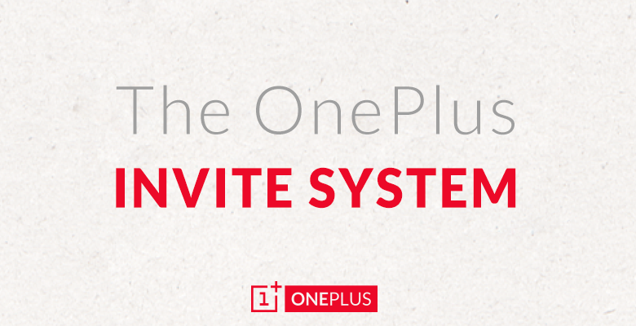

SCOPE

* The scope of this project has been limited to the Feedback of Customers through surveys used by OnePlus in mainly Indian Markets.
* This study includes a data analysis of a survey which helped me to understand people’s perspective, views and interests when they choose OnePlus for their SmartPhone Choice.

**RESEARCH METHODOLOGY**

For the purpose of collection of Primary Data, I made a questionnaire with the help of Google Forms. The form was more like a Multiple Type Questions with most of the questions having ‘yes’ and ‘no’ options to make it easy for people to fill. The questionnaire consists of 8 questions. 52 responses were received from the questionnaire. Pie charts and bar diagrams have been pasted to explain the data analysis of the responses so that it can be analyzed in a systematic manner and henceforth can be interpreted easily.

The sources of Secondary Data in this project are form various websites which publish online articles, brochures and magazines. Data has also been collected from websites like digit.in for review data and Wikipedia.

**CHAPTER 3**

**DATA ANALYSIS:**

For research purposes, a survey was conducted using Google Forms. A Total of 52 people participated in the Survey. All the participants were in the age group 20-35 years of age. Following are the results-

**No. of people aware about OnePlus.**

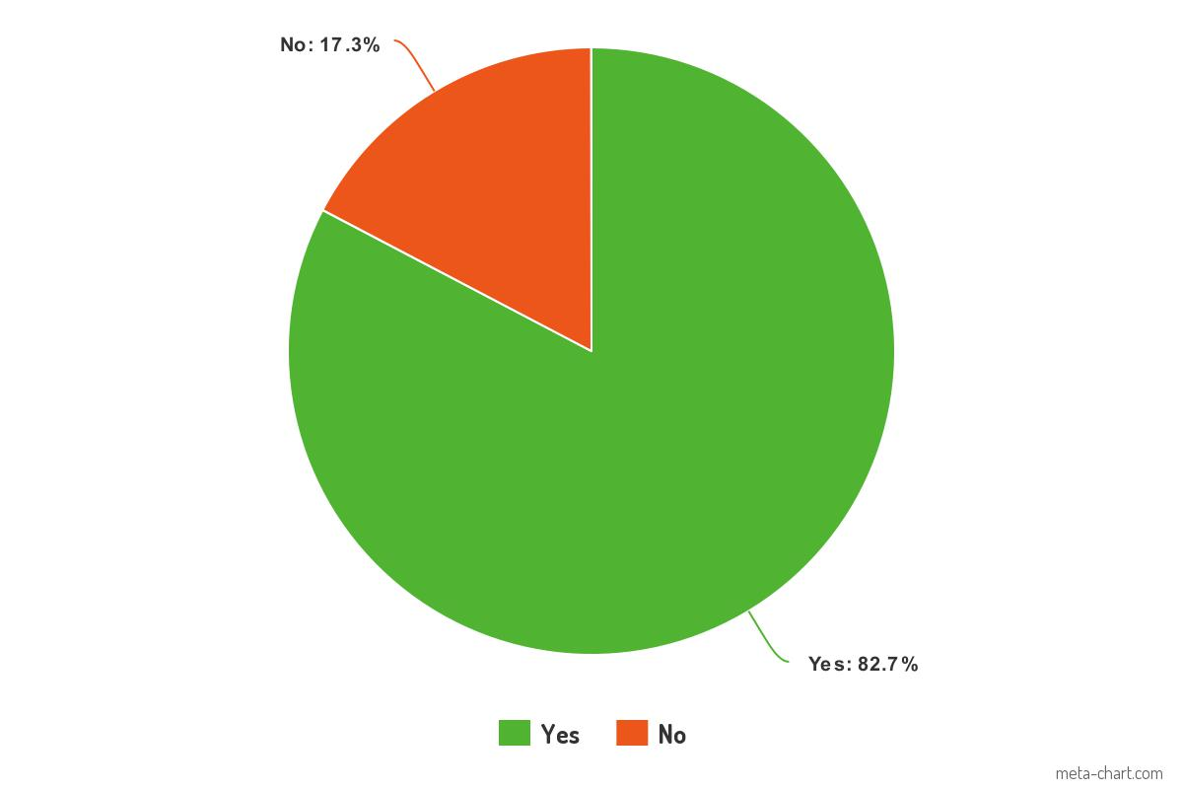

From this we can see that out of 52 people, 43 have heard and are well aware of OnePlus Brand and only 9 people have not heard about the company.

**How people heard about OnePlus for the first time**

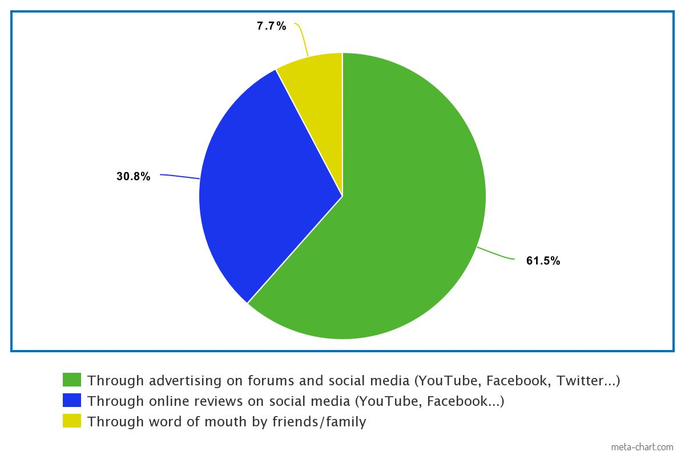

From this we can see that out of 52 people, 32 people have heard through advertisements 16 heard through Social Media and only 4 heard from other people.

**People who bought their phones using an invite.**

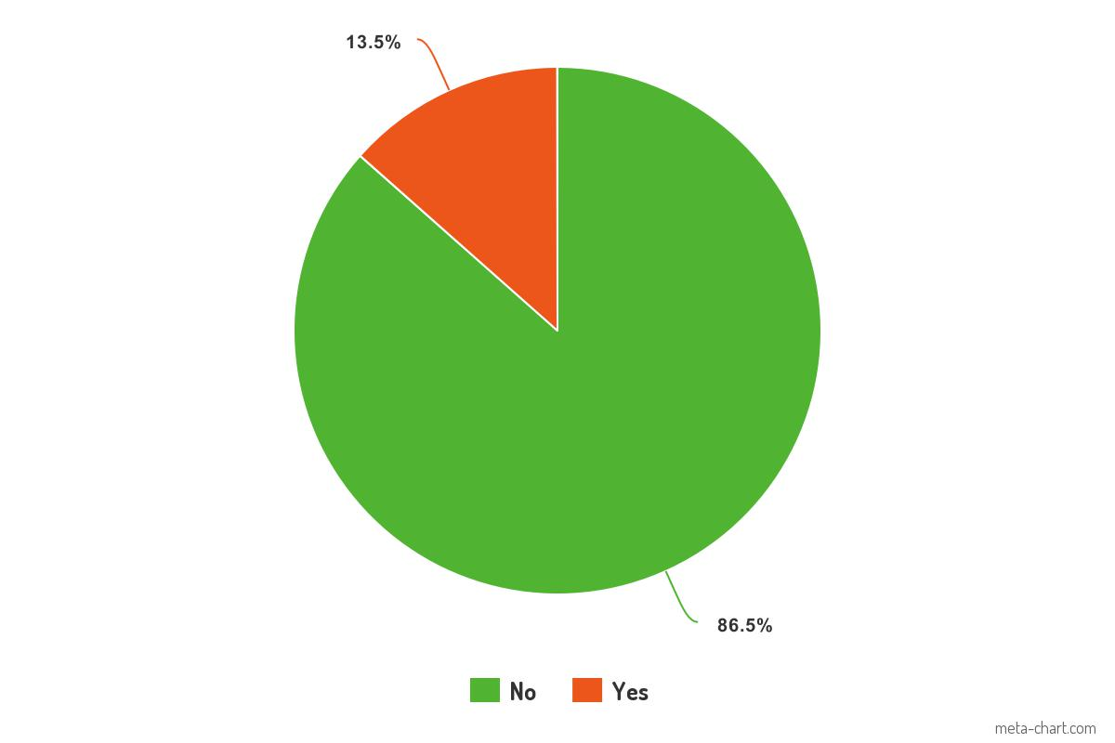

From this we can see that out of 52 people, only 7 people bought their OnePlus device using an invite. Initially, The OnePlus smartphones were available through invites only. This means that you needed to have an invite in order to be able to purchase an OnePlus phone. Nowadays, with the launch of the OnePlus3, the company has abandoned this system. The rest 45 people didn’t buy their phones from an invite.

**The amount people are ready to pay for an smartphone.(In Rs)**

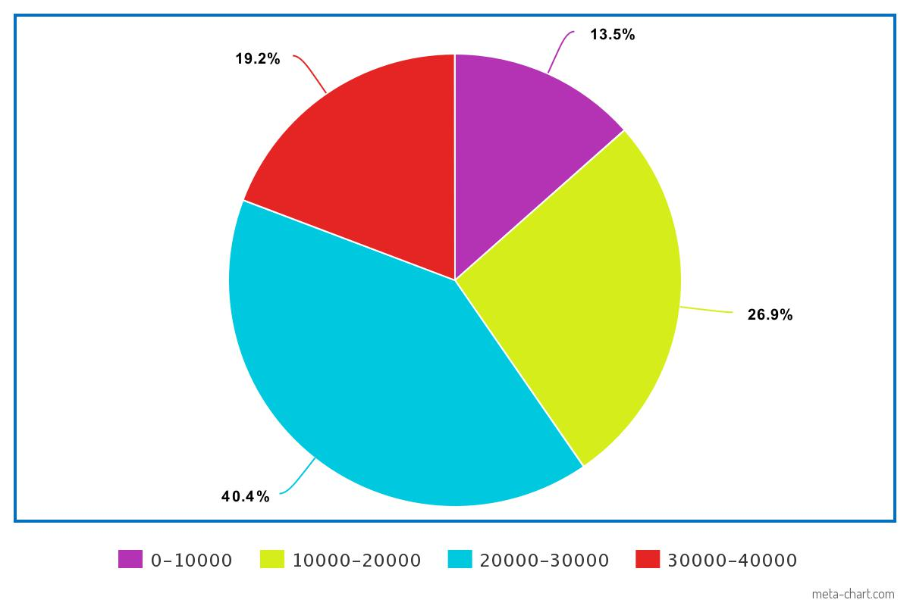

From this we can see that out of 52 people, 7 people prefer spending only between 0-10000 on a phone, 14 prefer to spend 10000-20000, 21 people prefer to spend 20000-30000 and 10 prefer to spend between 30000-40000. This is good for OnePlus as all their Smartphones range between 25000-35000. This is one of the main reasons for the success of the Company.

**The number of people who believe that OnePlus are the ‘flagship killers’**

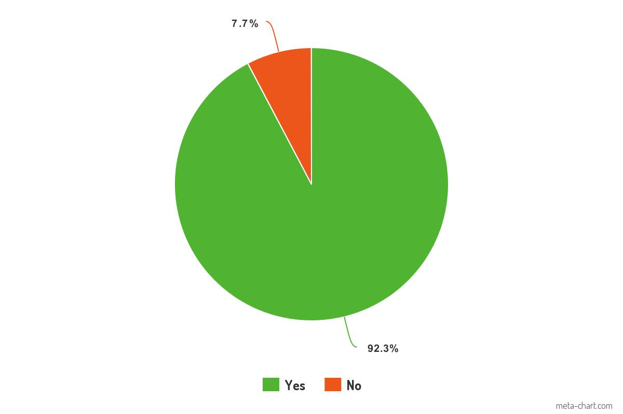

From this we can see that out of 52 people, 48 agree that Oneplus are FLAGSHIP KILLERS. They have conquered the Indian Market with their products and prices.

**Why people prefer OnePlus.**

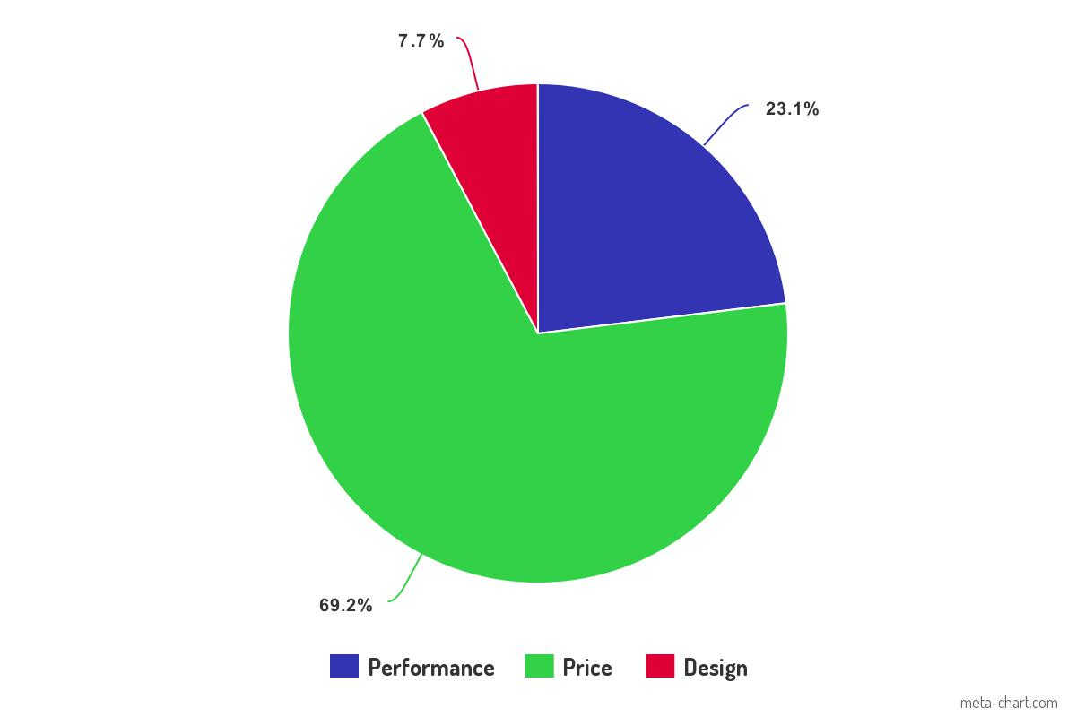

From this we can see that out of 52 people, most of the people prefer OnePlus because of their prices and Performance. This survey was answered by people between 20-40 age group. Most of them don’t prefer to spend much on a smartphone and also expect quality. OnePlus has all of its devices ranging from 30000-40000 which seems ideal for most of the people.

**OnePlus dares Apple on social media, poses a question for Siri.**

With the latest iPhones prohibitively expensive in India, OnePlus has seen many of the Apple lovers coming to its fold. With phones like the OnePlus 6 and the OnePlus 6T, the company has won many consumers. So many that it is according to some market research firms, is the top premium phone seller in India. In a recently conducted research, OnePlus was eventually found to be the fastest growing premium smartphone brand in India. And now OnePlus is daring Apple.

In a not so veiled challenge, OnePlus took a shot at Apple The post showed a banner stating: "Hey Siri, which is India's No.1 Premium Smartphone?" And the caption read: "iDare". You don't have to be a rocket scientist to figure out that OnePlus is taking a jibe at Apple's iPhones. iPhones have been ruling the premium smartphone market, both in India as well as the world. Of late, iPhones have seen their prices going up, with the iPhone XS debuting in India at a price of Rs 99,900. This has made iPhones out of reach for a major number of consumers and has forced premium smartphone seekers to opt for affordable alternatives.

**OnePlus Referral Program:**

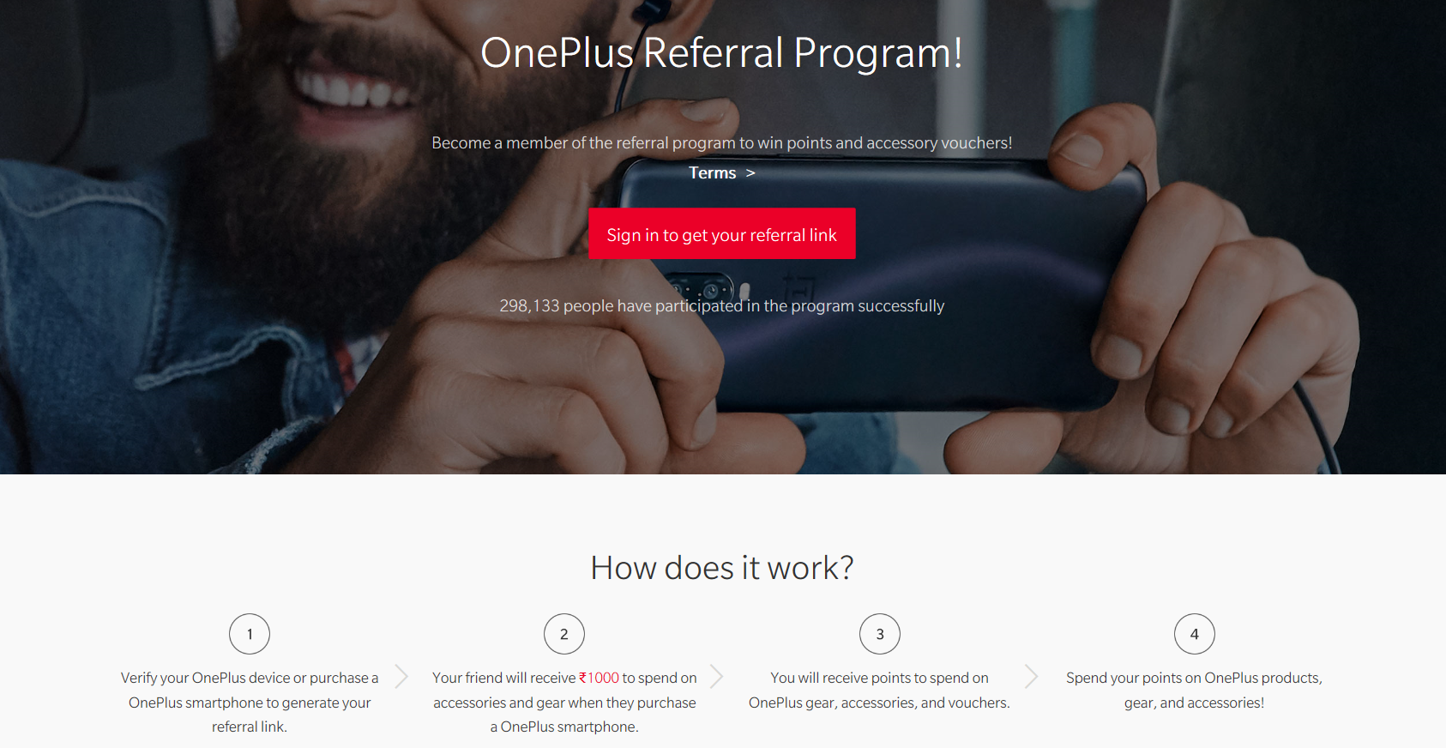

If you’ve ever purchased a OnePlus smartphone directly from OnePlus, you’re automatically eligible to join the Referral Program. Just head to the referral link attached below, click the Get your sharable link button, then log in to your OnePlus account. You’ll then be given a link which you can share with anyone you’d like. Once your friends or family use the link to buy a smartphone from OnePlus, they’ll receive $20 (or an equivalent amount in their local currency) off an accessory of their choosing.

**SWOT ANALYSIS**

* **STRENGTH**

1. Low cost smartphones with high end specs.
2. OnePlus is growing as one of the fastest growing companies in India
3. Exclusive partnership with major e-tailor Amazon
4. OnePlus sold out 30,000 units of the OnePlus 2 in China within 64 seconds after launching the product sale.
5. Special Android platform OxygenOS is a big strength since it sets them apart from other android users.

* **WEAKNESS**

1. Limited Production capacity
2. New entrant in market.
3. Highly competitive industry.
4. Online sales may eliminate offline audience

* **OPPURTUNITIES**

1. Broaden the geographical market base.
2. Resort to mainstream product advertising

* **THREATS**

1. New entrants selling equally competitive phones are lower prices.
2. Inability to keep up with the huge capital involvement in the industry trend.

**OnePlus Product Line-Up and Customer Problems**

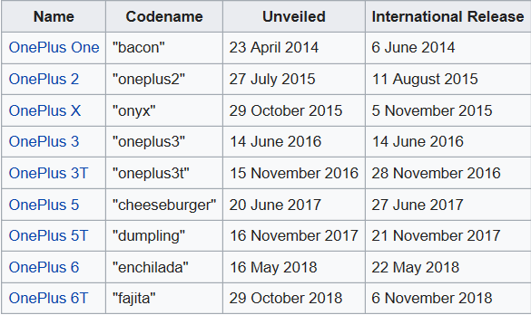

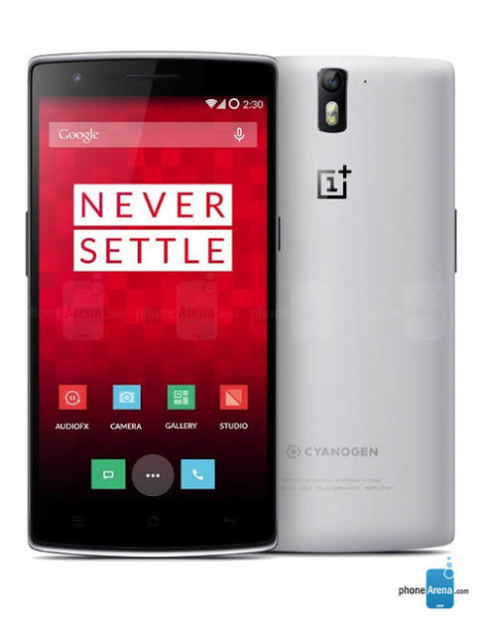

#### OnePlus One

The company's first product was the highly anticipated OnePlus One. It was unveiled on 23 April 2014, and was claimed as the "2014 Flagship Killer." The One had comparable, and in some ways better, specifications to other flagship phones of the year, while being sold at a signific

antly lower price at $299 for the 16 GB version or $349 for the 64 GB version. The One also debuted the infamous invite system, which ensured that the company didn't take more orders than it was capable of shipping.

The OnePlus One had several minor hardware issues at launch, which reportedly was corrected in later batches of the phone.

OnePlus One had a lot of problems at the start.

* **Problem** #1 – The battery doesn't last as long as expected.
* **Problem** #2 – Random reboots.
* **Problem** #3 – Charger overheats.
* **Problem** #4 – Yellow tint on phone display.
* **Problem** #5 – Poor or slow charging.
* **Problem** #6 – Various touch screen **problems**.

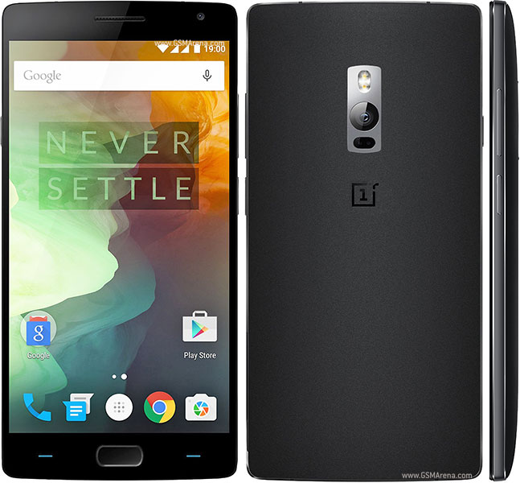

#### OnePlus 2

#### The OnePlus 2 was the successor to the company's highly successful first phone. It was unveiled a little over a year after the One, on 27 July 2015. It was highly promoted as "2016 Flagship killer". There were very high expectations for the second generation OnePlus phones, partly because the company managed to create a high amount of hype for the upcoming phone. One of the marketing channels used was YouTube tech reviewer MKBHD who was sent a unit, which he covered in detail leading up to the launch.

The OnePlus 2 had specifications comparable to other flagship phones of the time, including the highly criticizedQualcomm Snapdragon 810, though OnePlus had decided to leave out an NFC chip, as it didn't see mobile payment being an essential feature at the time. The phone was also one of the first Android devices to sport a USB-C port over the older micro USB port.

Some of the problems that customers had with the the OnePlus 2 were:

* Problem #1 – Capacitive home button and fingerprint sensor unresponsive
* Problem #2 – Dual-SIM selection issues
* Problem #3 – Clear All button from Recent Apps screen has disappeared
* Problem #4 – Camera issue
* Problem #5 – Phonebook sync issues when connecting phone to the car via Bluetooth
* Problem #6 – Connectivity issues

#### 

#### OnePlus X

The OnePlus X was OnePlus' entrance to the budget phone market, at 5 inches instead of the One and 2's 5.5 inches. The phone was unveiled on 29 October 2015. The phone was sold for $249, and consisted mostly of the same internal components as the year and half old OnePlus One, but had an AMOLED display.

Customers had problems with the OnePlus X too:

* [MicroSD Card](https://phoneradar.com/oneplus-x-problems-and-solutions/#SDCard)
* [LTE Connectivity](https://phoneradar.com/oneplus-x-problems-and-solutions/#LTE)
* [Vibration](https://phoneradar.com/oneplus-x-problems-and-solutions/#Vibration)
* [App Permission](https://phoneradar.com/oneplus-x-problems-and-solutions/#Permission)
* [Camera Issue](https://phoneradar.com/oneplus-x-problems-and-solutions/#Camera)
* [Battery Issue](https://phoneradar.com/oneplus-x-problems-and-solutions/#Battery)s

[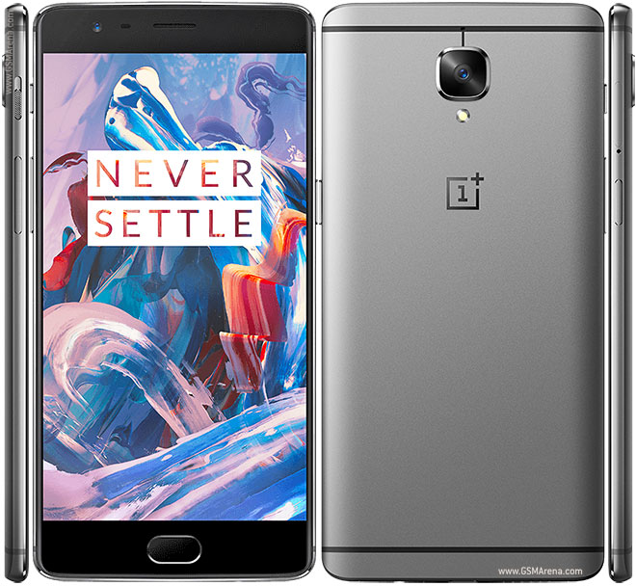](https://www.google.co.in/url?sa=i&rct=j&q=&esrc=s&source=images&cd=&cad=rja&uact=8&ved=2ahUKEwjTucnG_cXgAhVQSX0KHQBsDZ8QjRx6BAgBEAU&url=https://www.gsmarena.com/oneplus_3-7995.php&psig=AOvVaw3hLKhvsynyylaB-RU3QEKd&ust=1550603261875638)

#### OnePlus 3

The OnePlus 3 was unveiled on 14 June 2016. The 3 was the company's first "metal unibody" phone. The phone launched with a Qualcomm Snapdragon 820, 6 GB of RAM and 64 GB of UFS 2.0 storage. The phone was well regarded amongst critics, mostly for its low price and high specifications.

The OnePlus 3 is powered by 1.6GHz quad-core processor and it comes with 6GB of RAM. The phone packs 64GB of internal storage that cannot be expanded. As far as the cameras are concerned, the OnePlus 3 packs a 16-megapixel primary camera on the rear and a 8-megapixel front shooter for selfies.

The OnePlus 3 runs Android 6.0.1 and is powered by a 3000mAh non removable battery. It measures 152.70 x 74.70 x 7.35 (height x width x thickness) and weighs 158.00 grams.

The OnePlus 3 is a Dual-SIM (GSM and GSM) smartphone that accepts Nano-SIM and Nano-SIM. Connectivity options include Wi-Fi, GPS, Bluetooth, NFC, USB OTG, 3G and 4G (with support for Band 40 used by some LTE networks in India). Sensors on the phone include Compass/ Magnetometer, Proximity sensor, Accelerometer, Ambient light sensor and Gyroscope.

#### [Image result for oneplus 3t](https://www.google.co.in/url?sa=i&rct=j&q=&esrc=s&source=images&cd=&cad=rja&uact=8&ved=2ahUKEwiA_fqd_cXgAhWKbisKHZDoB9cQjRx6BAgBEAU&url=https://www.digit.in/mobile-phones/oneplus-3t-price-51571.html&psig=AOvVaw3_R266E-ocNKc6QPt1pGLE&ust=1550603179543266)

#### OnePlus 3T

The OnePlus 3T was unveiled on 15 November 2016 as a minor upgrade to the still relatively new OnePlus 3. The upgrade consisted the use of a newer SoC; the Qualcomm Snapdragon 820 was replaced with the Snapdragon 821. Also introduced were a higher-capacity battery, 64 or 128 GB of storage and 16 MP front-facing camera. The phone launched in the US on 22 November 2016 and in the EU on 28 November 2016.

The OnePlus 3 and OnePlus 3T had similar problems. Problems customers had were

* Ram Management
* Disappearing ring tones
* High device temperatures
* No signal
* Colour balance problems
* Bluetooth problems

The OnePlus 3T had a major camera focus issue. Customers reported that the rear camera was unable to focus. To tackle this problem, OnePlus went out of their way and offered free repair for customers even to people who ran out of warranty.

[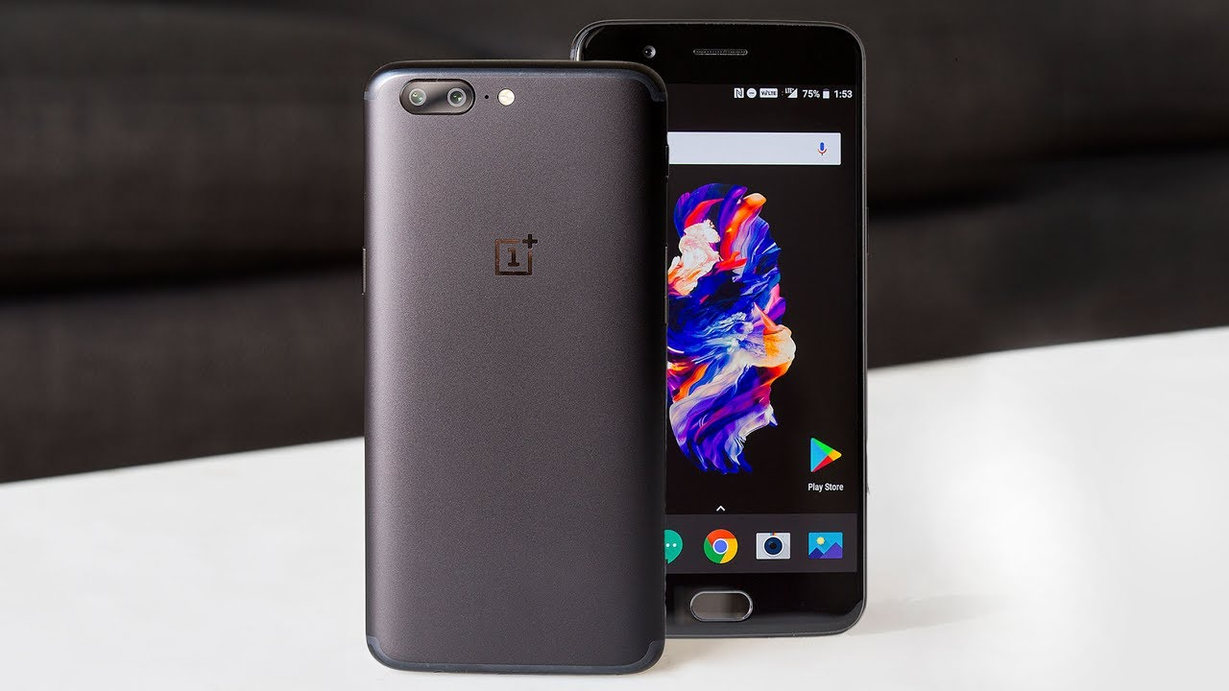](https://www.google.co.in/url?sa=i&rct=j&q=&esrc=s&source=images&cd=&cad=rja&uact=8&ved=2ahUKEwit9Yjd_MXgAhXabCsKHT4qB7cQjRx6BAgBEAU&url=https://www.youtube.com/watch?v=995M3VOGhYs&psig=AOvVaw0L7t-1_eewjUm-WNw3uhYl&ust=1550603065439788)

#### OnePlus 5

#### The OnePlus 5 was unveiled on 20 June 2017. It launched with a Qualcomm Snapdragon 835, a dual-lens camera setup, up to 8 GB RAM, and up to 128 GB of storage. It was released in two colours: Midnight Black and Slate Gray. A third limited edition colour, Soft Gold was released on 7 August 2017. Another special edition colour was launched on 20 September 2017, in collaboration with *Castelbajac.*

Problems that the customers had with OnePlus 5 were

* Odd jelly scrolling effect
* Phone unexpectedly vibrating while on a call
* PC doesn't recognise device
* Unable to maintain WiFi connection
* Random shutdown

#### 

#### OnePlus 5T

The OnePlus 5T was unveiled on 16 November 2017, as the successor to the OnePlus 5. It features the same Qualcomm Snapdragon 835 SoC and storage options as its predecessor. Notable features include a larger 6" 18:9 display, a new "Face Unlock" facial recognition method, and an improved dual-lens camera.

Problems that the customers had with the OnePlus 5T were

* Apps weren't full-screen
* Fingerprint scanner
* Audio distortion

#### [Image result for oneplus 6](https://www.google.co.in/url?sa=i&rct=j&q=&esrc=s&source=images&cd=&cad=rja&uact=8&ved=2ahUKEwjBoYnL_sXgAhUYfX0KHRWaBXMQjRx6BAgBEAU&url=https://www.zdnet.com/product/oneplus-6/&psig=AOvVaw0KVVvlfp3xP_8ETgtGjsA4&ust=1550603566920961)

#### OnePlus 6

OnePlus opened forums for the OnePlus 6 in April 2018 and launched the device on 17 May 2018 with sales starting on 22 May 2018. The phone notably features a display notch, water resistance (although not IP Code rated) and an all-glass design. The smartphone was the first from the company to offer a 256 GB inbuilt storage variant. At the launch event, OnePlus announced it would be opening five new OnePlus Experience stores in India, as well as 10 new service centres.

Problems that the customers had were

* Auto brightness flickering
* Overheating unnecessarily
* Calls going silent on speaker
* Delay in notifications

#### [Image result for oneplus 6 mclaren edition](https://www.google.co.in/url?sa=i&rct=j&q=&esrc=s&source=images&cd=&ved=2ahUKEwjZxfGo_sXgAhWMf30KHTy2DZQQjRx6BAgBEAU&url=https://www.youtube.com/watch?v=5I2XxMhbvn4&psig=AOvVaw20uGWZpBgVH4HRfDp8dl9s&ust=1550603496443529)

#### OnePlus 6T

The OnePlus 6T was unveiled on 29 October 2018. It launched with a Qualcomm Snapdragon 845, a dual-lens camera setup, up to 8 GB RAM, and up to 256 GB of storage. It also features a larger 6.41" 19.5:9 AMOLED display with In-Display fingerprint sensor running on OxygenOS based on Android 9 Pie. The camera has a 'Nightscape' mode which uses a longer exposure time to capture better photos in poor lighting conditions.

OnePlus set a Guinness World Record title of "the most people unboxing a phone simultaneously" on the launch of OnePlus 6T.

The OnePlus 6T is powered by octa-core (4x2.8GHz) processor and it comes with 8GB of RAM. The phone packs 128GB of internal storage that cannot be expanded. As far as the cameras are concerned, the OnePlus 6T packs a 16-megapixel (f/1.7, 1.22-micron) primary camera and a 20-megapixel (f/1.7, 1-micron) secondary camera on the rear and a 16-megapixel front shooter for selfies.

The OnePlus 6T runs Android 9.0 and is powered by a 3700mAh non removable battery. It measures 157.50 x 74.80 x 8.20 (height x width x thickness) and weighs 185.00 grams.

The OnePlus 6T is a Dual-SIM (GSM and GSM) smartphone that accepts Nano-SIM and Nano-SIM. Connectivity options include Wi-Fi, GPS, Bluetooth, NFC, USB OTG, USB Type-C, Active 4G on both SIM cards, 3G and 4G (with support for Band 40 used by some LTE networks in India). Sensors on the phone include Face unlock, Fingerprint sensor, Compass/ Magnetometer, Proximity sensor, Accelerometer, Ambient light sensor and Gyroscope.

Problems reported by customers were

* Not receiving SMS
* Phone not connecting to windows 10
* Auto brightness not working as expected
* Incoming call issues.

**Digit.in** have conducted an extensive and elaborate survey of Indian mobile phone users and their preferences. **Digit’s Great Indian Mobile Survey** not only gives keen insights into the most used and loved mobile phone brands of India, it also ranks them on the basis of **Performance**, **Build & Design**, **Camera**, **Value-For-Money** and **After Sales Support**.

**THE MOST USED SMARTPHONE BRAND**

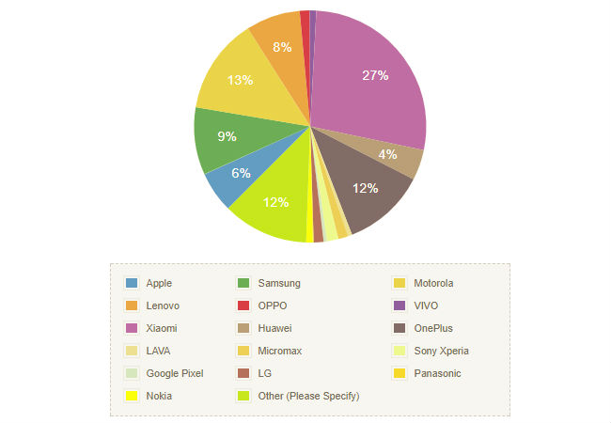

It was an easy win for **Xiaomi, with 27 percent** of the respondents to our survey picking the Chinese smartphone maker as their current handset choice. **13 Percent of the respondents use Motorola phones**, while **OnePlus** comes in as the third most used smartphone brand in the country with **12 percent** of the respondents using the devices.

**PERFORMANCE**

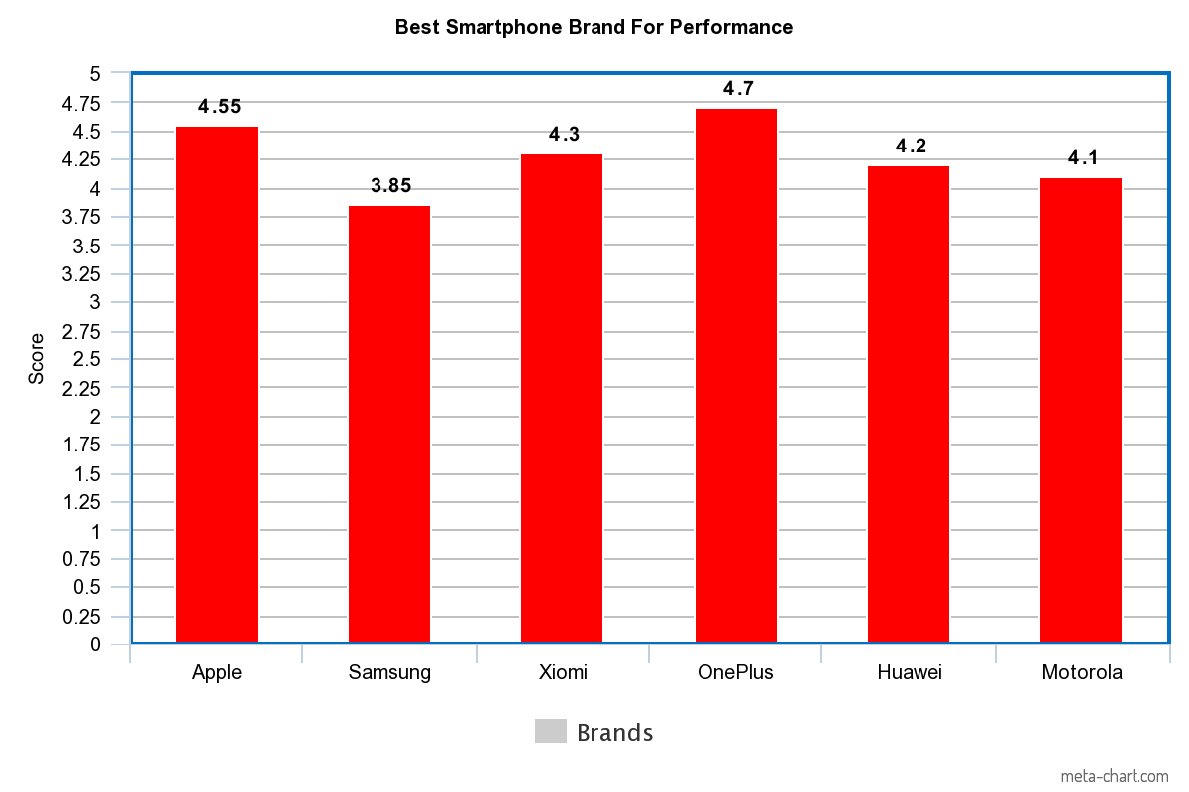

While most brands refer to communication themes that appease the attention dwindled generation, OnePlus has managed to create a community of engaged, loyal consumers through a steady mix of content, influencer marketing, UGC, and gratification. Through a cross-platform approach, OnePlus marketing strategy has many takeaways.

Influencer marketing in a double-edged sword – one wrong association or forced tweet and the entire campaign arrives to a grinding halt. OnePlus created a network of 117 influencers in one day that helped reach a massive chunk of their TG at the same time. For the launch of OnePlus6, the brand roped in influencers from various strata’s including, Suresh Raina, Mouni Roy, BeYouNick, and Anita Hassanadani to pose with the latest smartphone and create buzz.

**CONCLUSION**

By this research project we gather knowledge about how OnePlus cares about its customers and what all it does to keep them satisfied. OnePlus entered the Indian Market with the OnePlus One on an invite-only basis. Only the ones who received an invite were able to buy the device. They entered the market with the price tag of Rs.28000. The specs on the device were as good as a top end Samsung or Apple iPhone. People slowly started to buy and trust the brand.

Eventually, OnePlus stopped the Invite Program and made its devices available for all. It partnered with Amazon making Amazon its exclusive Seller. Since then, from OnePlus One to the most recent OnePlus 6T, OnePlus has enjoyed success with all.

It also started a Referral Program for the benefit of the customers. Customers would get a Rs.1000 Coupon to spend on the official website to buy accessories.

The Company also partnered with other brands like Marvel Avengers and McLaren to make Special Edition Smartphones.

The company has been quick to address issues and also come up with solutions. The OnePlus 3t had a major Camera Focus issue. All customers, with and without warranty were given a free repair.

From this, we understand that OnePlus has managed to keep very good customer relations, offered many schemes, quickly addressed issues and solutions.

**QUESTIONNAIRE**

Q1)Are you aware of OnePlus Brand?

Q2) Will you consider OnePlus to be your next smartphone?

Q3) Did you buy your OnePlus device through an invite?

Q4) How did you hear about OnePlus for the first time?

Q5) How much are you willing to pay for a smart phone?

Q6) Do you agree with OnePlus's claim that they are 'flagship killers’?

Q7) Why do you prefer OnePlus?

Q8) Does the feature of OnePLus influence your purchase decision?

**BIBLIOGRAPHY**

<https://docs.google.com/forms/d/1EMSP9ZtnSKnND2rla6kGksxom4g2CqXkV0gXLr-NPM/edit>

[www.wikipedia.com/oneplus](http://www.wikipedia.com/oneplus)

<https://creately.com/diagram/example/il3nms4r/SWOT%20Analysis%20-%20ONE%20PLUS>

[www.oneplus.com/referral](http://www.oneplus.com/referral)

<https://www.digit.in/mobile-phones/xiaomi-most-preferred-smartphone-brand-by-indian-buyers-finds-digits-great-indian-mobile-survey-38862.html>

<https://www.androidheadlines.com/2017/06/history-oneplus-boasty-startup-respected-oem.html>