*ANDROID PROGRAMMING*

**Student Name:- Diya Garg**

**Sem:- 3**

**Submitted to:- Dr. Megha Gupta**

***1.Create a “Hello World” application.***

***//activity_main.xml***

*<?***xml version="1.0" encoding="utf-8"***?>*<**android.support.constraint.ConstraintLayout xmlns:android="http://schemas.android.com/apk/res/android"  
 xmlns:app="http://schemas.android.com/apk/res-auto"  
 xmlns:tools="http://schemas.android.com/tools"  
 android:layout_width="match_parent"  
 android:layout_height="match_parent"  
 tools:context=".MainActivity"**>  
  
 <**TextView  
 android:layout_width="wrap_content"  
 android:layout_height="wrap_content"  
 android:textSize="60sp"  
 android:textColor="@color/Red"  
 android:textAppearance="@style/TextAppearance.AppCompat.Large"  
 android:text="Hello World!"  
 app:layout_constraintBottom_toBottomOf="parent"  
 app:layout_constraintLeft_toLeftOf="parent"  
 app:layout_constraintRight_toRightOf="parent"  
 app:layout_constraintTop_toTopOf="parent"** />  
  
</**android.support.constraint.ConstraintLayout**>

***//colors.xml***

*<?***xml version="1.0" encoding="utf-8"***?>*<**resources**>  
 <**color name="colorPrimary"**>#3F51B5</**color**>  
 <**color name="colorPrimaryDark"**>#303F9F</**color**>  
 <**color name="Red"**>#FF0000</**color**>  
 <**color name="colorAccent"**>#FF4081</**color**>  
</**resources**>

***//MainActivity.java***

**package** com.example.hp.helloworld;  
  
**import** android.support.v7.app.AppCompatActivity;  
**import** android.os.Bundle;  
  
**public class** MainActivity **extends** AppCompatActivity {  
  
 @Override  
 **protected void** onCreate(Bundle savedInstanceState) {  
 **super**.onCreate(savedInstanceState);  
 setContentView(R.layout.***activity_main***);  
 }  
}

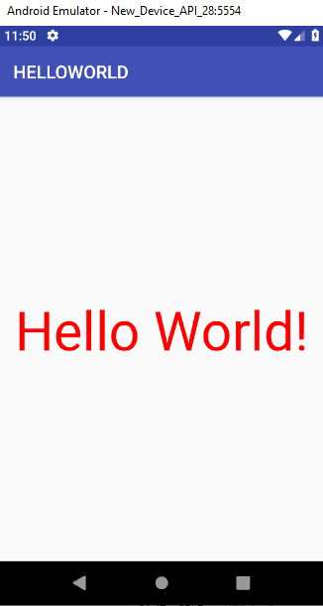



**q**

***2.Create a “WELCOME” application.***

***//activity_main.xml***

*<?***xml version="1.0" encoding="utf-8"***?>*<**androidx.constraintlayout.widget.ConstraintLayout xmlns:android="http://schemas.android.com/apk/res/android"  
 xmlns:app="http://schemas.android.com/apk/res-auto"  
 xmlns:tools="http://schemas.android.com/tools"  
 android:layout_width="match_parent"  
 android:layout_height="match_parent"  
 tools:context=".MainActivity"**>  
  
 <**TextView  
 android:layout_width="wrap_content"  
 android:layout_height="wrap_content"  
 android:text="Welcome to Mata Sundri College"  
 android:textColor="@android:color/holo_blue_dark"  
 app:layout_constraintBottom_toBottomOf="parent"  
 app:layout_constraintHorizontal_bias="0.51"  
 app:layout_constraintLeft_toLeftOf="parent"  
 app:layout_constraintRight_toRightOf="parent"  
 app:layout_constraintTop_toTopOf="parent"  
 app:layout_constraintVertical_bias="0.964"** />  
  
 <**TextView  
 android:layout_width="wrap_content"  
 android:layout_height="wrap_content"  
 android:layout_marginRight="16dp"  
 android:text="Welcome to Mata Sundri College"  
 android:textAllCaps="true"  
 android:textAppearance="@style/TextAppearance.AppCompat.Large"  
 android:textColor="@android:color/holo_orange_dark"  
 app:layout_constraintBottom_toBottomOf="parent"  
 app:layout_constraintHorizontal_bias="1.0"  
 app:layout_constraintLeft_toLeftOf="parent"  
 app:layout_constraintRight_toRightOf="parent"  
 app:layout_constraintTop_toTopOf="parent"  
 app:layout_constraintVertical_bias="0.059"** />  
  
 <**TextView  
 android:layout_width="wrap_content"  
 android:layout_height="wrap_content"  
 android:layout_marginRight="16dp"  
 android:background="@android:color/holo_purple"  
 android:text="Welcome to Mata Sundri College"  
 android:textAllCaps="true"  
 android:textAppearance="@style/TextAppearance.AppCompat.Large"  
 android:textColor="@android:color/white"  
 android:textSize="@android:dimen/app_icon_size"  
 app:layout_constraintBottom_toBottomOf="parent"  
 app:layout_constraintHorizontal_bias="0.0"  
 app:layout_constraintLeft_toLeftOf="parent"  
 app:layout_constraintRight_toRightOf="parent"  
 app:layout_constraintTop_toTopOf="parent"  
 app:layout_constraintVertical_bias="0.325"** />  
  
 <**TextView  
 android:layout_width="wrap_content"  
 android:layout_height="wrap_content"  
 android:text="http://www.google.com"  
 android:autoLink = "web"  
 app:layout_constraintBottom_toBottomOf="parent"  
 app:layout_constraintHorizontal_bias="0.426"  
 app:layout_constraintLeft_toLeftOf="parent"  
 app:layout_constraintRight_toRightOf="parent"  
 app:layout_constraintTop_toTopOf="parent"  
 app:layout_constraintVertical_bias="0.609"** />  
  
</**androidx.constraintlayout.widget.ConstraintLayout**>

***//MainActivity.java***

**package** com.example.welcome;  
  
**import** androidx.appcompat.app.AppCompatActivity;  
  
**import** android.os.Bundle;  
  
**public class** MainActivity **extends** AppCompatActivity {  
  
 @Override  
 **protected void** onCreate(Bundle savedInstanceState) {  
 **super**.onCreate(savedInstanceState);  
 setContentView(R.layout.activity_main);  
 }  
}

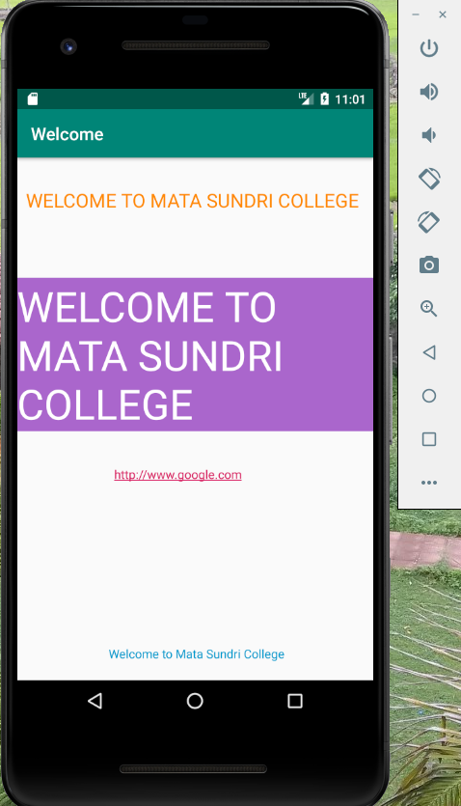

***3.Using EditText and Buttons.***

***//activity_main.xml***

*<?***xml version="1.0" encoding="utf-8"***?>*<**androidx.constraintlayout.widget.ConstraintLayout xmlns:android="http://schemas.android.com/apk/res/android"  
 xmlns:app="http://schemas.android.com/apk/res-auto"  
 xmlns:tools="http://schemas.android.com/tools"  
 android:layout_width="match_parent"  
 android:layout_height="match_parent"  
 tools:context=".MainActivity"**>  
  
 <**TextView  
 android:layout_width="282dp"  
 android:layout_height="53dp"  
 android:text="TYPE HERE:"  
 android:textColor="@android:color/holo_purple"  
 android:textSize="30sp"  
 android:textStyle="bold"  
 app:layout_constraintBottom_toBottomOf="parent"  
 app:layout_constraintHorizontal_bias="0.07"  
 app:layout_constraintLeft_toLeftOf="parent"  
 app:layout_constraintRight_toRightOf="parent"  
 app:layout_constraintTop_toTopOf="parent"  
 app:layout_constraintVertical_bias="0.035"** />  
  
 <**EditText  
 android:layout_width="322dp"  
 android:layout_height="79dp"  
 android:textColor="@android:color/holo_red_dark"  
 android:textStyle="italic"  
 app:layout_constraintBottom_toBottomOf="parent"  
 app:layout_constraintHorizontal_bias="0.411"  
 app:layout_constraintLeft_toLeftOf="parent"  
 app:layout_constraintRight_toRightOf="parent"  
 app:layout_constraintTop_toTopOf="parent"  
 app:layout_constraintVertical_bias="0.235"** />  
  
 <**Button  
 android:layout_width="wrap_content"  
 android:layout_height="wrap_content"  
 android:text="OK"  
 app:layout_constraintBottom_toBottomOf="parent"  
 app:layout_constraintHorizontal_bias="0.756"  
 app:layout_constraintLeft_toLeftOf="parent"  
 app:layout_constraintRight_toRightOf="parent"  
 app:layout_constraintTop_toTopOf="parent"  
 app:layout_constraintVertical_bias="0.498"** />  
  
 <**Button  
 android:layout_width="wrap_content"  
 android:layout_height="wrap_content"  
 android:text="CANCEL"  
 app:layout_constraintBottom_toBottomOf="parent"  
 app:layout_constraintHorizontal_bias="0.375"  
 app:layout_constraintLeft_toLeftOf="parent"  
 app:layout_constraintRight_toRightOf="parent"  
 app:layout_constraintTop_toTopOf="parent"  
 app:layout_constraintVertical_bias="0.498"** />  
  
  
</**androidx.constraintlayout.widget.ConstraintLayout**>

***//MainActivity.java***

**package** com.example.screen1;  
  
**import** androidx.appcompat.app.AppCompatActivity;  
  
**import** android.os.Bundle;  
  
**public class** MainActivity **extends** AppCompatActivity {  
  
 @Override  
 **protected void** onCreate(Bundle savedInstanceState) {  
 **super**.onCreate(savedInstanceState);  
 setContentView(R.layout.activity_main);  
 }  
}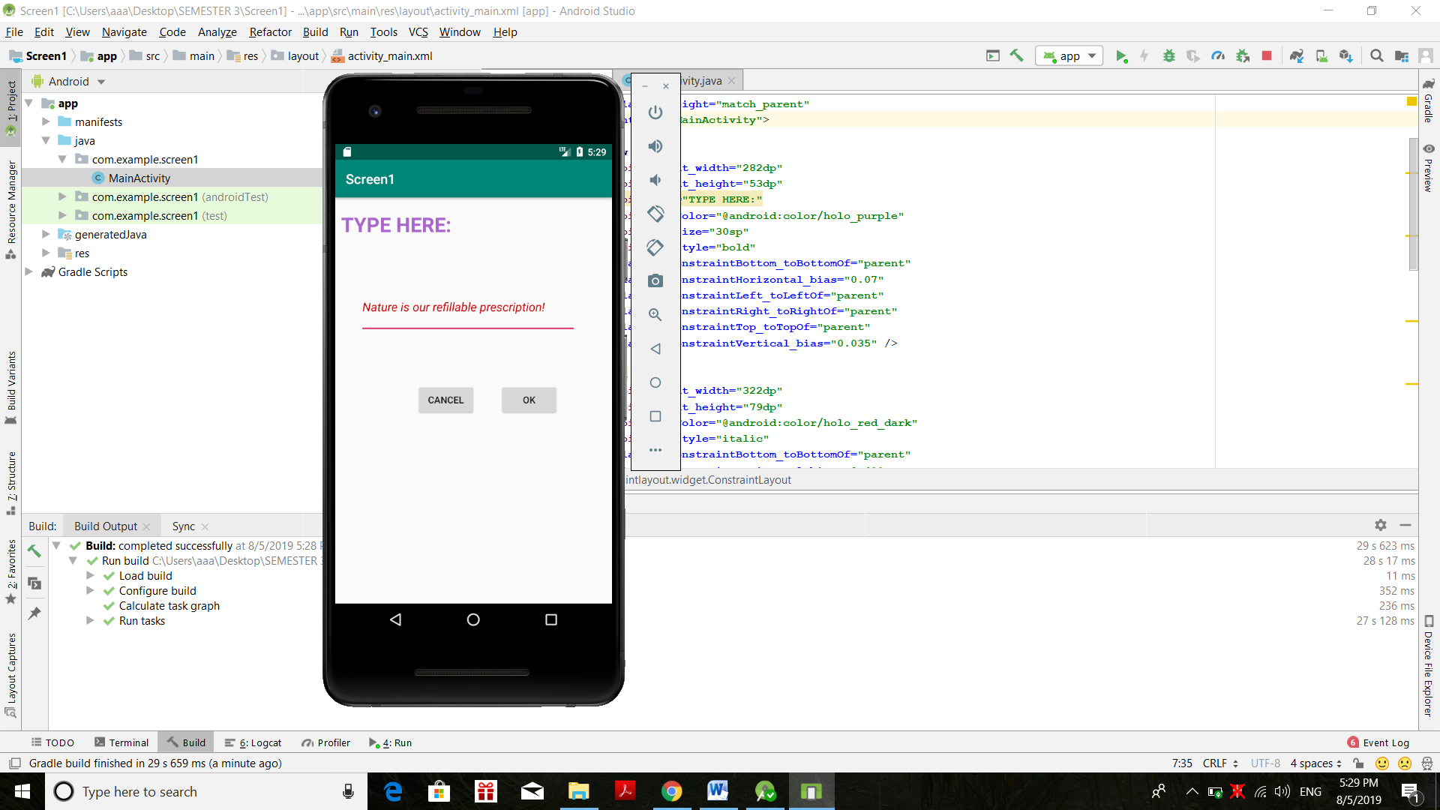



***4. Create a ‘Simple Calculator ’ application.***

***//activity_main.xml***

*<?***xml version="1.0" encoding="utf-8"***?>*<**androidx.constraintlayout.widget.ConstraintLayout xmlns:android="http://schemas.android.com/apk/res/android"  
 xmlns:app="http://schemas.android.com/apk/res-auto"  
 xmlns:tools="http://schemas.android.com/tools"  
 android:layout_width="match_parent"  
 android:layout_height="match_parent"  
 tools:context=".MainActivity"**>  
  
 <**TextView  
 android:layout_width="282dp"  
 android:layout_height="53dp"  
 android:text="Enter Number 1:"  
 android:textColor="@android:color/holo_purple"  
 android:textSize="30sp"  
 android:textStyle="bold"  
 app:layout_constraintBottom_toBottomOf="parent"  
 app:layout_constraintHorizontal_bias="0.156"  
 app:layout_constraintLeft_toLeftOf="parent"  
 app:layout_constraintRight_toRightOf="parent"  
 app:layout_constraintTop_toTopOf="parent"  
 app:layout_constraintVertical_bias="0.222"** />  
  
 <**EditText  
 android:layout_width="wrap_content"  
 android:layout_height="wrap_content"  
 android:textColor="@android:color/holo_red_dark"  
 android:textStyle="italic"  
 app:layout_constraintBottom_toBottomOf="parent"  
 app:layout_constraintHorizontal_bias="0.719"  
 app:layout_constraintLeft_toLeftOf="parent"  
 app:layout_constraintRight_toRightOf="parent"  
 app:layout_constraintTop_toTopOf="parent"  
 app:layout_constraintVertical_bias="0.219"** />  
  
 <**TextView  
 android:layout_width="282dp"  
 android:layout_height="53dp"  
 android:text="Enter Number 2:"  
 android:textColor="@android:color/holo_purple"  
 android:textSize="30sp"  
 android:textStyle="bold"  
 app:layout_constraintBottom_toBottomOf="parent"  
 app:layout_constraintHorizontal_bias="0.156"  
 app:layout_constraintLeft_toLeftOf="parent"  
 app:layout_constraintRight_toRightOf="parent"  
 app:layout_constraintTop_toTopOf="parent"  
 app:layout_constraintVertical_bias="0.395"** />  
  
 <**EditText  
 android:layout_width="wrap_content"  
 android:layout_height="wrap_content"  
 android:textColor="@android:color/holo_red_dark"  
 android:textStyle="italic"  
 app:layout_constraintBottom_toBottomOf="parent"  
 app:layout_constraintHorizontal_bias="0.718"  
 app:layout_constraintLeft_toLeftOf="parent"  
 app:layout_constraintRight_toRightOf="parent"  
 app:layout_constraintTop_toTopOf="parent"  
 app:layout_constraintVertical_bias="0.39"** />  
  
 <**TextView  
 android:layout_width="306dp"  
 android:layout_height="45dp"  
 android:text="Operation to Perform:"  
 android:textColor="@android:color/holo_purple"  
 android:textSize="30sp"  
 android:textStyle="bold"  
 app:layout_constraintBottom_toBottomOf="parent"  
 app:layout_constraintHorizontal_bias="0.205"  
 app:layout_constraintLeft_toLeftOf="parent"  
 app:layout_constraintRight_toRightOf="parent"  
 app:layout_constraintTop_toTopOf="parent"  
 app:layout_constraintVertical_bias="0.609"** />  
  
 <**Button  
 android:layout_width="64dp"  
 android:layout_height="45dp"  
 android:text="+"  
 app:layout_constraintBottom_toBottomOf="parent"  
 app:layout_constraintHorizontal_bias="0.023"  
 app:layout_constraintLeft_toLeftOf="parent"  
 app:layout_constraintRight_toRightOf="parent"  
 app:layout_constraintTop_toTopOf="parent"  
 app:layout_constraintVertical_bias="0.764"** />  
  
 <**Button  
 android:layout_width="64dp"  
 android:layout_height="45dp"  
 android:text="-"  
 app:layout_constraintBottom_toBottomOf="parent"  
 app:layout_constraintHorizontal_bias="0.307"  
 app:layout_constraintLeft_toLeftOf="parent"  
 app:layout_constraintRight_toRightOf="parent"  
 app:layout_constraintTop_toTopOf="parent"  
 app:layout_constraintVertical_bias="0.764"** />  
  
 <**Button  
 android:layout_width="64dp"  
 android:layout_height="45dp"  
 android:text="*"  
 app:layout_constraintBottom_toBottomOf="parent"  
 app:layout_constraintHorizontal_bias="0.625"  
 app:layout_constraintLeft_toLeftOf="parent"  
 app:layout_constraintRight_toRightOf="parent"  
 app:layout_constraintTop_toTopOf="parent"  
 app:layout_constraintVertical_bias="0.764"** />/>  
  
 <**Button  
 android:layout_width="64dp"  
 android:layout_height="45dp"  
 android:text="/"  
 app:layout_constraintBottom_toBottomOf="parent"  
 app:layout_constraintHorizontal_bias="0.95"  
 app:layout_constraintLeft_toLeftOf="parent"  
 app:layout_constraintRight_toRightOf="parent"  
 app:layout_constraintTop_toTopOf="parent"  
 app:layout_constraintVertical_bias="0.764"** />  
  
 <**TextView  
 android:layout_width="wrap_content"  
 android:layout_height="53dp"  
 android:text="RESULT: 0"  
 android:textColor="@android:color/holo_purple"  
 android:textSize="30sp"  
 android:textStyle="bold"  
 app:layout_constraintBottom_toBottomOf="parent"  
 app:layout_constraintHorizontal_bias="0.06"  
 app:layout_constraintLeft_toLeftOf="parent"  
 app:layout_constraintRight_toRightOf="parent"  
 app:layout_constraintTop_toTopOf="parent"  
 app:layout_constraintVertical_bias="0.965"** />  
  
  
</**androidx.constraintlayout.widget.ConstraintLayout**>

***//MainActivity.java***

**package** com.example.simple_calc;  
  
**import** androidx.appcompat.app.AppCompatActivity;  
  
**import** android.os.Bundle;  
  
**public class** MainActivity **extends** AppCompatActivity {  
  
 @Override  
 **protected void** onCreate(Bundle savedInstanceState) {  
 **super**.onCreate(savedInstanceState);  
 setContentView(R.layout.activity_main);  
 }  
}

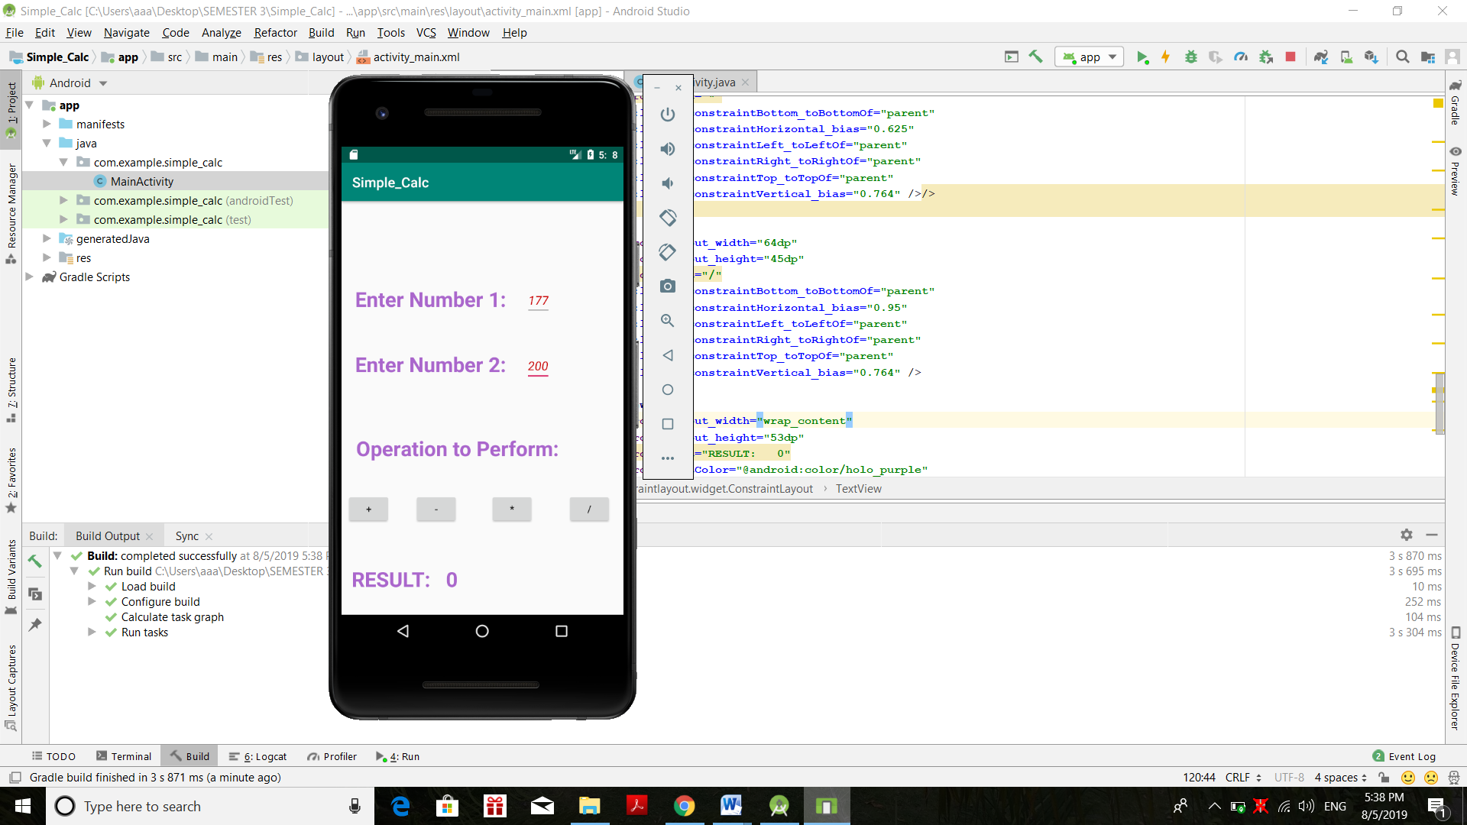

***5. Set TEXT layout by programming.***

***//activity_main.xml***

**<?xml version="1.0" encoding="utf-8"?>  
<RelativeLayout  
 xmlns:android="http://schemas.android.com/apk/res/android"  
 xmlns:tools="http://schemas.android.com/tools"  
 android:id="@+id/rl"  
 android:layout_width="match_parent"  
 android:layout_height="match_parent"  
 android:padding="16dp"  
 tools:context=".MainActivity"  
 android:background="@android:color/white"  
 >  
  
 <TextView  
 android:id="@+id/label1"  
 android:layout_width="wrap_content"  
 android:layout_height="wrap_content"  
 android:layout_toStartOf="@id/rl"  
 android:text="MATA SUNDRI COLLEGE"  
 android:textStyle="bold|italic" />  
  
 <Button  
 android:id="@+id/button1"  
 android:layout_width="match_parent"  
 android:layout_height="wrap_content"  
 android:layout_below="@id/label1"  
  
 android:text="OK"  
 android:textSize="20sp"  
 tools:layout_editor_absoluteX="28dp"  
 tools:layout_editor_absoluteY="16dp" />  
  
 <TextView  
 android:id="@+id/label2"  
 android:layout_width="wrap_content"  
 android:layout_height="wrap_content"  
 android:layout_below="@id/button1"  
  
 android:background="@android:color/holo_orange_light"  
 android:paddingTop="20sp"  
 android:text="DELHI UNIVERSITY"  
 android:textSize="40sp" />  
  
 <TextView  
 android:id="@+id/label3"  
 android:layout_width="wrap_content"  
 android:layout_height="wrap_content"  
 android:text="DELHI UNIVERSITY"  
 android:layout_below="@id/label2"  
  
 android:textSize="40sp"  
 android:paddingBottom="20sp"  
 android:background="@android:color/holo_purple" />  
  
 <TextView  
 android:id="@+id/label4"  
 android:layout_width="wrap_content"  
 android:layout_height="wrap_content"  
 android:text="DELHI UNIVERSITY"  
 android:layout_below="@id/label3"  
  
 android:textSize="40sp"  
 android:paddingRight="20sp"  
 android:background="@android:color/holo_green_light" />  
  
 <TextView  
 android:id="@+id/label5"  
 android:layout_width="365dp"  
 android:layout_height="73dp"  
 android:layout_below="@id/label4"  
  
 android:background="@android:color/holo_blue_light"  
 android:paddingLeft="20dp"  
 android:text="DELHI UNIVERSITY"  
 android:textSize="40sp" />  
  
</RelativeLayout>**

***//MainActivity.java***

**package** com.example.text1;  
  
**import** androidx.appcompat.app.AppCompatActivity;  
  
**import** android.os.Bundle;  
  
**public class** MainActivity **extends** AppCompatActivity {  
  
 @Override  
 **protected void** onCreate(Bundle savedInstanceState) {  
 **super**.onCreate(savedInstanceState);  
 setContentView(R.layout.activity_main);  
 }  
}

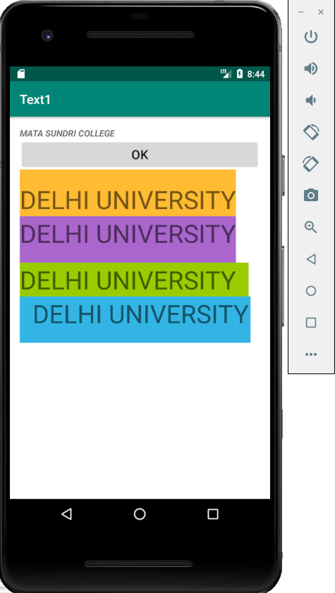

***6. Using Linear Layout with vertical and horizontal orientations.***

***//activity_main.xml***

***<?*xml version="1.0" encoding="utf-8"*?>*<LinearLayout  
 xmlns:android="http://schemas.android.com/apk/res/android"  
 xmlns:app="http://schemas.android.com/apk/res-auto"  
 xmlns:tools="http://schemas.android.com/tools"  
 android:orientation="horizontal"  
 android:layout_width="match_parent"  
 android:layout_height="match_parent"  
 tools:context=".MainActivity">  
  
 <TextView  
 android:layout_width="wrap_content"  
 android:layout_height="wrap_content"  
 android:text="FIRST LOVE YOURSELF!"  
 android:textAlignment="gravity"  
 android:textColor="@android:color/holo_red_dark"  
 android:textSize="35px"  
 android:padding="20px"/>  
  
 <Button  
 android:layout_width="wrap_content"  
 android:layout_height="wrap_content"  
 android:text="FLY"  
 android:textSize="35px"  
 android:textColor="@android:color/holo_blue_dark"/>  
  
 <TextView  
 android:layout_width="wrap_content"  
 android:layout_height="wrap_content"  
 android:text="BE HAPPY!"  
 android:textAlignment="gravity"  
 android:textColor="@android:color/holo_green_dark"  
 android:textSize="35px"  
 android:padding="20px"/>  
  
 <Button  
 android:layout_width="wrap_content"  
 android:layout_height="wrap_content"  
 android:text="DONE"  
 android:textSize="35px"  
 android:textColor="@android:color/widget_edittext_dark"/>  
  
</LinearLayout>**

***//MainActivity.java***

**package** com.example.linear_layout;  
  
**import** androidx.appcompat.app.AppCompatActivity;  
  
**import** android.os.Bundle;  
  
**public class** MainActivity **extends** AppCompatActivity {  
  
 @Override  
 **protected void** onCreate(Bundle savedInstanceState) {  
 **super**.onCreate(savedInstanceState);  
 setContentView(R.layout.activity_main);  
 }  
}

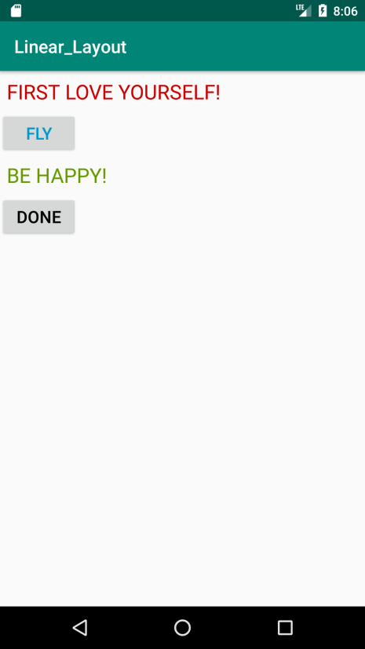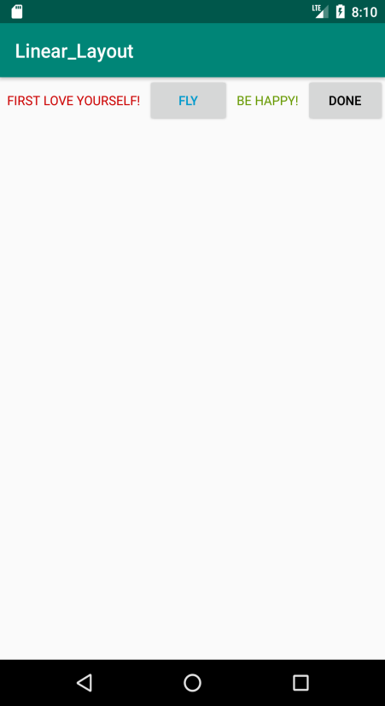

***7. Using ImageView.***

***//activity_main.xml***

***<?*xml version="1.0" encoding="utf-8"*?>*<androidx.constraintlayout.widget.ConstraintLayout**

**xmlns:android="http://schemas.android.com/apk/res/android"  
 xmlns:app="http://schemas.android.com/apk/res-auto"  
 xmlns:tools="http://schemas.android.com/tools"  
 android:layout_width="match_parent"  
 android:layout_height="match_parent"  
 tools:context=".MainActivity">  
  
 <ImageView  
 android:layout_width="match_parent"  
 android:layout_height="match_parent"  
 android:scaleType="fitCenter"  
 android:src="@drawable/i1" /> />  
  
</androidx.constraintlayout.widget.ConstraintLayout>**

***//MainActivity.java***

**package** com.example.image1;  
  
**import** androidx.appcompat.app.AppCompatActivity;  
  
**imposssrt** android.os.Bundle;  
  
**public class** MainActivity **extends** AppCompatActivity {  
  
 @Override  
 **protected void** onCreate(Bundle savedInstanceState) {  
 **super**.onCreate(savedInstanceState);  
 setContentView(R.layout.activity_main);  
 }  
}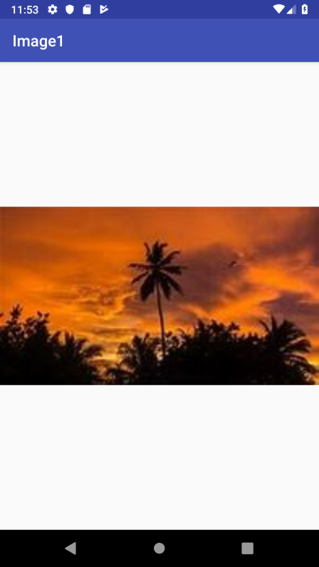

***8.Create a “Login” application.***

***//activity_main.xml***

***<?*xml version="1.0" encoding="utf-8"*?>*<RelativeLayout**

**xmlns:android="http://schemas.android.com/apk/res/android"  
 xmlns:app="http://schemas.android.com/apk/res-auto"  
 xmlns:tools="http://schemas.android.com/tools"  
 android:layout_width="match_parent"  
 android:layout_height="match_parent"  
 tools:context=".MainActivity">  
  
 <TextView  
 android:id="@+id/T1"  
 android:layout_width="wrap_content"  
 android:layout_height="wrap_content"  
 android:text="Email"  
 android:textSize="50sp"/>  
  
 <EditText  
 android:id="@+id/E1"  
 android:layout_width="match_parent"  
 android:layout_height="wrap_content"  
 android:textSize="30sp"  
 android:layout_below="@id/T1" />  
  
 <Button  
 android:id="@+id/B1"  
 android:layout_width="wrap_content"  
 android:layout_height="wrap_content"  
 android:text="LOGIN"  
 android:textSize="30sp"  
 android:layout_below="@id/E1"/>  
  
 <Button  
 android:id="@+id/B2"  
 android:layout_width="wrap_content"  
 android:layout_height="wrap_content"  
 android:text="CANCEL"  
 android:textSize="30sp"  
 android:layout_below="@id/E1"  
 android:layout_toRightOf="@id/B1"/>  
  
 <Button  
 android:id="@+id/B3"  
 android:layout_width="match_parent"  
 android:layout_height="wrap_content"  
 android:textSize="30sp"  
 android:text="Register for New User"  
 android:layout_alignParentBottom="true"/>  
  
</RelativeLayout>**

***//MainActivity.java***

**package** com.example.relative_layout;  
  
**import** androidx.appcompat.app.AppCompatActivity;  
  
**import** android.os.Bundle;  
  
**public class** MainActivity **extends** AppCompatActivity {  
  
 @Override  
 **protected void** onCreate(Bundle savedInstanceState) {  
 **super**.onCreate(savedInstanceState);  
 setContentView(R.layout.activity_main);  
 }  
}

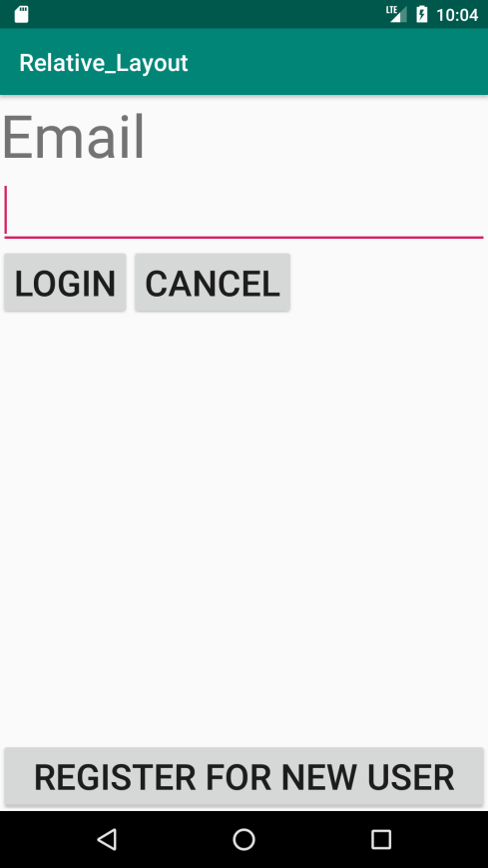

***9. Using ‘Table Layout’.***

***//activity_main.xml***

***<?*xml version="1.0" encoding="utf-8"*?>*<TableLayout xmlns:android="http://schemas.android.com/apk/res/android"  
 xmlns:app="http://schemas.android.com/apk/res-auto"  
 xmlns:tools="http://schemas.android.com/tools"  
 android:layout_width="match_parent"  
 android:layout_height="match_parent"  
 tools:context=".MainActivity">  
  
 <TableRow  
 android:layout_width="match_parent"  
 android:layout_height="275dp"  
 android:layout_gravity="center_horizontal">  
  
 <TextView  
 android:layout_column="1"  
 android:text="First Entry: "  
 android:textSize="30sp"  
 android:textColor="@android:color/holo_blue_dark" />  
 <EditText  
 android:layout_column="4"/>  
 </TableRow>  
  
 <TableRow  
 android:layout_width="match_parent"  
 android:layout_height="275dp"  
 android:layout_gravity="center_horizontal">  
  
 <TextView  
 android:layout_column="1"  
 android:text="Second Entry: "  
 android:textSize="30sp"  
 android:textColor="@android:color/holo_blue_dark" />  
 <EditText  
 android:layout_column="4"/>  
  
 </TableRow>  
  
</TableLayout>**

***//MainActivity.java***

**package com.example.tablelayout;  
  
import androidx.appcompat.app.AppCompatActivity;  
  
import android.os.Bundle;  
  
public class MainActivity extends AppCompatActivity {  
  
 @Override  
 protected void onCreate(Bundle savedInstanceState) {  
 super.onCreate(savedInstanceState);  
 setContentView(R.layout.*activity_main*);  
 }  
}**

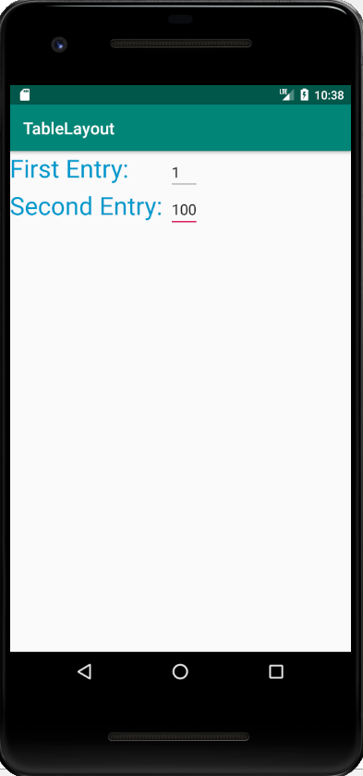

***10. Using ‘Frame Layout’.***

***//activity_main.xml***

***<?*xml version="1.0" encoding="utf-8"*?>*<FrameLayout xmlns:android="http://schemas.android.com/apk/res/android"  
 xmlns:app="http://schemas.android.com/apk/res-auto"  
 xmlns:tools="http://schemas.android.com/tools"  
 android:layout_width="match_parent"  
 android:layout_height="match_parent"  
 tools:context=".MainActivity">  
  
 <ImageView  
 android:layout_width="match_parent"  
 android:layout_height="wrap_content"  
 android:layout_gravity="center"  
 android:src="@drawable/i1"/>  
  
 <TextView  
 android:layout_width="wrap_content"  
 android:layout_height="wrap_content"  
 android:text="USING FRAME LAYOUT"  
 android:textColor="#FFFFFF"  
 android:layout_gravity="center"  
 android:textSize="30sp"/>  
  
</FrameLayout>**

***//MainActivity.java***

**package com.example.framelayout;  
  
import androidx.appcompat.app.AppCompatActivity;  
  
import android.os.Bundle;  
  
public class MainActivity extends AppCompatActivity {  
  
 @Override  
 protected void onCreate(Bundle savedInstanceState) {  
 super.onCreate(savedInstanceState);  
 setContentView(R.layout.*activity_main*);  
 }  
}**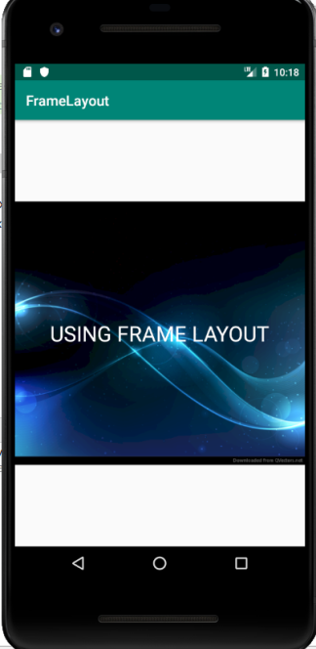

***11.Create an application that converts a string to upper case.***

***//activity_main.xml***

***<?*xml version="1.0" encoding="utf-8"*?>*<LinearLayout xmlns:android="http://schemas.android.com/apk/res/android"  
 xmlns:app="http://schemas.android.com/apk/res-auto"  
 xmlns:tools="http://schemas.android.com/tools"  
 android:layout_width="match_parent"  
 android:layout_height="match_parent"  
 android:orientation="vertical"  
 tools:context=".MainActivity">  
  
 <EditText  
 android:id="@+id/E1"  
 android:layout_width="wrap_content"  
 android:layout_height="wrap_content" />  
  
 <Button  
 android:id="@+id/B1"  
 android:layout_width="wrap_content"  
 android:layout_height="wrap_content"  
 android:text="To Upper Case"/>  
  
 <EditText  
 android:id="@+id/E2"  
 android:layout_width="wrap_content"  
 android:layout_height="wrap_content" />  
  
 <Button  
 android:id="@+id/B2"  
 android:layout_width="wrap_content"  
 android:layout_height="wrap_content"  
 android:text="QUIT"/>  
  
</LinearLayout>**

***//MainActivity.java***

**package com.example.uppercase;  
  
import androidx.appcompat.app.AppCompatActivity;  
  
import android.os.Bundle;  
import android.view.View;  
import android.widget.Button;  
import android.widget.EditText;  
  
public class MainActivity extends AppCompatActivity implements View.OnClickListener {  
  
 EditText e1,e2;  
 Button b1,b2;  
  
 @Override  
 protected void onCreate(Bundle savedInstanceState) {  
 super.onCreate(savedInstanceState);  
 setContentView(R.layout.*activity_main*);  
  
 e1=(EditText)findViewById(R.id.*E1*);  
 e2=(EditText)findViewById(R.id.*E2*);  
 b1=(Button) findViewById(R.id.*B1*);  
 b2=(Button) findViewById(R.id.*B2*);  
  
 b1.setOnClickListener(this);  
 b2.setOnClickListener(this);  
 }  
  
 public void onClick(View v)  
 {  
 if(v==b1)  
 {  
 String s=e1.getText().toString();  
 s=s.toUpperCase();  
 e2.setText(s);  
 }  
 else  
 this.finish();  
 }  
}**

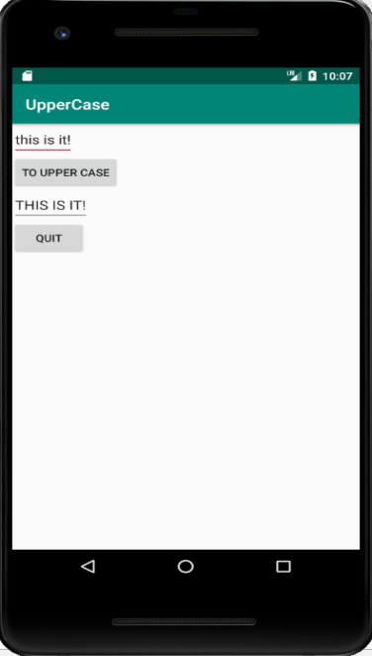

***12. Create an application SHOPPING LIST using CheckBox***

***//activity_main.xml***

*<?***xml version="1.0" encoding="utf-8"***?>*<**TableLayout xmlns:android="http://schemas.android.com/apk/res/android"  
 xmlns:app="http://schemas.android.com/apk/res-auto"  
 xmlns:tools="http://schemas.android.com/tools"  
 android:layout_width="match_parent"  
 android:layout_height="match_parent"  
 tools:context=".MainActivity"**>  
  
  
 <**TableRow**>  
 <**TextView  
 android:id="@+id/T"  
 android:text="SHOPPING LIST"  
 android:textSize="30sp"  
 android:layout_width="match_parent"  
 android:layout_gravity="center"  
 android:layout_height="wrap_content"**/>  
  
 </**TableRow**>  
 <**TableRow**>  
 <**EditText  
 android:id="@+id/T1"  
 android:text="Trousers"  
 android:textSize="20sp"  
 android:layout_column="0"**/>  
  
 <**CheckBox  
 android:id="@+id/C1"  
 android:layout_column="2"**/>  
 </**TableRow**>  
  
  
 <**TableRow**>  
 <**EditText  
 android:id="@+id/T2"  
 android:text="Bag"  
 android:textSize="20sp"  
 android:layout_column="0"**/>  
  
 <**CheckBox  
 android:id="@+id/C2"  
 android:layout_column="2"**/>  
 </**TableRow**>  
  
 <**TableRow**>  
 <**EditText  
 android:id="@+id/T3"  
 android:text="Shirt"  
 android:textSize="20sp"  
 android:layout_column="0"**/>  
  
 <**CheckBox  
 android:id="@+id/C3"  
 android:layout_column="2"**/>  
 </**TableRow**>  
 <**TableRow**>  
 <**EditText  
 android:id="@+id/T4"  
 android:text="Earrings"  
 android:textSize="20sp"  
 android:layout_column="0"**/>  
  
 <**CheckBox  
 android:id="@+id/C4"  
 android:layout_column="2"**/>  
 </**TableRow**>  
  
 <**TableRow**>  
 <**EditText  
 android:id="@+id/T5"  
 android:text="Perfumes"  
 android:textSize="20sp"  
 android:layout_column="0"**/>  
  
 <**CheckBox  
 android:id="@+id/C5"  
 android:layout_column="2"**/>  
 </**TableRow**>  
  
 <**TableRow**>  
 <**TextView  
 android:id="@+id/T6"  
 android:text=" "  
 android:textSize="40sp"  
 android:layout_column="2"**/>  
 </**TableRow**>  
  
   
  
 <**DigitalClock  
 android:layout_width="wrap_content"  
 android:layout_height="wrap_content"  
 android:gravity="center|bottom"  
 android:paddingTop="150sp"  
 android:textSize="35sp"** />  
   
  
</**TableLayout**>

***//MainActivity.java***

**package** com.example.hp.checkbox;  
  
**import** android.support.v7.app.AppCompatActivity;  
**import** android.os.Bundle;  
**import** android.view.View;  
**import** android.widget.CheckBox;  
**import** android.widget.EditText;  
**import** android.widget.TextView;  
  
**public class** MainActivity **extends** AppCompatActivity **implements** View.OnClickListener{  
  
 TextView **t1**=**null**;  
 TextView **t2**=**null**;  
 EditText **e1**=**null**;  
 EditText **e2**=**null**;  
 EditText **e3**=**null**;  
 EditText **e4**=**null**;  
 EditText **e5**=**null**;  
 CheckBox **c1**=**null**;  
 CheckBox **c2**=**null**;  
 CheckBox **c3**=**null**;  
 CheckBox **c4**=**null**;  
 CheckBox **c5**=**null**;  
  
 @Override  
 **protected void** onCreate(Bundle savedInstanceState) {  
 **super**.onCreate(savedInstanceState);  
 setContentView(R.layout.***activity_main***);  
 **t1**=(TextView)findViewById(R.id.***T***);  
 **t2**=(TextView)findViewById(R.id.***T6***);  
 **e1**=(EditText)findViewById(R.id.***T1***);  
 **e2**=(EditText)findViewById(R.id.***T2***);  
 **e3**=(EditText)findViewById(R.id.***T3***);  
 **e4**=(EditText)findViewById(R.id.***T4***);  
 **e5**=(EditText)findViewById(R.id.***T5***);  
 **c1**=(CheckBox)findViewById(R.id.***C1***);  
 **c2**=(CheckBox)findViewById(R.id.***C2***);  
 **c3**=(CheckBox)findViewById(R.id.***C3***);  
 **c4**=(CheckBox)findViewById(R.id.***C4***);  
 **c5**=(CheckBox)findViewById(R.id.***C5***);  
  
 **c1**.setOnClickListener(**this**);  
 **c2**.setOnClickListener(**this**);  
 **c3**.setOnClickListener(**this**);  
 **c4**.setOnClickListener(**this**);  
 **c5**.setOnClickListener(**this**);  
  
 **c1**.setChecked(**false**);  
 **c2**.setChecked(**false**);  
 **c3**.setChecked(**false**);  
 **c4**.setChecked(**false**);  
 **c5**.setChecked(**false**);  
  
 }  
  
 **public void** onClick(View v)  
 {  
 **if**(**c1**.isChecked()&**c2**.isChecked()&**c3**.isChecked()&**c4**.isChecked()&**c5**.isChecked())  
 **t2**.setText(**"DONE!"**);  
 **else  
 t2**.setText(**""**);  
 }  
}

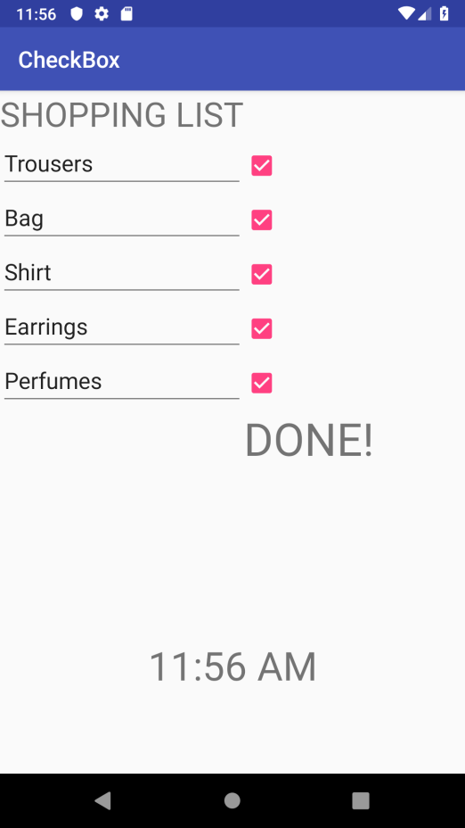 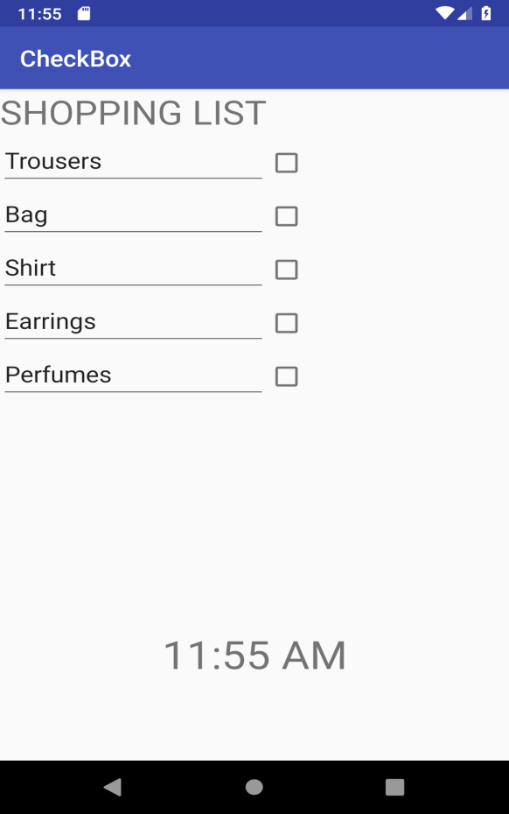

***13. Create an application CALC_TIP_AMT. using RadioButton***

***//activity_main.xml***

*<?***xml version="1.0" encoding="utf-8"***?>*<**LinearLayout xmlns:android="http://schemas.android.com/apk/res/android"  
 xmlns:app="http://schemas.android.com/apk/res-auto"  
 xmlns:tools="http://schemas.android.com/tools"  
 android:layout_width="match_parent"  
 android:layout_height="match_parent"  
 android:orientation="vertical"  
 tools:context=".MainActivity"**>  
  
 <**TableLayout  
 android:layout_width="wrap_content"  
 android:layout_height="wrap_content"**>  
  
 <**TableRow**>  
  
 <**TextView  
 android:id="@+id/tv1"  
 android:layout_width="wrap_content"  
 android:layout_height="wrap_content"  
 android:text="Enter Bill Amt. "  
 android:textSize="30sp"** />  
  
 <**EditText  
 android:id="@+id/et1"  
 android:layout_width="wrap_content"  
 android:layout_height="wrap_content"  
 android:text=""  
 android:textSize="30sp"** />  
 </**TableRow**>  
  
 </**TableLayout**>  
  
 <**RadioGroup  
 android:id="@+id/rgp"  
 android:layout_width="wrap_content"  
 android:layout_height="wrap_content"**>  
  
 <**RadioButton  
 android:id="@+id/t_rb"  
 android:layout_width="wrap_content"  
 android:layout_height="wrap_content"  
 android:text="10%"** />  
  
 <**RadioButton  
 android:id="@+id/f_rb"  
 android:layout_width="wrap_content"  
 android:layout_height="wrap_content"  
 android:text="15%"** />  
  
 <**RadioButton  
 android:id="@+id/ty_rb"  
 android:layout_width="wrap_content"  
 android:layout_height="wrap_content"  
 android:text="20%"** />  
  
 </**RadioGroup**>  
  
 <**TableLayout  
 android:layout_width="wrap_content"  
 android:layout_height="wrap_content"**>  
  
 <**TableRow**>  
  
 <**TextView  
 android:id="@+id/tv2"  
 android:layout_width="wrap_content"  
 android:layout_height="wrap_content"  
 android:text="Tip Amt. "  
 android:textSize="30sp"** />  
  
 <**TextView  
 android:id="@+id/tv3"  
 android:layout_width="wrap_content"  
 android:layout_height="wrap_content"  
 android:text=""  
 android:textSize="30sp"** />  
 </**TableRow**>  
  
 </**TableLayout**>  
  
  
</**LinearLayout**>

***//MainActivity.java***

**package** com.example.hp.myapplication;  
  
**import** android.support.v7.app.AppCompatActivity;  
**import** android.os.Bundle;  
**import** android.widget.EditText;  
**import** android.widget.RadioButton;  
**import** android.widget.RadioGroup;  
**import** android.widget.TextView;  
  
**import** java.text.DecimalFormat;  
  
**public class** MainActivity **extends** AppCompatActivity **implements** RadioGroup.OnCheckedChangeListener{  
  
  
 TextView **t1**=**null**;  
 EditText **e1**=**null**;  
 RadioGroup **rgp1**=**null**;  
 RadioButton **rb1**=**null**;  
 RadioButton **rb2**=**null**;  
 RadioButton **rb3**=**null**;  
 TextView **t2**=**null**;  
 TextView **t3**=**null**;  
  
 DecimalFormat **df**=**new** DecimalFormat(**"Rs####.00"**);  
  
 @Override  
 **protected void** onCreate(Bundle savedInstanceState) {  
 **super**.onCreate(savedInstanceState);  
 setContentView(R.layout.***activity_main***);  
 **rgp1**=(RadioGroup)findViewById(R.id.***rgp***);  
 **rb1**=(RadioButton)findViewById(R.id.***t_rb***);  
 **rb2**=(RadioButton)findViewById(R.id.***f_rb***);  
 **rb3**=(RadioButton)findViewById(R.id.***ty_rb***);  
 **t1**=(TextView)findViewById(R.id.***tv1***);  
 **t2**=(TextView)findViewById(R.id.***tv2***);  
 **t3**=(TextView)findViewById(R.id.***tv3***);  
 **e1**=(EditText)findViewById(R.id.***et1***);  
  
 **rgp1**.setOnCheckedChangeListener(**this**);  
 }  
  
 **public void** onCheckedChanged(RadioGroup rg,**int** i)  
 {  
 **if**(i==**rb1**.getId())  
 **t3**.setText(**df**.format(Double.*parseDouble*(**e1**.getText().toString())*.10));  
  
 **if**(i==**rb2**.getId())  
 **t3**.setText(**df**.format(Double.*parseDouble*(**e1**.getText().toString())*.15));  
  
 **if**(i==**rb3**.getId())  
 **t3**.setText(**df**.format(Double.*parseDouble*(**e1**.getText().toString())*.20));  
 }  
}

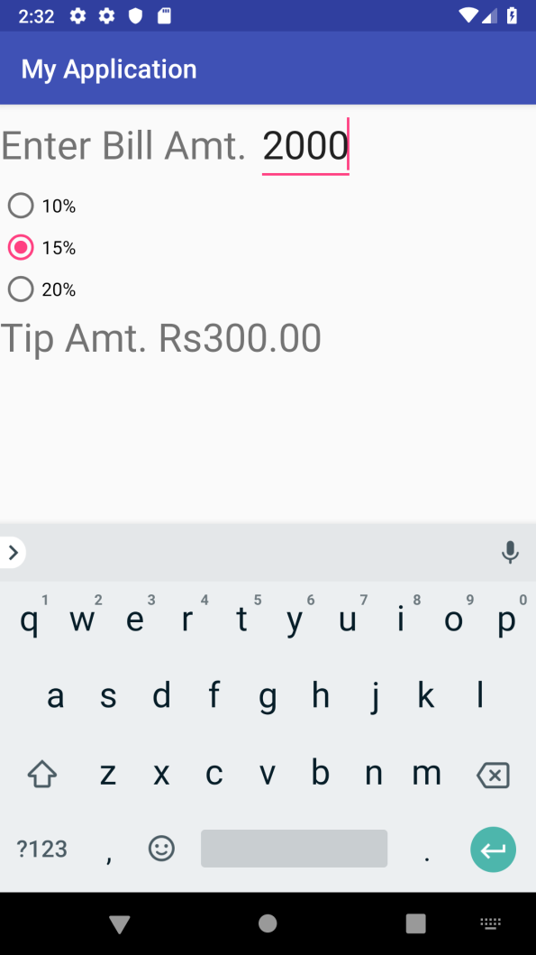

***14. Create an application CALCULATOR using RadioButton***

***//activity_main.xml***

***<?*xml version="1.0" encoding="utf-8"*?>*<LinearLayout xmlns:android="http://schemas.android.com/apk/res/android"  
 xmlns:app="http://schemas.android.com/apk/res-auto"  
 xmlns:tools="http://schemas.android.com/tools"  
 android:layout_width="match_parent"  
 android:layout_height="match_parent"  
 android:orientation="vertical"  
  
 tools:context=".MainActivity">  
  
 <TableLayout  
 android:layout_width="match_parent"  
 android:layout_height="wrap_content">  
  
 <TableRow>  
  
 <TextView  
 android:id="@+id/tv1"  
 android:layout_width="wrap_content"  
 android:layout_height="wrap_content"  
 android:text="Enter First Number : "  
 android:textSize="30sp" />  
  
 <EditText  
 android:id="@+id/et1"  
 android:layout_width="wrap_content"  
 android:layout_height="wrap_content"  
 android:layout_column="1"  
 android:text=""  
 android:textSize="30sp" />  
 </TableRow>  
  
 <TableRow>  
 <TextView  
 android:id="@+id/tv2"  
 android:layout_width="wrap_content"  
 android:layout_height="wrap_content"  
 android:text="Enter Second Number : "  
 android:textSize="30sp" />  
  
 <EditText  
 android:id="@+id/et2"  
 android:layout_width="wrap_content"  
 android:layout_height="wrap_content"  
 android:text=""  
 android:textSize="30sp" />  
 </TableRow>  
  
 </TableLayout>  
  
 <RadioGroup  
 android:id="@+id/rgp"  
 android:layout_width="wrap_content"  
 android:layout_height="wrap_content">  
  
 <RadioButton  
 android:id="@+id/add"  
 android:layout_width="wrap_content"  
 android:layout_height="wrap_content"  
 android:text="ADD"  
 android:textSize="20sp"/>  
  
 <RadioButton  
 android:id="@+id/sub"  
 android:layout_width="wrap_content"  
 android:layout_height="wrap_content"  
 android:text="SUBTRACT"  
 android:textSize="20sp"/>  
  
 <RadioButton  
 android:id="@+id/mul"  
 android:layout_width="wrap_content"  
 android:layout_height="wrap_content"  
 android:text="MULTIPLY"  
 android:textSize="20sp"/>  
  
 <RadioButton  
 android:id="@+id/div"  
 android:layout_width="wrap_content"  
 android:layout_height="wrap_content"  
 android:text="DIVIDE"  
 android:textSize="20sp"/>  
  
 </RadioGroup>  
  
 <TableLayout  
 android:layout_width="wrap_content"  
 android:layout_height="wrap_content">  
  
 <TableRow>  
  
 <TextView  
 android:id="@+id/tv3"  
 android:layout_width="wrap_content"  
 android:layout_height="wrap_content"  
 android:text="RESULT = "  
 android:textSize="30sp" />  
  
 <TextView  
 android:id="@+id/tv4"  
 android:layout_width="wrap_content"  
 android:layout_height="wrap_content"  
  
 android:textSize="30sp" />  
 </TableRow>  
  
 </TableLayout>  
  
  
</LinearLayout>**

***//MainActivity.java***

**package com.example.hp.myapplication;  
  
import android.support.v7.app.AppCompatActivity;  
import android.os.Bundle;  
import android.widget.EditText;  
import android.widget.RadioButton;  
import android.widget.RadioGroup;  
import android.widget.TextView;  
  
import java.text.DecimalFormat;  
  
public class MainActivity extends AppCompatActivity implements RadioGroup.OnCheckedChangeListener{  
  
  
 TextView t1=null;  
 EditText e1=null;  
 EditText e2=null;  
 RadioGroup rgp1=null;  
 RadioButton rb1=null;  
 RadioButton rb2=null;  
 RadioButton rb3=null;  
 RadioButton rb4=null;  
 TextView t2=null;  
 TextView t3=null;  
 TextView t4=null;  
  
 @Override  
 protected void onCreate(Bundle savedInstanceState) {  
 super.onCreate(savedInstanceState);  
 setContentView(R.layout.*activity_main*);  
 rgp1=(RadioGroup)findViewById(R.id.*rgp*);  
 rb1=(RadioButton)findViewById(R.id.*add*);  
 rb2=(RadioButton)findViewById(R.id.*sub*);  
 rb3=(RadioButton)findViewById(R.id.*mul*);  
 rb4=(RadioButton)findViewById(R.id.*div*);  
 t1=(TextView)findViewById(R.id.*tv1*);  
 t2=(TextView)findViewById(R.id.*tv2*);  
 t3=(TextView)findViewById(R.id.*tv3*);  
 t4=(TextView)findViewById(R.id.*tv4*);  
 e1=(EditText)findViewById(R.id.*et1*);  
 e2=(EditText)findViewById(R.id.*et2*);  
  
 rgp1.setOnCheckedChangeListener(this);  
 }  
  
 public void onCheckedChanged(RadioGroup rg,int i)  
 {  
  
 double a=Double.*parseDouble*(e1.getText().toString());  
 double b=Double.*parseDouble*(e2.getText().toString());  
  
  
 if(i==rb1.getId())  
 t4.setText(Double.*toString*(a+b));  
  
 if(i==rb2.getId())  
 t4.setText(Double.*toString*(Double.*parseDouble*(e1.getText().toString()) - Double.*parseDouble*(e2.getText().toString())));  
  
  
 if(i==rb3.getId())  
 t4.setText(Double.*toString*(Double.*parseDouble*(e1.getText().toString()) * Double.*parseDouble*(e2.getText().toString())));  
  
  
 if(i==rb4.getId())  
 t4.setText(Double.*toString*(Double.*parseDouble*(e1.getText().toString()) / Double.*parseDouble*(e2.getText().toString())));  
  
 }  
}**

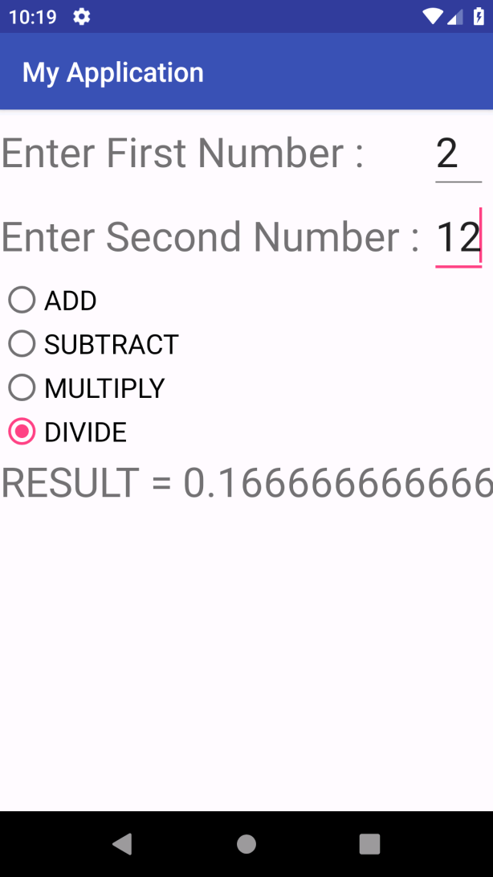

***15. Create an application SPINNER using Spinner Attributes***

***//activity_main.xml***

*<?***xml version="1.0" encoding="utf-8"***?>*<**LinearLayout xmlns:android="http://schemas.android.com/apk/res/android"  
 xmlns:app="http://schemas.android.com/apk/res-auto"  
 xmlns:tools="http://schemas.android.com/tools"  
 android:layout_width="match_parent"  
 android:layout_height="match_parent"  
 tools:context=".MainActivity"**>  
  
 <**Spinner  
 android:prompt="@string/sprompt"  
 android:layout_width="wrap_content"  
 android:layout_height="wrap_content"  
 android:id= "@+id/spin"  
 android:entries="@array/CountryName"**/>  
  
 <**TextView  
 android:id="@+id/t1"  
 android:layout_width="wrap_content"  
 android:layout_height="wrap_content"** />  
</**LinearLayout**>

***//string.xml***

<**resources**>  
<**string name="app_name"**>Spinner</**string**>  
<**string name="sprompt"**>Select Country</**string**>  
<**string-array name="CountryName"**>  
 <**item**>SELECT COUNTRY</**item**>  
<**item**>Australia</**item**>  
<**item**>India</**item**>  
<**item**>Japan</**item**>  
<**item**>Korea</**item**>  
</**string-array**>  
 </**resources**>

***//MainActivity.java***

**package com.example.hp.spinner;  
  
import android.support.v7.app.AppCompatActivity;  
import android.os.Bundle;  
import android.view.View;  
import android.widget.AdapterView;  
import android.widget.Spinner;  
import android.widget.TextView;  
  
public class MainActivity extends AppCompatActivity implements AdapterView.OnItemSelectedListener {  
  
 Spinner c_spinner = null;  
 TextView tv1 = null;  
  
 @Override  
 protected void onCreate(Bundle savedInstanceState) {  
 super.onCreate(savedInstanceState);  
 setContentView(R.layout.*activity_main*);  
 c_spinner = (Spinner) findViewById(R.id.*spin*);  
 tv1 = (TextView) findViewById(R.id.*t1*);  
  
 c_spinner.setOnItemSelectedListener(this);  
 }  
  
 public void onItemSelected(AdapterView<?> parent, View v, int pos, long id) {  
 tv1.setText(((TextView) v).getText());  
 }  
  
 public void onNothingSelected(AdapterView<?> parent) {}  
}**

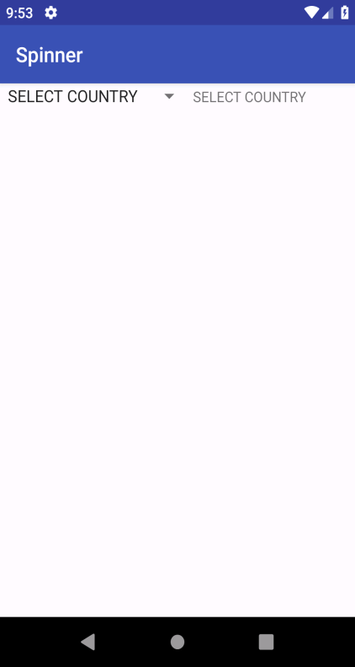 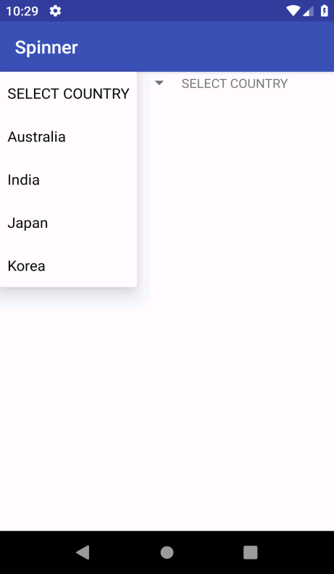 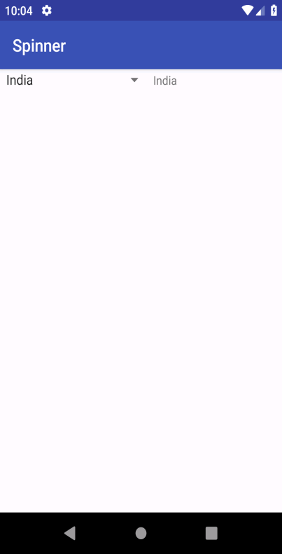

***16. Create an application DYNAMIC SPINNER using Spinner Attributes***

***//activity_main.xml***

***<?*xml version="1.0" encoding="utf-8"*?>*<LinearLayout xmlns:android="**[**http://schemas.android.com/apk/res/android**](http://schemas.android.com/apk/res/android)**"  
xmlns:app="**[**http://schemas.android.com/apk/res-auto**](http://schemas.android.com/apk/res-auto)**"  
xmlns:tools="**[**http://schemas.android.com/tools**](http://schemas.android.com/tools)**"  
android:layout_width="match_parent"  
android:layout_height="match_parent"  
tools:context=".MainActivity">  
  
<Spinner  
android:prompt="@string/sprompt"  
android:layout_width="wrap_content"  
android:layout_height="wrap_content"  
android:id= "@+id/spin"  
android:entries="@array/CountryName"/>  
  
<TextView  
android:id="@+id/t1"  
android:layout_width="wrap_content"  
android:layout_height="wrap_content"  
/>  
</LinearLayout>**

***//string.xml***

**<resources>  
 <string name="app_name">Spinner</string>  
 <string name="sprompt">Select Country</string>  
 <string-array name="CountryName">  
 <item>Australia</item>  
 <item>India</item>  
 <item>Japan</item>  
 <item>Korea</item>  
 </string-array>  
</resources>**

***//MainActivity.java***

**package com.example.hp.dynamic_spinner;  
  
import android.support.v7.app.AppCompatActivity;  
import android.os.Bundle;  
import android.widget.AdapterView;  
import android.widget.ArrayAdapter;  
import android.widget.Spinner;  
import android.widget.TextView;  
import android.view.View;  
import android.widget.Adapter;  
  
 public class MainActivity extends AppCompatActivity implements AdapterView.OnItemSelectedListener {  
  
 Spinner c_spinner = null;  
 TextView tv1 = null;  
  
 @Override  
 protected void onCreate(Bundle savedInstanceState) {  
 super.onCreate(savedInstanceState);  
 setContentView(R.layout.*activity_main*);  
 c_spinner = (Spinner)findViewById(R.id.*spin*);  
 tv1 = (TextView)findViewById(R.id.*t1*);  
  
 c_spinner.setOnItemSelectedListener(this);  
  
 String[] states = new String[5];  
 states[0] = "Punjab";  
 states[1] = "Kerala";  
 states[2] = "Delhi";  
 states[3] = "Tamil Nadu";  
 states[4] = "Haryana";  
  
 ArrayAdapter<String> adapter = new ArrayAdapter<String>(this, android.R.layout.*simple_spinner_item*, states);  
 adapter.setDropDownViewResource(android.R.layout.*simple_spinner_dropdown_item*);  
 c_spinner.setAdapter(adapter);  
  
 }  
  
 public void onItemSelected(AdapterView<?> parent, View v, int pos, long id)  
 {  
 tv1.setText(((TextView)v).getText());  
 }  
  
 public void onNothingSelected(AdapterView<?> parent)  
 {}  
 }**

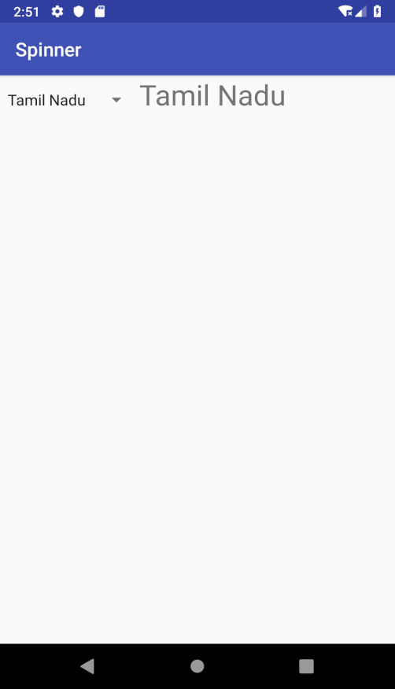 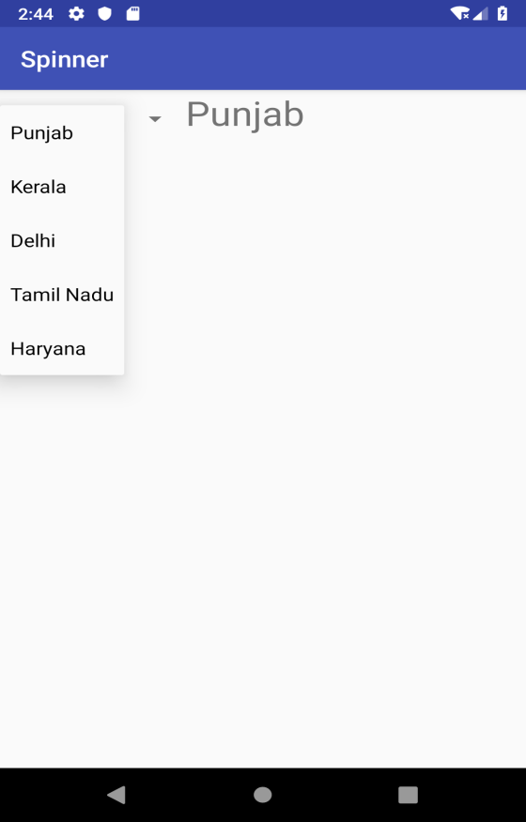

***17.Change the background color by clicking the button[Vertical].***

***//activity_main.xml***

***<?*xml version="1.0" encoding="utf-8"*?>*<LinearLayout xmlns:android="http://schemas.android.com/apk/res/android"  
 xmlns:app="http://schemas.android.com/apk/res-auto"  
 xmlns:tools="http://schemas.android.com/tools"  
 android:id="@+id/Linear"  
 android:layout_width="match_parent"  
 android:layout_height="match_parent"  
 android:orientation="vertical"  
 tools:context=".MainActivity">  
  
 <Button  
 android:id="@+id/b1"  
 android:layout_width="wrap_content"  
 android:layout_height="wrap_content"  
 android:textSize="30sp"  
 android:text="PINK"/>  
  
 <Button  
 android:id="@+id/b2"  
 android:layout_width="wrap_content"  
 android:layout_height="wrap_content"  
 android:textSize="30sp"  
 android:text="Blue"/>  
  
 <Button  
 android:id="@+id/b3"  
 android:layout_width="wrap_content"  
 android:layout_height="wrap_content"  
 android:textSize="30sp"  
 android:text="Green"/>  
</LinearLayout>**

***//colors.xml***

***<?*xml version="1.0" encoding="utf-8"*?>*<resources>  
 <color name="colorPrimary">#3F51B5</color>  
 <color name="colorPrimaryDark">#303F9F</color>  
 <color name="colorAccent">#FF4081</color>  
 <color name="yellow">#FFFF00</color>  
 <color name="blue">#0000FF</color>  
 <color name="green">#00FF00</color>  
</resources>**

***//MainActivity.java***

**package com.example.hp.ques8;  
  
import android.content.Context;  
import android.support.v7.app.AppCompatActivity;  
import android.os.Bundle;  
import android.view.View;  
import android.widget.Button;  
import android.widget.LinearLayout;  
  
public class MainActivity extends AppCompatActivity implements View.OnClickListener {  
  
 Button a=null;  
 Button b=null;  
 Button c=null;  
 LinearLayout l=null;  
 @Override  
 protected void onCreate(Bundle savedInstanceState) {  
 super.onCreate(savedInstanceState);  
 setContentView(R.layout.*activity_main*);  
  
 a=(Button)findViewById(R.id.*b1*);  
 b=(Button)findViewById(R.id.*b2*);  
 c=(Button)findViewById(R.id.*b3*);  
 l=(LinearLayout)findViewById(R.id.*Linear*) ;  
 a.setOnClickListener(this);  
 b.setOnClickListener(this);  
 c.setOnClickListener(this);  
 }  
  
 public void onClick(View v)  
 {  
  
 if(v==a)  
 l.setBackgroundResource(R.color.*colorAccent*);  
  
 if(v==b)  
 l.setBackgroundResource(R.color.*blue*);  
  
 if(v==c)  
 l.setBackgroundResource(R.color.*green*);  
 }  
}**

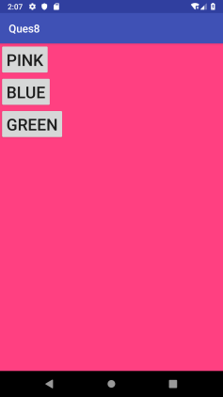 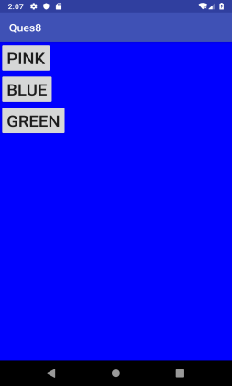 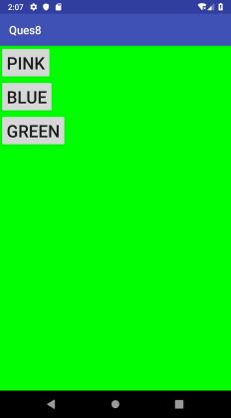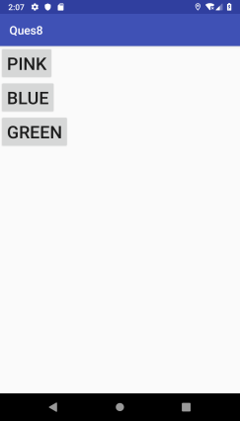

***17.Change the background color by clicking the button[Horizontal].***

***//activity_main.xml***

***<?*xml version="1.0" encoding="utf-8"*?>*<LinearLayout xmlns:android="http://schemas.android.com/apk/res/android"  
 xmlns:app="http://schemas.android.com/apk/res-auto"  
 xmlns:tools="http://schemas.android.com/tools"  
 android:id="@+id/Linear"  
 android:layout_width="match_parent"  
 android:layout_height="match_parent"  
 android:orientation="horizontal"  
 tools:context=".MainActivity">  
  
 <Button  
 android:id="@+id/b1"  
 android:layout_width="wrap_content"  
 android:layout_height="wrap_content"  
 android:textSize="30sp"  
 android:text="PINK"/>  
  
 <Button  
 android:id="@+id/b2"  
 android:layout_width="wrap_content"  
 android:layout_height="wrap_content"  
 android:textSize="30sp"  
 android:text="Blue"/>  
  
 <Button  
 android:id="@+id/b3"  
 android:layout_width="wrap_content"  
 android:layout_height="wrap_content"  
 android:textSize="30sp"  
 android:text="Green"/>  
</LinearLayout>**

***//colors.xml***

***<?*xml version="1.0" encoding="utf-8"*?>*<resources>  
 <color name="colorPrimary">#3F51B5</color>  
 <color name="colorPrimaryDark">#303F9F</color>  
 <color name="colorAccent">#FF4081</color>  
 <color name="yellow">#FFFF00</color>  
 <color name="blue">#0000FF</color>  
 <color name="green">#00FF00</color>  
</resources>**

***//MainActivity.java***

**package com.example.hp.ques8;  
  
import android.content.Context;  
import android.support.v7.app.AppCompatActivity;  
import android.os.Bundle;  
import android.view.View;  
import android.widget.Button;  
import android.widget.LinearLayout;  
  
public class MainActivity extends AppCompatActivity implements View.OnClickListener {  
  
 Button a=null;  
 Button b=null;  
 Button c=null;  
 LinearLayout l=null;  
 @Override  
 protected void onCreate(Bundle savedInstanceState) {  
 super.onCreate(savedInstanceState);  
 setContentView(R.layout.*activity_main*);  
  
 a=(Button)findViewById(R.id.*b1*);  
 b=(Button)findViewById(R.id.*b2*);  
 c=(Button)findViewById(R.id.*b3*);  
 l=(LinearLayout)findViewById(R.id.*Linear*) ;  
 a.setOnClickListener(this);  
 b.setOnClickListener(this);  
 c.setOnClickListener(this);  
 }  
  
 public void onClick(View v)  
 {  
  
 if(v==a)  
 l.setBackgroundResource(R.color.*colorAccent*);  
  
 if(v==b)  
 l.setBackgroundResource(R.color.*blue*);  
  
 if(v==c)  
 l.setBackgroundResource(R.color.*green*);  
 }  
}**

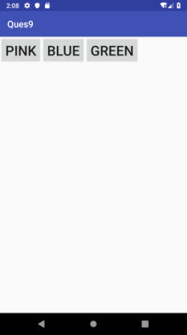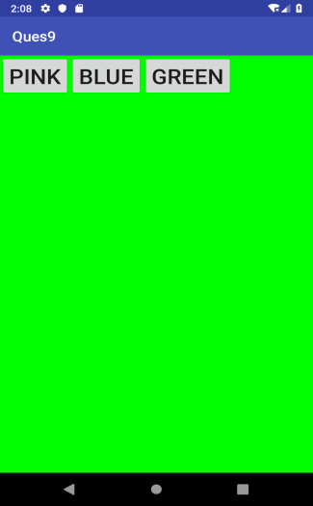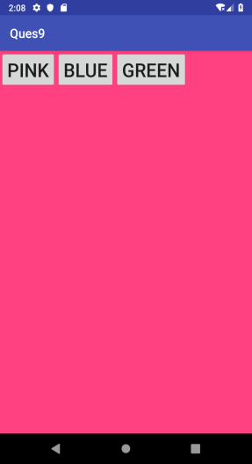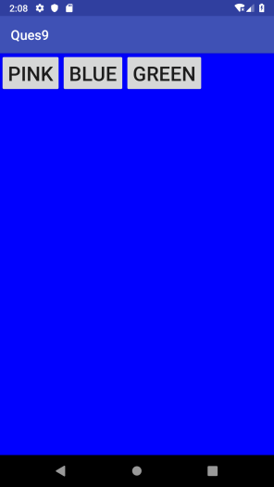

***18.Create an application CALENDER using Datepicker tag***

***//activity_main.xml***

***<?*xml version="1.0" encoding="utf-8"*?>*<LinearLayout xmlns:android="**[**http://schemas.android.com/apk/res/android**](http://schemas.android.com/apk/res/android)**"  
 xmlns:app="**[**http://schemas.android.com/apk/res-auto**](http://schemas.android.com/apk/res-auto)**"  
 xmlns:tools="**[**http://schemas.android.com/tools**](http://schemas.android.com/tools)**"  
 android:layout_width="match_parent"  
 android:layout_height="match_parent"  
 android:orientation="vertical"  
 tools:context=".MainActivity">  
  
 <TextView  
 android:id="@+id/T1"  
 android:layout_width="wrap_content"  
 android:layout_height="wrap_content"  
 android:text="SELECT DATE OF BIRTH: "  
 android:textColor="#000000"  
 android:textSize="20sp" />  
  
 <DatePicker  
 android:id="@+id/D1"  
 android:layout_width="wrap_content"  
 android:layout_height="wrap_content"  
 android:layout_gravity="center"></DatePicker>  
  
 <TextView  
 android:id="@+id/T2"  
 android:layout_width="wrap_content"  
 android:layout_height="wrap_content"  
 android:text="SELECTED DATE OF BIRTH IS: "  
 android:textColor="#000000"  
 android:textSize="20sp" />  
  
 <TextView  
 android:id="@+id/T3"  
 android:layout_width="match_parent"  
 android:layout_height="wrap_content"  
 android:textColor="#000000"  
 android:textSize="20sp"/>  
  
  
</LinearLayout>**

***//MainActivity.java***

**package com.example.calender;  
  
import androidx.appcompat.app.AppCompatActivity;  
  
import android.os.Bundle;  
import android.widget.DatePicker;  
import android.widget.TextView;  
  
import java.util.Calendar;  
  
public class MainActivity extends AppCompatActivity implements DatePicker.OnDateChangedListener {  
 DatePicker dp=null;  
 Calendar cal=null;  
 TextView change_date=null;  
  
 @Override  
 protected void onCreate(Bundle savedInstanceState) {  
 super.onCreate(savedInstanceState);  
 setContentView(R.layout.*activity_main*);  
  
 dp=(DatePicker)findViewById(R.id.*D1*);  
 change_date=(TextView)findViewById(R.id.*T3*);  
  
 cal=Calendar.getInstance();  
 dp.init(dp.getYear(), dp.getMonth(), dp.getDayOfMonth(), this);  
 }  
  
 public void onDateChanged(DatePicker dpView, int y, int m, int d)  
 {  
 cal.set(y,m,d);  
  
 java.util.Date d1=cal.getTime();  
 change_date.setText(String.valueOf(d1.getMonth()+1) + "/" + String.valueOf(d1.getDate()) + "/" + String.valueOf(d1.getYear()+1900));  
 }  
}**

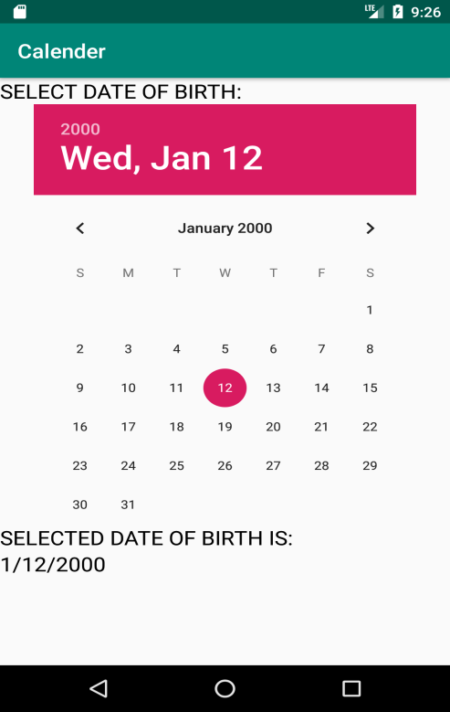

***19.Create an application SCROLLER using ScrollView tag.***

***//activity_main.xml***

*<?***xml version="1.0" encoding="utf-8"***?>*<**ScrollView xmlns:android="**[**http://schemas.android.com/apk/res/android**](http://schemas.android.com/apk/res/android)**"  
 xmlns:app="**[**http://schemas.android.com/apk/res-auto**](http://schemas.android.com/apk/res-auto)**"  
 xmlns:tools="**[**http://schemas.android.com/tools**](http://schemas.android.com/tools)**"  
 android:layout_width="match_parent"  
 android:layout_height="match_parent"  
 tools:context=".MainActivity"**>  
 <**LinearLayout  
 android:id="@+id/L1"  
 android:layout_width="match_parent"  
 android:layout_height="match_parent"  
 android:orientation="vertical"**>  
  
 <**TextView  
 android:layout_width="wrap_content"  
 android:layout_height="wrap_content"  
 android:text="WELCOME!"  
 android:textColor="#000"  
 android:textSize="20sp"**/>  
  
  
 </**LinearLayout**>  
</**ScrollView**>

***//MainActivity.java***

**package com.example.scrollview;  
  
import androidx.appcompat.app.AppCompatActivity;  
  
import android.content.Context;  
import android.graphics.Color;  
import android.os.Bundle;  
import android.widget.LinearLayout;  
import android.widget.TextView;  
  
public class MainActivity extends AppCompatActivity {  
  
 TextView[] tvarray= new TextView[30];  
 LinearLayout myLayout= null;  
 Context myContext= null;  
  
 @Override  
 protected void onCreate(Bundle savedInstanceState) {  
 super.onCreate(savedInstanceState);  
 setContentView(R.layout.*activity_main*);  
  
 myContext= this.getApplicationContext();  
 myLayout=(LinearLayout)findViewById(R.id.*L1*);  
  
 for(int ct=0; ct<=29; ct++)  
 {  
 int colormult;  
 tvarray[ct]= new TextView(myContext);  
 tvarray[ct].setText("EXAMPLE "+String.*valueOf*(ct));  
 colormult= (ct+1000)*8;**

**tvarray[ct].setBackgroundColor(Color.*rgb*(colormult,colormult*10,colormult*50));  
   
 tvarray[ct].setTextSize(25);  
 myLayout.addView(tvarray[ct]);  
 }  
 }  
}**

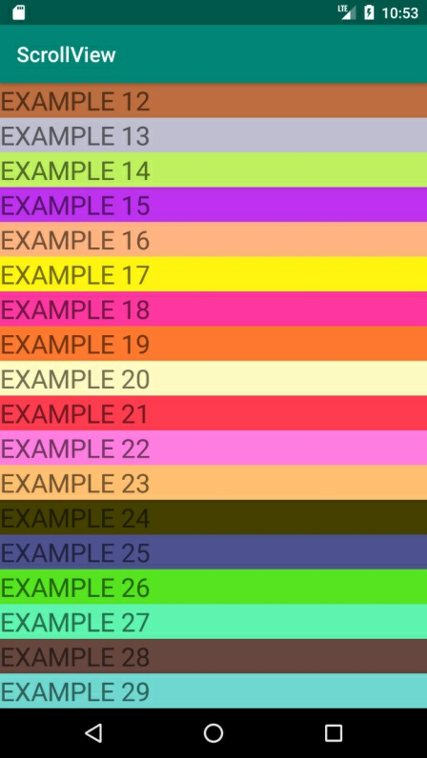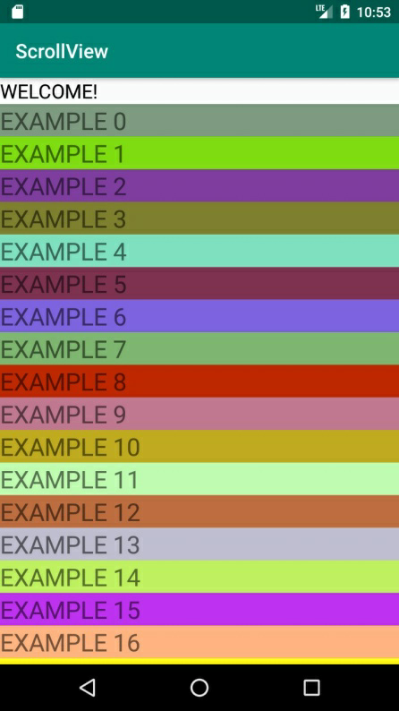

***20.Create an application SCROLLER using HorizontalScrollView tag.***

***//activity_main.xml***

*<?***xml version="1.0" encoding="utf-8"***?>*<**ScrollView xmlns:android="**[**http://schemas.android.com/apk/res/android**](http://schemas.android.com/apk/res/android)**"  
 xmlns:app="**[**http://schemas.android.com/apk/res-auto**](http://schemas.android.com/apk/res-auto)**"  
 xmlns:tools="**[**http://schemas.android.com/tools**](http://schemas.android.com/tools)**"  
 android:layout_width="match_parent"  
 android:layout_height="match_parent"  
 tools:context=".MainActivity"**>  
 <**LinearLayout  
 android:id="@+id/L1"  
 android:layout_width="match_parent"  
 android:layout_height="match_parent"  
 android:orientation="vertical"**>  
  
 <**TextView  
 android:layout_width="wrap_content"  
 android:layout_height="wrap_content"  
 android:text="WELCOME!"  
 android:textColor="#000"  
 android:textSize="20sp"**/>  
  
  
 </**LinearLayout**>  
</**ScrollView**>

***//MainActivity.java***

**package com.example.horizontalscrollview;  
  
import androidx.appcompat.app.AppCompatActivity;  
  
import android.content.Context;  
import android.graphics.Color;  
import android.os.Bundle;  
import android.widget.LinearLayout;  
import android.widget.TextView;  
  
public class MainActivity extends AppCompatActivity {  
  
 TextView[] tvarray= new TextView[30];  
 LinearLayout myLayout= null;  
 Context myContext= null;  
  
 @Override  
 protected void onCreate(Bundle savedInstanceState) {  
 super.onCreate(savedInstanceState);  
 setContentView(R.layout.*activity_main*);  
  
 myContext= this.getApplicationContext();  
 myLayout=(LinearLayout)findViewById(R.id.*L1*);  
  
 for(int ct=0; ct<=29; ct++)  
 {  
 int colormult;  
 tvarray[ct]= new TextView(myContext);  
 tvarray[ct].setText("EXAMPLE "+String.*valueOf*(ct));  
 colormult= (ct+1000)*8;  
  
 tvarray[ct].setBackgroundColor(Color.*rgb*(colormult, colormult*10, colormult*50));   
 tvarray[ct].setTextSize(25);  
 myLayout.addView(tvarray[ct]);  
 }  
 }  
}**

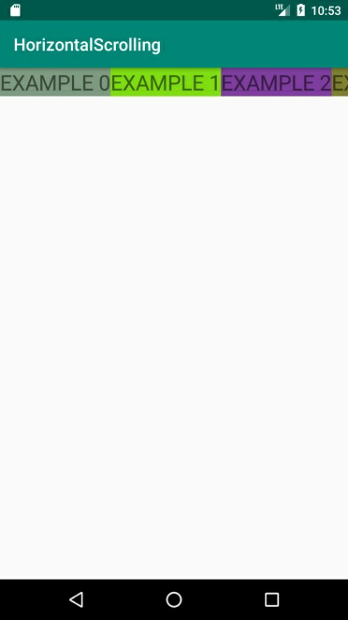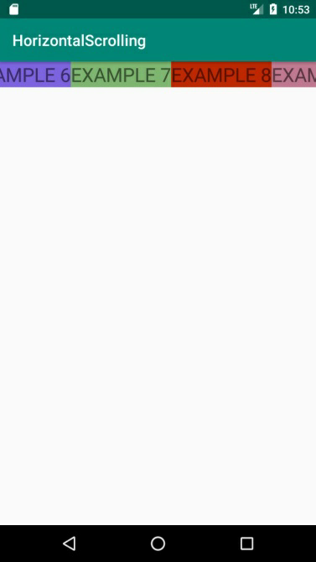

***21.Create an application to show a POP UP DIALOG box .***

***//activity_main.xml***

***<?*xml version="1.0" encoding="utf-8"*?>*<LinearLayout xmlns:android="http://schemas.android.com/apk/res/android"  
 xmlns:app="http://schemas.android.com/apk/res-auto"  
 xmlns:tools="http://schemas.android.com/tools"  
 android:layout_width="match_parent"  
 android:layout_height="match_parent"  
 tools:context=".MainActivity"  
 android:orientation="vertical">  
  
 <TextView  
 android:id="@+id/tv"  
 android:layout_width="wrap_content"  
 android:layout_height="wrap_content"  
 android:text=" " />  
 <Button  
 android:id="@+id/bt"  
 android:layout_width="wrap_content"  
 android:layout_height="wrap_content"  
 android:text="REQUEST"/>  
  
</LinearLayout>**

***//MainActivity.java***

**package com.example.hp.pop_up;  
  
import android.content.DialogInterface;  
import android.support.v7.app.AlertDialog;  
import android.support.v7.app.AppCompatActivity;  
import android.os.Bundle;  
import android.view.View;  
import android.widget.Button;  
import android.widget.TextView;  
  
public class MainActivity extends AppCompatActivity {  
  
 Button popup = null;  
 TextView rqst = null;  
 AlertDialog.Builder adb = null;  
 AlertDialog ad= null;  
  
 @Override  
 protected void onCreate(Bundle savedInstanceState) {  
 super.onCreate(savedInstanceState);  
 setContentView(R.layout.*activity_main*);  
 popup = (Button)findViewById(R.id.*bt*);  
 rqst = (TextView)findViewById(R.id.*tv*);  
 adb = new AlertDialog.Builder(this);  
 adb.setCancelable(false);  
 adb.setMessage("Do You Want To Continue Yes or No ");  
 adb.setPositiveButton("Yes", new DialogInterface.OnClickListener() {  
 @Override  
 public void onClick(DialogInterface dialogInterface, int i) {  
 rqst.setText("YES");  
 }  
 });  
 adb.setNegativeButton("No", new DialogInterface.OnClickListener() {  
 @Override  
 public void onClick(DialogInterface dialogInterface, int i) {  
 rqst.setText("NO");  
 }  
 });  
 ad = adb.create();  
 ad.setTitle("Yes or No ?");  
 popup.setOnClickListener(new View.OnClickListener() {  
 @Override  
 public void onClick(View view) {  
 ad.show();  
 }  
 });  
 }  
}**

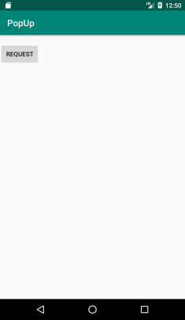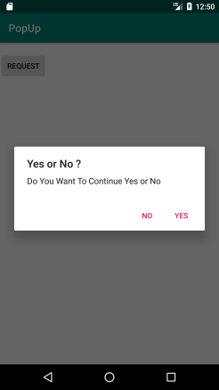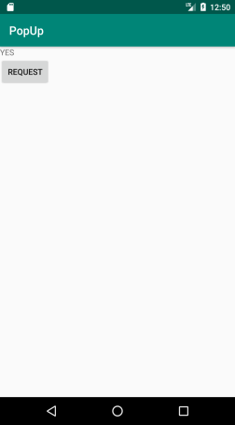

***23.Create an application to show a MENU using MENU TAG.***

***//activity_main.xml***

***<?*xml version="1.0" encoding="utf-8"*?>*<LinearLayout xmlns:android="http://schemas.android.com/apk/res/android"  
 xmlns:app="http://schemas.android.com/apk/res-auto"  
 xmlns:tools="http://schemas.android.com/tools"  
 android:layout_width="match_parent"  
 android:layout_height="match_parent"  
 tools:context=".MainActivity"  
 android:orientation="vertical">  
  
 <TextView  
 android:id="@+id/tv1"  
 android:layout_width="wrap_content"  
 android:layout_height="wrap_content"  
 android:text="THE SELECTED OPTION: "  
 android:textSize="30sp"  
 android:layout_gravity="center"/>  
  
 <TextView  
 android:id="@+id/tv"  
 android:layout_width="wrap_content"  
 android:layout_height="wrap_content"  
 android:text=" "  
 android:textSize="30sp"  
 android:layout_gravity="center"/>  
  
</LinearLayout>**

//mymenu.xml file

***<?*xml version="1.0" encoding="utf-8"*?>* <menu xmlns:android="http://schemas.android.com/apk/res/android"  
 xmlns:app="http://schemas.android.com/apk/res-auto">  
 <item  
 android:id="@+id/i1"  
 android:title="Student"  
 android:icon="@drawable/im"  
 app:showAsAction="always"/>  
  
 <item  
 android:id="@+id/i2"  
 android:title="Admission"  
 android:icon="@drawable/i11"  
 app:showAsAction="always"/>  
  
 <item  
 android:id="@+id/i3"  
 android:title="Alumnae"  
 />  
  
 <item  
 android:id="@+id/i4"  
 android:title="Attendance" />  
  
 <item  
 android:id="@+id/i5"  
 android:title="exit" />  
  
</menu>**

***//MainActivity.java***

**package com.example.hp.pop_up;  
  
import android.content.ClipData;  
import android.support.v7.app.AppCompatActivity;  
import android.os.Bundle;  
import android.view.Menu;  
import android.view.MenuInflater;  
import android.view.MenuItem;  
import android.widget.TextView;  
  
public class MainActivity extends AppCompatActivity {  
  
 TextView t1=null;  
 TextView t2=null;  
  
  
 @Override  
 protected void onCreate(Bundle savedInstanceState) {  
 super.onCreate(savedInstanceState);  
 setContentView(R.layout.*activity_main*);  
 t1=(TextView)findViewById(R.id.*tv*);  
 t2=(TextView)findViewById(R.id.*tv1*);  
 }  
  
 @Override  
 public boolean onCreateOptionsMenu(Menu menu)  
 {  
 MenuInflater inflater=getMenuInflater();  
 inflater.inflate(R.menu.*mymenu*,menu);  
 return super.onCreateOptionsMenu(menu);  
 }  
  
 @Override  
 public boolean onOptionsItemSelected( MenuItem mi)  
 {  
 if(mi.getItemId()==R.id.*i1*)  
 {  
 t1.setText("STUDENT");  
 return true;  
 }  
  
 if(mi.getItemId()==R.id.*i2*)  
 {  
 t1.setText("ADMISSION");  
 return true;  
 }  
  
 if(mi.getItemId()==R.id.*i3*)  
 {  
 t1.setText("ALUMNAE");  
 return true;  
 }  
  
 if(mi.getItemId()==R.id.*i4*)  
 {  
 t1.setText("ATTENDANCE");  
 return true;  
 }  
  
 if(mi.getItemId()==R.id.*i5*)  
 {  
 this.finish();  
 }  
 return true;}**

**}**

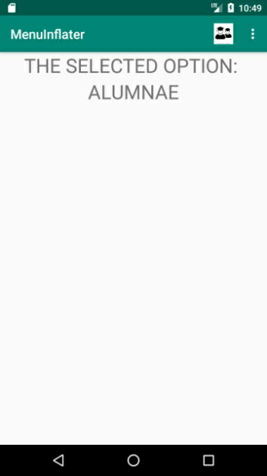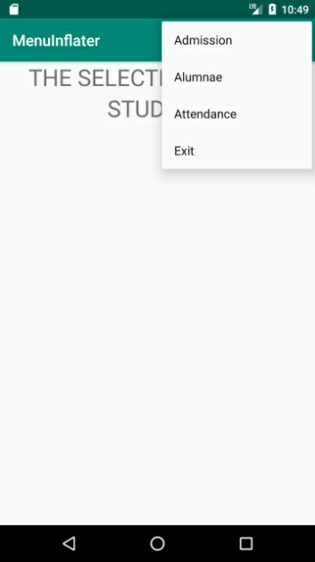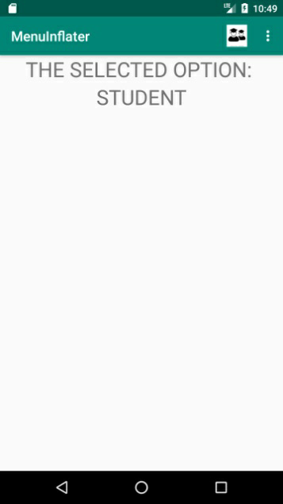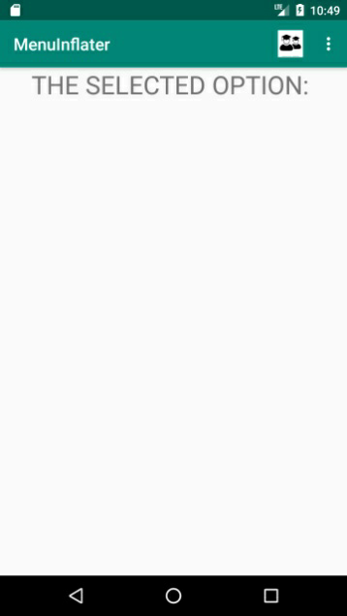

***24.Create an application to show the lifecycle of an activity***

***//activity_main.xml***

***<?*xml version="1.0" encoding="utf-8"*?>*<LinearLayout xmlns:android="http://schemas.android.com/apk/res/android"  
 xmlns:app="http://schemas.android.com/apk/res-auto"  
 xmlns:tools="http://schemas.android.com/tools"  
 android:layout_width="match_parent"  
 android:layout_height="match_parent"  
 tools:context=".MainActivity"  
 android:orientation="vertical">  
  
 <TextView  
 android:id="@+id/tv1"  
 android:layout_width="wrap_content"  
 android:layout_height="wrap_content"  
 android:text=" "  
 android:textSize="30sp"  
 android:layout_gravity="center"/>  
  
 <TextView  
 android:id="@+id/tv2"  
 android:layout_width="wrap_content"  
 android:layout_height="wrap_content"  
 android:text=" "  
 android:textSize="30sp"  
 android:layout_gravity="center"/>  
  
 <TextView  
 android:id="@+id/tv3"  
 android:layout_width="wrap_content"  
 android:layout_height="wrap_content"  
 android:text=" "  
 android:textSize="30sp"  
 android:layout_gravity="center"/>  
  
 <TextView  
 android:id="@+id/tv4"  
 android:layout_width="wrap_content"  
 android:layout_height="wrap_content"  
 android:text=" "  
 android:textSize="30sp"  
 android:layout_gravity="center"/>  
  
 <TextView  
 android:id="@+id/tv5"  
 android:layout_width="wrap_content"  
 android:layout_height="wrap_content"  
 android:text=" "  
 android:textSize="30sp"  
 android:layout_gravity="center"/>  
  
 <TextView  
 android:id="@+id/tv6"  
 android:layout_width="wrap_content"  
 android:layout_height="wrap_content"  
 android:text=" "  
 android:textSize="30sp"  
 android:layout_gravity="center"/>  
  
</LinearLayout>**

***//MainActivity.java***

**package com.example.hp.pop_up;  
  
  
import android.support.v7.app.AppCompatActivity;  
import android.os.Bundle;  
import android.widget.TextView;  
  
public class MainActivity extends AppCompatActivity {  
  
 TextView t1=null;  
 TextView t2=null;  
 TextView t3=null;  
 TextView t4=null;  
 TextView t5=null;  
 TextView t6=null;  
  
 @Override  
 protected void onCreate(Bundle savedInstanceState) {  
 super.onCreate(savedInstanceState);  
 setContentView(R.layout.*activity_main*);  
 t1=(TextView)findViewById(R.id.*tv1*);  
 t2=(TextView)findViewById(R.id.*tv2*);  
 t3=(TextView)findViewById(R.id.*tv3*);  
 t4=(TextView)findViewById(R.id.*tv4*);  
 t5=(TextView)findViewById(R.id.*tv5*);  
 t6=(TextView)findViewById(R.id.*tv6*);  
 t1.setText("ON CREATE");  
 }  
  
 @Override  
 protected void onStart() {  
 super.onStart();  
 t2.setText("ON START");  
 }  
  
 @Override  
 protected void onResume() {  
 super.onResume();  
 t3.setText("ON RESUME");  
 }  
  
 @Override  
 protected void onPause() {  
 super.onPause();  
 t4.setText("ON PAUSE");  
 }  
  
 @Override  
 protected void onStop() {  
 super.onStop();  
 t5.setText("ON STOP");  
 }  
  
 @Override  
 protected void onDestroy() {  
 super.onDestroy();  
 t6.setText("ON DESTROY");  
 }  
}**

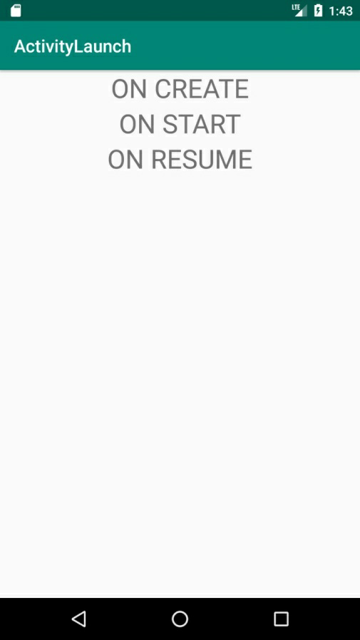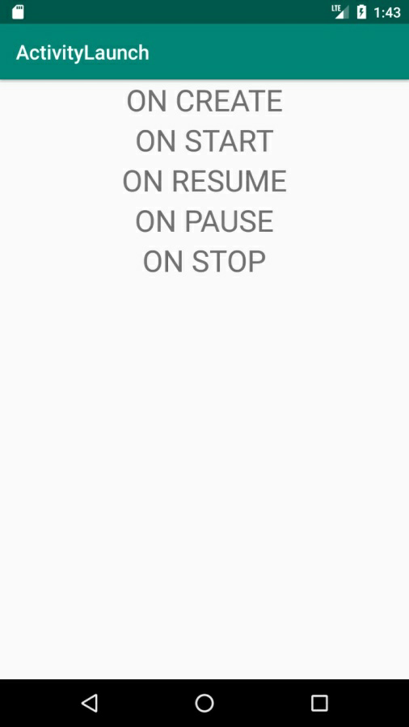

***26.Create an application to make buttons using JAVA FILE.***

***//activity_main.xml***

*<?***xml version="1.0" encoding="utf-8"***?>*<**LinearLayoutxmlns:android="http://schemas.android.com/apk/res/android"  
xmlns:app="http://schemas.android.com/apk/res-auto"  
xmlns:tools="http://schemas.android.com/tools"  
android:layout_width="match_parent"  
android:layout_height="match_parent"  
tools:context=".MainActivity"  
android:id="@+id/l"**>  
  
</**LinearLayout**>

***//MainActivity.java***

**package com.example.hp.buttonbyjava;  
  
import android.content.Context;  
import android.support.v7.app.AppCompatActivity;  
import android.os.Bundle;  
import android.widget.Button;  
import android.widget.LinearLayout;  
  
public class MainActivityextends AppCompatActivity {  
 Button b1=null;  
 Button b2=null;  
 Context c=null;  
LinearLayoutl=null;  
  
@Override  
protected void onCreate(Bundle savedInstanceState) {  
super.onCreate(savedInstanceState);  
setContentView(R.layout.*activity_main*);  
c=this.getApplication();  
l=(LinearLayout)findViewById(R.id.*l*);  
b1=new Button(c);  
b2=new Button(c);  
b1.setText("CANCEL");  
b2.setText("OK");  
l.addView(b1);  
l.addView(b2);  
 }  
}**

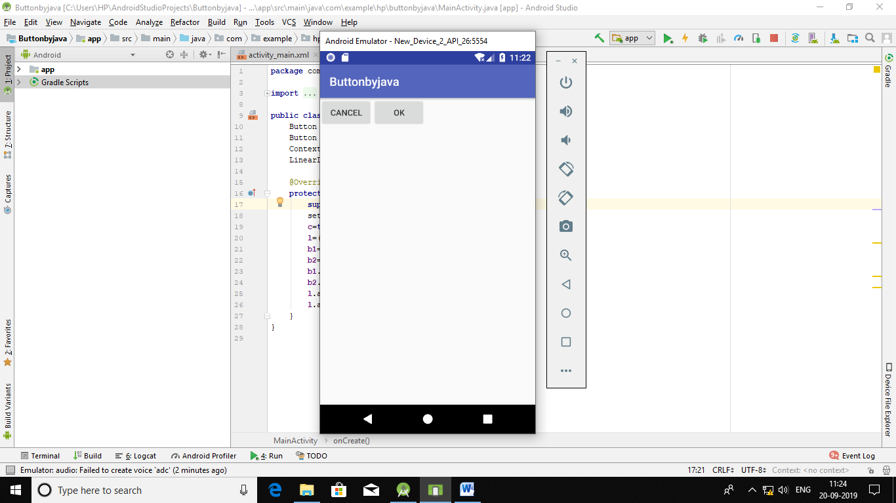

***27.Create a LOGIN application that redirects to another screen upon successful login.***

***//activity_main.xml***

**<?xml version="1.0" encoding="utf-8"?>**

**<LinearLayout xmlns:android="http://schemas.android.com/apk/res/android"**

**android:orientation="vertical" android:layout_width="match_parent"**

**android:layout_height="match_parent">**

**<Button**

**android:id="@+id/s2b2"**

**android:layout_width="wrap_content"**

**android:layout_height="wrap_content"**

**android:text="LOGOUT"**

**android:textSize="20sp"/>**

**</LinearLayout>**

***//MainActivity.java***

**package com.example.loginapp;**

**import androidx.appcompat.app.AppCompatActivity;**

**import android.os.Bundle;**

**import android.widget.EditText;**

**import android.widget.TextView;**

**import android.widget.Button;**

**import android.view.View;**

**import android.widget.Toast;**

**import android.content.Intent;**

**public class MainActivity extends AppCompatActivity {**

**TextView tv1 = null;**

**TextView tv2 = null;**

**EditText et1 = null;**

**EditText et2 = null;**

**Button bt1 = null;**

**private final int second_activity = 2;**

**@Override**

**protected void onCreate(Bundle savedInstanceState) {**

**super.onCreate(savedInstanceState);**

**setContentView(R.layout.activity_main);**

**tv1 = (TextView) findViewById(R.id.t1);**

**tv2 = (TextView) findViewById(R.id.t2);**

**et1 = (EditText) findViewById(R.id.e1);**

**et2 = (EditText) findViewById(R.id.e2);**

**bt1 = (Button) findViewById(R.id.b1);**

**bt1.setOnClickListener(new View.OnClickListener() {**

**@Override**

**public void onClick(View view) {**

**if (et1.getText().toString().equals("admin") &&**

**et2.getText().toString().equals("admin")) {**

**Toast.makeText(getApplicationContext(),**

**"Welcome Admin", Toast.LENGTH_SHORT).show();**

**Intent myIntent = new Intent(view.getContext(), secondscreen.class);**

**myIntent.putExtra("PAYLOAD", 2);**

**startActivityForResult(myIntent, second_activity);**

**} else {**

**Toast.makeText(getApplicationContext(), "Wrong Credentials", Toast.LENGTH_SHORT).show(); }**

**}**

**});**

**}**

**public void onActivityResult(int requestID, int resultID, Intent i) {**

**super.onActivityResult(requestID, resultID, i);**

**Bundle response = i.getExtras();**

**}**

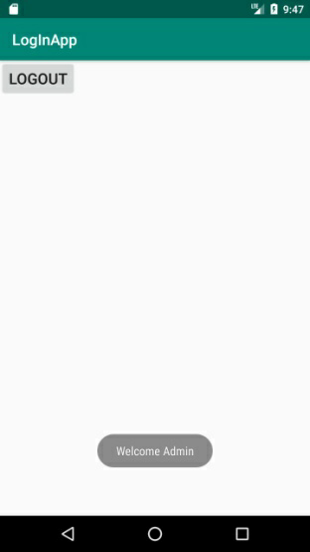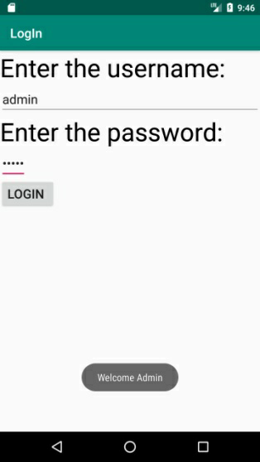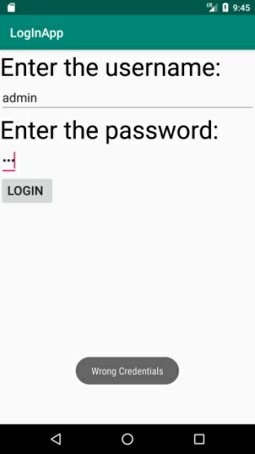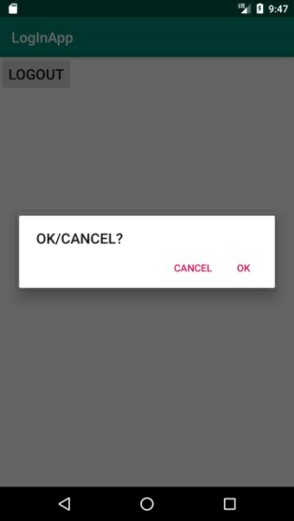

***28.Create an application to show the name of the Teachere-in-Charge on selecting an option.***

***//activity_main.xml***

**<?xml version="1.0" encoding="utf-8"?>**

**<LinearLayout xmlns:android="http://schemas.android.com/apk/res/android"**

**xmlns:app="http://schemas.android.com/apk/res-auto"**

**xmlns:tools="http://schemas.android.com/tools"**

**android:layout_width="match_parent"**

**android:layout_height="match_parent"**

**android:orientation="vertical"**

**tools:context=".MainActivity">**

**<TextView**

**android:id="@+id/tv1"**

**android:layout_width="wrap_content"**

**android:layout_height="wrap_content"**

**android:text="Select the course: "**

**android:textSize="30sp" />**

**<RadioGroup**

**android:id="@+id/rgp"**

**android:layout_width="wrap_content"**

**android:layout_height="wrap_content">**

**<RadioButton**

**android:id="@+id/t_rb"**

**android:layout_width="wrap_content"**

**android:layout_height="wrap_content"**

**android:text="CS" />**

**<RadioButton**

**android:id="@+id/f_rb"**

**android:layout_width="wrap_content"**

**android:layout_height="wrap_content"**

**android:text="Maths"/>**

**<RadioButton**

**android:id="@+id/ty_rb"**

**android:layout_width="wrap_content"**

**android:layout_height="wrap_content"**

**android:text="Stats" />**

**</RadioGroup>**

**<TextView**

**android:id="@+id/tv2"**

**android:layout_width="wrap_content"**

**android:layout_height="wrap_content"**

**android:text="Teacher-in Charge "**

**android:textSize="30sp" />**

**<TextView**

**android:id="@+id/tv3"**

**android:layout_width="wrap_content"**

**android:layout_height="wrap_content"**

**android:text=""**

**android:textSize="30sp"/>**

**</LinearLayout>**

***//MainActivity.java***

**package com.example.ques7;**

**import androidx.appcompat.app.AppCompatActivity;**

**import android.os.Bundle;**

**import android.widget.EditText;**

**import android.widget.RadioButton;**

**import android.widget.RadioGroup;**

**import android.widget.TextView;**

**public class MainActivity extends AppCompatActivity implements RadioGroup.OnCheckedChangeListener{**

**TextView t1=null;**

**RadioGroup rgp1=null;**

**RadioButton rb1=null;**

**RadioButton rb2=null;**

**RadioButton rb3=null;**

**TextView t2=null;**

**TextView t3=null;**

**@Override**

**protected void onCreate(Bundle savedInstanceState) {**

**super.onCreate(savedInstanceState);**

**setContentView(R.layout.activity_main);**

**rgp1=(RadioGroup)findViewById(R.id.rgp);**

**rb1=(RadioButton)findViewById(R.id.t_rb);**

**rb2=(RadioButton)findViewById(R.id.f_rb);**

**rb3=(RadioButton)findViewById(R.id.ty_rb);**

**t1=(TextView)findViewById(R.id.tv1);**

**t2=(TextView)findViewById(R.id.tv2);**

**t3=(TextView)findViewById(R.id.tv3);**

**rgp1.setOnCheckedChangeListener(this);**

**}**

**public void onCheckedChanged(RadioGroup rg,int i)**

**{**

**if(i==rb1.getId())**

**t3.setText("PRIYANKA MA'AM");**

**if(i==rb2.getId())**

**t3.setText("SONIA MA'AM");**

**if(i==rb3.getId())**

**t3.setText("ARCHANA MA'AM");**

**}**

**}**

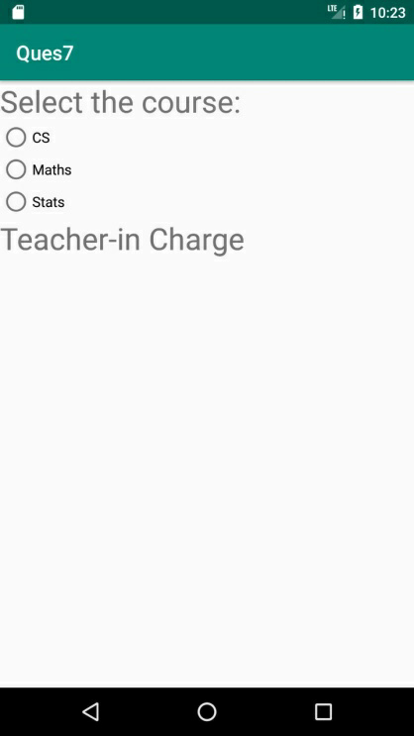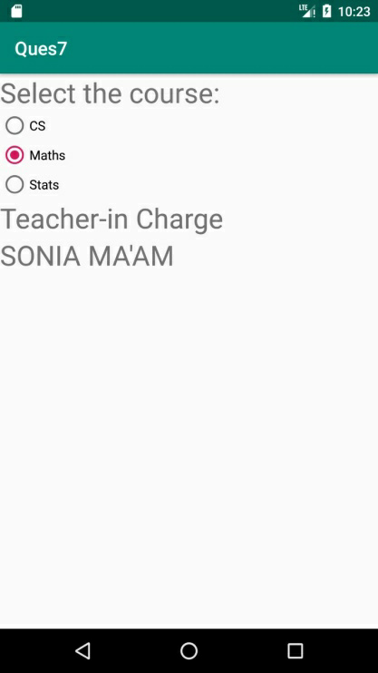

***29.Create an application to show Multiple screens.***

***//activity_main.xml***

***<?*xml version="1.0" encoding="utf-8"*?>*<LinearLayout xmlns:android="http://schemas.android.com/apk/res/android"  
 xmlns:app="http://schemas.android.com/apk/res-auto"  
 xmlns:tools="http://schemas.android.com/tools"  
 android:layout_width="match_parent"  
 android:layout_height="match_parent"  
 tools:context=".MainActivity"  
 android:orientation="vertical">  
  
 <TextView  
 android:id="@+id/tv1"  
 android:layout_width="wrap_content"  
 android:layout_height="wrap_content"  
 android:text="SCREEN 1"  
 android:textSize="30sp"  
 android:layout_gravity="center"/>  
  
 <Button  
 android:id="@+id/s1b1"  
 android:layout_width="wrap_content"  
 android:layout_height="wrap_content"  
 android:layout_gravity="center"  
 android:text="CLICK TO MOVE FORWARD"  
 android:textSize="25sp" />  
 <TextView  
 android:id="@+id/tv2"  
 android:layout_width="wrap_content"  
 android:layout_height="wrap_content"  
 android:text="BACK TO SCREEN 1"  
 android:textSize="30sp"  
 android:layout_gravity="center"/>  
  
  
</LinearLayout>**

***//MainActivity.java***

**package com.example.hp.pop_up;  
  
  
import android.content.Intent;  
import android.support.v7.app.AppCompatActivity;  
import android.os.Bundle;  
import android.widget.TextView;  
import android.widget.*;  
import android.view.*;  
  
public class MainActivity extends AppCompatActivity  
{  
  
 Button b1=null;  
  
 @Override  
 protected void onCreate(Bundle savedInstanceState)  
 {  
 super.onCreate(savedInstanceState);  
 setContentView(R.layout.*activity_main*);  
 b1=(Button)findViewById(R.id.*s1b1*);  
 b1.setOnClickListener(new View.OnClickListener()  
 {  
 public void onClick(View v)  
 {  
 Intent myIntent=new Intent(v.getContext(),SecondScreen.class);  
 startActivity(myIntent);  
 }  
 });  
  
 }**

***//second.xml***

***<?*xml version="1.0" encoding="utf-8"*?>*<LinearLayout  
 xmlns:android="http://schemas.android.com/apk/res/android"  
 xmlns:tools="http://schemas.android.com/tools"  
 android:layout_width="match_parent"  
 android:layout_height="match_parent"  
 tools:context=".SecondScreen"  
 android:orientation="vertical">  
  
 <TextView  
 android:id="@+id/tv1"  
 android:layout_width="wrap_content"  
 android:layout_height="wrap_content"  
 android:text="SCREEN 2"  
 android:textSize="30sp"  
 android:layout_gravity="center"/>  
  
 <Button  
 android:id="@+id/s2b2"  
 android:layout_width="wrap_content"  
 android:layout_height="wrap_content"  
 android:layout_gravity="center"  
 android:text="CLICK TO MOVE TO MAIN SCREEN"  
 android:textSize="25sp" />  
 <TextView  
 android:id="@+id/tv2"  
 android:layout_width="wrap_content"  
 android:layout_height="wrap_content"  
 android:text="BACK TO SCREEN 2"  
 android:textSize="30sp"  
 android:layout_gravity="center"/>  
  
  
</LinearLayout>**

***//SecondScreen.java***

**package com.example.hp.pop_up;  
  
  
import android.content.Intent;  
import android.support.v7.app.AppCompatActivity;  
import android.os.Bundle;  
import android.widget.TextView;  
import android.widget.*;  
import android.view.*;  
  
public class SecondScreen extends AppCompatActivity {  
  
 Button b2 = null;  
  
 @Override  
 protected void onCreate(Bundle savedInstanceState) {  
 super.onCreate(savedInstanceState);  
 setContentView(R.layout.*second*);  
 b2 = (Button) findViewById(R.id.*s2b2*);  
 b2.setOnClickListener(new View.OnClickListener() {  
 public void onClick(View v) {  
 finish();  
 }  
 });  
  
 }  
}**

***//MANIFEST FILE***

*<?***xml version="1.0" encoding="utf-8"***?>*<**manifest xmlns:android="http://schemas.android.com/apk/res/android"  
 package="com.example.hp.pop_up"**>  
  
 <**application  
 android:allowBackup="true"  
 android:icon="@mipmap/ic_launcher"  
 android:label="@string/app_name"  
 android:roundIcon="@mipmap/ic_launcher_round"  
 android:supportsRtl="true"  
  
 android:theme="@style/AppTheme"**>  
 <**activity android:name=".MainActivity"**>  
  
  
 <**intent-filter**>  
 <**action android:name="android.intent.action.MAIN"** />  
  
 <**category android:name="android.intent.category.LAUNCHER"** />  
 </**intent-filter**>  
 </**activity**>  
 <**activity android:name=".SecondScreen"**>  
  
 </**activity**>  
 </**application**>  
  
</**manifest**>

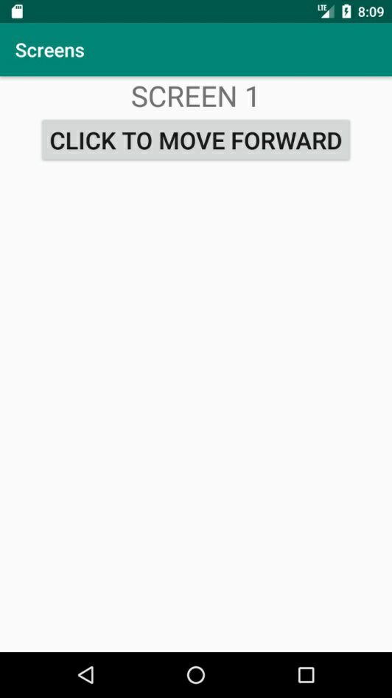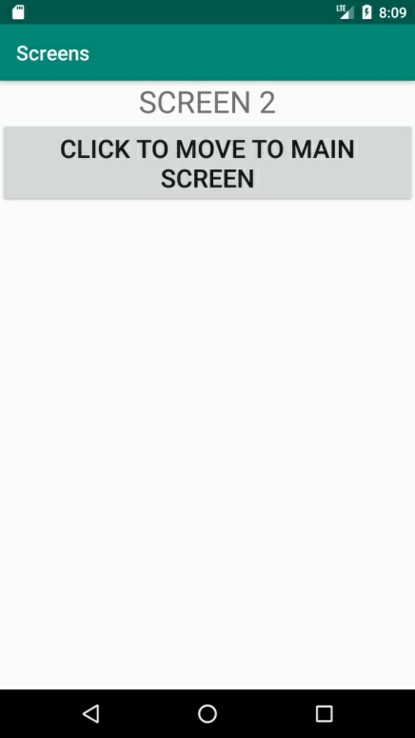

***30.Create an application to show Multiple screens which can be edited.***

***//activity_main.xml***

**<?xml version="1.0" encoding="utf-8"?>**

**<LinearLayout xmlns:android="http://schemas.android.com/apk/res/android"**

**xmlns:app="http://schemas.android.com/apk/res-auto"**

**xmlns:tools="http://schemas.android.com/tools"**

**android:layout_width="match_parent"**

**android:layout_height="match_parent"**

**tools:context=".MainActivity"**

**android:orientation="vertical">**

**<TextView**

**android:id="@+id/tv1"**

**android:layout_width="wrap_content"**

**android:layout_height="wrap_content"**

**android:text="ENTER YOUR NAME-"**

**android:textSize="30sp"**

**android:layout_gravity="center"/>**

**<EditText**

**android:id="@+id/payLoad"**

**android:layout_width="wrap_content"**

**android:layout_height="wrap_content"**

**android:textSize="30sp"**

**android:layout_gravity="center"/>**

**<Button**

**android:id="@+id/s1b1"**

**android:layout_width="wrap_content"**

**android:layout_height="wrap_content"**

**android:layout_gravity="center"**

**android:text="OKAY"**

**android:textSize="25sp" />**

**</LinearLayout>**

***//MainActivity.java***

**package com.example.hp.pop_up;**

**import android.content.Intent;**

**import android.support.v7.app.AppCompatActivity;**

**import android.os.Bundle;**

**import android.widget.TextView;**

**import android.widget.*;**

**import android.view.*;**

**public class MainActivity extends AppCompatActivity**

**{**

**Button b1=null;**

**EditText et1=null;**

**private final int second_activity = 2;**

**@Override**

**protected void onCreate(Bundle savedInstanceState)**

**{**

**super.onCreate(savedInstanceState);**

**setContentView(R.layout.activity_main);**

**b1=(Button)findViewById(R.id.s1b1);**

**et1=(EditText) findViewById(R.id.payLoad);**

**b1.setOnClickListener(new View.OnClickListener()**

**{**

**public void onClick(View v)**

**{**

**Intent myIntent=new Intent(v.getContext(),SecondScreen.class);**

**myIntent.putExtra("PAYLOAD",et1.getText().toString());**

**startActivityForResult(myIntent,second_activity);**

**}**

**});**

**}**

**@Override**

**public void onActivityResult(int requestID, int resultID, Intent i)**

**{**

**super.onActivityResult(requestID, resultID, i);**

**Bundle response = i.getExtras();**

**et1.setText(response.getString("returnPayLoad"));**

**}**

**}**

***//second.xml***

**<?xml version="1.0" encoding="utf-8"?>**

**<LinearLayout**

**xmlns:android="http://schemas.android.com/apk/res/android"**

**xmlns:tools="http://schemas.android.com/tools"**

**android:layout_width="match_parent"**

**android:layout_height="match_parent"**

**tools:context=".SecondScreen"**

**android:orientation="vertical">**

**<TextView**

**android:id="@+id/tv1"**

**android:layout_width="wrap_content"**

**android:layout_height="wrap_content"**

**android:text="SCREEN 2"**

**android:textSize="30sp"**

**android:layout_gravity="center"/>**

**<EditText**

**android:id="@+id/pay2"**

**android:layout_width="wrap_content"**

**android:layout_height="wrap_content"**

**android:textSize="30sp"**

**android:layout_gravity="center"/>**

**<Button**

**android:id="@+id/s2b2"**

**android:layout_width="wrap_content"**

**android:layout_height="wrap_content"**

**android:layout_gravity="center"**

**android:text="BACK"**

**android:textSize="25sp" />**

**</LinearLayout>**

***//SecondScreen.java***

**package com.example.hp.pop_up;**

**import android.content.Intent;**

**import android.support.v7.app.AppCompatActivity;**

**import android.os.Bundle;**

**import android.widget.TextView;**

**import android.widget.*;**

**import android.view.*;**

**public class SecondScreen extends AppCompatActivity {**

**Button b2 = null;**

**EditText et2=null;**

**@Override**

**protected void onCreate(Bundle savedInstanceState) {**

**super.onCreate(savedInstanceState);**

**setContentView(R.layout.second);**

**b2 = (Button) findViewById(R.id.s2b2);**

**et2=(EditText) findViewById(R.id.pay2);**

**Bundle incoming=this.getIntent().getExtras();**

**et2.setText(incoming.getString("PAYLOAD"));**

**b2.setOnClickListener(new View.OnClickListener()**

**{**

**public void onClick(View v)**

**{**

**Intent goback = new Intent();**

**goback.putExtra("returnPayLoad", et2.getText().toString());**

**setResult(RESULT_OK, goback);**

**finish();**

**}**

**});**

**}**

**}**

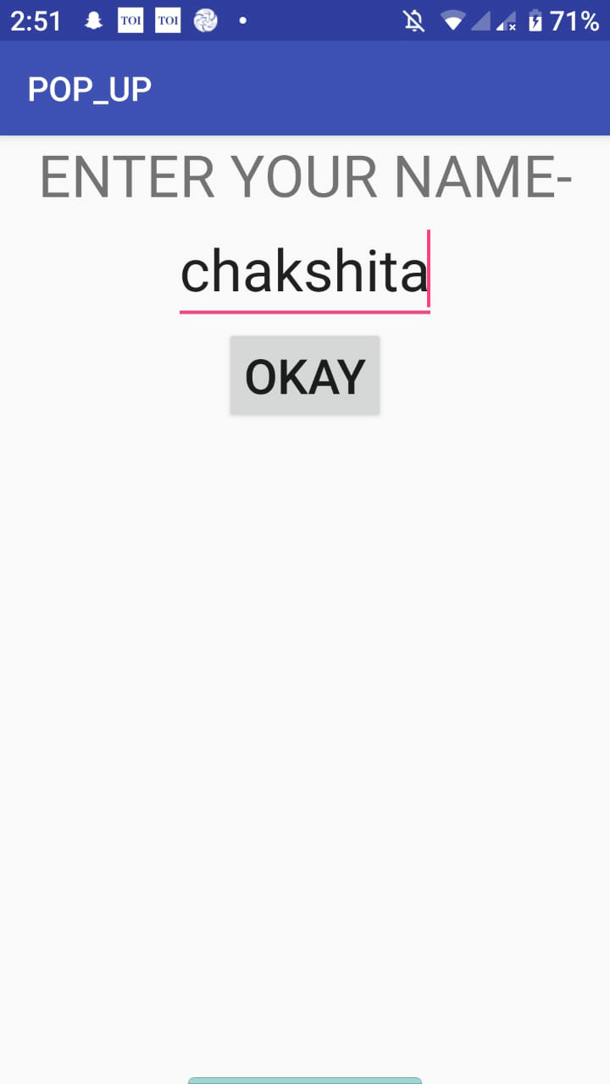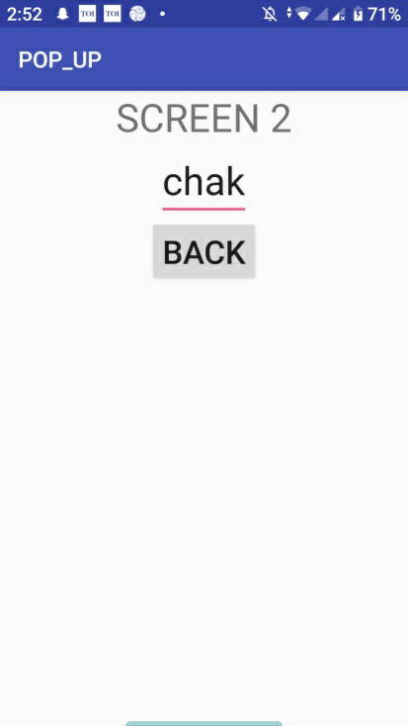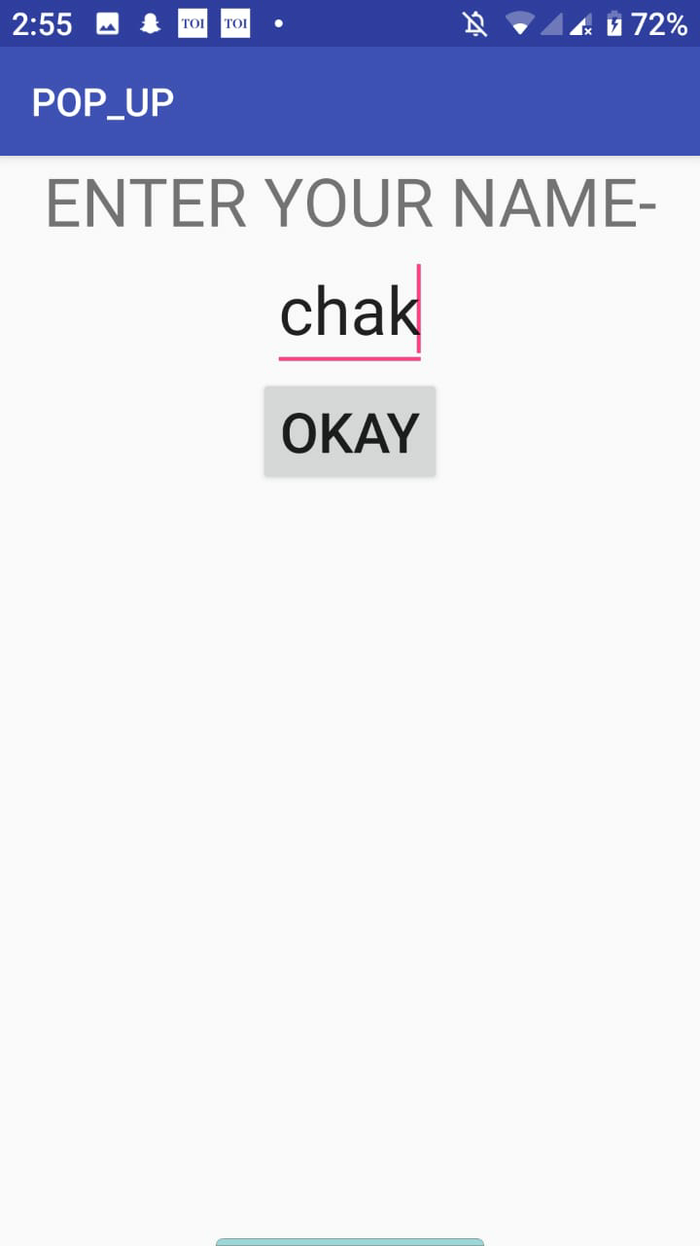

***31.Create an application to show IMPLICIT INTENT.***

***//activity_main.xml***

***<?*xml version="1.0" encoding="utf-8"*?>*<LinearLayout xmlns:android="http://schemas.android.com/apk/res/android"  
 xmlns:app="http://schemas.android.com/apk/res-auto"  
 xmlns:tools="http://schemas.android.com/tools"  
 android:layout_width="match_parent"  
 android:layout_height="match_parent"  
 android:orientation="vertical"  
 tools:context=".MainActivity">  
  
  
 <EditText  
 android:id="@+id/e1"  
 android:layout_width="match_parent"  
 android:layout_height="wrap_content"  
 android:inputType="textUri"  
 android:text="Colombia"  
 />  
 <Button  
 android:id="@+id/s1b1"  
 android:layout_width="wrap_content"  
 android:layout_height="wrap_content"  
 android:layout_gravity="center"  
 android:layout_marginVertical="33dp"  
 android:text="Navigate"  
 android:textStyle="bold"  
 android:textSize="20dp"  
 />  
  
 <TextView  
 android:id="@+id/tv1"  
 android:layout_width="wrap_content"  
 android:layout_height="wrap_content"  
 android:paddingTop="40dp"  
 android:paddingLeft="85dp"  
 android:textSize="30dp"  
 android:text="--"  
 android:textStyle="bold"  
 />  
</LinearLayout>**

***//MainActivity.java***

**package com.example.hp.website;  
  
import android.content.Intent;  
import android.net.Uri;  
import android.support.v7.app.AppCompatActivity;  
import android.os.Bundle;  
import android.view.View;  
import android.widget.Button;  
import android.widget.EditText;  
import android.widget.TextView;  
  
  
public class MainActivity extends AppCompatActivity {  
 Button b1=null;  
 EditText e=null;  
 TextView t = null;  
 Uri addressUri = null;  
 @Override  
 protected void onCreate(Bundle savedInstanceState) {  
 super.onCreate(savedInstanceState);  
 setContentView(R.layout.*activity_main*);  
 b1=(Button)findViewById(R.id.*s1b1*);  
 e=(EditText) findViewById(R.id.*e1*);  
 t=(TextView) findViewById(R.id.*tv1*);  
  
 String loc = e.getText().toString();  
  
 *// Parse the location and create the intent.* addressUri = Uri.*parse*("geo:0,0?q=" + loc);  
b1.setOnClickListener(new View.OnClickListener() {  
 @Override  
 public void onClick(View v) {  
 Intent intent = new Intent(Intent.*ACTION_VIEW*, addressUri);  
if (intent.resolveActivity(getPackageManager()) != null) {  
 startActivity(intent);  
 } else {  
 t.setText("Can not handle this");  
 }  
 }  
 });  
  
  
 }  
  
}**

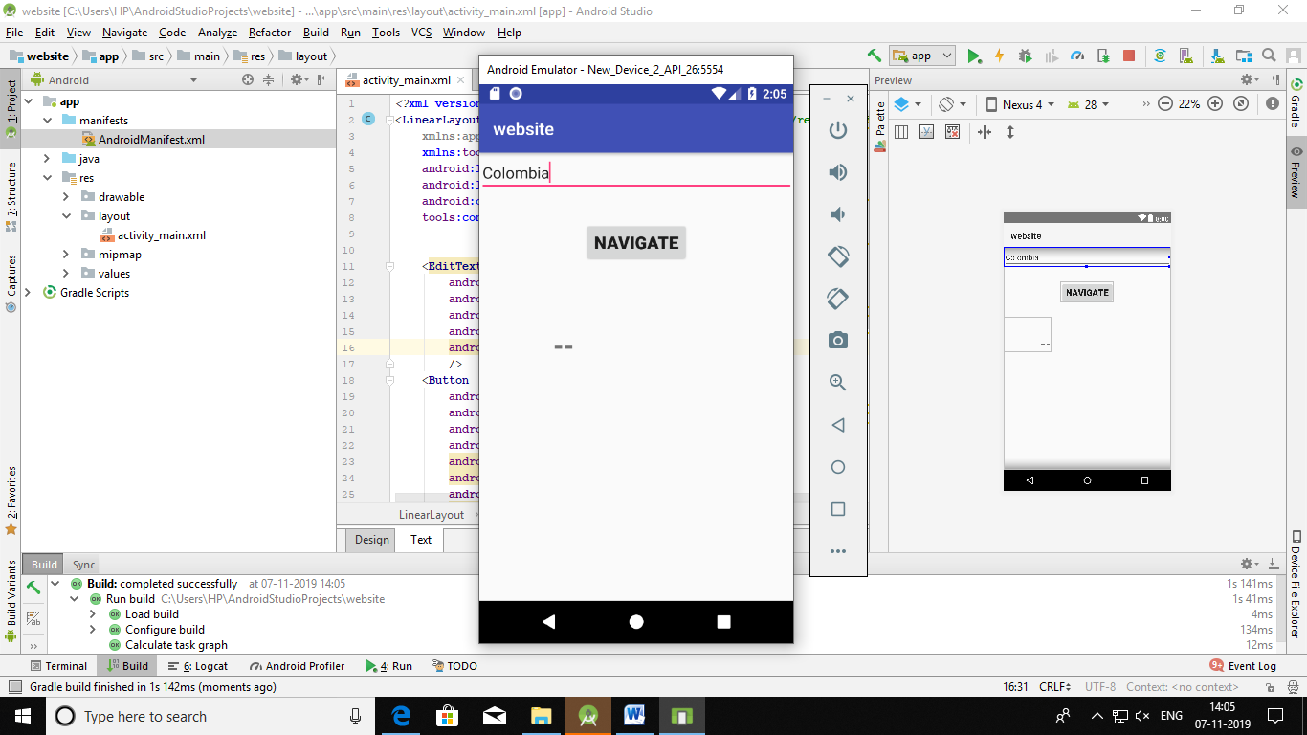 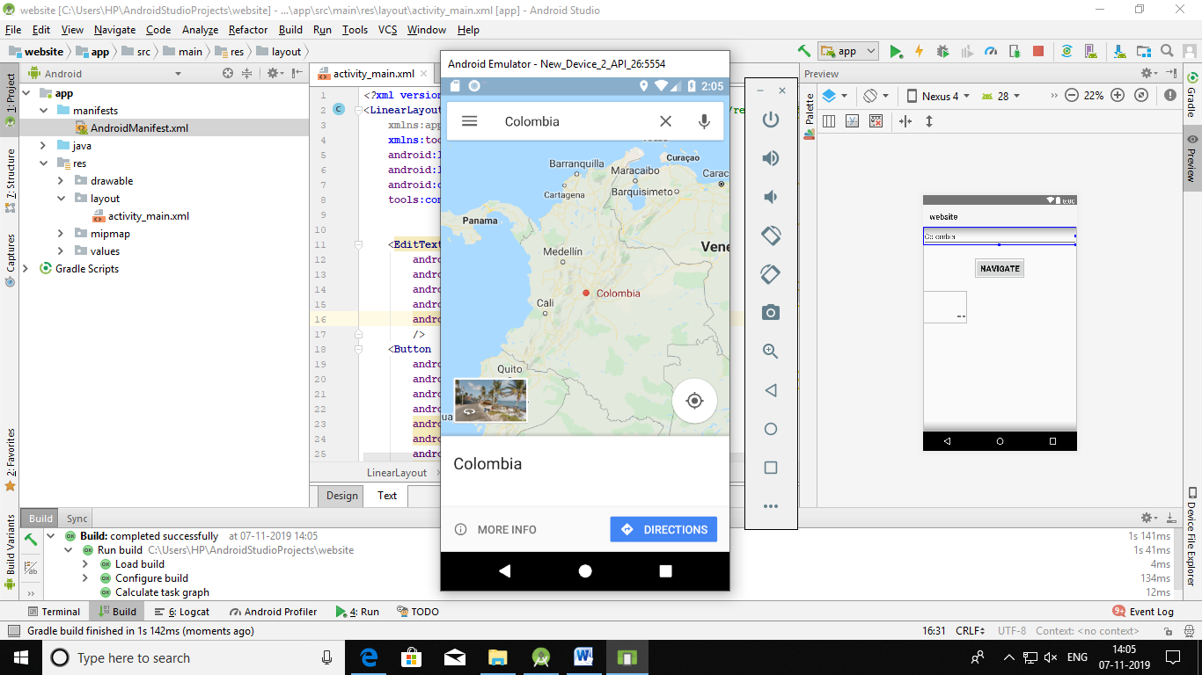

***31.Create an application to show DIFFERENT IMAGES USING SPINNER.***

***//activity_main.xml***

*<?***xml version="1.0" encoding="utf-8"***?>*<**LinearLayout xmlns:android="http://schemas.android.com/apk/res/android"  
 xmlns:app="http://schemas.android.com/apk/res-auto"  
 xmlns:tools="http://schemas.android.com/tools"  
 android:layout_width="match_parent"  
 android:layout_height="match_parent"  
 tools:context=".MainActivity"**>  
  
 <**Spinner  
 android:prompt="@string/sprompt"  
 android:layout_width="wrap_content"  
 android:layout_height="wrap_content"  
 android:id= "@+id/spin"  
 android:entries="@array/SELECT_IMAGE"**/>  
  
 <**TextView  
 android:id="@+id/t1"  
 android:layout_width="wrap_content"  
 android:layout_height="wrap_content"** />  
  
 <**ImageView  
 android:id="@+id/imageView1"  
 android:layout_height="wrap_content"  
 android:layout_width="match_parent"**>  
  
 </**ImageView**>  
  
</**LinearLayout**>  
  
  
***//strings.xml***

<**resources**>  
 <**string name="app_name"**>Spinner</**string**>  
 <**string name="sprompt"**>SELECT IMAGE</**string**>  
 <**string-array name="SELECT_IMAGE"**>  
 <**item**>SELECT IMAGE</**item**>  
 <**item**>DOG</**item**>  
 <**item**>CAT</**item**>  
 <**item**>SQUIRREL</**item**>  
 <**item**>RABBIT</**item**>  
 </**string-array**>  
</**resources**>

***//ActivityMain.java***

**package** com.example.spinnerimage;  
  
**import** androidx.appcompat.app.AppCompatActivity;  
**import** android.os.Bundle;  
**import** android.view.View;  
**import** android.widget.AdapterView;  
**import** android.widget.Spinner;  
**import** android.widget.TextView;  
**import** android.widget.ImageView;  
  
  
**public class** MainActivity **extends** AppCompatActivity **implements** AdapterView.OnItemSelectedListener{  
  
 Spinner c_spinner = **null**;  
 ImageView img=**null**;  
  
 @Override  
 **protected void** onCreate(Bundle savedInstanceState) {  
 **super**.onCreate(savedInstanceState);  
 setContentView(R.layout.activity_main);  
 c_spinner = (Spinner) findViewById(R.id.spin);  
 img=(ImageView)findViewById(R.id.imageView1);  
  
  
 **c_spinner**.setOnItemSelectedListener(**this**);  
 }  
  
 **public void** onItemSelected(AdapterView<?> parent, View v, **int** arg2, **long** id) {  
 **if**(arg2==1)  
 {  
 **img**.setImageResource(R.drawable.***dog***);  
 }  
 **if**(arg2==2)  
 {  
 **img**.setImageResource(R.drawable.***cat***);  
 }  
 **if**(arg2==3)  
 {  
 **img**.setImageResource(R.drawable.***squirrel***);  
 }  
 **if**(arg2==4)  
 {  
 **img**.setImageResource(R.drawable.***rabbit***);  
 }  
 }  
  
 **public void** onNothingSelected(AdapterView<?> parent) {}  
}

