Aditi Varshney

CSC/19/89

Microprocessors

Q1. WAP to display "Hello World"

Ans :

.model small ;defines the memory model to be used for the ALP

.data ;DATA SEGMENTS BEGIN HERE

msg db "Hello World$"

.code

;remove special characters

mov ax,@data

mov ds,ax

; display procedure

LEA dx, msg

mov ah,09h

int 21h

; terminate procedure

mov ah,4ch

int 21h

end

Output :

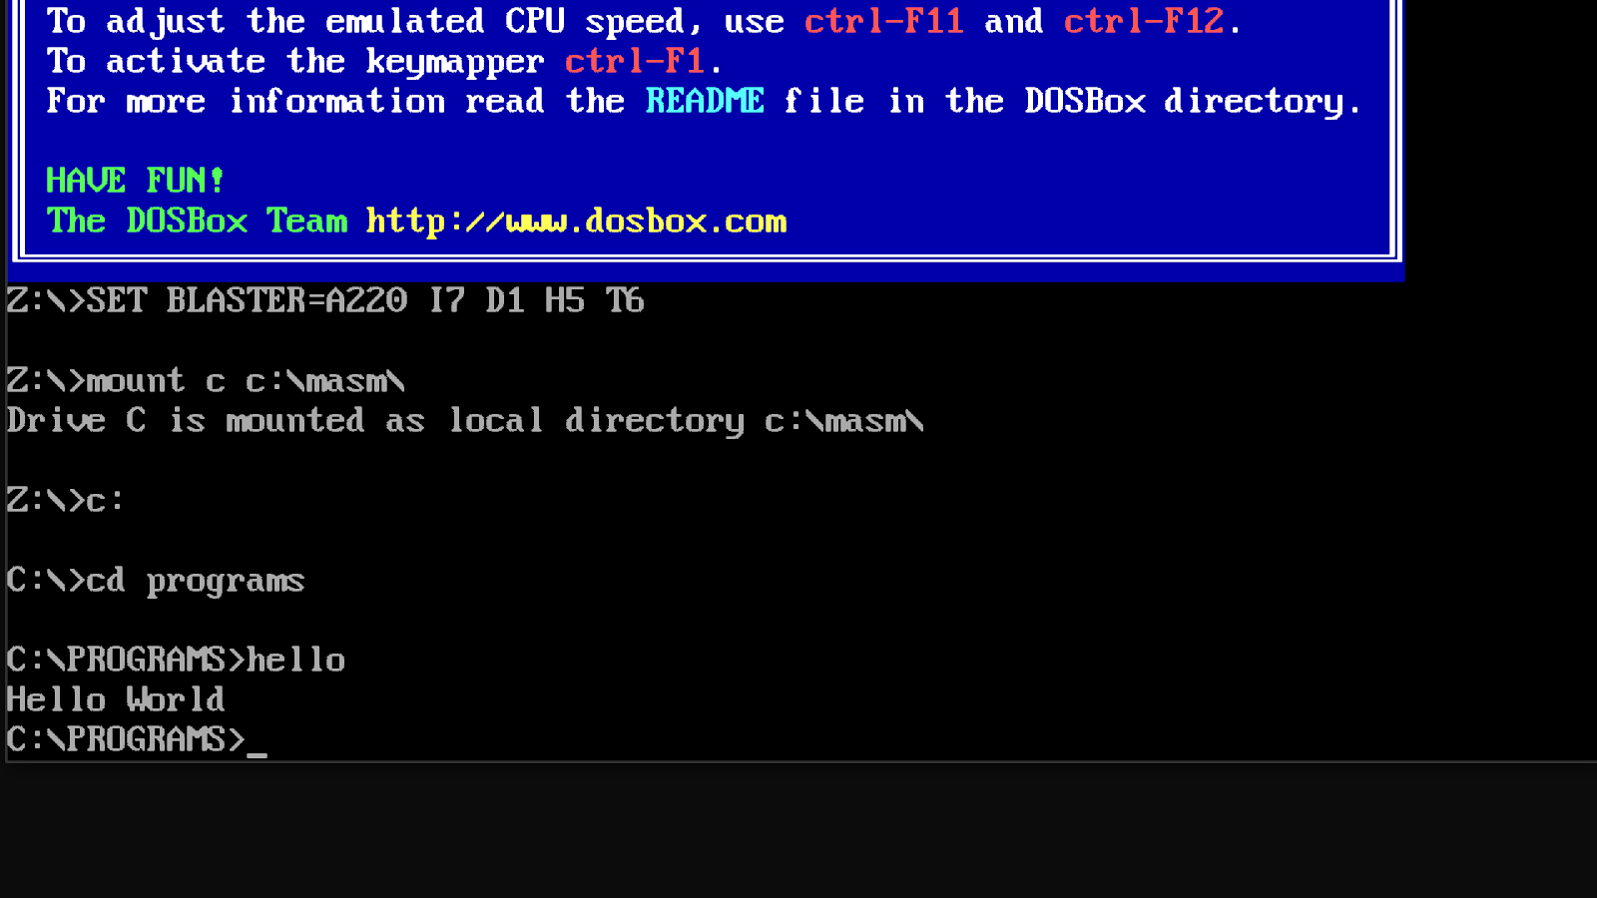

Q2. WAP to display multiple line text (combination of character, digit, symbol).

Ans :

.model small ;defines the memory model to be used for the ALP

.data ;DATA SEGMENTS BEGIN HERE

msg db 10d,13d, "Hello World$"

VAR db 10d,13d, "Mata Sundri Women Sikh College$"

message db 10d,13d, "Connect with us$"

.code

;remove special characters

mov ax,@data

mov ds,ax

; display procedure

LEA dx, msg

mov ah,09h

int 21h

LEA dx, VAR

mov ah,09h

int 21h

LEA dx, message

mov ah,09h

int 21h

; terminate procedure

mov ah,4ch

int 21h

end

Output :

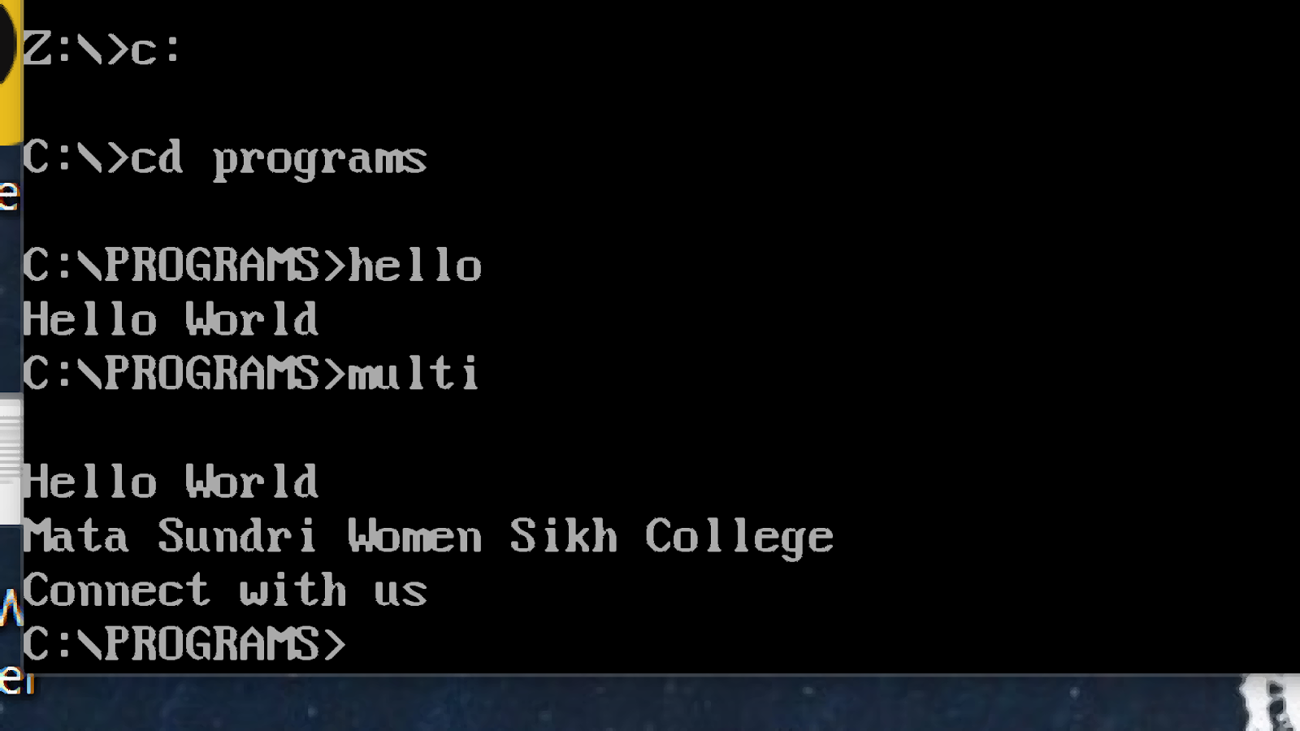

                    ****Thank You ****

Q1. Addition of two  user input numbers .

Ans :

.model small

.data

msg db 10d,13d, "Enter Value 1 : $"

msg1 db 10d,13d, "Enter Value 2 : $"

msg2 db 10d,13d, "Addition is : $"

.code

;remove special characters

mov ax,@data

mov ds,ax

; display procedure

LEA dx, msg

mov ah,09h

int 21h

;input value

mov ah,01h

;add dl,30h

int 21h

mov cl,al

int 21h

; display procedure

LEA dx, msg1

mov ah,09h

int 21h

;input value

mov ah,01h

;mov cl,al

int 21h

; display procedure

LEA dx, msg2

mov ah,09h

int 21h

;input2

add cl,al

;add cl,30h

sub cl,48

mov dl,cl

mov ah,02h

int 21h

; terminate procedure

mov ah,4ch

int 21h

end

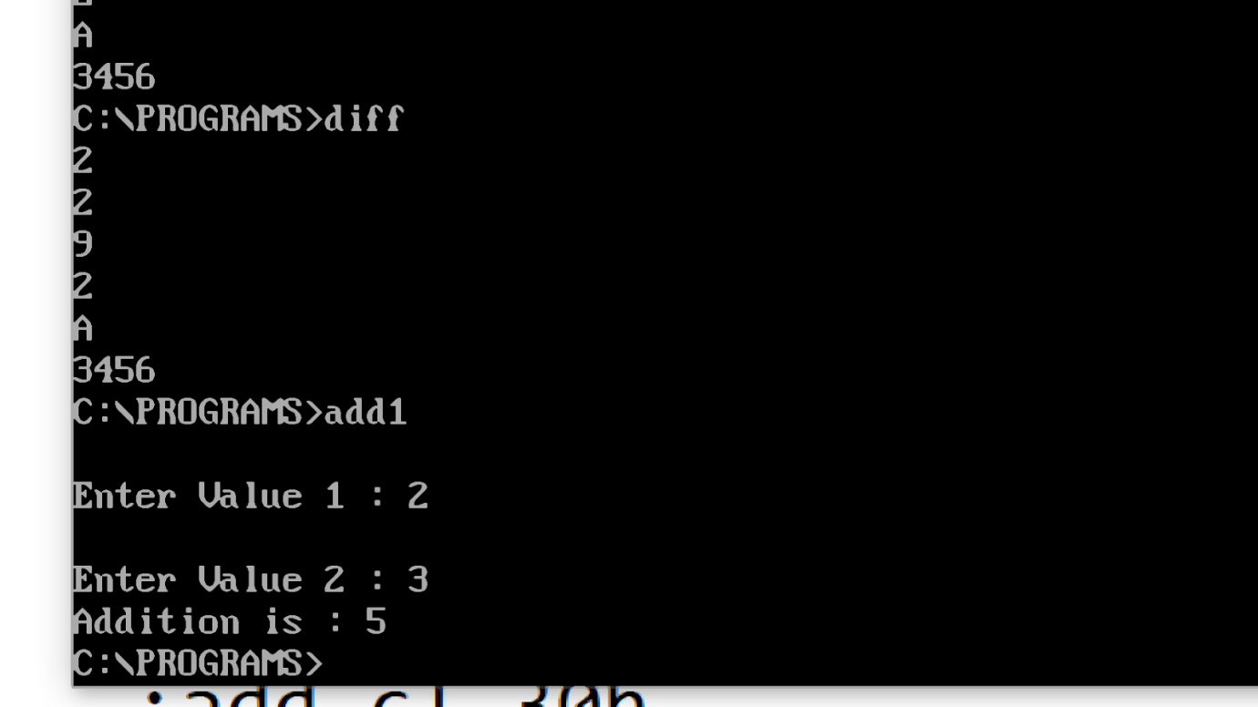

Q2. Addition of a constant and an user input numbers

Ans :

.model small

.data

   var db 3

   msg db  "Value 1 : $"

msg1 db  "Enter Value 2 : $"

msg2 db 10d,13d, "Addition is : $"

.code

  ;remove special characters

  mov ax,@data

  mov ds,ax

  ; display procedure

  Lea dx,msg

  mov ah,09h

  int 21h

   mov dl,var

   add dl,48

   mov ah,02h

   int 21h

   mov dl,0ah   ;next line

   int 21h

  ; display procedure

  Lea dx,msg1

  mov ah,09h

  int 21h

   ;input value

   mov ah,01h

   add al,48

   int 21h

  Lea dx,msg2

  mov ah,09h

  int 21h

  ;input1

  mov dl,var

  add dl,48

  add dl,al

  sub dl,48

  mov ah,02h

  int 21h

  ; terminate procedure

  mov ah,4ch

  int 21h

end

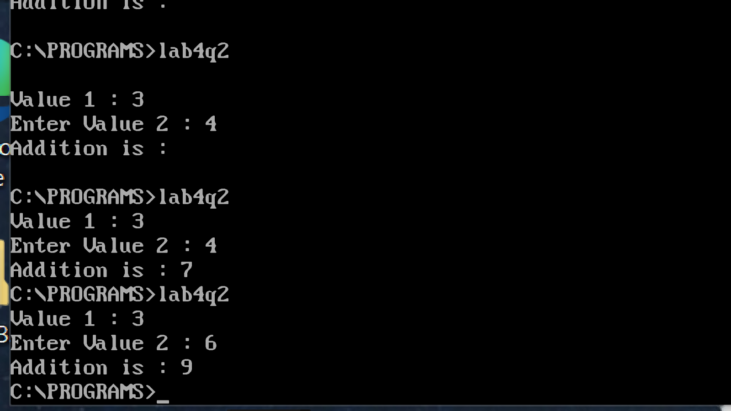

**THANK YOU**

Q1. Subtraction of two 32-bit numbers (USE user input numbers)

Ans:

; You may customize this and other start-up templates;

; The location of this template is c:\emu8086\inc\0_com_template.txt

org 100h

; add your code here

.model small

.data

msg db 10d,13d, "Enter 1st number : $"

msg1 db 10d,13d, "Enter 2nd number : $"

msg2 db 10d,13d, "Subtraction : $"

num1 db 08 dup(?)

num2 db 08 dup(?)

.code

;remove special characters

mov ax,@data

mov ds,ax

;display

LEA dx, msg

mov ah,09h

int 21h

;read number 1

mov cl,08h

lea si,num1

readnum:

mov ah,01h

int 21h

mov [si],al

inc si

loop readnum

dec si

;display

LEA dx, msg1

mov ah,09h

int 21h

;read number 2

mov cl,08h

lea di,num2

readnum1:

mov ah,01h

int 21h

mov [di],al

inc di

loop readnum1

dec di

;display

LEA dx, msg2

mov ah,09h

int 21h

;addition

mov cl,08h

;sbb ;put the value 0 in carry flag

sub1:

mov bh,[si]

mov bl,[di]

sbb bh,bl   ;bh=bh-bl-borrow , sbb=subtract by borrow bit

mov al,bh

mov ah,00h

aas

mov [si],al

dec si

dec di

loop sub1

mov cl,08h

jnc display ;if there is carry

; these three lines print 1 if carry

mov dl,31h

mov ah,02h

int 21h

display:

mov dl,[si+1]

add dl,48

mov ah,02h

int 21h

inc si

loop display

; terminate procedure

mov ah,4ch

int 21h

ret

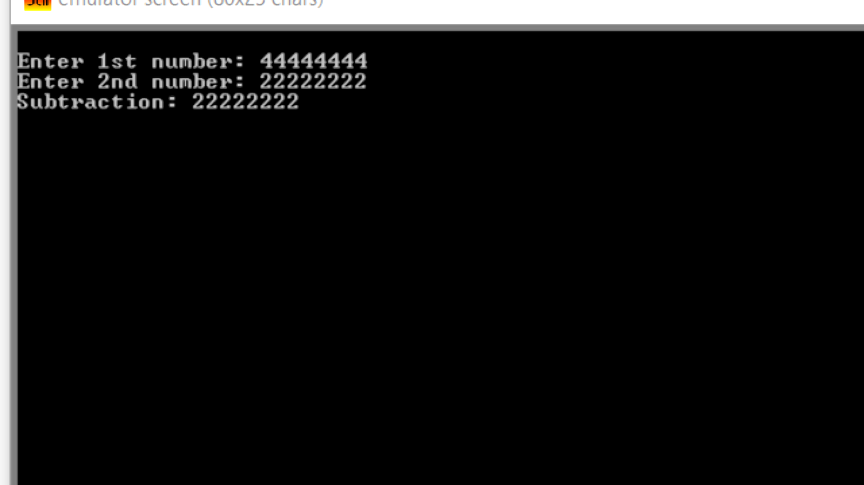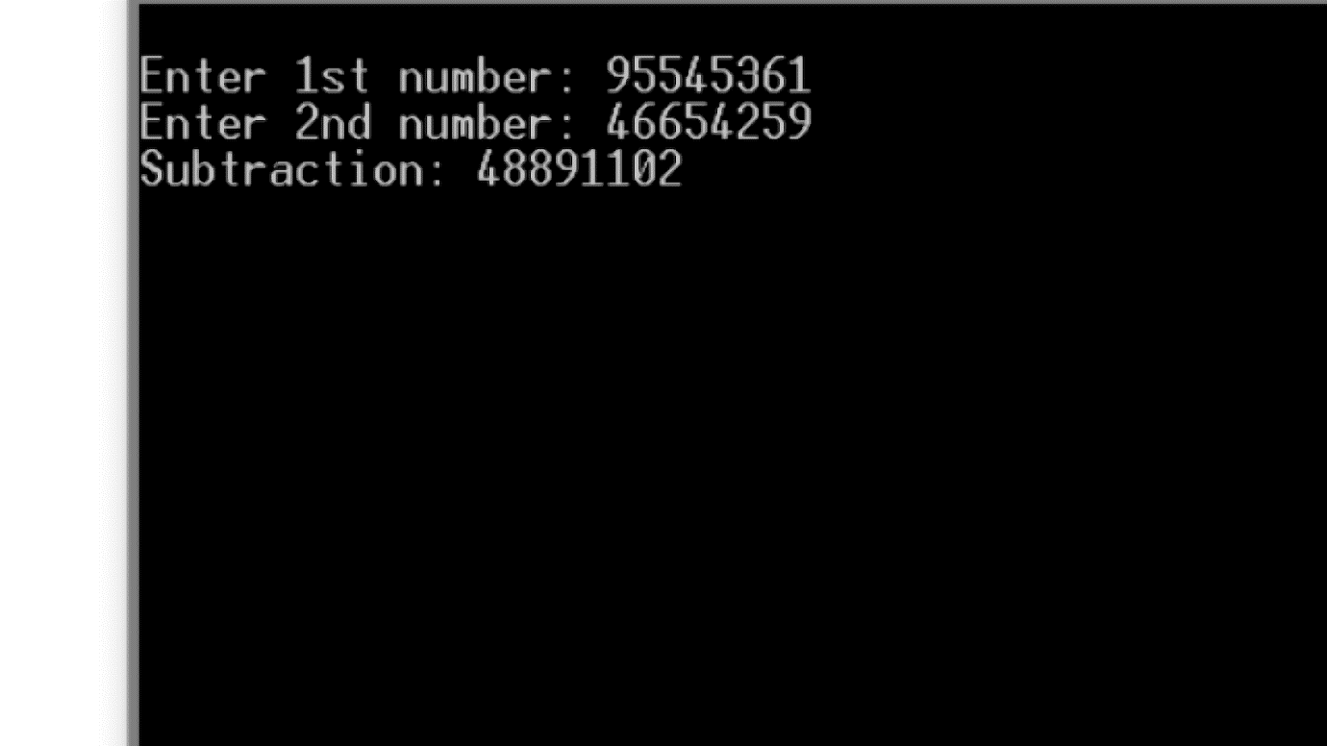

Q2. Subtraction of two 32-bit numbers (USE data segment variables)

Ans:

.model small

.386

.data

    var1 dd 66666666h

    var2 dd 11111111h

    msg1 db "Difference = $"

.code

MOV ax,@data

MOV ds,ax

LEA dx,msg1

MOV ah,09h

INT 21h

MOV EAX,var1

MOV EBX,var2

SBB EAX,EBX

MOV ah,4ch

INT 21h

end

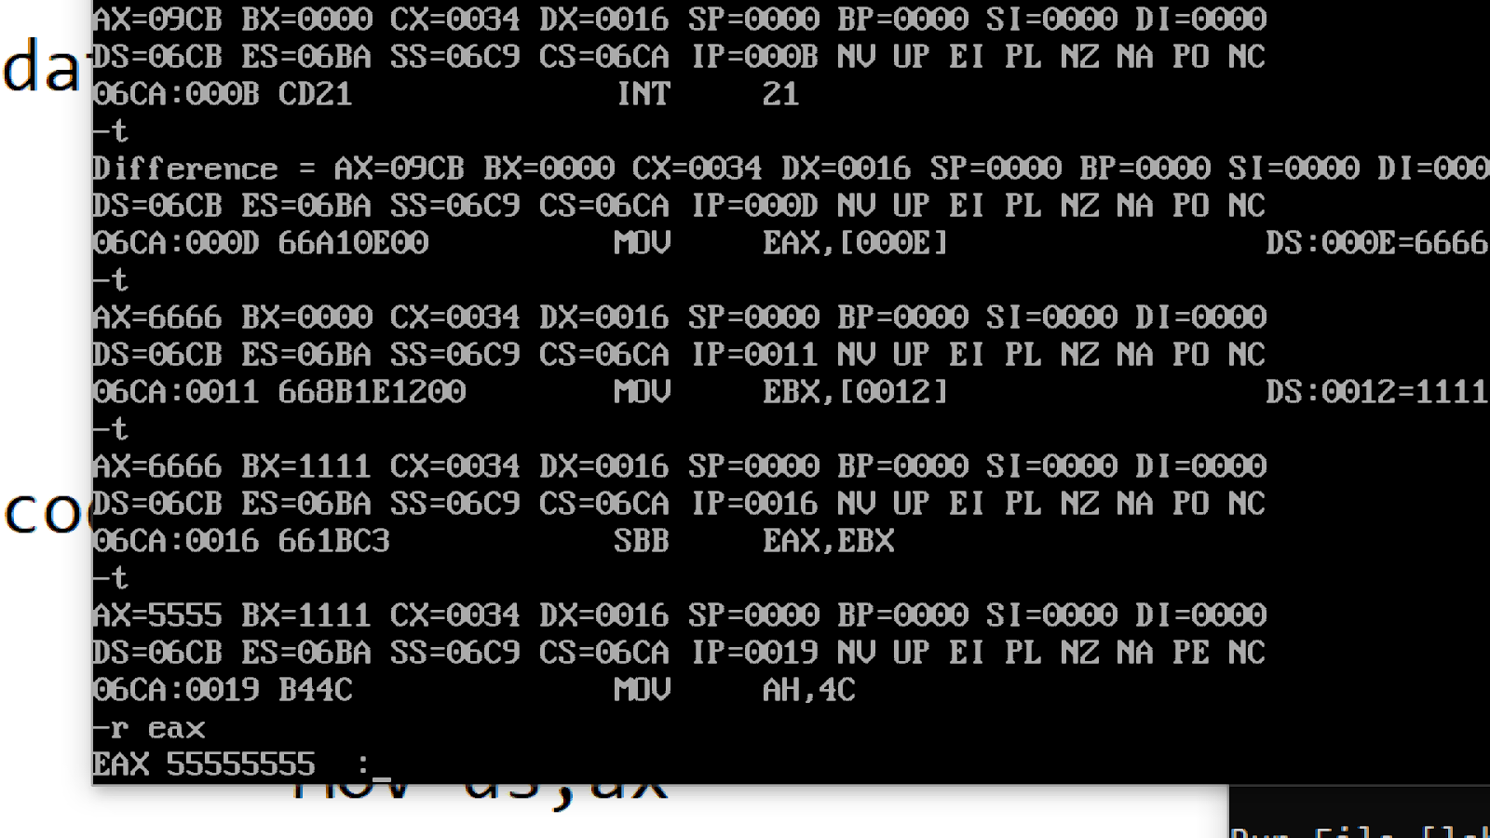

Q3. Perform subtraction on a user input value and a constant value.

Ans:

.model small

.data

msg1 db 10d, 13d, "Enter a number1 : $"

msg2 db 10d, 13d, "Second number : 2$"

msg3 db 10d, 13d, "Difference = $"

.code

mov ax, @data

mov ds, ax

LEA dx, msg1

mov ah, 09h

int 21h

mov ah, 01h

int 21h

LEA dx, msg2

mov ah, 09h

int 21h

LEA dx, msg3

mov ah, 09h

int 21h

sub al, 2

add al, 48 ;to change 2 from machine language to human language

mov dl, al

sub dl, 48

mov ah, 02h

int 21h

mov ah, 4ch

int 21h

end

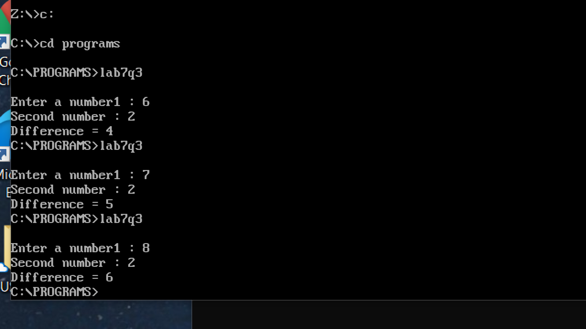

Thank You

Q1. Subtraction of 1 -digit number and 2-digit number  e.g.   8-4  ;   77-30

Ans:

**1 -digit number**

; You may customize this and other start-up templates;

; The location of this template is c:\emu8086\inc\0_com_template.txt

org 100h

; add your code here

.model small

.data

msg db , "Subtraction of 7 and 3 is : $"

.code

;remove special characters

mov ax,@data

mov ds,ax

; display procedure

LEA dx, msg

mov ah,09h

int 21h

mov dl,7

sub dl,3

add dl,48

mov ah,02h

int 21h

; terminate procedure

mov ah,4ch

int 21h

ret

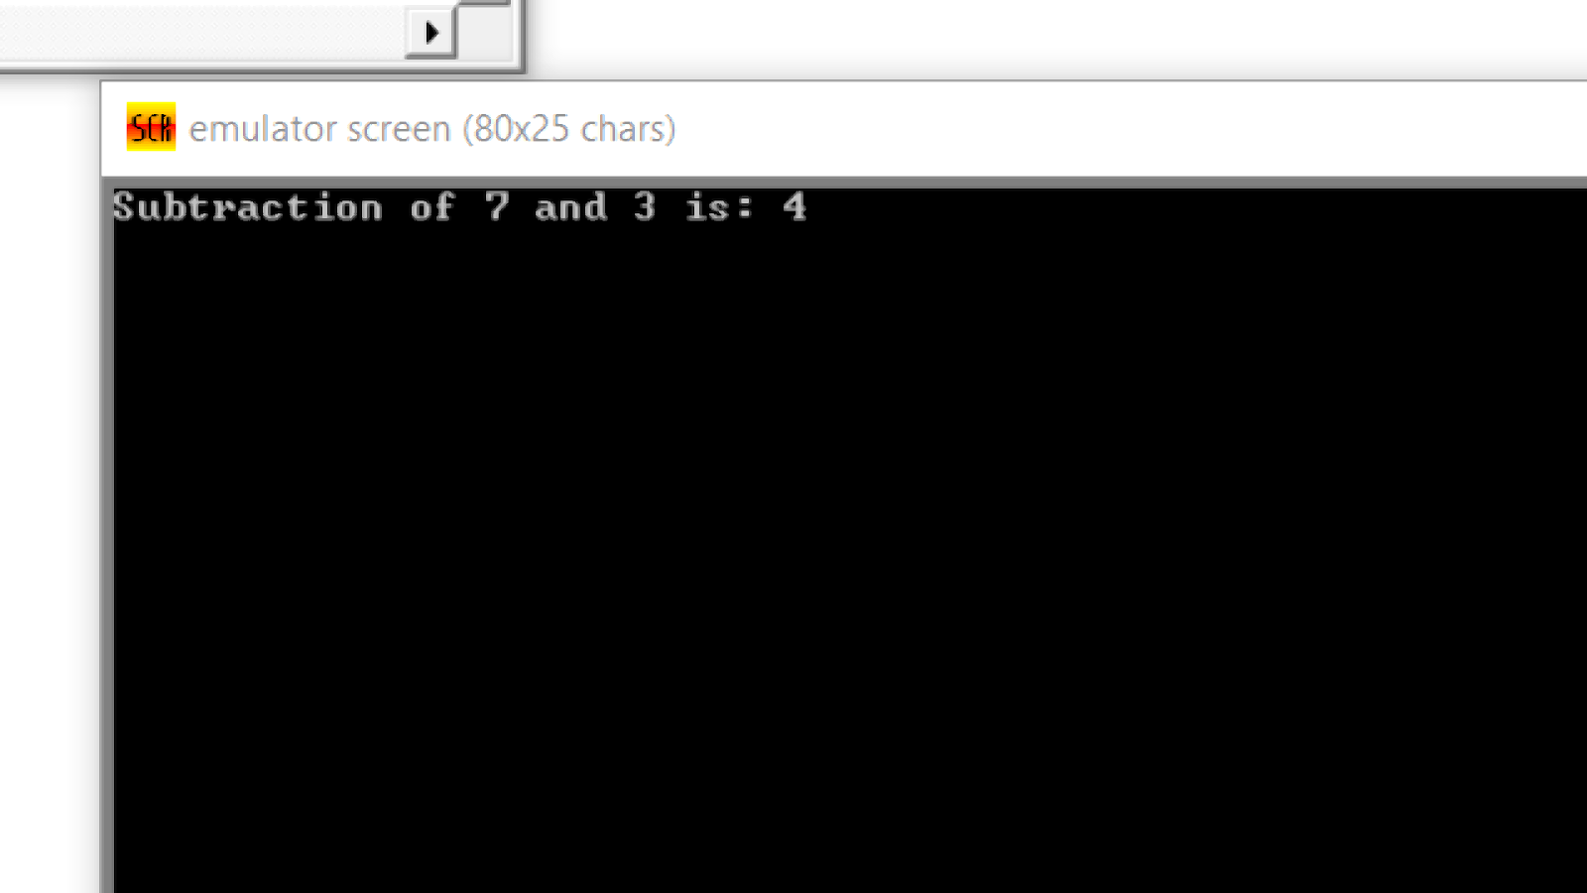

**2-digit number**

; You may customize this and other start-up templates;

; The location of this template is c:\emu8086\inc\0_com_template.txt

org 100h

; add your code here

.model small

.data

msg db , "Subtraction of 77 and 30 is : $"

.code

;remove special characters

mov ax,@data

mov ds,ax

; display procedure

LEA dx, msg

mov ah,09h

int 21h

;add digit by digit

;add first digits

mov dl,7

sub dl,3

add dl,48

mov ah,02h

int 21h

;add second digits

mov dl,7

sub dl,0

add dl,48

mov ah,02h

int 21h

; terminate procedure

mov ah,4ch

int 21h

ret

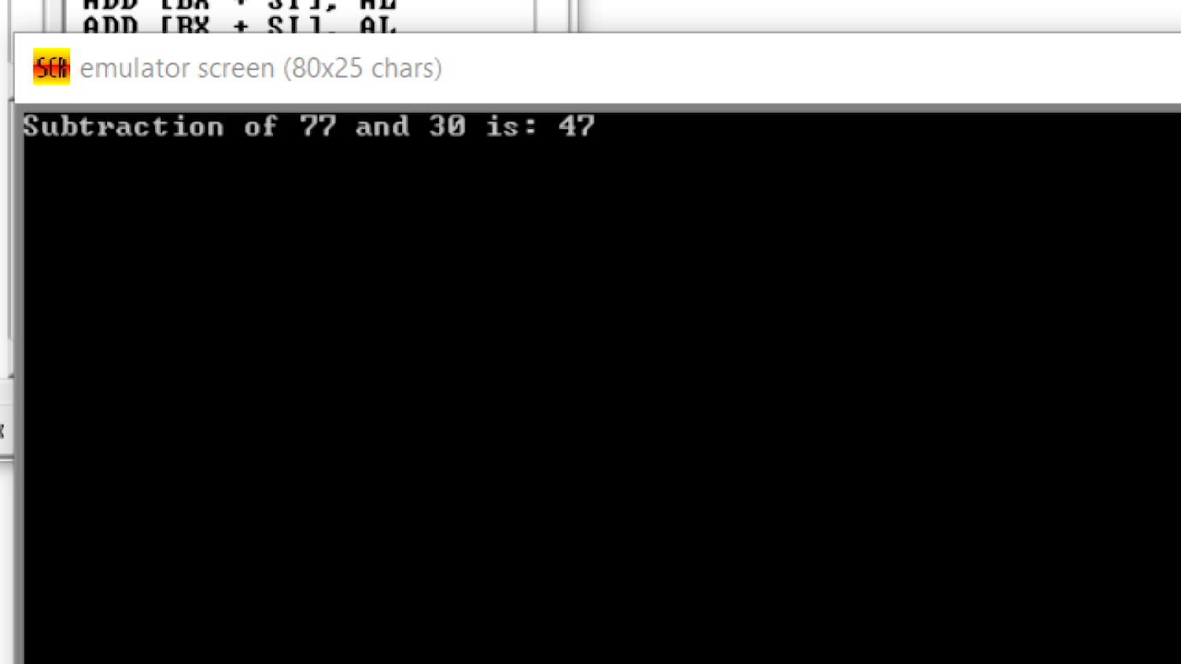

Q2. Subtraction of 1 -digit number and 2-digit number with user input

Ans:

; You may customize this and other start-up templates;

; The location of this template is c:\emu8086\inc\0_com_template.txt

org 100h

; add your code here

.model small

.data

msg db 10d,13d, "Enter 1st number : $"

msg1 db 10d,13d, "Enter 2nd number : $"

msg2 db 10d,13d, "Subtraction : $"

num1 db 02 dup(?)

num2 db 01 dup(?)

;ans db 08 dup(?)

.code

;remove special characters

mov ax,@data

mov ds,ax

;display

LEA dx, msg

mov ah,09h

int 21h

;read number 1

mov cl,02h

lea si,num1

readnum:

mov ah,01h

int 21h

mov [si],al

inc si

loop readnum

dec si

;display

LEA dx, msg1

mov ah,09h

int 21h

;read number 2

mov cl,01h

lea di,num2

readnum1:

mov ah,01h

int 21h

mov [di],al

inc di

loop readnum1

dec di

;display

LEA dx, msg2

mov ah,09h

int 21h

mov cl,02h

;sbb ;put the value 0 in carry flag

mov bh,[si]

mov bl,[di]

sbb bh,bl   ;bh=bh-bl-borrow , sbb=subtract by borrow bit

mov al,bh

mov ah,00h

aas

mov [si],al

dec si

mov bh,[si]

mov bl,0

sbb bh,bl

mov al,bh

mov ah,00h

aas

mov [si],al

mov cl,02h

jnc display ;if there is carry

; these three lines print 1 if carry

mov dl,31h

mov ah,02h

int 21h

display:

mov dl,[si]

add dl,48

mov ah,02h

int 21h

inc si

loop display

; terminate procedure

mov ah,4ch

int 21h

ret

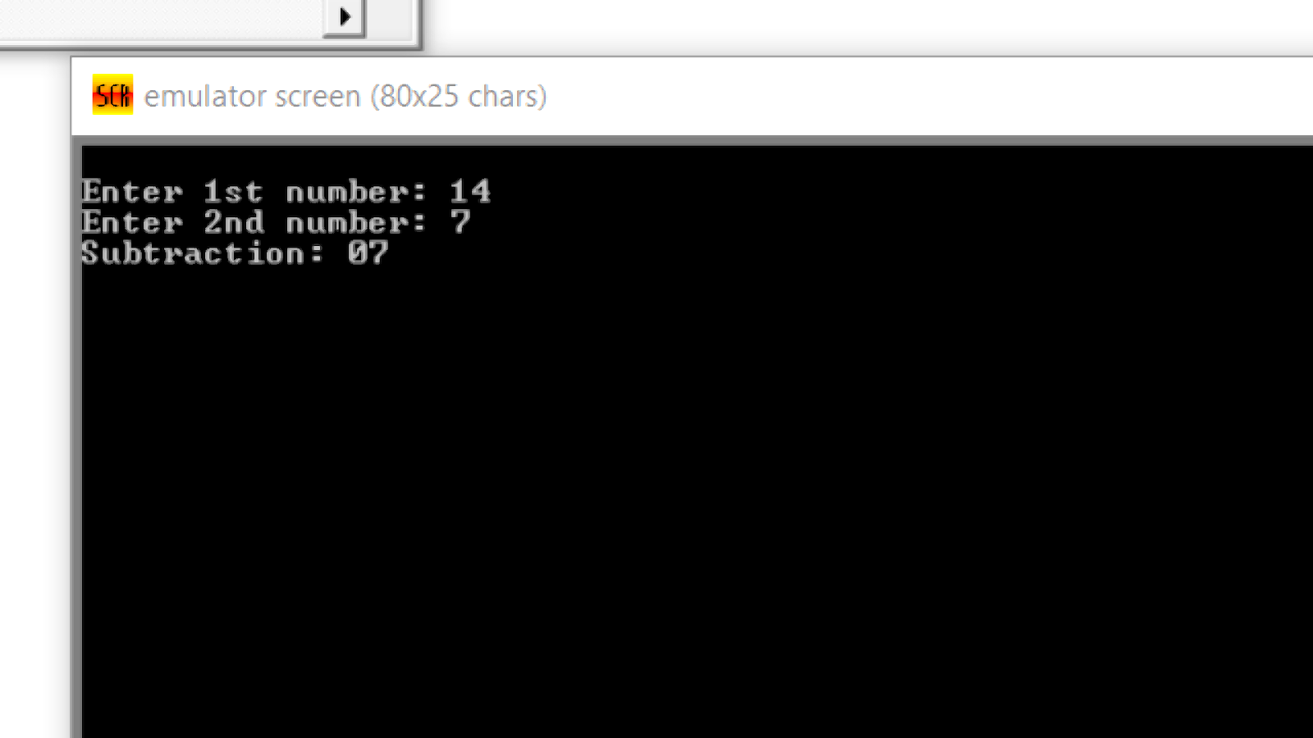

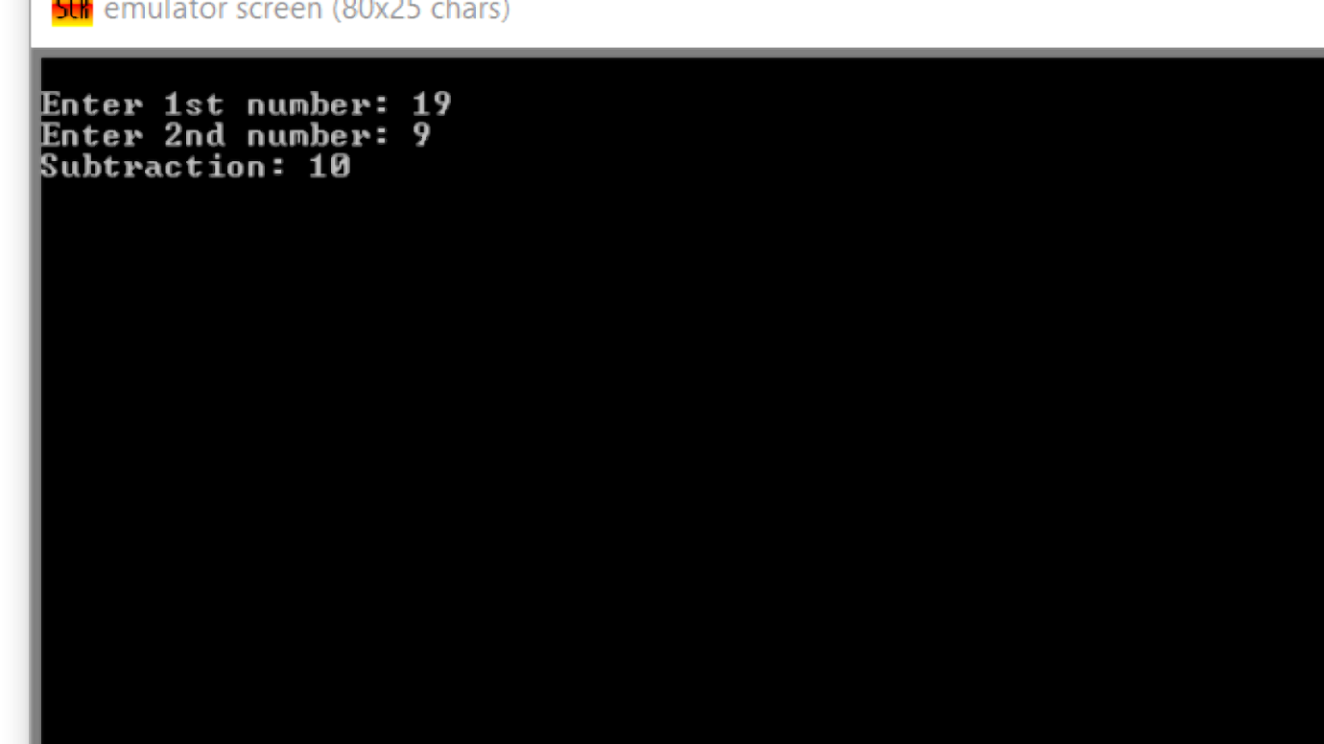

Q3. Subtraction of two 16-bit numbers with user input

Ans:

; You may customize this and other start-up templates;

; The location of this template is c:\emu8086\inc\0_com_template.txt

org 100h

; add your code here

.model small

.data

msg db 10d,13d, "Enter 1st number : $"

msg1 db 10d,13d, "Enter 2nd number : $"

msg2 db 10d,13d, "Subtraction : $"

num1 db 04 dup(?)

num2 db 04 dup(?)

;ans db 08 dup(?)

.code

;remove special characters

mov ax,@data

mov ds,ax

;display

LEA dx, msg

mov ah,09h

int 21h

;read number 1

mov cl,04h

lea si,num1

readnum:

mov ah,01h

int 21h

mov [si],al

inc si

loop readnum

dec si

;display

LEA dx, msg1

mov ah,09h

int 21h

;read number 2

mov cl,04h

lea di,num2

readnum1:

mov ah,01h

int 21h

mov [di],al

inc di

loop readnum1

dec di

;display

LEA dx, msg2

mov ah,09h

int 21h

;addition

mov cl,04h

;sbb ;put the value 0 in carry flag

sub1:

mov bh,[si]

mov bl,[di]

sbb bh,bl   ;bh=bh-bl-borrow , sbb=subtract by borrow bit

mov al,bh

mov ah,00h

aas

mov [si],al

dec si

dec di

loop sub1

mov cl,04h

jnc display ;if there is carry

; these three lines print 1 if carry

mov dl,31h

mov ah,02h

int 21h

display:

mov dl,[si+1]

add dl,48

mov ah,02h

int 21h

inc si

loop display

; terminate procedure

mov ah,4ch

int 21h

ret

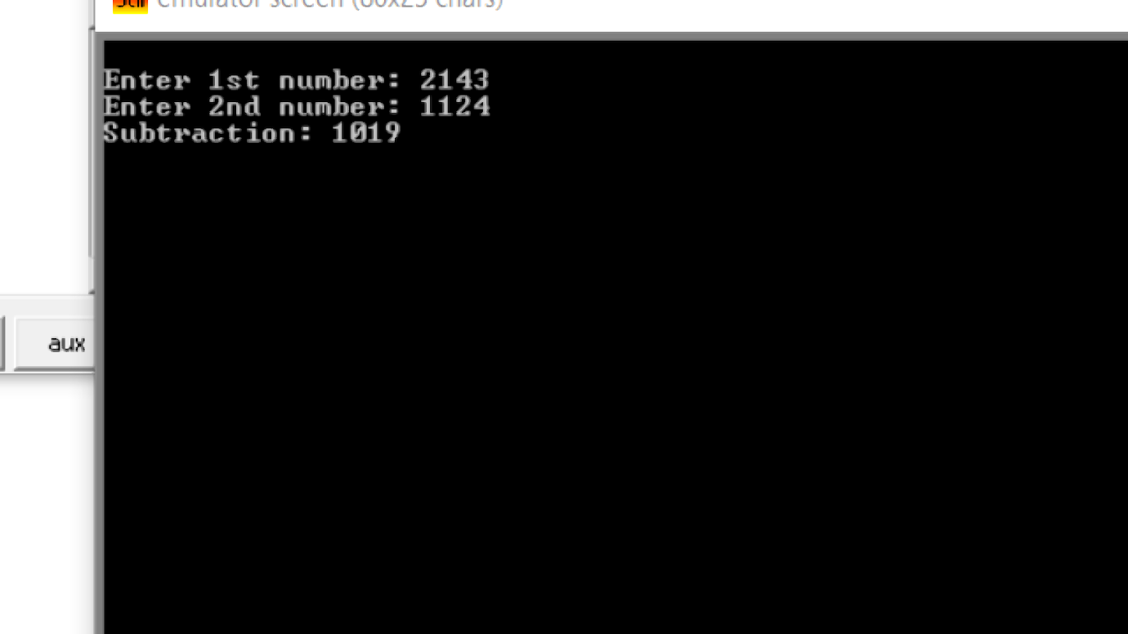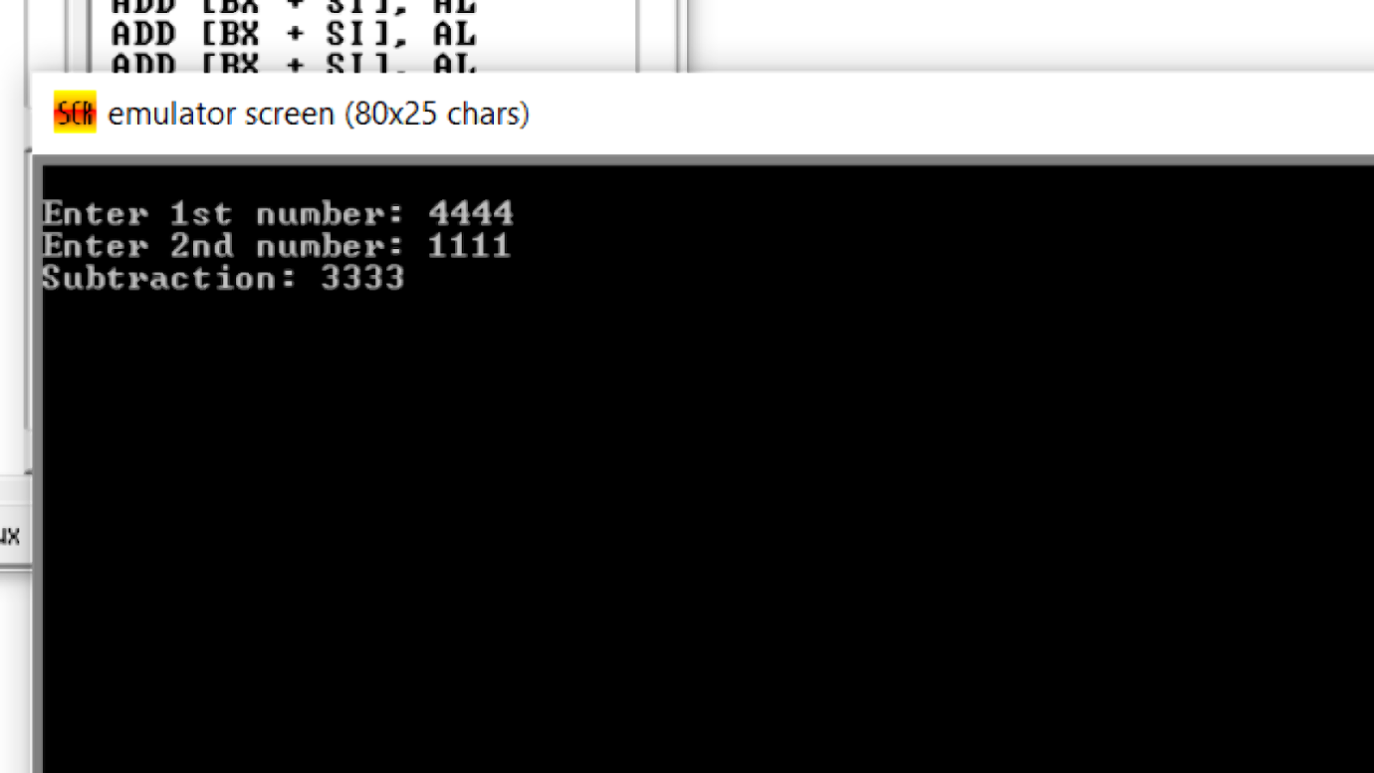

**Thank You**

Question : Write ALP to swap two memory locations data

Ans :

.model small

.data

var1 db 9

var2 db 5

msg db 10d,13d, "Variable 1 : $"

msg1 db 10d,13d, "Variable 2 : $"

msg2 db 10d,13d, "Before Swapping : $"

msg3 db 10d,13d, "After Swapping : $"

.code

;remove special characters

mov ax,@data

mov ds,ax

; display procedure

LEA dx, msg2

mov ah,09h

int 21h

LEA dx, msg

mov ah,09h

int 21h

mov dl,var1

add dl,48

    mov ah,02h

    int 21h

mov dl,0ah   ;next line

    int 21h

LEA dx, msg1

mov ah,09h

int 21h

mov dl,var2

add dl,48

    mov ah,02h

    int 21h

mov dl,0ah   ;next line

    int 21h

; display procedure

LEA dx, msg3

mov ah,09h

int 21h

mov dl,var1

   add dl,48

mov cl,dl

mov dl,var2

mov var2,cl

   add dl,48

mov var1,dl

LEA dx, msg

mov ah,09h

int 21h

mov dl,var1

    mov ah,02h

    int 21h

mov dl,0ah   ;next line

    int 21h

LEA dx, msg1

mov ah,09h

int 21h

mov dl,var2

    mov ah,02h

    int 21h

mov dl,0ah   ;next line

    int 21h

; terminate procedure

   mov ah,4ch

   int 21h

end

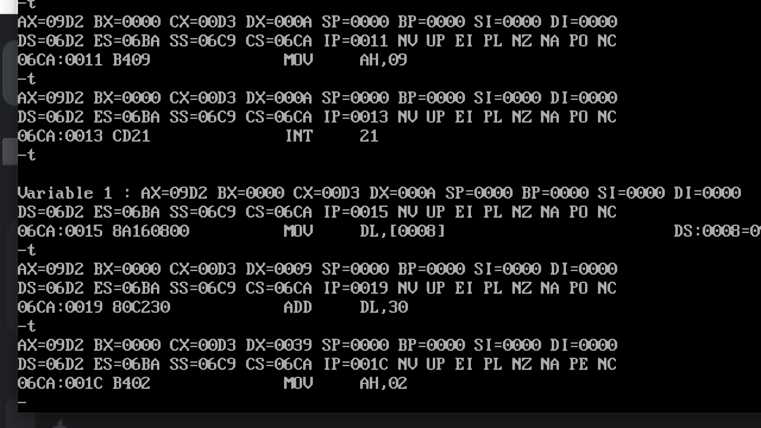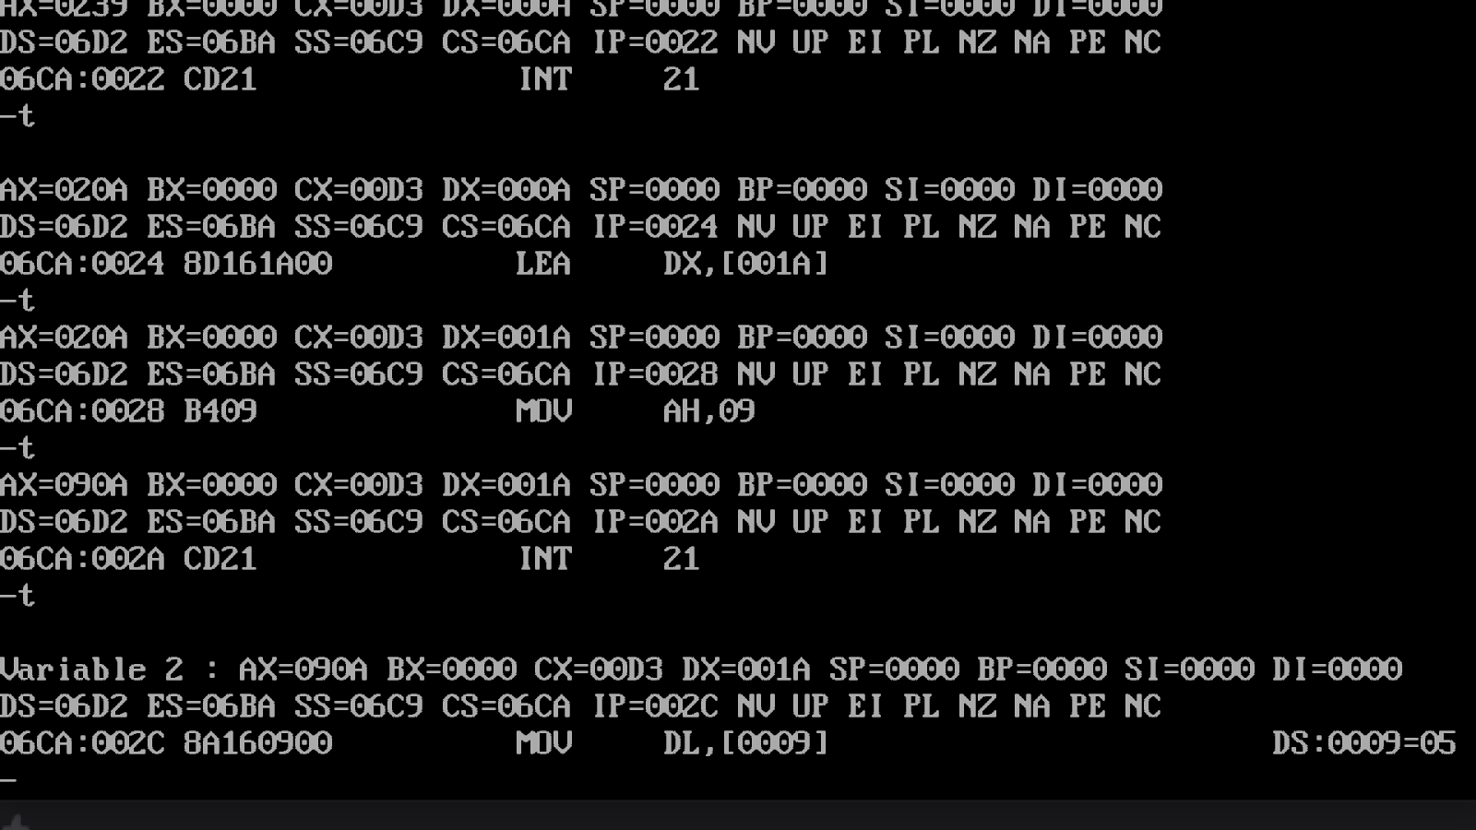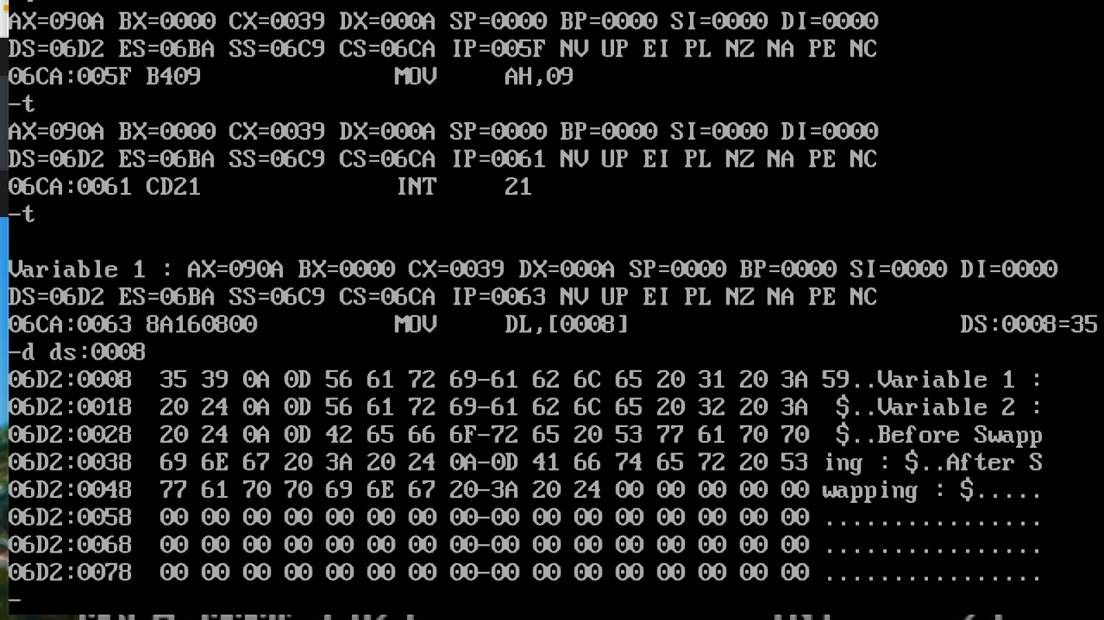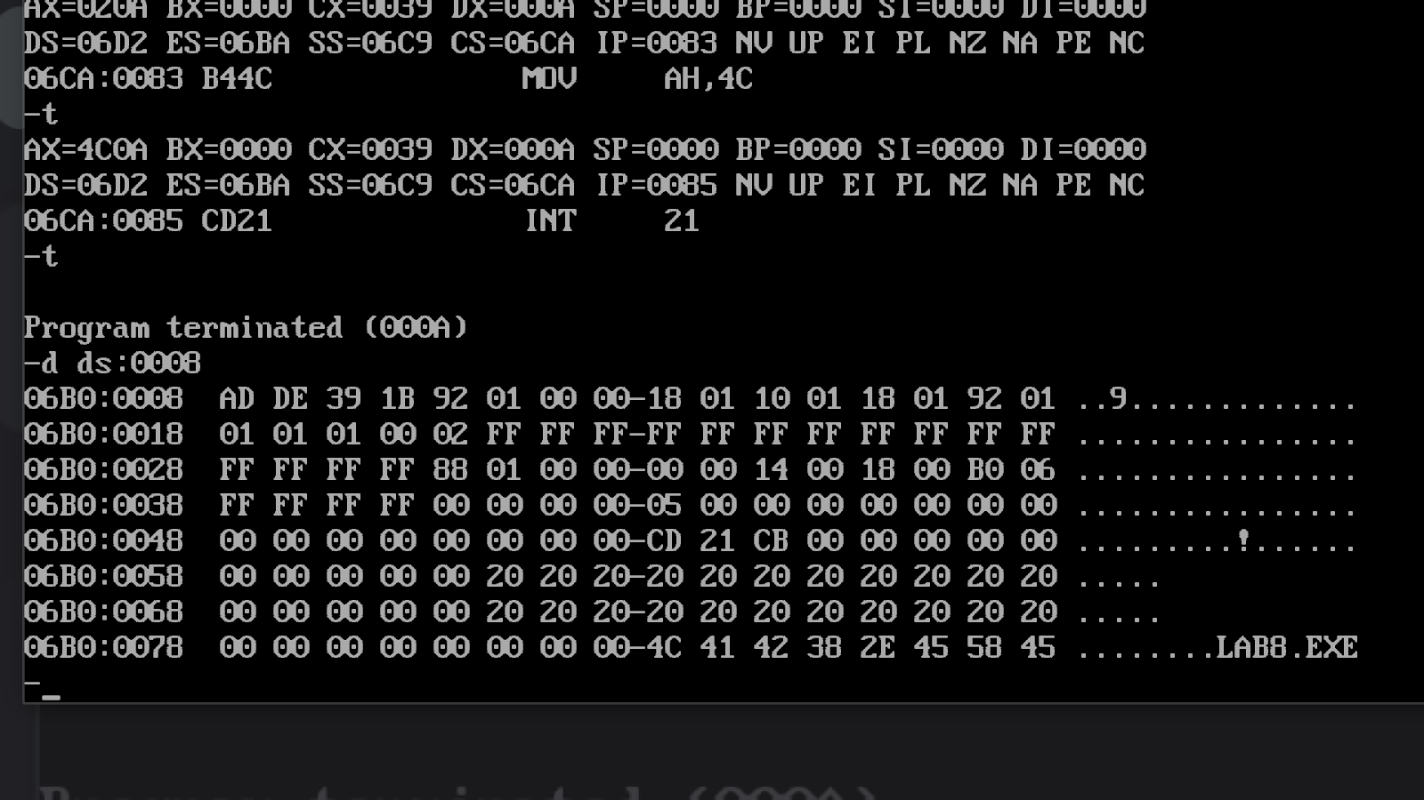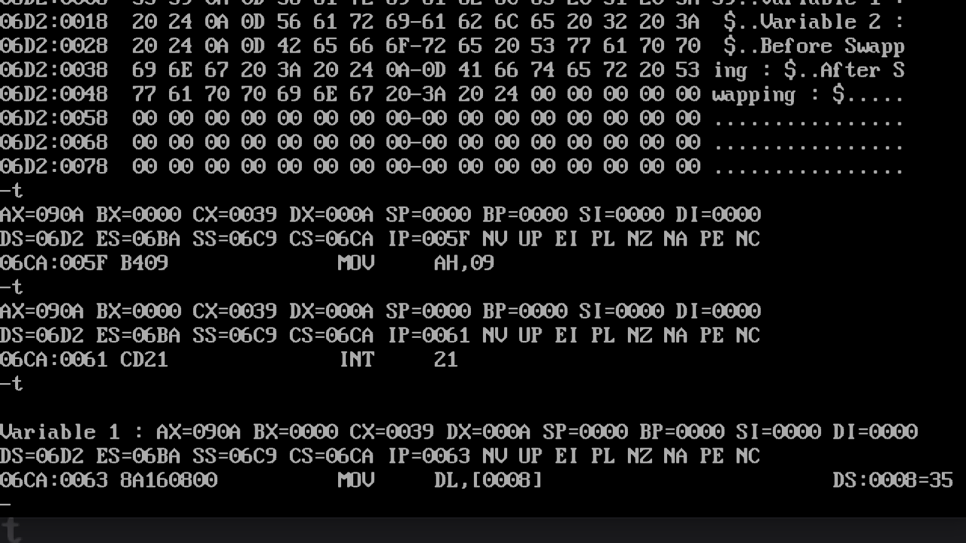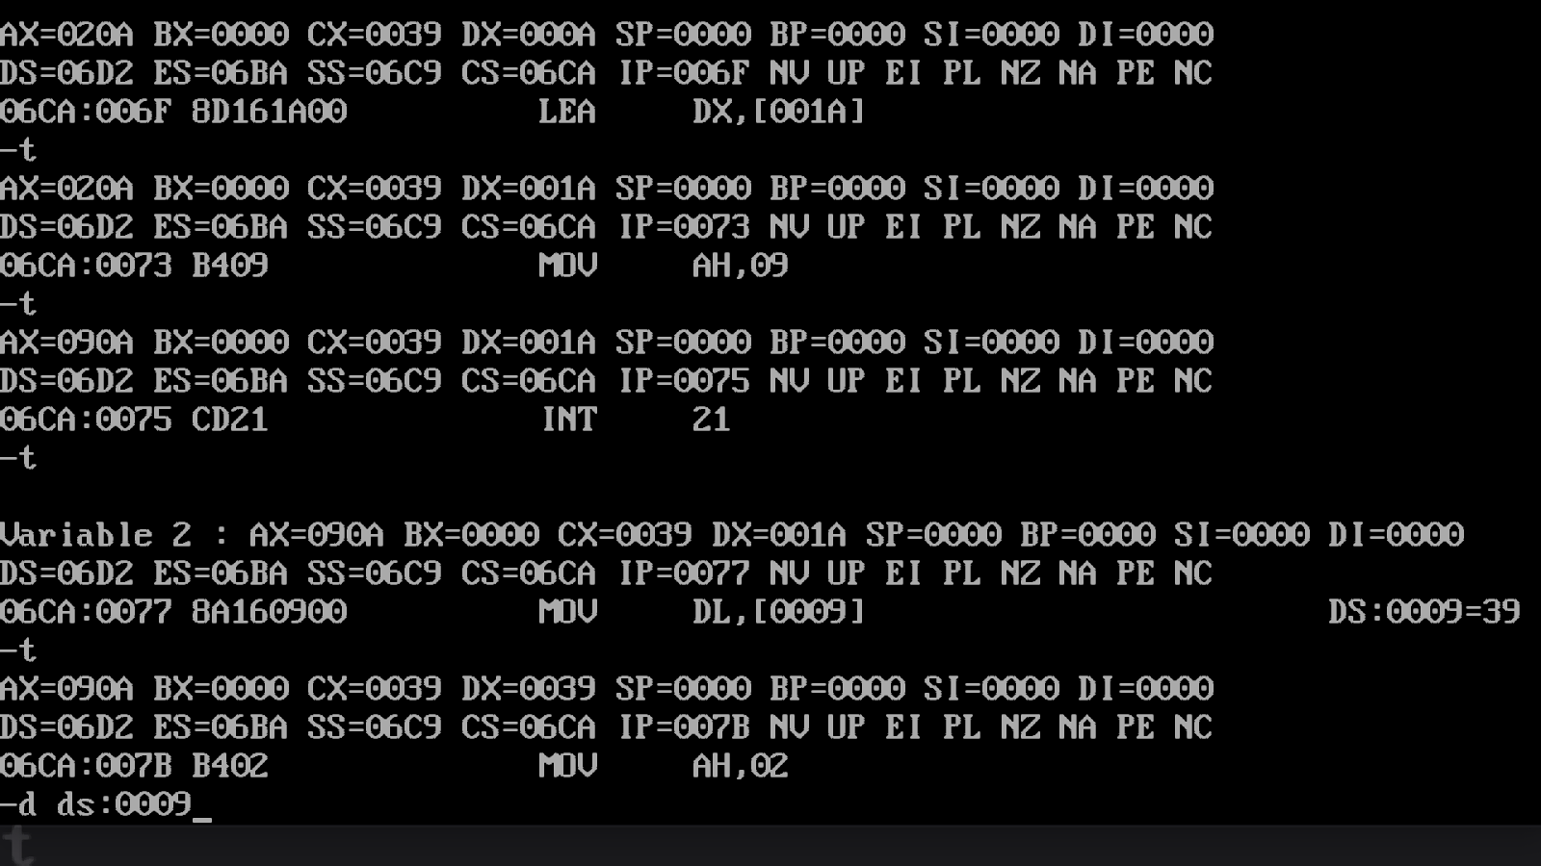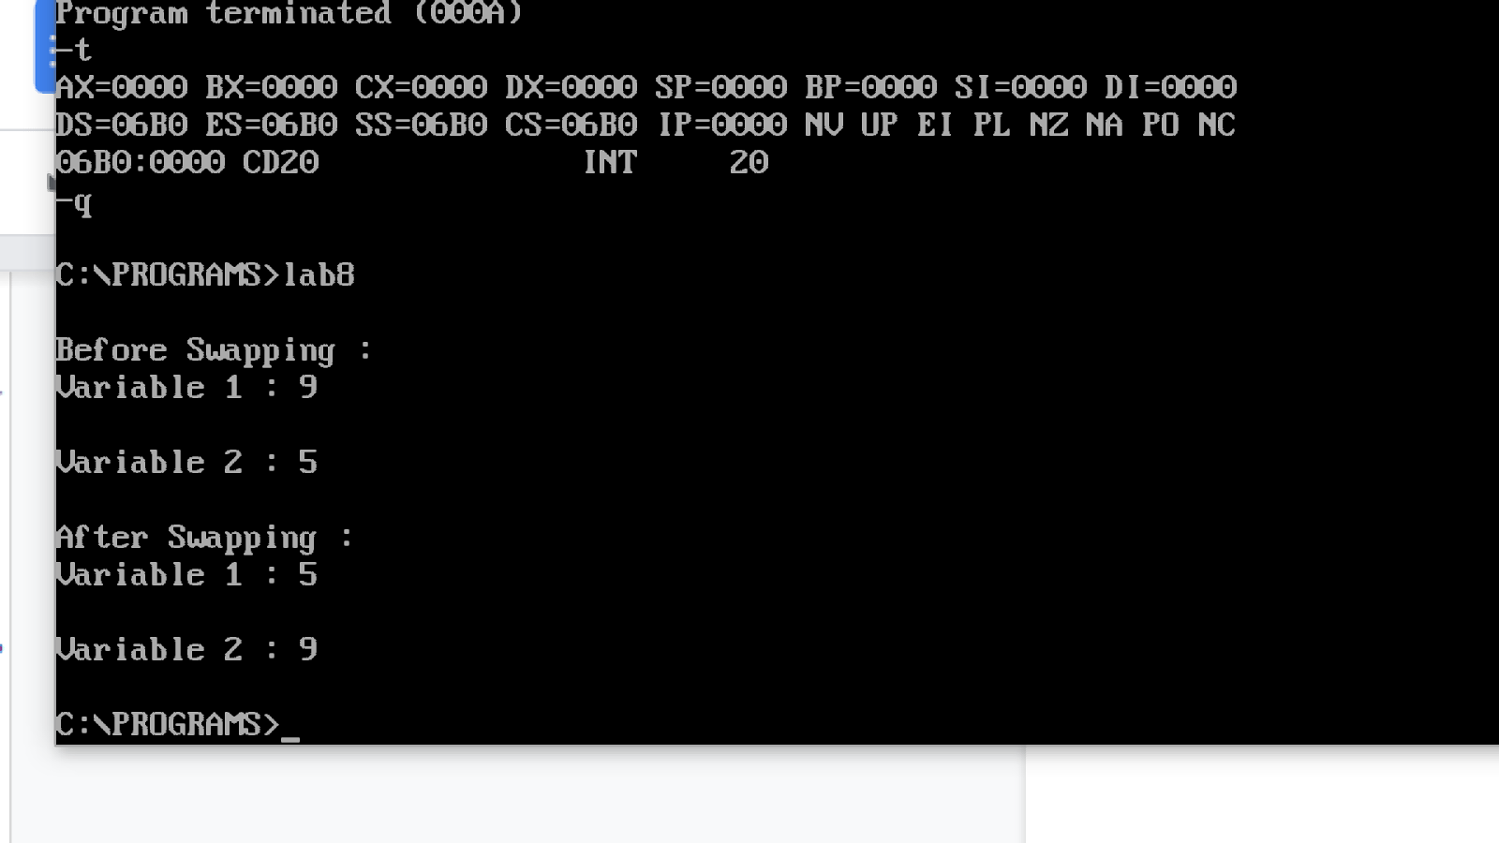

Thank You

Q. Multiplication of two 16-bit numbers

Ans:

.model small

.data

msg db 10d,13d, "Multiplication of is $"

.code

;remove special characters

mov ax,@data

mov ds,ax

; display procedure

LEA dx, msg

mov ah,09h

int 21h

mov ax,2245h

mov bx,4445h

mul bx

;mov dx,ax

;add dx,48

;mov ah,02h

    ;int 21h

; terminate procedure

   mov ah,4ch

   int 21h

end

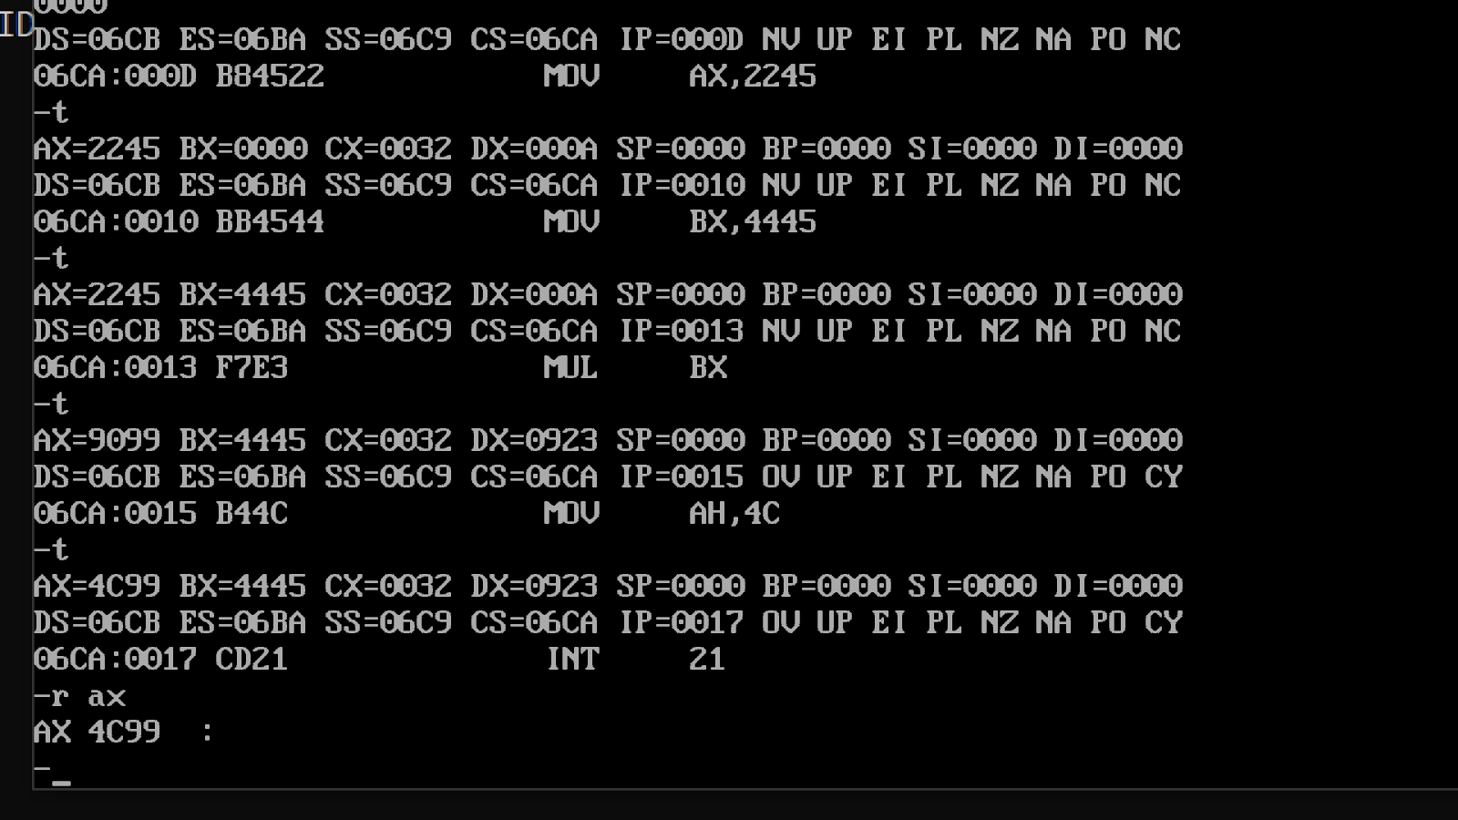

                                          Thank You

Q1- Write a Program to perform memory to register addition

Ans-

.model small

.data

.code

mov ax,@data

mov ds,ax

mov DI,1200H

mov Al,0

add al,[di]

add al,[di+1]

mov ah,4ch

int 21h

end

Output:

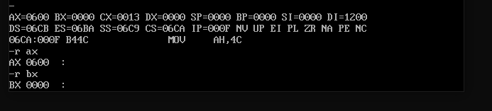

Q2- Write a Program to perform array addition [array must be of atleast 5 elements]

Ans-

.model small

.data

ARRAY dB 10, 20, 30, 40, 50, 60, 70, 80

.code

mov ax,@data

mov ds,ax

mov AL,0

mov SI,3

add al,ARRAY[SI]

add al,ARRAY[SI+2]

add al,ARRAY[SI+4]

add al,ARRAY[SI+6]

add al,ARRAY[SI+8]

mov ah,4ch

int 21h

end

Output:

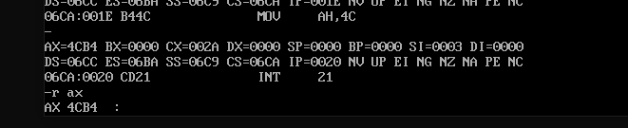

Q3- Write a Program to perform INC and DEC command for 16-bit register

Ans-

.model small

.data

A DW 1000H

var2 db 10d,13d,"increment od 1000 and decrement of1000 is $ "

.code

mov ax,@data

mov ds,ax

LEA dx, var2

mov ah,09h

int 21h

mov ax,1000H

inc ax

mov DI,1000H

dec A[DI]

mov ah,4ch

int 21h

End

Output:

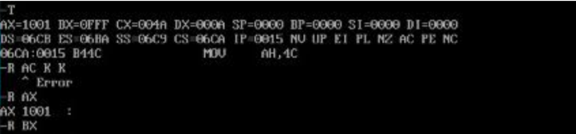

Q1- Write a Program to perform division of two 16 bits numbers

Ans-

.model small

.data

num1 dw 0100h

num2 dw 0020h

.code

mov ax,@data

mov ds,ax

mov ax,num1

mov bx,num2

div bx

mov ah,4ch

int 21h

End

Output:

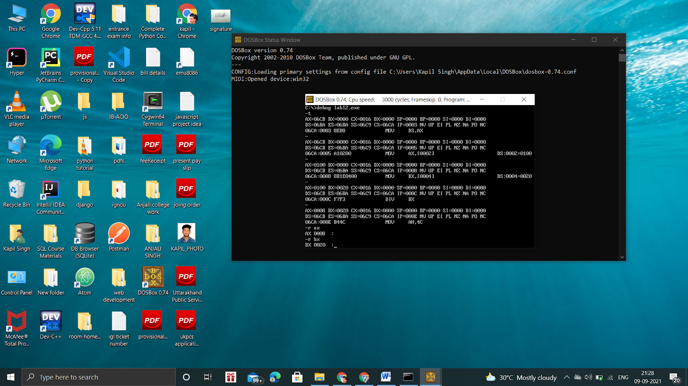

Q1 : Write a program for Compare 3 integer values.

Ans:

.model small

.data

msg db 10d,13d,"Largest number : $"

.code

        mov ax,@data

        mov ds,ax

mov al,5

mov bl,9

mov cl,2

.IF al>bl && al>cl

LEA dx,msg

mov ah,09h

int 21h

add al,48

mov dl,al

mov ah,02h

         int 21h

.ELSEIF bl>al && bl>cl

LEA dx,msg

mov ah,09h

int 21h

add bl,48

mov dl,bl

mov ah,02h

         int 21h

.ELSE

LEA dx,msg

mov ah,09h

int 21h

add cl,48

mov dl,cl

mov ah,02h

         int 21h

.ENDIF

MOV ah,4ch

INT 21h

end

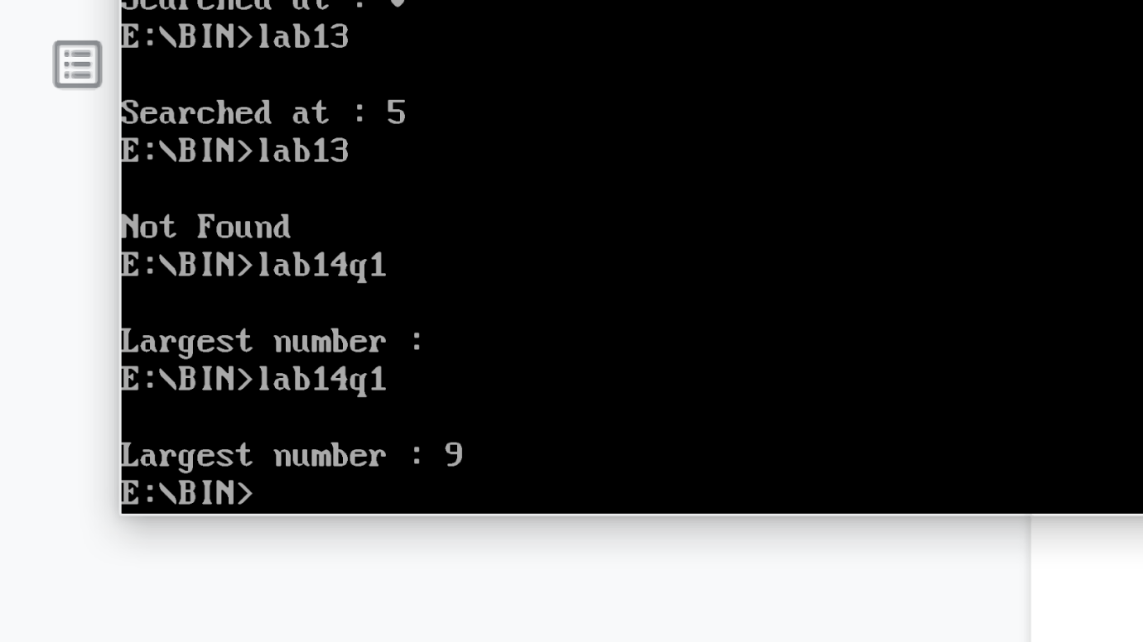

Q2 :  Write a program for Linear Search

Ans:

.model small

.data

        ARRAY dB 1h,2h,3h,4h,5h,6h,7h,8h

msg db 10d,13d,"Searched at : $"

msg1 db 10d,13d,"Not Found $"

.code

         mov ax,@data

         mov ds,ax

mov dl,9

mov cx,8

mov al,1

mov si,offset ARRAY

readnum:

cmp dl,[si]

je rd1

inc si

inc al

dec cx

jz nf

jnz readnum

rd1:

LEA dx,msg

mov ah,09h

int 21h

add al,48

mov dl,al

mov ah,02h

         int 21h

jmp termi

nf:

LEA dx,msg1

mov ah,09h

int 21h

jmp termi

termi :

MOV ah,4ch

INT 21h

end



Thank You

Q: Write a program to perform binary search.

Ans:

.model small

.data

arr dw 1010h, 1111h, 2222h, 3330h,4424h, 5556h, 6669h,7777h, 8888h,

9989h

len dw ($-arr)/2

key equ 1234h ; key to be searched

mssg db "Search element: 1234$"

msg1 db 10d,13d,"Element is found at "

res db " position ", 10, 13, "$"

msg2 db 10d,13d,"Element not found$"

.code

mov ax, @data

mov ds, ax

lea dx,mssg

mov ah,09h

int 21h

mov bx, 00 ;lower bound

mov dx, len ;upper bound

mov cx, key ;key to be searched

again:

cmp bx, dx

ja fail ;if bx is greater than dx

mov ax, bx

add ax, dx

shr ax, 1 ;divide by 2

mov si, ax

add si, si

cmp cx, arr[si]

jae big ;above and equal

dec ax ;move to first half of array

mov dx, ax

jmp again

big:

je success

inc ax ;move to second part of array

mov bx, ax

jmp again

success:

add al, 01

add al,48

lea si, res

mov [si], al

lea dx, msg1

jmp disp

fail:

lea dx, msg2

disp:

mov ah, 09h

int 21h

mov ah, 4ch

int 21h

end

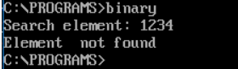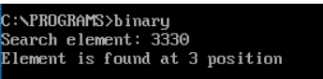

Aditi Varshney

CSC/19/89

Lab 21

.model small

.data

msg1 db 10d,13d, "Enter ASCII Value : $" msg2 db 10d,13d, "Binary Value : $" var db 02h

.code

;remove special characters

mov ax,@data

mov ds,ax

; display procedure

LEA dx, msg1

mov ah,09h

int 21h

mov bl,0

mov ah,01h

int 21h

mov bl,al

; display procedure LEA dx, msg2

mov ah,09h

int 21h

mov cl,08h

binary:

mov ah,02h

shl bl,1

jc printone

mov dl,48

jmp print

printone:

mov dl,49

print:

int 21h

loop binary

; terminate procedure mov ah,4ch

int 21h

end

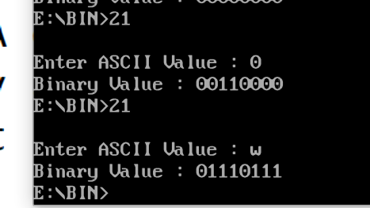Thank You