**Question 1(a)- Same program-Different code (Parent-Child)**

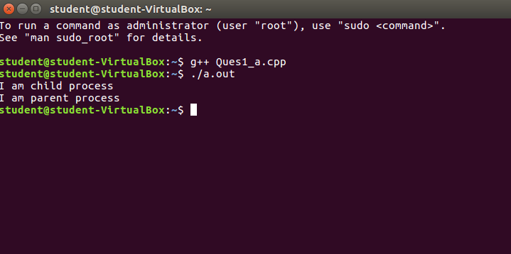

#include<iostream>

#include<unistd.h>

using namespace std;

//same program, different code for parent & child, running as concurrent processes

int main()

{

int pid=fork();

if(pid<0)

{

cout<<"\nUnsuccessful\n";

return -1;

}

else if(pid==0)

{

cout<<"I am child process \n";

}

else

{

sleep(10);

cout<<"I am parent process \n";

}

return 0;

}

**Question 1(b**)- **Same program-Different code,but parent waits for child (Parent-Child)**

//PARENT WAITS FOR CHILD BEFORE FINISHING ITS TASK

//same program, different code for parent & child but parent waits for child to finish

#include<iostream>

#include<sys/types.h>

#include<sys/wait.h>

#include<unistd.h>

#include<stdio.h>

using namespace std;

int main()

{

int status;

int pid= fork();

int x;

if(pid<0)

{

cout<<"\nChild process can not be created \n";

return -1;

}

else if(pid==0)

{

cout<<"\nI am child : "<<pid<<"\n";

cout<<"\nI am child. Child process id: "<<getpid()<<"\n";

execlp("/bin/ls", "ls", NULL);

}

else

{

x=wait(&status);

cout<<"\nChild complete \n";

cout<<"\nI am parent. Parent process id: "<<getpid()<<"\n";

cout<<"\nInfo returned by wait(&status): "<<x<<" which is = child processid\n";

}

return 0;

}

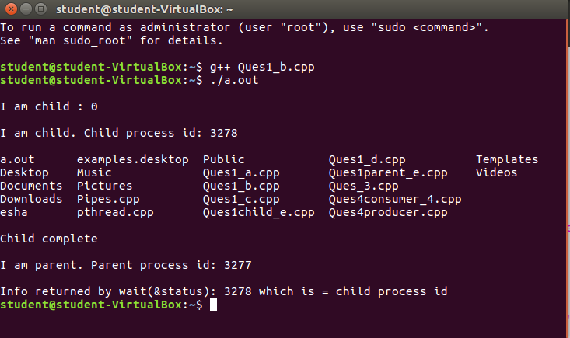

**Question 1(c)- Same program-Same code(Parent-Child)**

//SAME PROGRAM, SAME CODE, concurrent processes

#include<iostream>

#include<unistd.h>

#include<sys/types.h>

#include<sys/wait.h>

using namespace std;

int main()

{

int code=fork();

int status;

if(code<0)

{

cout<<"\nUnsuccessful \n";

}

else // run same code for child and parent process

{

cout <<"pid = " << getpid() << " return code: "<< code<<"\n";

}

return 0;

}

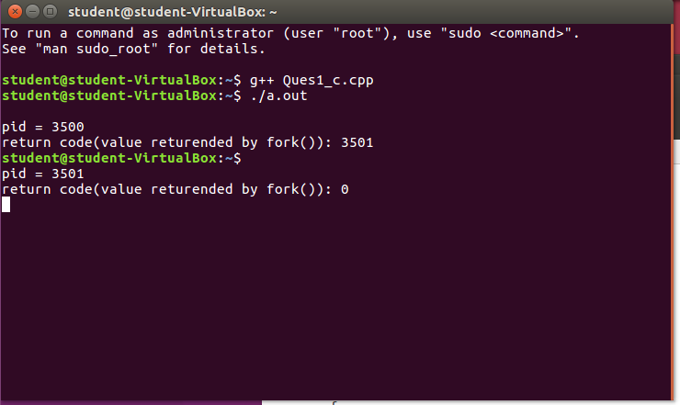

**Question 1(d)- Same program – Same code, but parent waits for child (Parent-Child)**

//SAME PROGRAM, SAME CODE, parent process waits for child to finish :-

#include<iostream>

#include<unistd.h>

#include<sys/types.h>

#include<sys/wait.h>

using namespace std;

int main()

{

int code=fork();

int status;

if(code<0)

{

cout<<"\nUnsuccessful \n";

}

else // run same code for child and parent process

{

wait(NULL);

cout <<"pid = " << getpid() << " return code: "<< code<<"\n";

}

return 0;

}

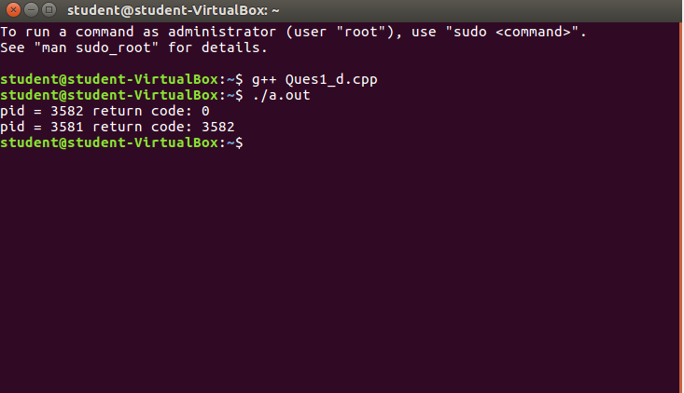

**Question 1(e)- Diffrent program-Diffreant code(Parent-Child)**

//Different programs

// parent.cpp: the parent program

/*

To compile & execute the parent-child programs, steps are:

step 1) g++ child.cpp -o child

step 2) g++ parent.cpp

step 3) ./a.out

*/

#include <iostream>

#include <stdlib.h>

#include <string.h>

#include <sys/wait.h>

#include <sys/types.h>

#include <unistd.h>

using namespace std;

int main (int argc, char **argv)

{

int i = 0;

long sum;

int pid;

int status, ret;

cout<<"Parent: Hello, World!\n";

pid = fork ();

if (pid == 0) {

// I am the child: loading a different program in the child process

execvp ("./child", argv);

}

// I am the parent

cout<<"Parent: Waiting for Child to complete.\n";

if ((ret = waitpid (pid, &status, 0)) == -1)

cout<<"parent:error\n";

if (ret == pid)

cout<<"Parent: Child process waited for.\n";

}

// child.cpp: the child program

#include <iostream>

#include <stdlib.h>

#include <string.h>

#define A 500

#define B 600

#define C 700

using namespace std;

int main (int argc, char **argv)

{

int i, j;

long sum;

// Some arbitrary work done by the child

cout<<"Child: Hello, World!\n";

for (j = 0; j < 30; j++ ) {

for (i =0; i < 900000; i++) {

sum = A * i + B * i * i + C;

sum %= 543;

}

}

cout<<"Child: Work completed!\n";

cout<<"Child: Bye now.\n";

exit (0);

}

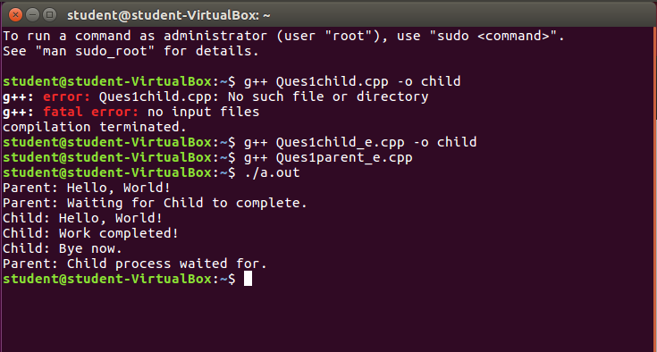

**Question 2 – Pipes**

/*

WAP to demonstrate Inter-Process Communication (IPC) between parent

and child using pipe system call

*/

#include<iostream>

#include<unistd.h>

#include<string.h>

#include<sys/types.h>

#define BUFFERSIZE 25

#define READEND 0

#define WRITEEND 1

using namespace std;

int main(void)

{

char writemsg[BUFFERSIZE] = "Greetings";

char readmsg[BUFFERSIZE];

int fd[2];

pid_t pid;

if (pipe(fd) == -1) /* create the pipe */

{

cout<<"Pipe failed!";

return 1;

}

pid = fork();/* fork a child process */

if (pid < 0)

{

cout<<"Fork Failed!"; /* error occurred */

return 1;

}

if (pid > 0) /* parent process */

{

close(fd[READEND]); /* close the unused end of the pipe */

write(fd[WRITEEND], writemsg, strlen(writemsg)+1); /* write to the pipe */

close(fd[WRITEEND]); /* close the write end of the pipe */

}

else /* child process */

{

close(fd[WRITEEND]); /* close the unused end of the pipe */

read(fd[READEND], readmsg, BUFFERSIZE); /* read from the pipe */

cout<<"read: "<<readmsg;

close(fd[READEND]); /* close the write end of the pipe */

}

return 0;

}

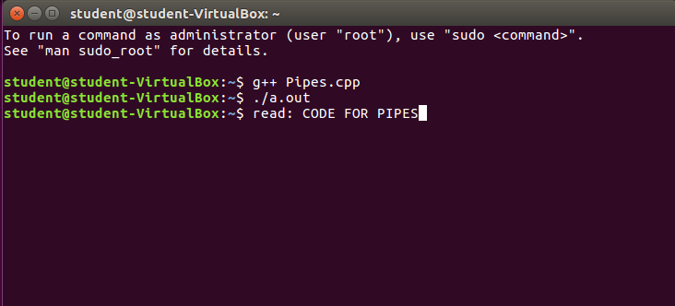

**Question 3** – **Kernel**

/*

WAP to display the following:

a. Kernel version

b. CPU type and model

c. Information on configured memory, amount of free and used memory

*/

#include<iostream>

#include<stdlib.h>

#include<stdio.h>

using namespace std;

int main()

{

cout<<"\nKernel version is:\n";

system("cat /proc/sys/kernel/osrelease");

cout<<"\nCPU space: \n";

system("cat /proc/cpuinfo |awk 'NR==3,NR==4{print}' \n");

cout<<"\n Configured memory is :\n";

system("cat /proc/meminfo |awk 'NR==1{print $2}'\n");

cout<<"\n Amount of free memory is :\n";

system("cat /proc/meminfo |awk 'NR==2{print $2}'\n");

cout<<"\n Amount of used memory is :\n";

system("cat /proc/meminfo |awk '{if (NR==1) a=$2; if (NR==2) b=$2 } END {print a-b}'\n");

return 0;

}

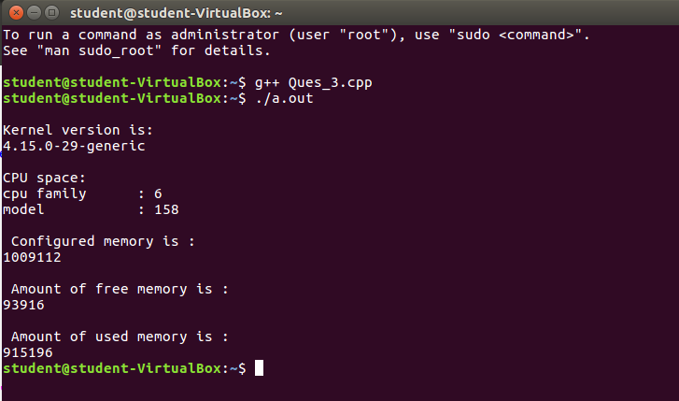

**Question 4** –**Consumer-Producer**

//WAP to demonstrate producer-consumer problem using shared memory.

//C++ program for Consumer process illustrating POSIX shared-memory API.

#include<iostream>

#include<stdlib.h> // used for shm_open

#include<string.h>

#include<fcntl.h>

#include<sys/shm.h>

#include<sys/stat.h>

#include<sys/mman.h>

#include<sys/unistd.h>

#include<sys/types.h>

#include<stdio.h>

using namespace std;

//To run, use:

// g++ consumer.cpp -lrt

int main()

{

const int SIZE =4096;

const char *name ="/my_eg";

int shm_fd; /* shared memory file descriptor */

void* ptr; /* pointer to shared memory object */

shm_fd = shm_open(name, O_RDONLY, 0666); /* open the shared memory object */

if(shm_fd<0)

{ cout<<"\nERROR\n"; }

else

{

/* memory map the shared memory object */

ptr = mmap(0, SIZE, PROT_READ, MAP_SHARED, shm_fd, 0);

/* read from the shared memory object */

cout<<(char*)ptr;

/* remove the shared memory object */

shm_unlink(name);

}

return 0;

}

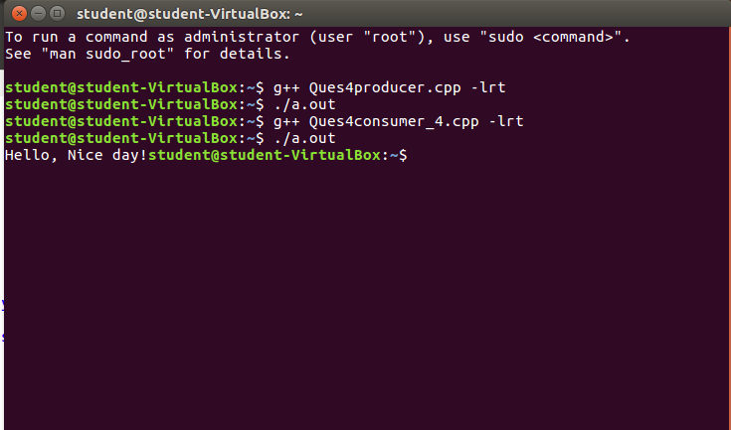

**Question 5** – **pthread**

//Write program to understand working of Pthread library.

/* To compile & run the program, do following:

step 1) g++ -pthread Ques5_pthread.cpp

step 2) ./a.out 5

*/

#include<pthread.h>

#include<stdio.h>

#include<stdlib.h>

#include<iostream>

using namespace std;

int sum;

void* runner(void* param);

int main(int argc,char *argv[])

{

pthread_t tid;

pthread_attr_t attr;

if(argc!=2)

{

cout<<"\nUsage :a.out<integer value>\n";

return -1;

}

if(atoi(argv[1])<0)

{

cout<<"\n%d must be >=0\n"<<atoi((const char*)(argv[1]));

return -1;

}

//get the default attributes

pthread_attr_init(&attr);

//create the thread:

pthread_create(&tid,&attr,runner,argv[1]);

//parent waits for the child thread to finish

pthread_join(tid,NULL);

//output the value of shared data "sum"

cout<<"\nSUM is: "<<sum<<endl;

return 0;

}

//child thread will begin execution here:

void* runner(void* param)

{

int i,upper=atoi((const char*)param);

sum=0;

for(i=1;i<=upper;i++)

sum+=i;

pthread_exit(0);

}

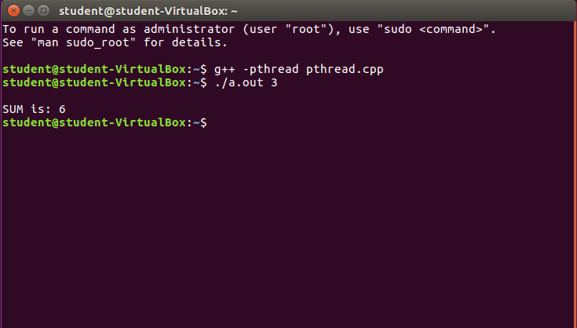

**Question 6** – **File Details**

**/\***

**WAP to print file details including owner access permissions, file**

**access time, where file name is given as a command line argument.**

**\*/**

**#include<iostream>**

**#include<stdlib.h>**

**#include<stdio.h>**

**#include<unistd.h>**

**#include <sys/stat.h>**

**#include <sys/types.h>**

**using namespace std;**

**/\***

**Steps to compile and run the program are:**

**step 1) g++ Ques6.cpp**

**step 2) ./a.out <name of any file>**

**For eg:- ./a.out producer.cpp**

**\*/**

**int main(int argc, char** argv)**

**{**

**if(argc !=2)**

**{**

**cout<<"\nEnter file name!\n";**

**return 1;**

**}**

**struct stat fileStat;**

**if(stat(argv[1],&fileStat) < 0)**

**return 1;**

**cout<<"\nFile details for "<< argv[1]<<" are :\n";**

**cout<<"File Size: "<<fileStat.st_size<<" bytes\n";**

**printf(" time of last access: %ld : %s", fileStat.st_atime, ctime(&fileStat.st_atime));**

**printf(" time of last modification: %ld : %s", fileStat.st_mtime, ctime(&fileStat.st_mtime));**

**printf(" time of last change: %ld : %s", fileStat.st_ctime, ctime(&fileStat.st_ctime));**

**//system("ls -l "argv[1]);**

**cout<<"File Permissions: \t";**

**printf( (S_ISDIR(fileStat.st_mode)) ? "d" : "-");**

**printf( (fileStat.st_mode & S_IRUSR) ? "r" : "-");**

**printf( (fileStat.st_mode & S_IWUSR) ? "w" : "-");**

**printf( (fileStat.st_mode & S_IXUSR) ? "x" : "-");**

**printf( (fileStat.st_mode & S_IRGRP) ? "r" : "-");**

**printf( (fileStat.st_mode & S_IWGRP) ? "w" : "-");**

**printf( (fileStat.st_mode & S_IXGRP) ? "x" : "-");**

**printf( (fileStat.st_mode & S_IROTH) ? "r" : "-");**

**printf( (fileStat.st_mode & S_IWOTH) ? "w" : "-");**

**printf( (fileStat.st_mode & S_IXOTH) ? "x" : "-");**

**cout<<endl;**

**return 0;**

**}**

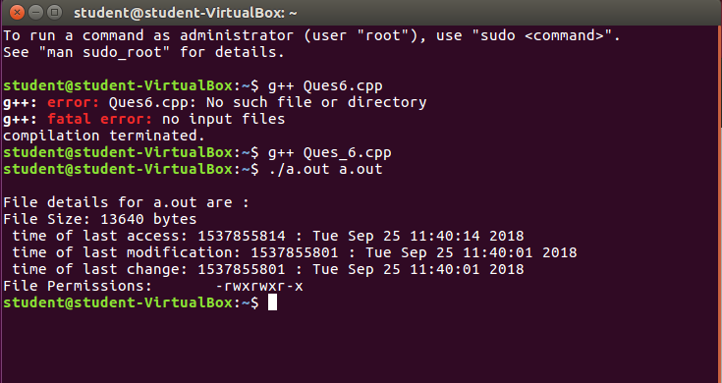

**Question 7** – **Storing our content in file**

/*

WAP to copy a source file into the target file and display the

target file using system calls.

Steps to compile and execute the program:

step 1) g++ Ques_7.cpp -o cpcmd

step 2) ./cpcmd src.txt dest.txt

Error opening file src.txt errno = 2

step 3) touch src.txt

step 4) echo "This program is a simulation of the Linux copy command "cp" using I/O system calls. We copy the content from one file to another " > src.txt

step 5) ./cpcmd src.txt dest.txt

step 6) cat dest.txt

This program is a simulation of the Linux copy command "cp" using I/O system calls. We copy the content from one file to another */

#include <iostream>

#include <stdlib.h>

#include <fcntl.h>

#include <errno.h>

#include<unistd.h>

#include<sys/types.h>

#define BUFF_SIZE 1024

using namespace std;

int main(int argc, char* argv[])

{

int srcFD,destFD,nbread,nbwrite;

char *buff[BUFF_SIZE];

/*Check if both src & dest files are received or --help is received to get usage*/

if(argc != 3 || argv[1] == "--help")

{

cout<<"\nUsage: cpcmd source_file destination_file\n";

exit(EXIT_FAILURE);

}

/*Open source file*/

srcFD = open(argv[1],O_RDONLY);

if(srcFD == -1)

{

cout<<"\nError opening file "<<argv[1]<<" errno = \n"<<errno;

exit(EXIT_FAILURE);

}

/*Open destination file with respective flags & modes

O_CREAT & O_TRUNC is to truncate existing file or create a new file

S_IXXXX are file permissions for the user,groups & others*/

destFD = open(argv[2],O_WRONLY | O_CREAT | O_TRUNC, S_IRUSR | S_IWUSR | S_IRGRP | S_IWGRP | S_IROTH | S_IWOTH);

if(destFD == -1)

{

cout<<"\nError opening file "<<argv[2]<<" errno = \n"<<errno;

exit(EXIT_FAILURE);

}

/*Start data transfer from src file to dest file till it reaches EOF*/

while((nbread = read(srcFD,buff,BUFF_SIZE)) > 0)

{

if(write(destFD,buff,nbread) != nbread)

cout<<"\nError in writing data to \n"<<argv[2];

}

if(nbread == -1)

cout<<"\nError in reading data from \n"<<argv[1];

if(close(srcFD) == -1)

cout<<"\nError in closing file \n"<<argv[1];

if(close(destFD) == -1)

cout<<"\nError in closing file \n"<<argv[2];

exit(EXIT_SUCCESS);

}

