**CODE AND OUTPUT FOR ALL PROGRAMS**

**Ques 1(A)**

**#include<iostream>**

**#include<unistd.h>**

**using namespace std;**

**//same program, different code for parent & child, running as concurrent processes**

**int main()**

**{**

**int pid=fork();**

**if(pid<0)**

**{**

**cout<<"\nUnsuccessful\n";**

**return -1;**

**}**

**else if(pid==0)**

**{**

**cout<<"I am child process \n";**

**}**

**else**

**{**

**sleep(10);**

**cout<<"I am parent process \n";**

**}**

**return 0;**

**}**

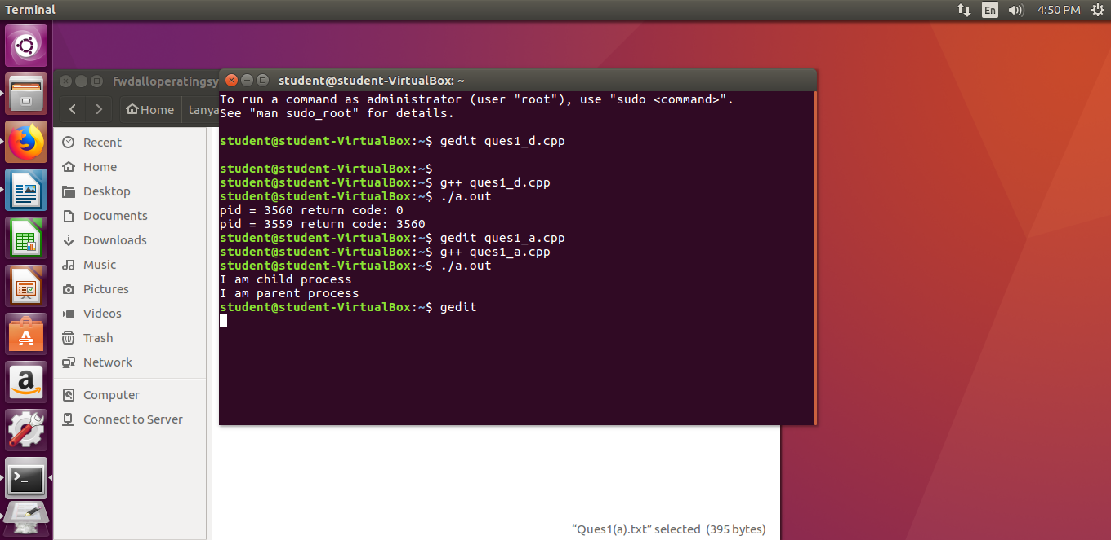

**Ques 1(b)**

**//PARENT WAITS FOR CHILD BEFORE FINISHING ITS TASK**

**//same program, different code for parent & child but parent waits for child to finish**

**#include<iostream>**

**#include<sys/types.h>**

**#include<sys/wait.h>**

**#include<unistd.h>**

**#include<stdio.h>**

**using namespace std;**

**int main()**

**{**

**int status;**

**int pid= fork();**

**int x;**

**if(pid<0)**

**{**

**cout<<"\nChild process can not be created \n";**

**return -1;**

**}**

**else if(pid==0)**

**{**

**cout<<"\nI am child : "<<pid<<"\n";**

**cout<<"\nI am child. Child process id: "<<getpid()<<"\n";**

**execlp("/bin/ls", "ls", NULL);**

**}**

**else**

**{**

**x=wait(&status);**

**cout<<"\nChild complete \n";**

**cout<<"\nI am parent. Parent process id: "<<getpid()<<"\n";**

**cout<<"\nInfo returned by wait(&status): "<<x<<" which is = child process id\n";**

**}**

**return 0;**

**}**

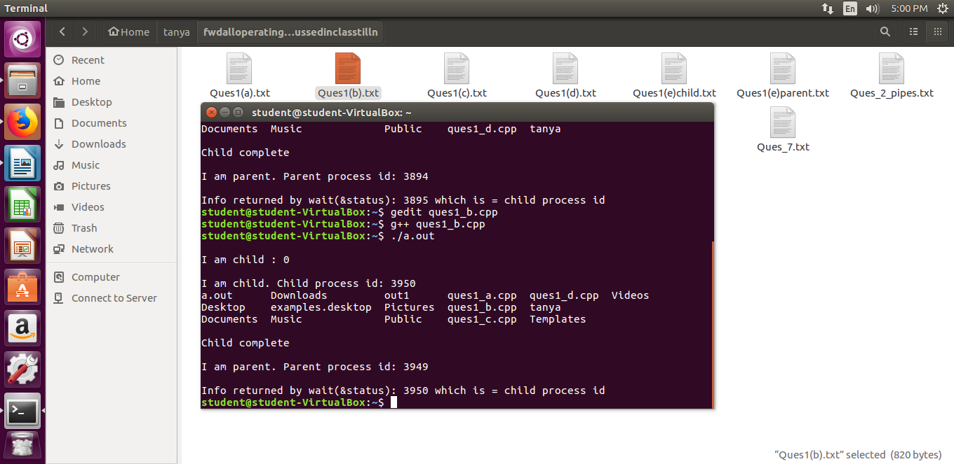

**Ques 1(c)**

**//SAME PROGRAM, SAME CODE, concurrent processes :-**

**#include<iostream>**

**#include<unistd.h>**

**#include<sys/types.h>**

**#include<sys/wait.h>**

**using namespace std;**

**int main()**

**{**

**int code=fork();**

**int status;**

**if(code<0)**

**{**

**cout<<"\nUnsuccessful \n";**

**}**

**else // run same code for child and parent process**

**{**

**cout <<"pid = " << getpid() << " return code: "<< code<<"\n";**

**}**

**return 0;**

**}**

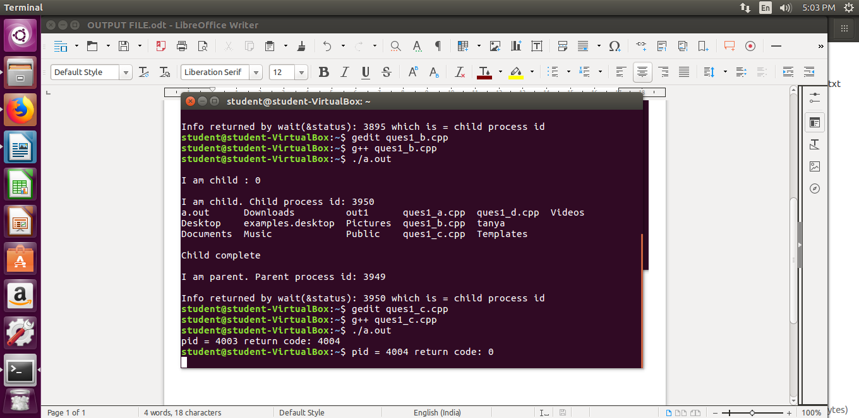

**Ques 1(d)**

**//SAME PROGRAM, SAME CODE, parent process waits for child to finish :-**

**#include<iostream>**

**#include<unistd.h>**

**#include<sys/types.h>**

**#include<sys/wait.h>**

**using namespace std;**

**int main()**

**{**

**int code=fork();**

**int status;**

**if(code<0)**

**{**

**cout<<"\nUnsuccessful \n";**

**}**

**else // run same code for child and parent process**

**{**

**wait(NULL);**

**cout <<"pid = " << getpid() << " return code: "<< code<<"\n";**

**}**

**return 0;**

**}**

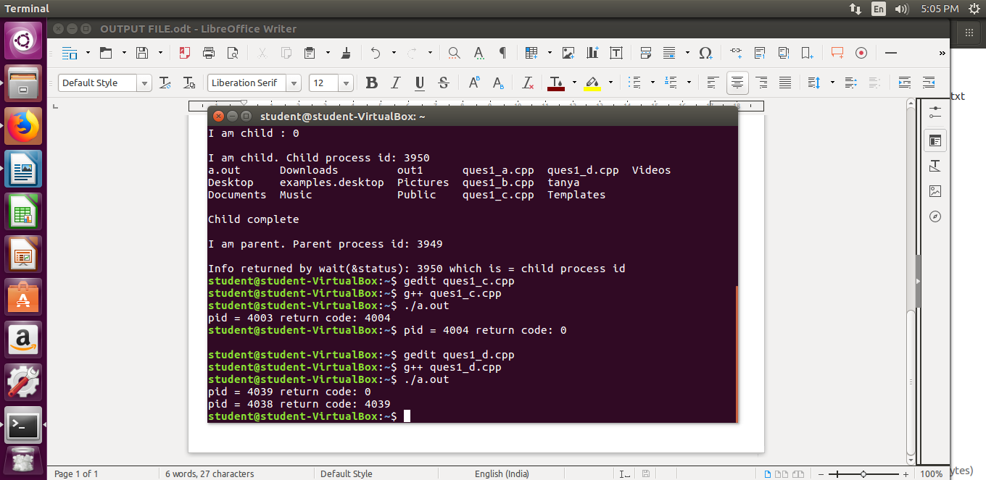

**Ques 1(e)**

**//Child program**

**// child.cpp: the child program**

**#include <iostream>**

**#include <stdlib.h>**

**#include <string.h>**

**#define A 500**

**#define B 600**

**#define C 700**

**using namespace std;**

**int main (int argc, char **argv)**

**{**

**int i, j;**

**long sum;**

**// Some arbitrary work done by the child**

**cout<<"Child: Hello, World!\n";**

**for (j = 0; j < 30; j++ ) {**

**for (i =0; i < 900000; i++) {**

**sum = A * i + B * i * i + C;**

**sum %= 543;**

**}**

**}**

**cout<<"Child: Work completed!\n";**

**cout<<"Child: Bye now.\n";**

**exit (0);**

**}**

**//Parent Program**

**//Different programs**

**// parent.cpp: the parent program**

**/\***

**To compile & execute the parent-child programs, steps are:**

**step 1) g++ child.cpp -o child**

**step 2) g++ parent.cpp**

**step 3) ./a.out**

**\*/**

**#include <iostream>**

**#include <stdlib.h>**

**#include <string.h>**

**#include <sys/wait.h>**

**#include <sys/types.h>**

**#include <unistd.h>**

**using namespace std;**

**int main (int argc, char **argv)**

**{**

**int i = 0;**

**long sum;**

**int pid;**

**int status, ret;**

**cout<<"Parent: Hello, World!\n";**

**pid = fork ();**

**if (pid == 0) {**

**// I am the child: loading a different program in the child process**

**execvp ("./child", argv);**

**}**

**// I am the parent**

**cout<<"Parent: Waiting for Child to complete.\n";**

**if ((ret = waitpid (pid, &status, 0)) == -1)**

**cout<<"parent:error\n";**

**if (ret == pid)**

**cout<<"Parent: Child process waited for.\n";**

**}**

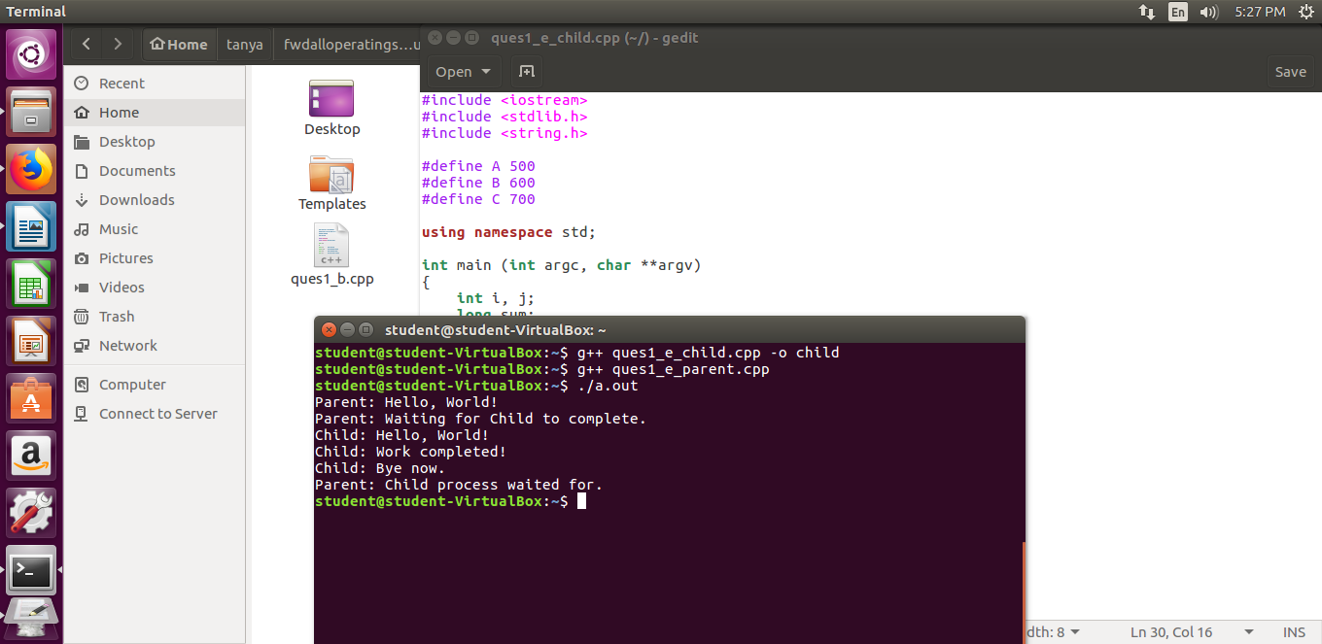

**Ques 2**

**/\***

**WAP to demonstrate Inter-Process Communication (IPC) between parent**

**and child using pipe system call**

**\*/**

**#include<iostream>**

**#include<unistd.h>**

**#include<string.h>**

**#include<sys/types.h>**

**#define BUFFERSIZE 25**

**#define READEND 0**

**#define WRITEEND 1**

**using namespace std;**

**int main(void)**

**{**

**char writemsg[BUFFERSIZE] = "Greetings";**

**char readmsg[BUFFERSIZE];**

**int fd[2];**

**pid_t pid;**

**/* create the pipe */**

**if (pipe(fd) == -1) {**

**cout<<"Pipe failed!";**

**return 1;**

**}**

**/* fork a child process */**

**pid = fork();**

**if (pid < 0) { /* error occurred */**

**cout<<"Fork Failed!";**

**return 1;**

**}**

**if (pid > 0) { /* parent process */**

**/* close the unused end of the pipe */**

**close(fd[READEND]);**

**/* write to the pipe */**

**write(fd[WRITEEND], writemsg, strlen(writemsg)+1);**

**/* close the write end of the pipe */**

**close(fd[WRITEEND]);**

**}**

**else { /* child process */**

**/* close the unused end of the pipe */**

**close(fd[WRITEEND]);**

**/* read from the pipe */**

**read(fd[READEND], readmsg, BUFFERSIZE);**

**cout<<"read: "<<readmsg;**

**/* close the write end of the pipe */**

**close(fd[READEND]);**

**}**

**return 0;**

**}**

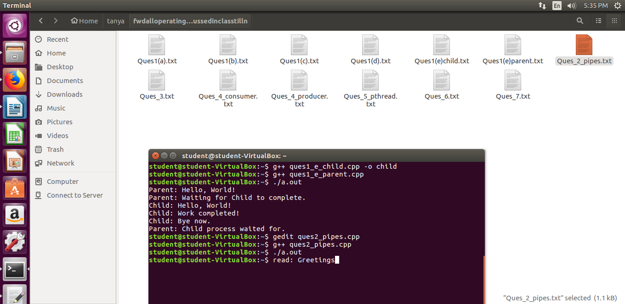

**Ques 3**

**/\***

**WAP to display the following:**

**a. Kernel version**

**b. CPU type and model**

**c. Information on configured memory, amount of free and used memory**

**\*/**

**#include<iostream>**

**#include<stdlib.h>**

**#include<stdio.h>**

**using namespace std;**

**int main()**

**{**

**cout<<"\nKernel version is:\n";**

**system("cat /proc/sys/kernel/osrelease");**

**cout<<"\nCPU space: \n";**

**system("cat /proc/cpuinfo |awk 'NR==3,NR==4{print}' \n");**

**cout<<"\n Configured memory is :\n";**

**system("cat /proc/meminfo |awk 'NR==1{print $2}'\n");**

**cout<<"\n Amount of free memory is :\n";**

**system("cat /proc/meminfo |awk 'NR==2{print $2}'\n");**

**cout<<"\n Amount of used memory is :\n";**

**system("cat /proc/meminfo |awk '{if (NR==1) a=$2; if (NR==2) b=$2 } END {print a-b}'\n");**

**return 0;**

**}**

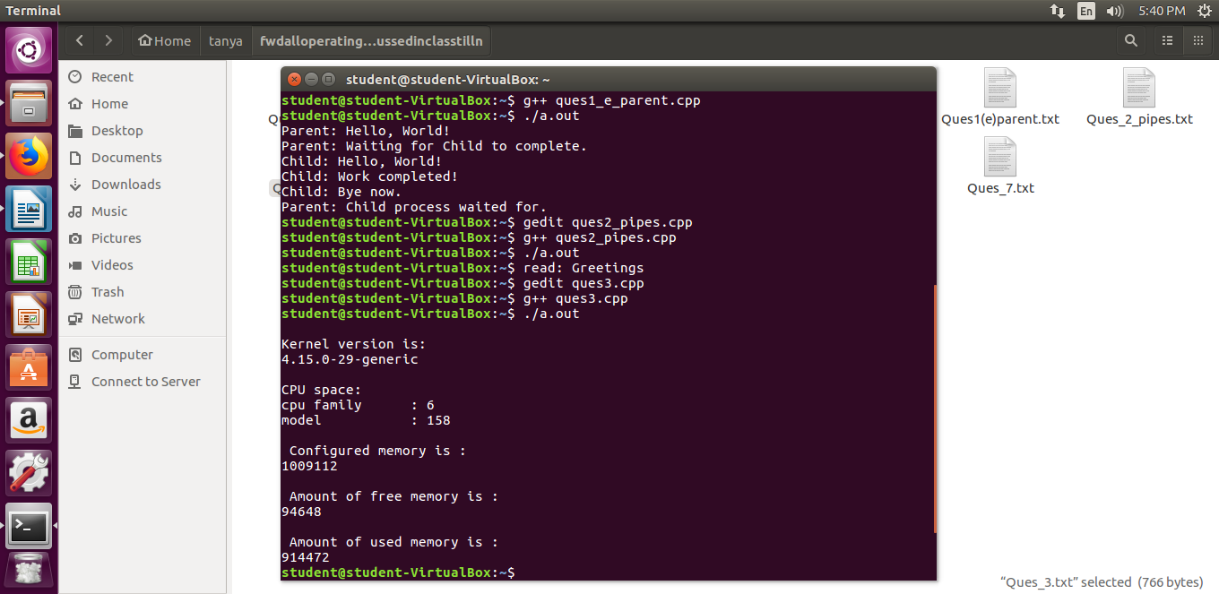

**Ques 4**

**//Consumer**

**/\***

**WAP to demonstrate producer-consumer problem using shared memory.**

**\*/**

**//C++ program for Consumer process illustrating POSIX shared-memory API.**

**#include<iostream>**

**#include<stdlib.h> // used for shm_open**

**#include<string.h>**

**#include<fcntl.h>**

**#include<sys/shm.h>**

**#include<sys/stat.h>**

**#include<sys/mman.h>**

**#include<sys/unistd.h>**

**#include<sys/types.h>**

**#include<stdio.h>**

**using namespace std;**

**//To run, use:**

**// g++ consumer.cpp -lrt**

**int main()**

**{**

**const int SIZE =4096;**

**const char *name ="/my_eg";**

**/* shared memory file descriptor */**

**int shm_fd;**

**/* pointer to shared memory object */**

**void* ptr;**

**/* open the shared memory object */**

**shm_fd = shm_open(name, O_RDONLY, 0666);**

**if(shm_fd<0)**

**{**

**cout<<"\nERROR\n";**

**}**

**else**

**{**

**/* memory map the shared memory object */**

**ptr = mmap(0, SIZE, PROT_READ, MAP_SHARED, shm_fd, 0);**

**/* read from the shared memory object */**

**//printf("%s", (char*)ptr);**

**cout<<(char*)ptr;**

**/* remove the shared memory object */**

**shm_unlink(name);**

**}**

**return 0;**

**}**

**//Producer**

**/\***

**WAP to demonstrate producer-consumer problem using shared memory.**

**\*/**

**//C++ program for Producer process illustrating POSIX shared-memory API.**

**#include <stdio.h>**

**#include <stdlib.h>**

**#include <unistd.h>**

**#include <string.h>**

**#include <fcntl.h>**

**#include <sys/shm.h>**

**#include <sys/stat.h>**

**#include <sys/mman.h>**

**#include <sys/types.h>**

**#include <errno.h>**

**#include <iostream>**

**/\***

**3 main APIs used with POSIX shared memory:**

**shm_open():**

**-Open existing shared memory (SHM) object, or**

**-Create and open new SHM object**

**-Returns a file descriptor used in later calls**

**ftruncate():**

**-set size of SHM object**

**-New SHM objects have length 0**

**-Before mapping, must set size using ftruncate(fd, size)**

**-Bytes in newly extended object are initialized to 0**

**-If existing object is shrunk, truncated data is lost**

**mmap(): map SHM object into caller’s address space**

**include <sys/mman.h>**

**void *mmap(void *addr , size_t length , int prot ,**

**int flags , int fd , off_t offset );**

**Compile with g++ producer.cpp -lrt**

**\*/**

**using namespace std;**

**int main()**

**{**

**/* the size (in bytes) of shared memory object */**

**const int SIZE = 4096;**

**/* name of the shared memory object */**

**const char* name = "/my_eg";**

**/* strings written to shared memory */**

**const char* message_0 = "Hello,";**

**const char* message_1 = " Nice day!";**

**/* shared memory file descriptor */**

**int shm_fd;**

**/* pointer to shared memory obect */**

**void* ptr;**

**/* create the shared memory object */**

**shm_fd = shm_open(name, O_CREAT | O_RDWR, 0666);**

**if (shm_fd < 0)**

**{**

**cout<<"In shm_open() of producer.";**

**exit(1);**

**}**

**/* configure the size of the shared memory object */**

**ftruncate(shm_fd, SIZE);**

**/* memory map the shared memory object */**

**ptr = mmap(0, SIZE, PROT_WRITE, MAP_SHARED, shm_fd, 0);**

**if (ptr == NULL)**

**{**

**cout<<"Error In mmap() requesting .";**

**exit(1);**

**}**

**char *cptr=(char*)ptr;**

**/* write to the shared memory object */**

**cptr=strcat(cptr,message_0);**

**cptr=strcat(cptr,message_1);**

**/\***

**sprintf(cptr, "%s", message_0);**

**cptr += strlen(message_0);**

**sprintf(cptr, "%s", message_1);**

**cptr += strlen(message_1);**

**\*/**

**return 0;**

**}**

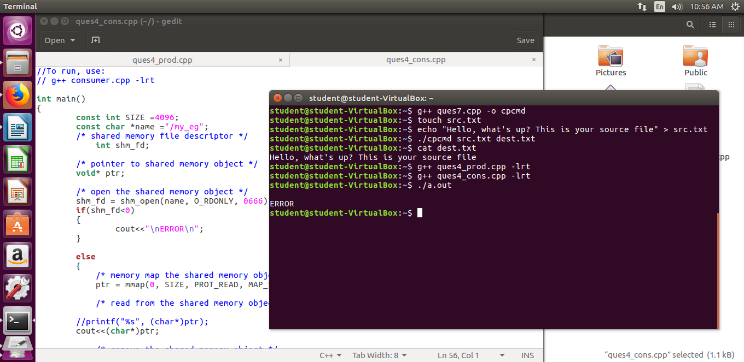

**Ques 5**

**//Write program to understand working of Pthread library.**

**/* To compile & run the program, do following:**

**step 1) g++ -pthread Ques5_pthread.cpp**

**step 2) ./a.out 5**

**\*/**

**#include<pthread.h>**

**#include<stdio.h>**

**#include<stdlib.h>**

**#include<iostream>**

**using namespace std;**

**int sum;**

**void* runner(void* param);**

**int main(int argc,char *argv[])**

**{**

**pthread_t tid;**

**pthread_attr_t attr;**

**if(argc!=2)**

**{**

**cout<<"\nUsage :a.out<integer value>\n";**

**return -1;**

**}**

**if(atoi(argv[1])<0)**

**{**

**cout<<"\n%d must be >=0\n"<<atoi((const char*)(argv[1]));**

**return -1;**

**}**

**//get the default attributes**

**pthread_attr_init(&attr);**

**//create the thread:**

**pthread_create(&tid,&attr,runner,argv[1]);**

**//parent waits for the child thread to finish**

**pthread_join(tid,NULL);**

**//output the value of shared data "sum"**

**cout<<"\nSUM is: "<<sum<<endl;**

**return 0;**

**}**

**//child thread will begin execution here:**

**void* runner(void* param)**

**{**

**int i,upper=atoi((const char*)param);**

**sum=0;**

**for(i=1;i<=upper;i++)**

**sum+=i;**

**pthread_exit(0);**

**}**

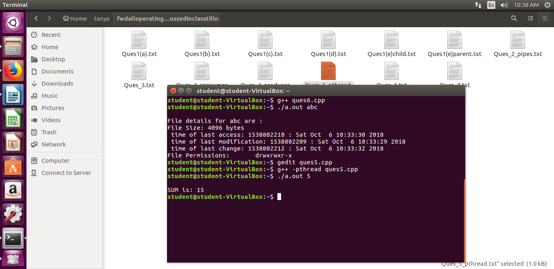

**Ques 6**

**/\***

**WAP to print file details including owner access permissions, file**

**access time, where file name is given as a command line argument.**

**\*/**

**#include<iostream>**

**#include<stdlib.h>**

**#include<stdio.h>**

**#include<unistd.h>**

**#include <sys/stat.h>**

**#include <sys/types.h>**

**/\***

**Steps to compile and run the program are:**

**step 1) g++ Ques6.cpp**

**step 2) ./a.out <name of any file>**

**For eg:- ./a.out producer.cpp**

**\*/**

**using namespace std;**

**int main(int argc, char** argv)**

**{**

**if(argc !=2)**

**{**

**cout<<"\nEnter file name!\n";**

**return 1;**

**}**

**struct stat fileStat;**

**if(stat(argv[1],&fileStat) < 0)**

**return 1;**

**cout<<"\nFile details for "<< argv[1]<<" are :\n";**

**cout<<"File Size: "<<fileStat.st_size<<" bytes\n";**

**printf(" time of last access: %ld : %s", fileStat.st_atime, ctime(&fileStat.st_atime));**

**printf(" time of last modification: %ld : %s", fileStat.st_mtime, ctime(&fileStat.st_mtime));**

**printf(" time of last change: %ld : %s", fileStat.st_ctime, ctime(&fileStat.st_ctime));**

**//system("ls -l "argv[1]);**

**cout<<"File Permissions: \t";**

**printf( (S_ISDIR(fileStat.st_mode)) ? "d" : "-");**

**printf( (fileStat.st_mode & S_IRUSR) ? "r" : "-");**

**printf( (fileStat.st_mode & S_IWUSR) ? "w" : "-");**

**printf( (fileStat.st_mode & S_IXUSR) ? "x" : "-");**

**printf( (fileStat.st_mode & S_IRGRP) ? "r" : "-");**

**printf( (fileStat.st_mode & S_IWGRP) ? "w" : "-");**

**printf( (fileStat.st_mode & S_IXGRP) ? "x" : "-");**

**printf( (fileStat.st_mode & S_IROTH) ? "r" : "-");**

**printf( (fileStat.st_mode & S_IWOTH) ? "w" : "-");**

**printf( (fileStat.st_mode & S_IXOTH) ? "x" : "-");**

**cout<<endl;**

**return 0;**

**}**

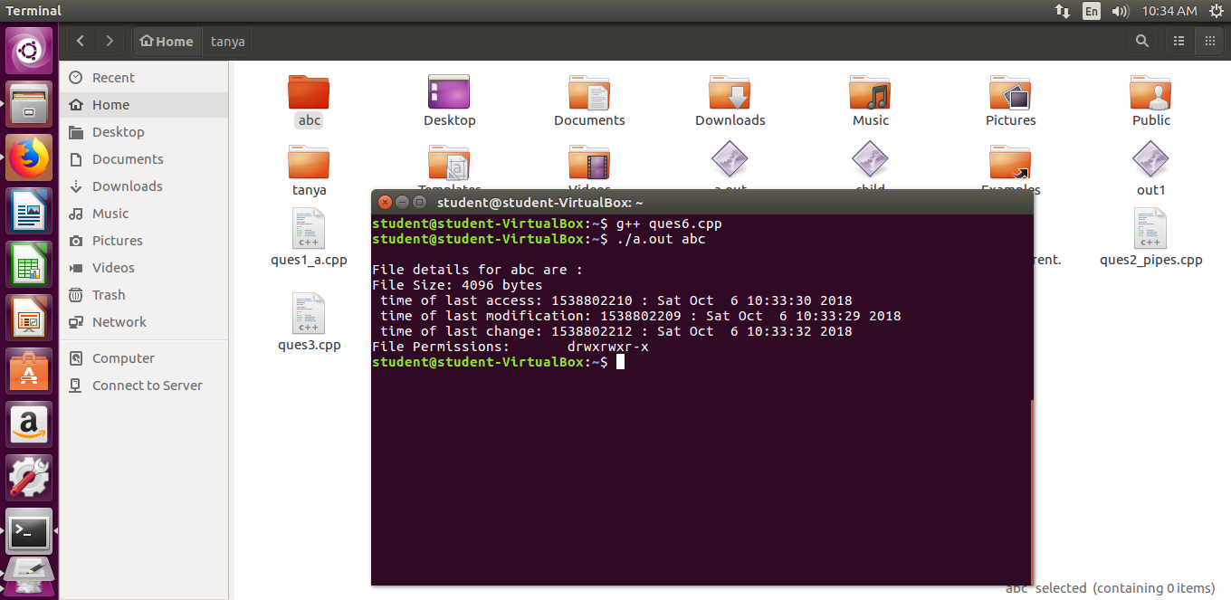

**Ques 7**

**/\***

**WAP to copy a source file into the target file and display the**

**target file using system calls.**

**\*/**

**/\***

**Steps to compile and execute the program:**

**step 1) g++ Ques_7.cpp -o cpcmd**

**step 2) ./cpcmd src.txt dest.txt**

**Error opening file src.txt errno = 2**

**step 3) touch src.txt**

**step 4) echo "This program is a simulation of the Linux copy command "cp" using I/O system calls. We copy the content from one file to another " > src.txt**

**step 5) ./cpcmd src.txt dest.txt**

**step 6) cat dest.txt**

**This program is a simulation of the Linux copy command "cp" using I/O system calls. We copy the content from one file to another**

**\*/**

**#include <iostream>**

**#include <stdlib.h>**

**#include <fcntl.h>**

**#include <errno.h>**

**#include<unistd.h>**

**#include<sys/types.h>**

**#define BUFF_SIZE 1024**

**using namespace std;**

**int main(int argc, char* argv[])**

**{**

**int srcFD,destFD,nbread,nbwrite;**

**char *buff[BUFF_SIZE];**

**/*Check if both src & dest files are received or --help is received to get usage*/**

**if(argc != 3 || argv[1] == "--help")**

**{**

**cout<<"\nUsage: cpcmd source_file destination_file\n";**

**exit(EXIT_FAILURE);**

**}**

**/*Open source file*/**

**srcFD = open(argv[1],O_RDONLY);**

**if(srcFD == -1)**

**{**

**cout<<"\nError opening file "<<argv[1]<<" errno = \n"<<errno;**

**exit(EXIT_FAILURE);**

**}**

**/*Open destination file with respective flags & modes**

**O_CREAT & O_TRUNC is to truncate existing file or create a new file**

**S_IXXXX are file permissions for the user,groups & others*/**

**destFD = open(argv[2],O_WRONLY | O_CREAT | O_TRUNC, S_IRUSR | S_IWUSR | S_IRGRP | S_IWGRP | S_IROTH | S_IWOTH);**

**if(destFD == -1)**

**{**

**cout<<"\nError opening file "<<argv[2]<<" errno = \n"<<errno;**

**exit(EXIT_FAILURE);**

**}**

**/*Start data transfer from src file to dest file till it reaches EOF*/**

**while((nbread = read(srcFD,buff,BUFF_SIZE)) > 0)**

**{**

**if(write(destFD,buff,nbread) != nbread)**

**cout<<"\nError in writing data to \n"<<argv[2];**

**}**

**if(nbread == -1)**

**cout<<"\nError in reading data from \n"<<argv[1];**

**if(close(srcFD) == -1)**

**cout<<"\nError in closing file \n"<<argv[1];**

**if(close(destFD) == -1)**

**cout<<"\nError in closing file \n"<<argv[2];**

**exit(EXIT_SUCCESS);**

**}**

