

Programme Name - B.Sc (Hons.) Computer Science
Semester - III
Paper Title - Operating System Practicals

Submitted by - Darshpreet Kaur
Examination Roll No - 19044570001
College RollNo - CSC/19/2
College Name - Mata Sundri College for Women, University of Delhi
College Address - Mata Sundri Lane, New Delhi 110002

Ques1. Write a program (using fork() and exec() commands) where parent and child execute :
(a) same program , same code
Answer(a)
// (a) same program , same code

#include<iostream>
#include<unistd.h>
#include<sys/types.h>
#include<sys/wait.h>
using namespace std;
int main()
{
int code=fork();
int status;
if(code<0)
{
cout<<"UNSUCCESSFUL"<<endl;
}
else
{
cout<<"ProcessID = "<< getpid() << endl;
cout<<"return code : " << code << endl;
}
return 0;
}
OUTPUT :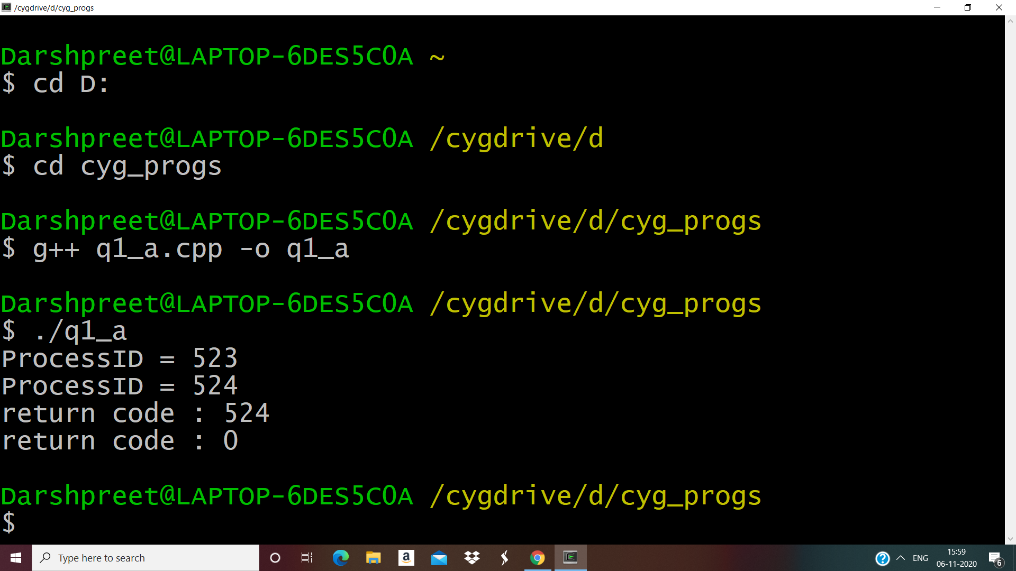

(b) same program , different code
// same program , different code

#include<iostream>
#include<unistd.h>
using namespace std;
int main()
{
int pid = fork();
if (pid<0)
{
cout<<"UNSUCCESSFUL"<<endl;
return -1;
}
else if(pid==0)
{
cout<<"I am a child process" <<" "<< pid <<" " <<getpid()<<endl;
}
else
{
sleep(-5);
cout<<"I am parent process " <<" " << pid <<" " << getpid() <<endl;
}
return 0;
}
OUTPUT : 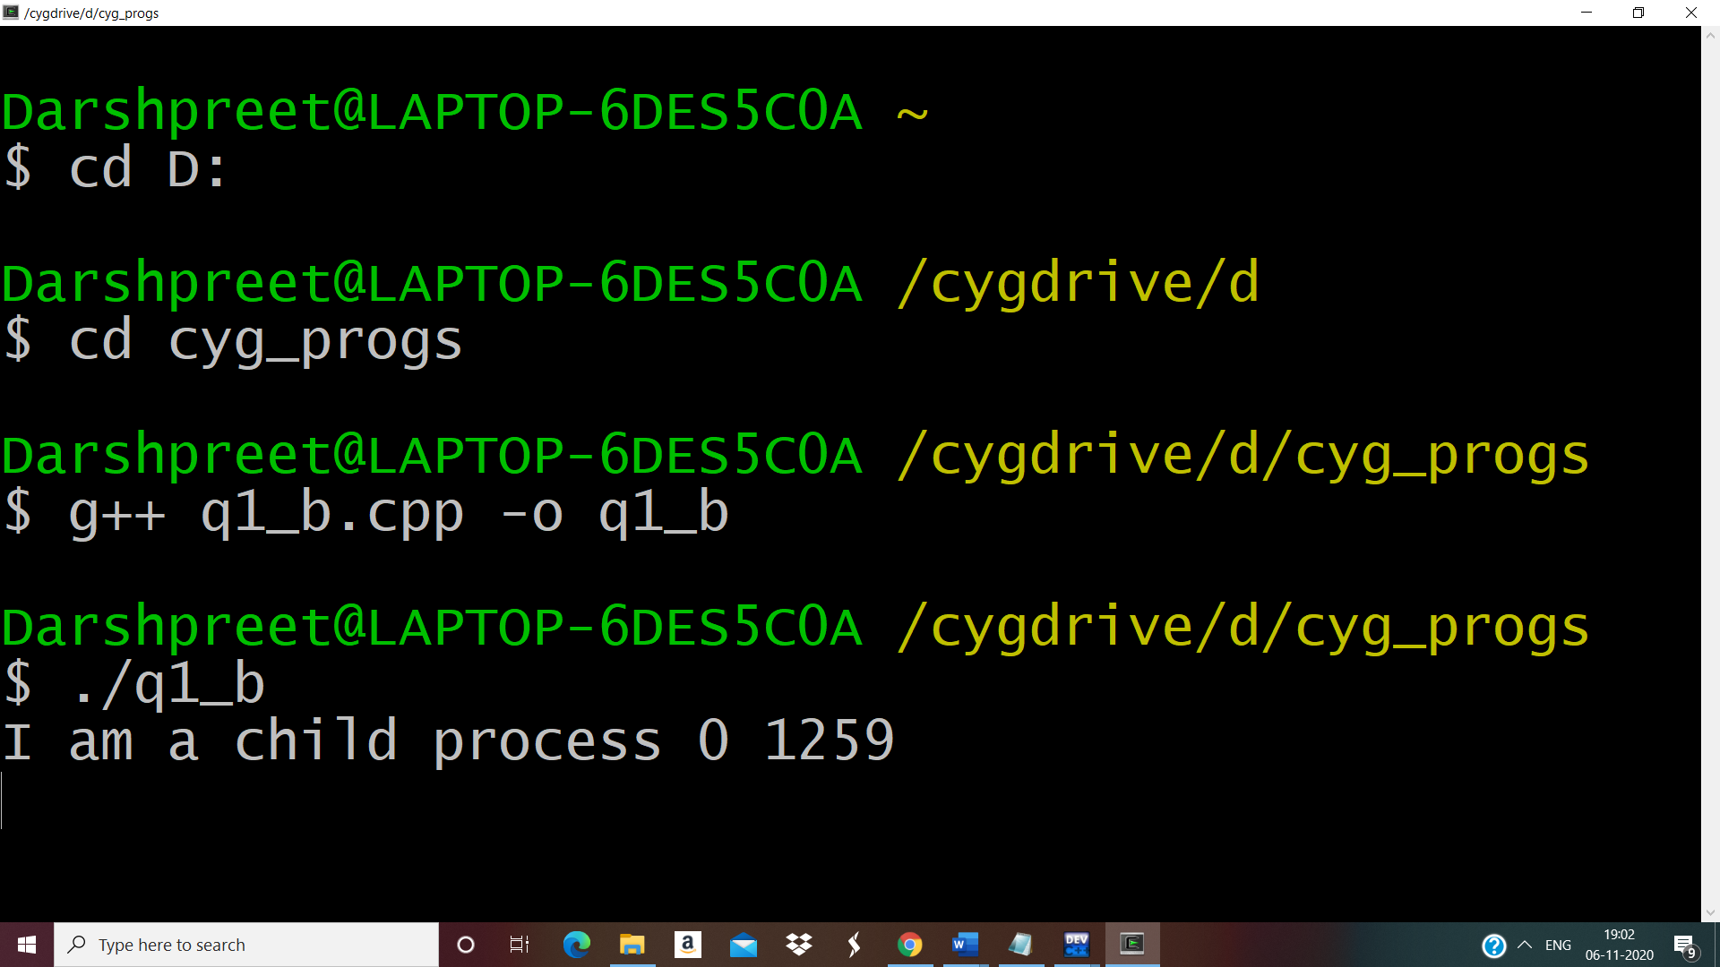
(b) before terminating , the parent waits for the child to finish its task , both for above mentioned cases a) and b)
//Same Program , Same Code(Parent process waits for child to finish)

#include<iostream>
#include<unistd.h>
#include<sys/types.h>
#include<sys/wait.h>
using namespace std;
int main()
{
int code = fork();
int status,x;
if(code<0)
{
cout<<"UNSUCCESSFUL"<<endl;
}
else //Run same code for child and parent process
{
x = wait(&status);
cout<<"pid= " <<" "<< getpid() <<" "<< “return code = ” << code<<" "<<"x="<<" " << x <<endl;
}
return 0;
}
OUTPUT : 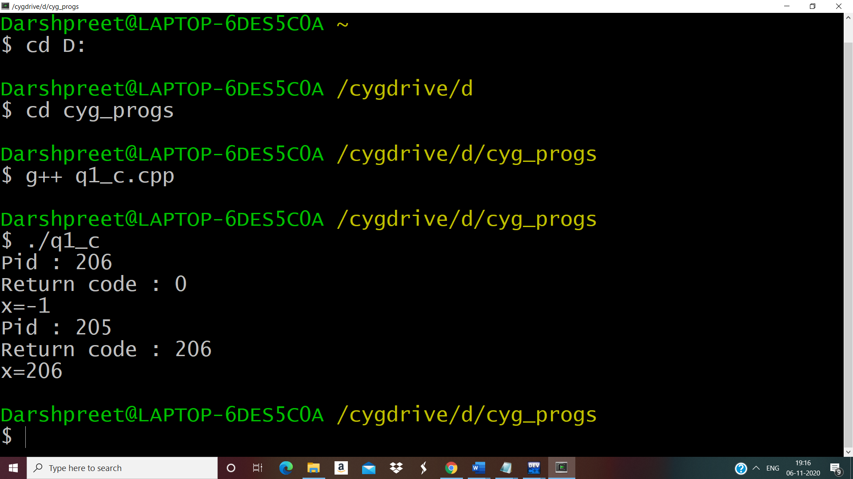//Same Program , Different Code (Parent process waits to child to finish)

#include<iostream>
#include<sys/types.h>
#include<sys/wait.h>
#include<unistd.h>
#include<stdio.h>
using namespace std;
int main()
{
int status;
int pid=fork();
int x;
if(pid<0)
{
cout<<"Child process cannot be created\n";
return -1;
}
else if(pid==0)
{
cout<<"Child Executing : "<<pid<<"\n";
cout<<"\nI am Child. Child process id: "<<getpid()<<"\n";
execlp("/bin/ls", "ls", NULL);
}
else
{
x=wait(&status);
cout<<"\nChild complete \n";
cout<<"\nI am Parent. Parent process id: "<<getpid()<<"\n";
cout<<"\nInfo returned by wait(&status): "<<x<<" which is = child process id\n";
}
return 0;
}
OUTPUT :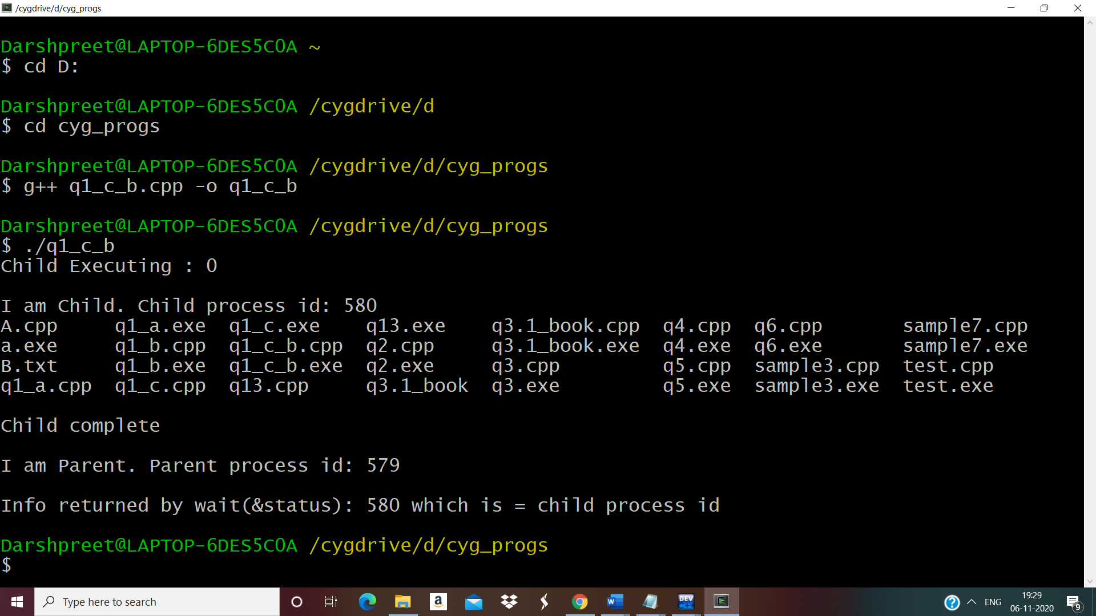

………………………………………………………………………………………………
Ques2 . Write a program to show how multiple fork( ) system calls work .
Answer
// Program to show how multiple fork() system calls work

#include<iostream>
#include<unistd.h>
#include<sys/types.h>
#include<sys/wait.h>
using namespace std;
int main()
{
int ID1=fork();
int ID2=fork();

if(ID1<0)
cout<<"\n Unsuccessful \n";
if(ID1==0)
cout <<" Im child pid = " << getpid() <<" return ID1: "<< ID1<<"\n";
else
cout <<" Im parent pid = " << getpid() <<" return ID1: "<< ID1<<"\n";
if(ID2<0)
cout<<"\n Unsuccessful \n";
if(ID2==0)
cout <<" Im child pid = " << getpid() <<" return ID2: "<< ID2<<"\n";
else
cout <<" Im parent pid = " << getpid() <<" return ID2: "<< ID2<<"\n";
return 0;
}
OUTPUT :
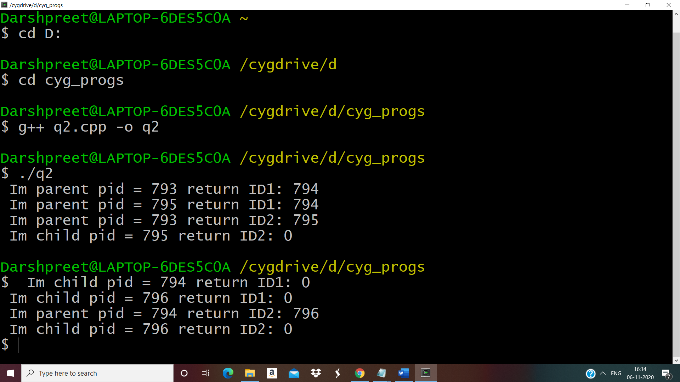………………………………………………………………………………………………

Ques3 . Write a program to report behaviour of Linux kernel including kernel version , CPU type and model.(CPU INFORMATION)
Answer
// Behaviour of Linux Kernel including Kernel version , CPU type , model (CPU information)

#include<iostream>
using namespace std;

int main()
{
cout<<"\n Kernel version:\n";
system("uname -s");
cout<<"\nCPU space: \n";
system("cat /proc/cpuinfo |awk 'NR==3,NR==4{print}' \n");
return 0;
}
OUTPUT :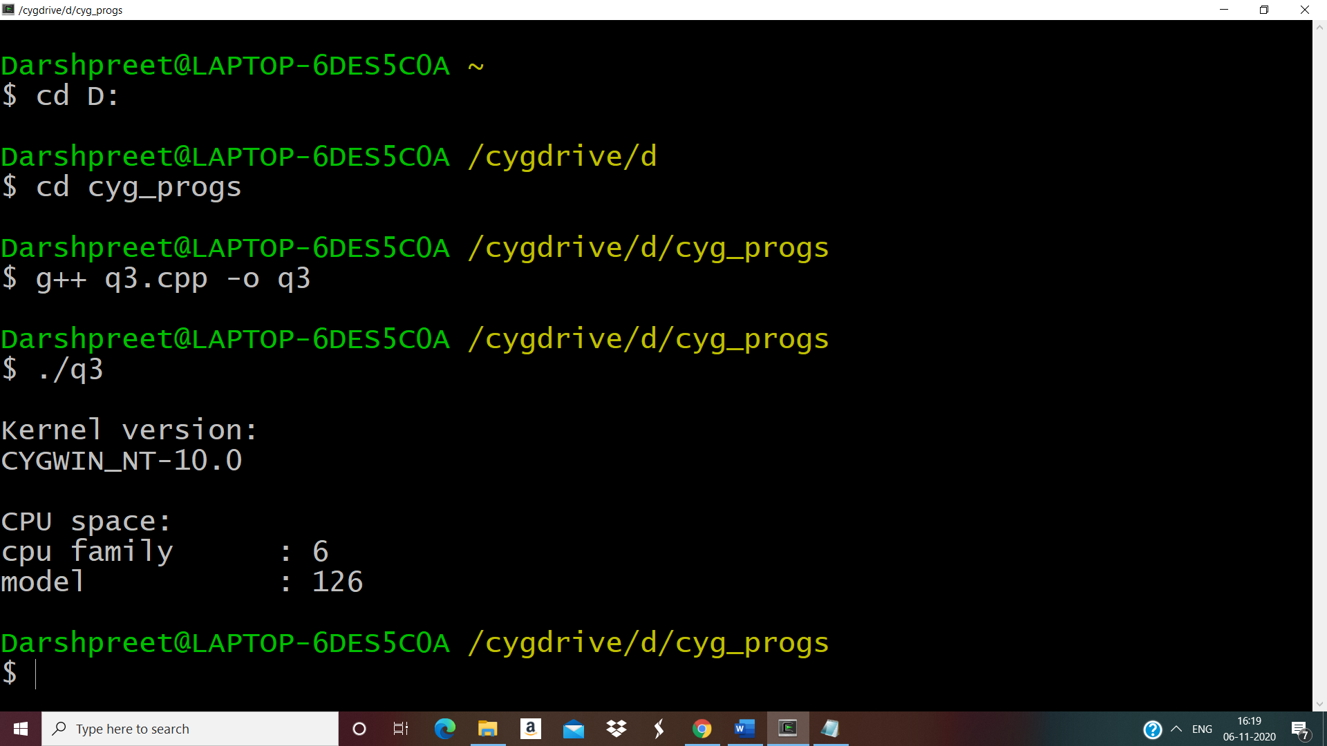………………………………………………………………………………………………
Ques4 . Write a program to report behaviour of Linux kernel including information on configured memory , amount of free space and used space.
Answer

// Behaviour of Linux Kernel including info on configured memory , amount of free and used space

#include<iostream>
using namespace std;
int main()
{
cout<<"\nConfigured memory is :\n";
system("cat /proc/meminfo |awk 'NR==1{print $2}'\n");
cout<<"\nAmount of free memory is :\n";
system("cat /proc/meminfo |awk 'NR==2{print $2}'\n");
cout<<"\nAmount of used memory is :\n";
system("cat /proc/meminfo |awk '{if (NR==1) a=$2; if (NR==2) b=$2 } END
{print a-b}'\n");
return 0;
}
OUTPUT :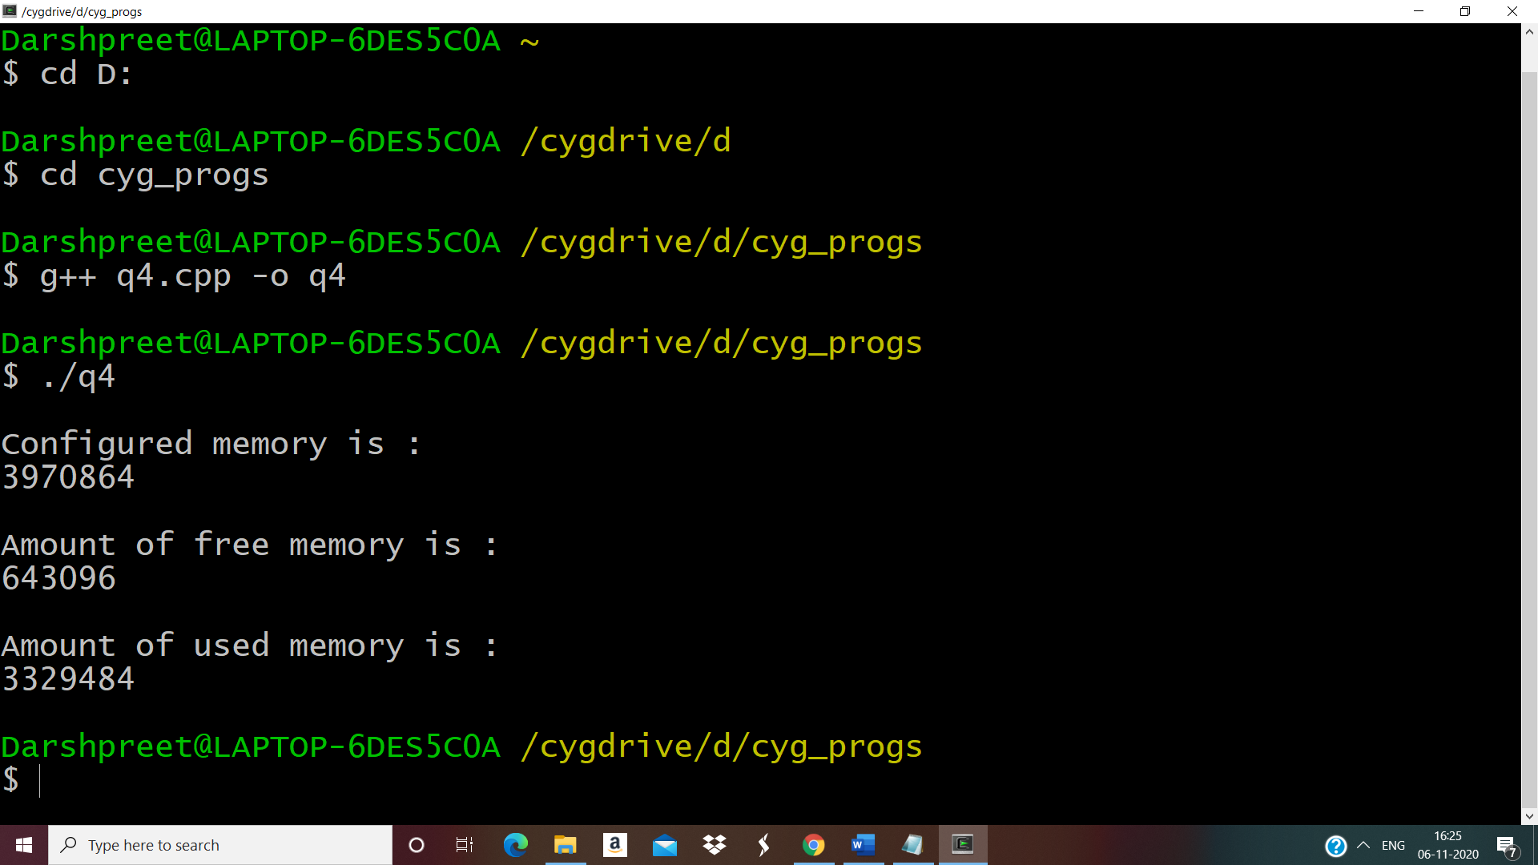
………………………………………………………………………………………………
Ques5. Write a program to print file details including owner access permission , file access time , where file name is given as command line argument.
Answer
// Program to print file details including owner access permissions , file access time , where file name is given as command line argument .

#include<iostream>
#include<stdlib.h>
#include<stdio.h>
#include<unistd.h>
#include <sys/stat.h>
#include <sys/types.h>
using namespace std;
int main(int argc, char** argv)
{
if(argc !=2)
{
cout<<"\nEnter file name!\n";
return 1;
}
struct stat fileStat;
if(stat(argv[1],&fileStat)<0)
return 1;
cout<<"\nFile details for "<< argv[1]<<" are :\n";
cout<<"File Size: "<<fileStat.st_size<<" bytes\n";
cout<<" time of last access is : "<<ctime(&fileStat.st_atime);
cout<<" time of last modification is : " << ctime(&fileStat.st_mtime);
cout<<" time of last change is : "<< ctime(&fileStat.st_ctime);
cout<<"File Permissions: \t";
cout<<( (S_ISDIR(fileStat.st_mode)) ? "d" : "-");
cout<<( (fileStat.st_mode & S_IRUSR) ? "r" : "-");
cout<<( (fileStat.st_mode & S_IWUSR) ? "w" : "-");
cout<<( (fileStat.st_mode & S_IXUSR) ? "x" : "-");
cout<<( (fileStat.st_mode & S_IRGRP) ? "r" : "-");
cout<<( (fileStat.st_mode & S_IWGRP) ? "w" : "-");
cout<<( (fileStat.st_mode & S_IXGRP) ? "x" : "-");
cout<<( (fileStat.st_mode & S_IROTH) ? "r" : "-");
cout<<( (fileStat.st_mode & S_IWOTH) ? "w" : "-");
cout<<( (fileStat.st_mode & S_IXOTH) ? "x" : "-");
cout<<endl;
return 0;
}
OUTPUT :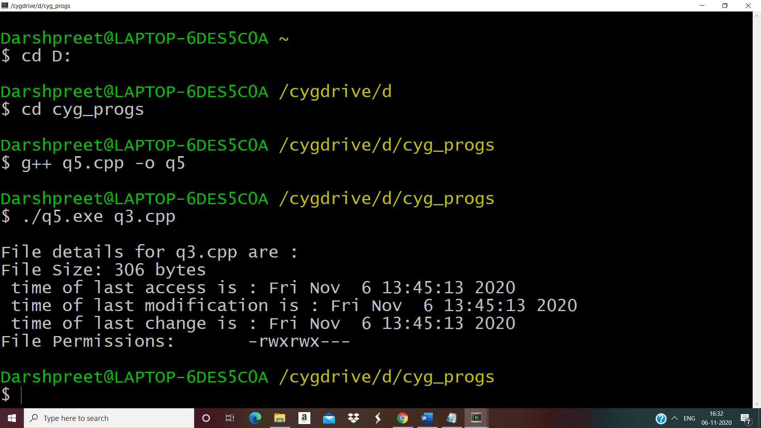………………………………………………………………………………………………
Ques6. Write a program to copy files using system calls.
Answer
// Program to copy files using system calls

#include <iostream>
#include <stdlib.h>
#include <fcntl.h>
#include <errno.h>
#include<unistd.h>
#include<sys/types.h>
#define BUFF_SIZE 1024
using namespace std;
int main(int argc, char* argv[])
{
int srcFD, destFD, nbread, nbwrite ;
char *buff[BUFF_SIZE];

if(argc != 3 || argv[1] == "--help")
{
cout<<"\nUsage: cpcmd source_file destination_file\n";
exit(EXIT_FAILURE);
}

srcFD = open(argv[1],O_RDONLY);
if(srcFD == -1)
{
cout<<"\nError opening file "<<argv[1]<<" errno = \n"<<errno;
exit(EXIT_FAILURE);
}
destFD = open(argv[2],O_WRONLY | O_CREAT | O_TRUNC, S_IRUSR | S_IWUSR |S_IRGRP | S_IWGRP | S_IROTH | S_IWOTH);
if(destFD == -1)
{
cout<<"\nError opening file "<<argv[2]<<" errno = \n"<<errno;
exit(EXIT_FAILURE);
}
while((nbread = read(srcFD,buff,BUFF_SIZE)) > 0)
{
if(write(destFD,buff,nbread) != nbread)
cout<<"\nError in writing data to \n"<<argv[2];
}
if(nbread == -1)
cout<<"\nError in reading data from \n"<<argv[1];
if(close(srcFD) == -1)
cout<<"\nError in closing file \n"<<argv[1];
if(close(destFD) == -1)
cout<<"\nError in closing file \n"<<argv[2];
exit(EXIT_SUCCESS);
}
OUTPUT :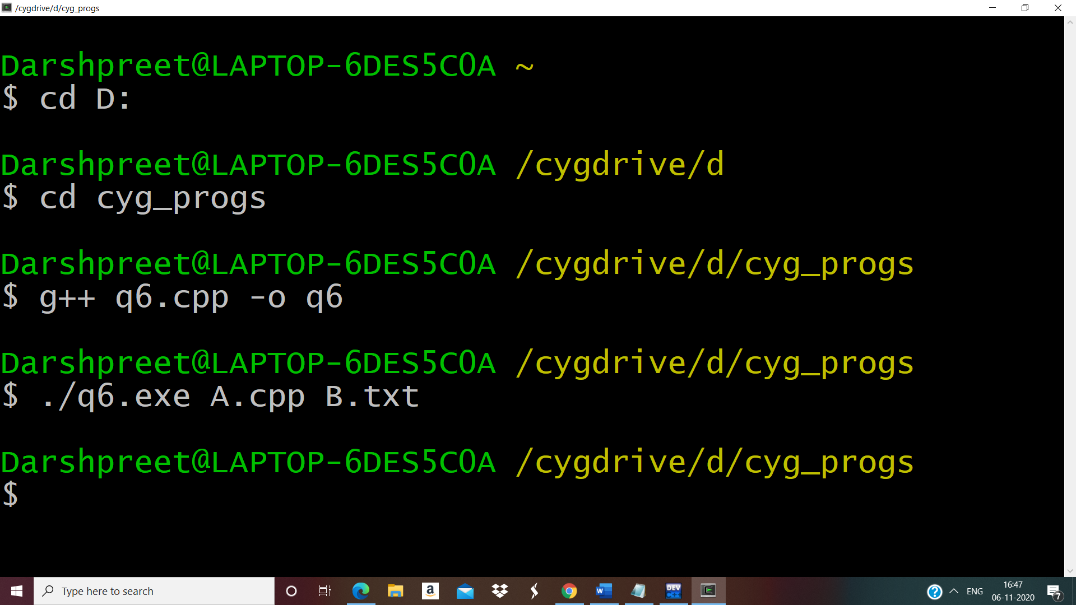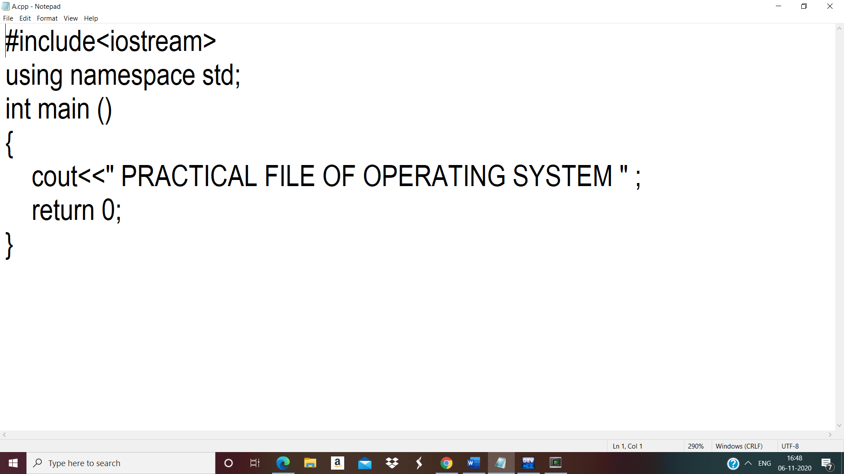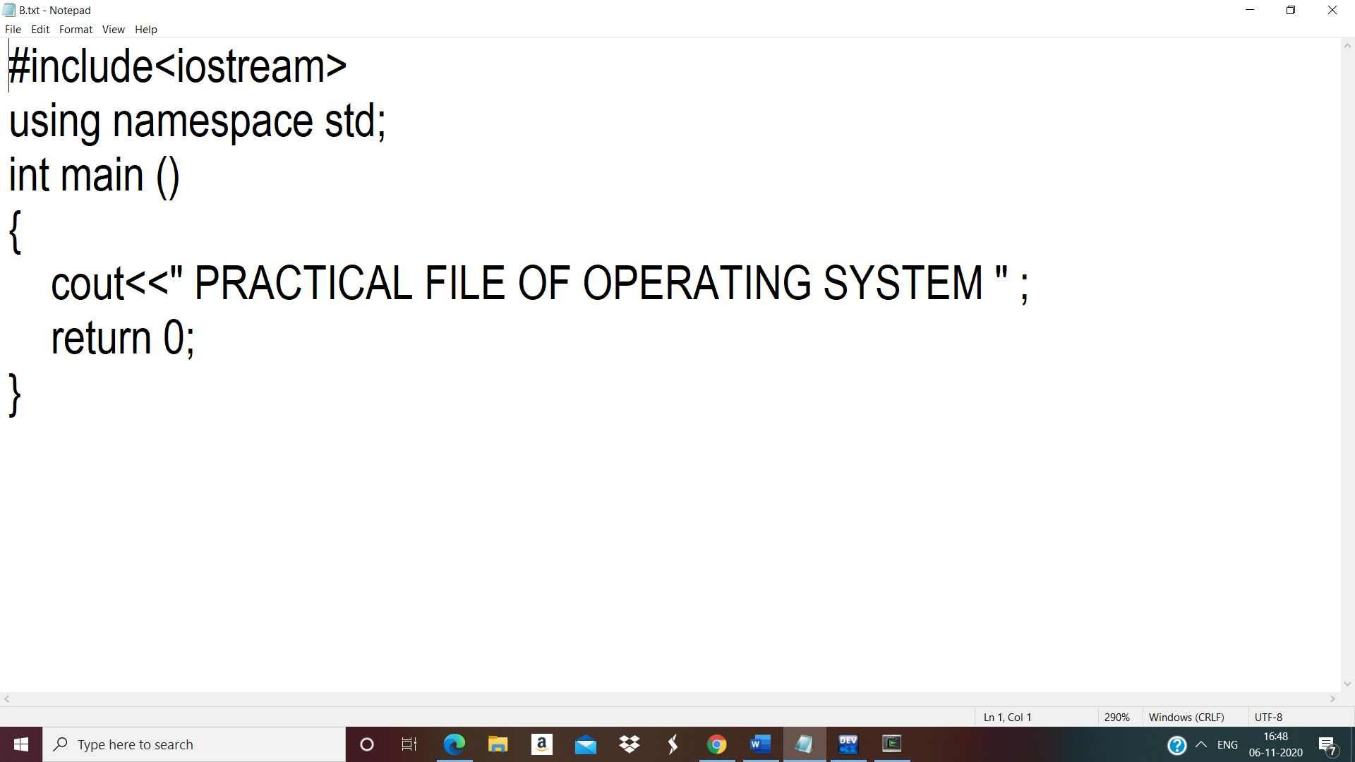
………………………………………………………………………………………………
Ques7.Write a program to implement FCFS scheduling algorithm.
Answer
// FCFS Scheduling Algorithm

#include<iostream>
#include<stdio.h>
using namespace std;

class Process
{
int n,pid,at,bt,tat,st,wt,ct;
Process *proc;
public:
void input();
void sort_at();
void fcfs();
};

void Process :: input()
{
cout<<"Enter no of Processes :"<<" " <<endl;
cin>>n;
proc=new Process[n];
cout<<"ENTER DETAILS :" <<endl;

for(int i=0;i<n;i++)
{
cout<<"Enter the PId for Process "<<i+1<<" : ";
cin>>proc[i].pid;

cout<<"Enter the Process Arrival Time for Process "<<i+1<<" : ";
cin>>proc[i].at;

cout<<"Enter the Process Burst Time for Process "<<i+1<<" : ";
cin>>proc[i].bt;
cout<<endl;
}
cout<<"\npid\tAt\tBt\n";
for(int i=0; i<n; i++)
{
cout<<proc[i].pid<<"\t"<<proc[i].at<<"\t"<<proc[i].bt<<"\n";
}
}

void Process :: sort_at()
{
for(int i=0;i<n;i++)
{
for(int j=0;j<n-i-1;j++)
{
if(proc[j].at>proc[j+1].at)
{
Process temp=proc[j];
proc[j]=proc[j+1];
proc[j+1]=temp;
}
}
}
}

void Process :: fcfs()
{
sort_at();
int t,ct,wt,tat ;
t=proc[0].at;
cout<<"Execution sequence as follow: ";
cout<<"\npid\tST\tCT\tWT\tTAT\n";
for(int i=0;i<n;i++)
{
ct=t+proc[i].bt;
wt=t-proc[i].at;
tat= ct-proc[i].at;

cout<<proc[i].pid<<"\t"<<t<<"\t"<<ct<<"\t"<<wt<<"\t"<<tat<<"\t"<<endl;
t=ct;
if(t<proc[i].at)
{
t=proc[i+1].at;
}
}
}

int main()
{
Process p;
p.input();
p.fcfs();
return 0;
}
OUTPUT : 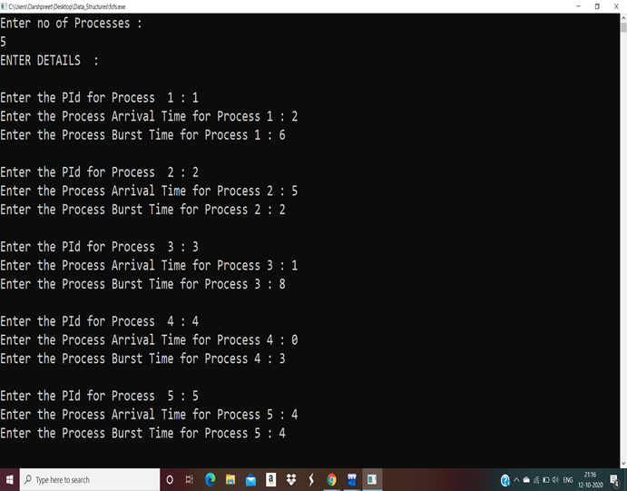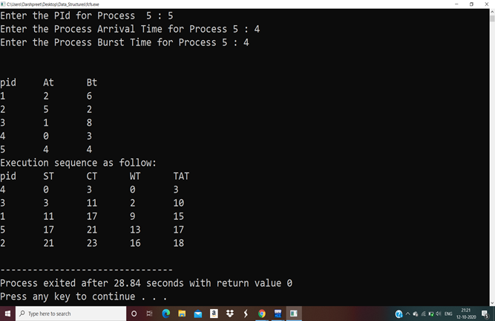
………………………………………………………………………………………………
Ques8.Write a program to implement Round Robin scheduling algorithm.
Answer
//Round Robin Scheduling Algorithm

#include<iostream>
using namespace std;

int main()
{
int count,j,n,time,remain,flag=0,time_quantum,i=0;
int wt=0,tat=0,at[20],bt[20],rt[20],gantt[20][2];
cout<<"\nEnter no of Processes : ";
cin>>n;
cout<<"Enter Time Quantum : ";
cin>>time_quantum;
remain=n;
cout<<"*****ENTER DETAILS*****"<<endl;
for(count=0;count<n;count++)
{
cout<<"\nPId : "<<count+1;
cout<<"\nArrival Time : ";
cin>>at[count];
cout<<"Burst Time : ";
cin>>bt[count];
rt[count]=bt[count];
}
cout<<"\nPId\tAt\tbt\n";
for(count=0; count<n; count++)
{
cout<<count+1<<"\t"<<at[count]<<"\t"<<bt[count]<<"\n";
}
cout<<"\n\nPId\tTAT\tWT\n";
for(time=0,count=0;remain!=0;)
{
if(rt[count]<=time_quantum && rt[count]>0)
{
time+=rt[count];
rt[count]=0;
gantt[i][0]= count;
gantt[i][1]= time;
i++;
flag=1;
}
else if(rt[count]>0)
{
rt[count]-=time_quantum;
time+=time_quantum;
gantt[i][0]= count;
gantt[i][1]= time;
i++;
}
if(rt[count]==0 && flag==1)
{
remain--;
cout<<count+1<<"\t"<<time-at[count]<<"\t "<<time-at[count]-bt[count]<<"\n";
wt+=time-at[count]-bt[count];
tat+=time-at[count];
flag=0;
}
if(count==n-1)
count=0;
else if(at[count+1]<=time)
count++;
else
count=0;
}
cout<<"\nAverage Waiting Time="<<wt*1.0/n<<endl;
cout<<"Avg Turnaround Time ="<<tat*1.0/n<<endl;
cout<<endl<<"*****Gantt Chart*****"<<endl<<"PID\tEnd Time\t"<<endl;
for(int k=0;k<i;k++)
{
cout<<gantt[k][0]+1<<"\t"<<gantt[k][1]<<"\t"<<endl;

}
return 0;
}
OUTPUT : 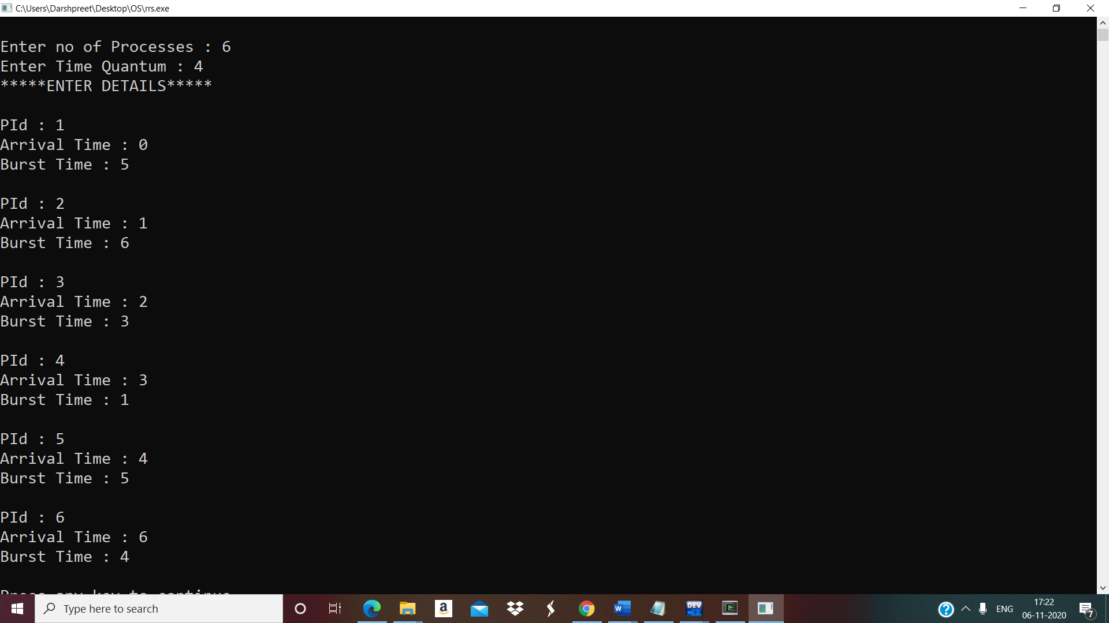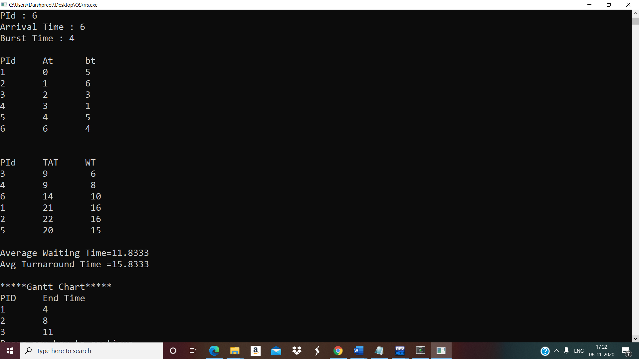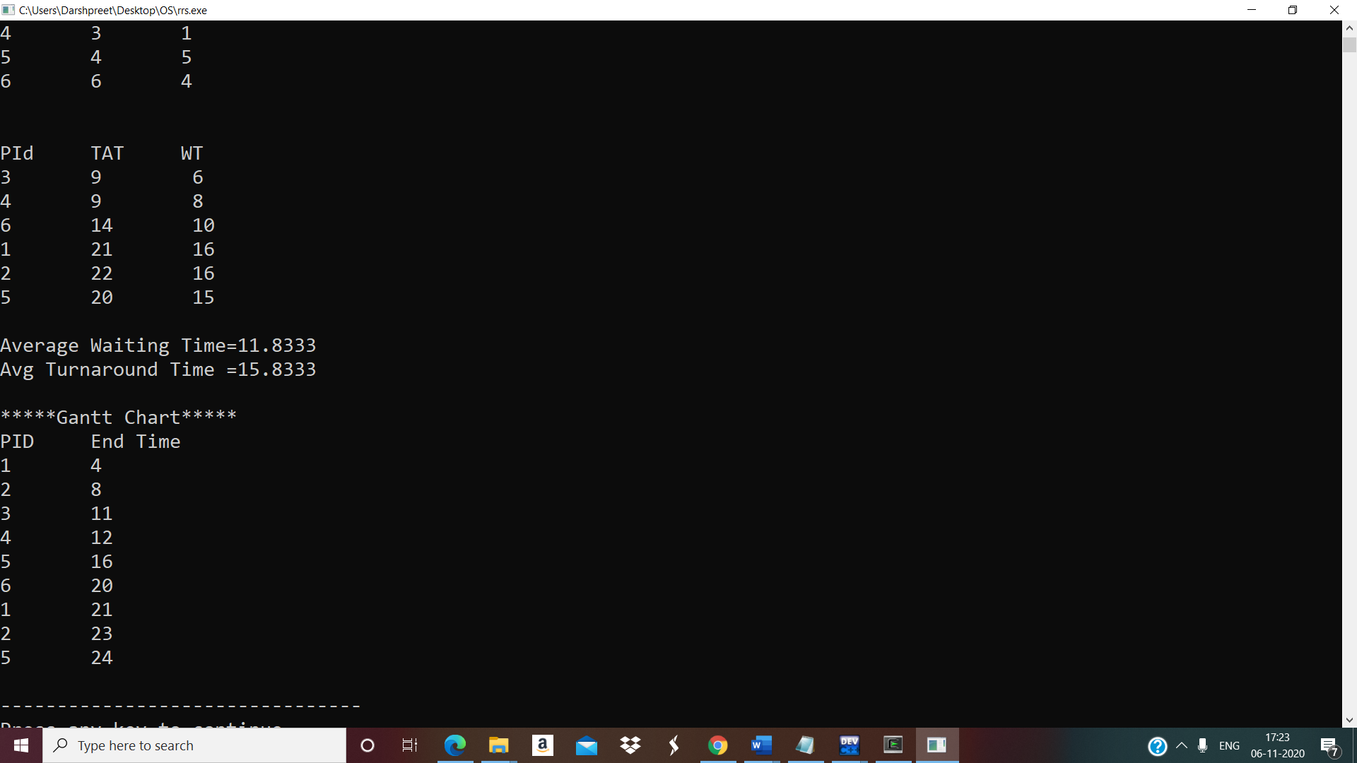………………………………………………………………………………………………
Ques9.Write a program to implement SJF scheduling algorithm.
Answer
//SJF
#include<iostream>
#include<stdlib.h>
#include<stdio.h>
using namespace std;
int n;
class Process
{
int n,pid,at,bt,tat,st,wt,ct;
int completed_flag;
Process *proc;
public:
void input();
void sort_at();
void sjf();
};

void Process :: input()
{
cout<<"Enter no of Processes :"<<" " <<endl;
cin>>n;
cout<<"\n";
proc=new Process[n];
cout<<"ENTER DETAILS :" <<endl;
for(int i=0; i<n; i++)
{
cout<<"Enter the PId for Process "<<i+1<<" : ";
cin>>proc[i].pid;

cout<<"Enter the Process Arrival Time for Process "<<i+1<<" : ";
cin>>proc[i].at;

cout<<"Enter the Process Burst Time for Process "<<i+1<<" : ";
cin>>proc[i].bt;
cout<<endl;
proc[i].completed_flag=0;
}
cout<<"\npid\tAT\tBT\n";
for(int i=0; i<n; i++)
{
cout<<proc[i].pid<<"\t"<<proc[i].at<<"\t"<<proc[i].bt<<"\n";
}
}

void Process::sort_at ()
{
for (int i=0; i<n; i++)
{
for(int j=0; j<n-i-1; j++)
{
if(proc[j].at>proc[j+1].at)
{
Process temp=proc[j];
proc[j]=proc[j+1];
proc[j+1]=temp;
}
}
}
}

void Process::sjf()
{
int ct,wt,tat,i;
sort_at();
ct=proc[0].at;
tat=ct-proc[i].at;
cout<<"Execution sequence as follow:\nSelected process info :\n";
cout<<"\nPid\tAT\tBT\tST\tCT\tWT\tTAT\n";
for(int count=0; count<n; )
{
int selected_process=-1;
for( i=0; i<n; i++)
{
if(proc[i].at<=ct && proc[i].completed_flag!=1)
{
if(selected_process==-1)
selected_process=i;
else if(proc[selected_process].bt>proc[i].bt)
selected_process=i;
}
else if (proc[i].at>ct)
break;
}
if(selected_process==-1)
{
ct++;
continue;
}
cout<<proc[selected_process].pid<<"\t"<<proc[selected_process].at<<"\t"<<proc[selected_process].bt<<"\t"<<ct<<"\t"<<ct+proc[selected_process].bt<<"\t"<<ct-proc[selected_process].at<<"\t"<<(ct+proc[selected_process].bt)-proc[selected_process].at<<"\n";
proc[selected_process].completed_flag=1;
ct=ct+proc[selected_process].bt;
count++;
}
}

int main()
{
Process p;
p.input();
p.sjf();
return 0;
}
OUTPUT : (A) WITHOUT ARRIVAL TIME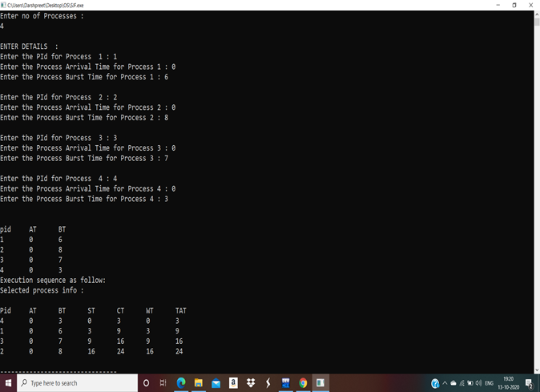 (B) WITH ARRIVAL TIME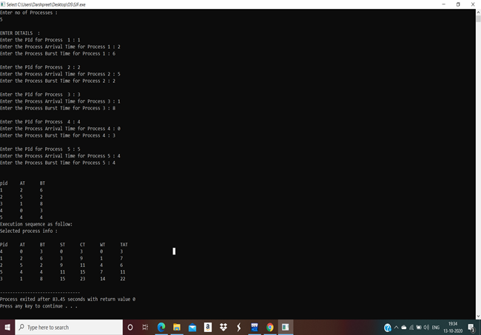
………………………………………………………………………………………………
Ques10.Write a program to implement non-preemptive priority based scheduling algorithm.
Answer
//PRIORITY(NON-PREEMPTIVE):-

#include<iostream>
using namespace std;
class Process
{
int pid;
int at; //arrival time
int bt; //brust time
int priority;
int n;
int completed_flag;
Process *proc;
public:
void input();
void sort_at();
void nonprem_priority();
};

void Process :: input()
{
cout<<"Enter no of Processes :"<<" " <<endl;
cin>>n;
cout<<"\n";
proc=new Process[n];
cout<<"ENTER DETAILS :" <<endl;
cout<<endl;
for(int i=0; i<n; i++)
{
cout<<"Enter the PId for Process "<<i+1<<" : ";
cin>>proc[i].pid;

cout<<"Enter the Process Arrival Time for Process " <<i+1<<" : ";
cin>>proc[i].at;

cout<<"Enter the Process Burst Time for Process "<<i+1<<" : ";
cin>>proc[i].bt;
cout<<"Enter the Priority for Process "<<i+1<<" : ";
cin>>proc[i].priority;
cout<<endl;
proc[i].completed_flag=0;
}

cout<<"\nPId\tAt\tBt\tPriority\n";
for(int i=0; i<n; i++)
{
cout<<proc[i].pid<<"\t"<<proc[i].at<<"\t"<<proc[i].bt<<"\t"<<proc[i].priority<<"\n";
}
}

void Process :: sort_at()
{
for (int i=0; i<n; i++)
{
for(int j=0; j<n-i-1; j++)
{
if(proc[j].at>proc[j+1].at)
{
Process temp=proc[j];
proc[j]=proc[j+1];
proc[j+1]=temp;
}
}
}
}
void Process :: nonprem_priority()
{
int ct;
sort_at();
ct=proc[0].at;
cout<<"Execution sequence as follow:\nSelected process info :\n";
cout<<endl;
cout<<"\nPId\tAT\tBT\tPriority\tST\tCT\tWT\tTAT\n";
for(int count=0;count<n; )
{
int selected_process=-1;
for(int i=0; i<n; i++)
{
if(proc[i].at<=ct && proc[i].completed_flag!=1)
{
if(selected_process==-1)
selected_process=i;

else if(proc[selected_process].priority>proc[i].priority)
selected_process=i;
}
else if (proc[i].at>ct)
break;
}
if(selected_process==-1)
{
ct++;
continue;
}
cout<<proc[selected_process].pid<<"\t"<<proc[selected_process].at<<"\t"<<proc[selected_process].bt<<"\t"<<proc[selected_process].priority<<"\t\t"<<ct<<"\t"<<ct+proc[selected_process].bt<<"\t"<<ct-proc[selected_process].at<<"\t"<<proc[selected_process].bt+(ct-proc[selected_process].at)<<"\n";
proc[selected_process].completed_flag=1;
ct=ct+proc[selected_process].bt;
count++;
}
}

int main()
{
Process p;
p.input();
p.nonprem_priority();
return 0;
}
OUTPUT :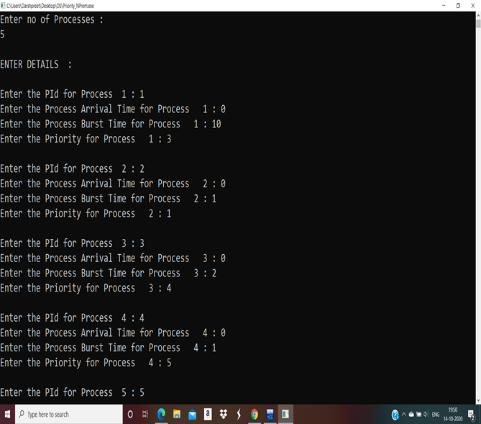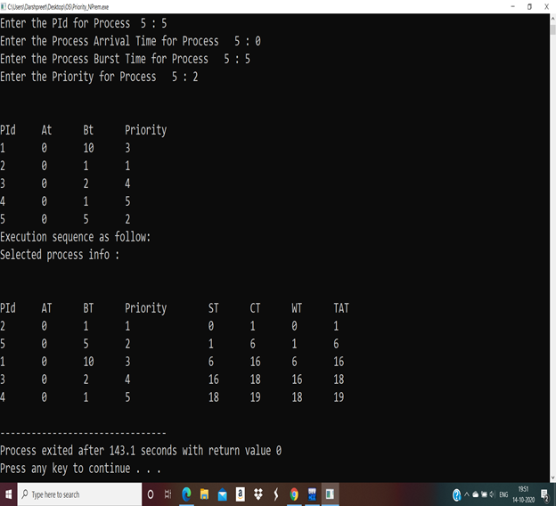………………………………………………………………………………………………
Ques11.Write a program to implement preemptive priority based scheduling algorithm.
Answer
//Preemptive priority based scheduling algorithm.

#include<iostream>
using namespace std;
class Process
{
int pid;
int at;
int bt;
int rt;
int priority;
int n;
int completed_flag;
Process *proc;
public:
void input();
void sort_at();
void prem_priority();
};

void Process :: input()
{
cout<<"\nEnter no of Processes : ";
cin>>n;
cout<<endl;
proc=new Process[n];
cout<<"ENTER DETAILS"<<endl;
cout<<endl;
for(int i=0;i<n;i++)
{
cout<<"Enter the PId for Process "<<i+1<<" : ";
cin>>proc[i].pid;

cout<<"Enter the Process Arrival Time for Process " <<i+1<<" : ";
cin>>proc[i].at;

cout<<"Enter the Process Burst Time for Process "<<i+1<<" : ";
cin>>proc[i].bt;
cout<<"Enter the Priority for Process "<<i+1<<" : ";
cin>>proc[i].priority;
cout<<endl;
proc[i].completed_flag=0;
proc[i].rt=proc[i].bt;
cout<<endl;
}
cout<<"\nPId\tAt\tBt\tPriority\n";
for(int i=0; i<n; i++)
{
cout<<proc[i].pid<<"\t"<<proc[i].at<<"\t"<<proc[i].bt<<"\t"<<proc[i].priority<<"\n";
}
}

void Process :: sort_at()
{
for (int i=0; i<n; i++)
{
for(int j=0; j<n-i-1; j++)
{
if(proc[j].at>proc[j+1].at)
{
Process temp=proc[j];
proc[j]=proc[j+1];
proc[j+1]=temp;
}
}
}
}
void Process :: prem_priority()
{
int ct;
sort_at();
cout<<"Execution sequence as follow:\nSelected process info :\n";
cout<<"\nPid\tAT\tBT\tPriority\tST\tCT\n";
for(int count=0,ct=proc[0].at; count<n;ct++ )
{
int selected_process=-1;
for(int i=0; i<n; i++)
{
if(proc[i].at<=ct && proc[i].completed_flag!=1)
{
if(selected_process==-1)
selected_process=i;

else if(proc[selected_process].priority>proc[i].priority)
selected_process=i;
}
else if (proc[i].at>ct)
break;
}
if(selected_process==-1)
{
continue;
}
cout<<proc[selected_process].pid<<"\t"<<proc[selected_process].at<<"\t"<<proc[selected_process].bt<<"\t"<<proc[selected_process].priority<<"\t\t"<<ct<<"\t"<<ct+1<<"\n";
proc[selected_process].rt--;
if(proc[selected_process].rt==0)
{
proc[selected_process].completed_flag=1;
count++;
}
}
}

int main()
{
Process p;
p.input();
p.prem_priority();
return 0;
}
OUTPUT :
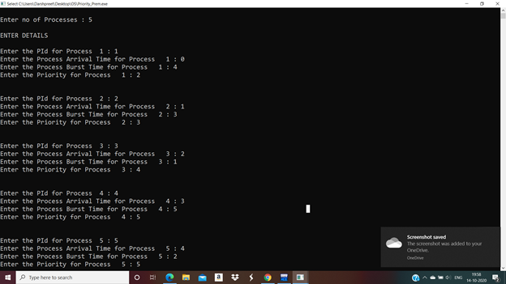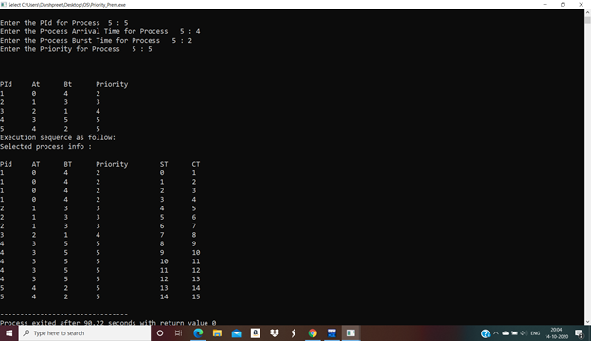
………………………………………………………………………………………………
Ques12.Write a program to implement SRTF scheduling algorithm.
Answer
//SJF(PREEMPTIVE): Shortest Remaining time First:-

#include<iostream>
#include<stdlib.h>
#include<stdio.h>
using namespace std;
int n;
class Process
{
int n,pid,at,bt,tat,st,wt,ct,rt;
int completed_flag;
Process *proc;
public:
void input();
void sort_at();
void srtf();
};

void Process :: input()
{
cout<<"Enter no of Processes :"<<" " <<endl;
cin>>n;
cout<<"\n";
proc=new Process[n];
cout<<"ENTER DETAILS :" <<endl;
for(int i=0; i<n; i++)
{
cout<<"Enter the PId for Process "<<i+1<<" : ";
cin>>proc[i].pid;

cout<<"Enter the Process Arrival Time for Process "<<i+1<<" : ";
cin>>proc[i].at;

cout<<"Enter the Process Burst Time for Process "<<i+1<<" : ";
cin>>proc[i].bt;
cout<<endl;

proc[i].completed_flag=0;
proc[i].rt=proc[i].bt;
}
cout<<"\npid\tAT\tBT\n";
for(int i=0; i<n; i++)
{
cout<<proc[i].pid<<"\t"<<proc[i].at<<"\t"<<proc[i].bt<<"\n";
}
}

void Process :: sort_at()
{
for (int i=0; i<n; i++)
{
for(int j=0; j<n-i-1; j++)
{
if(proc[j].at>proc[j+1].at)
{
Process temp=proc[j];
proc[j]=proc[j+1];
proc[j+1]=temp;
}
}
}
}

void Process :: srtf()
{
int ct;
sort_at();
cout<<"Execution sequence as follow:\nSelected process info :\n";
cout<<"\nPid\tST\tFT\n";
for(int count=0, ct= proc[0].at; count<n;ct++ )
{
int selected_process=-1;
for(int i=0; i<n; i++)
{
if(proc[i].at<=ct && proc[i].completed_flag!=1)
{
if(selected_process==-1)
selected_process=i;
else if(proc[selected_process].rt>proc[i].rt)
selected_process=i;
}
else if (proc[i].at>ct)
break;
}
if(selected_process==-1)
{
ct++;
continue;
}
cout<<proc[selected_process].pid<<"\t"<<ct<<"\t"<<ct+1<<"\n";
proc[selected_process].rt--;
if(proc[selected_process].rt==0)
{
proc[selected_process].completed_flag=1;
count++;
}
}
}

int main()
{
Process p;
p.input();
p.srtf();
return 0;
}
OUTPUT :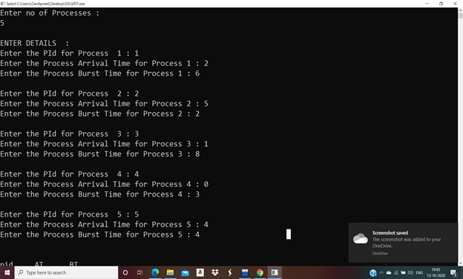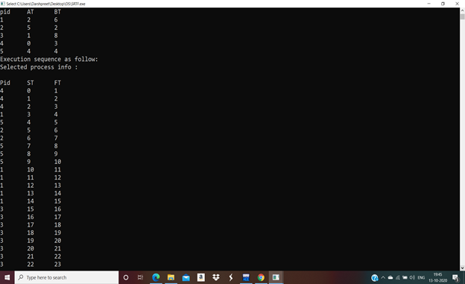………………………………………………………………………………………………
Ques13.Write a program to calculate the sum of n numbers using a thread library.
Answer
// Calculate sum of n numbers using thread library

#include<pthread.h>
#include<iostream>
using namespace std;
int sum;
void* runner(void* param);
int main(int argc,char *argv[])
{
pthread_t tid;
pthread_attr_t attr;
if(argc!=2)
{
cout<<"\nUsage :a.out<integer value>\n";
return -1;
}
if(atoi(argv[1])<0)
{
cout<<"\n%d must be >=0\n"<<atoi((const char*)(argv[1]))<<endl;
return -1;
}
pthread_attr_init(&attr); //get the default attributes
pthread_create(&tid,&attr,runner,argv[1]);//create the thread:
pthread_join(tid,NULL);//parent waits for the child thread to finish
cout<<"\nSUM is: "<<sum<<endl;//output the value of shared data "sum"
return 0;
}

//child thread will begin execution here:
void* runner(void* param)
{
int i,upper=atoi((const char*)param);
sum=0;
for(i=1;i<=upper;i++)
sum+=i;
pthread_exit(0);
}
OUTPUT :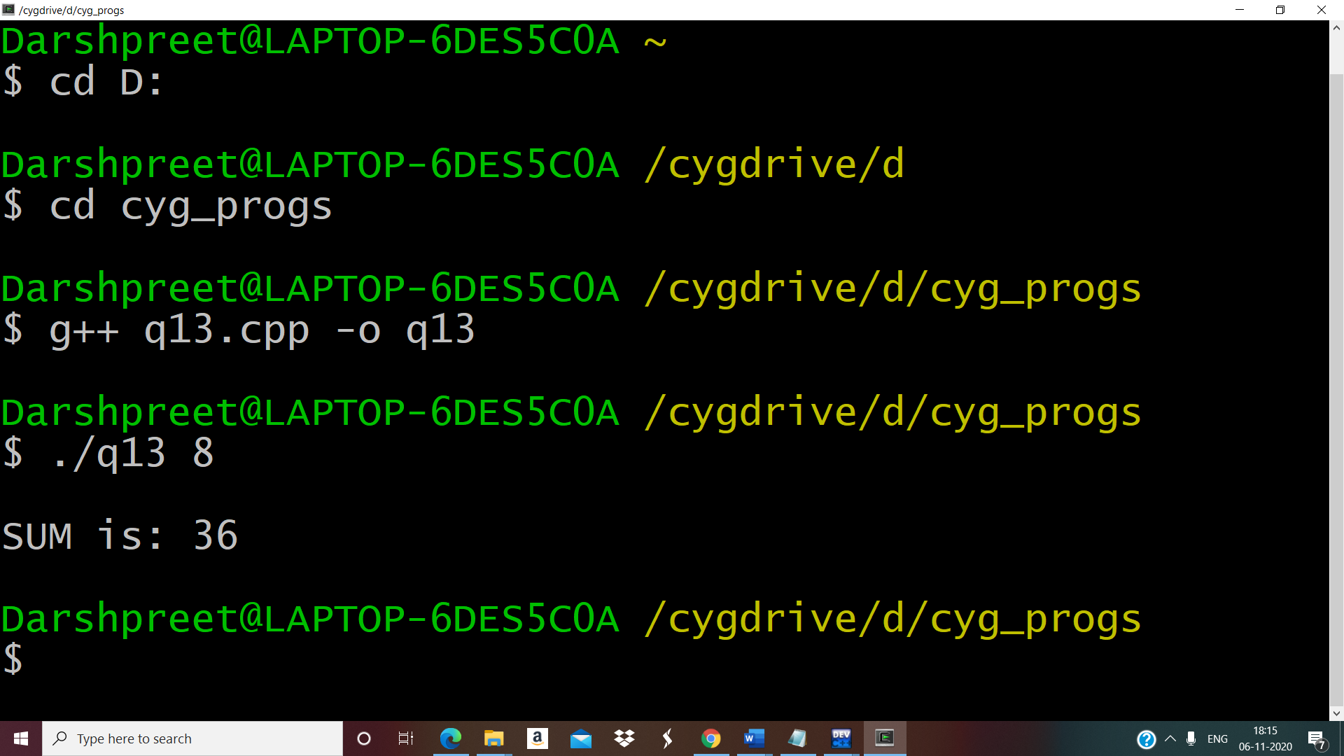
………………………………………………………………………………………………
Ques14.Write a program to implement first fit , best fit , and worst fit allocation strategies.
Answer
#include <iostream>
using namespace std;

class Fit
{
int p,h;
int *process,*hole;
public:
Fit(int,int);
void input();
void firstFit();
void bestFit();
void worstFit();
};

Fit :: Fit(int n1,int n2)
{
p=n1;
h=n2;
process=new int[p];
hole=new int[h];
}

void Fit :: input()
{
cout<<"Enter the process size :\n";
for(int i=0;i<p;i++)
{
cout<<"Process[" << i+1 << "] : ";
cin>>process[i];
}
cout<<"\nEnter the hole size :\n";
for(int i=0;i<h;i++)
{
cout<<"Hole[" << i+1 << "] : ";
cin>>hole[i];
}
}

void Fit :: firstFit()
{
int flag=1;
for(int i=0;i<p;i++)
{
for(int j=0;j<h;j++)
{
if(process[i]<=hole[j])
{
cout<<"Process size : "<<process[i]<<" -----> Hole Size : "<< hole[j] <<endl;
int flag=0;
hole[j]-=process[i];
break;
}
}
}
}

void Fit :: bestFit()
{
int loc,temp,min;
for(int i=0;i<h-1;i++)
{
min=hole[i];
loc=i;
for(int j=i+1;j<h;j++)
{
if(min>hole[j])
{
min=hole[j];
loc=j;
}
}
temp=hole[i];
hole[i]=hole[loc];
hole[loc]=temp;
}
for(int i=0;i<p;i++)
{
for(int j=0;j<h;j++)
{
if(process[i]<=hole[j])
{
cout<<"Process size : "<<process[i]<<" -----> Hole Size : "<<hole[j]<<endl;
hole[j]-=process[i];
break;
}
}
}
}

void Fit :: worstFit()
{
int flag=1;
if(p<=h)
{
for(int i=0;i<p;i++)
{
for(int j=i+1;j<h;j++)
{
if(hole[i]<hole[j])
{
int temp=hole[i];
hole[i]=hole[j];
hole[j]=temp;
}
}
}
for(int i=0;i<p;i++)
{
for(int j=0;j<h;j++)
{
if(process[i]<=hole[j])
{
cout<<"Process size : "<<process[i]<<" -----> Hole Size : "<<hole[j]<<endl;
flag=0;
hole[j]=0;
break;
}
else
flag=1;
}
if(flag==1)
cout<<"Process size : "<<process[i]<<" -----> Not Allocated"<<endl;
}
}
}

int main()
{
char ans='y';
int p,h,choice;
do
{
cout<<"Enter number of processes : ";
cin>>p;
cout<<"Enter number of holes : ";
cin>>h;
Fit f(p,h);
f.input();
cout<<"\n*****CHOOSE ALLOCATION STRATEGY*****\n";
cout<<"1.First Fit\n";
cout<<"2.Best Fit\n";
cout<<"3.Worst Fit\n";
cout<<"\nYour Choice : ";
cin>>choice;
switch(choice)
{
case 1:
f.firstFit();
break;
case 2:
f.bestFit();
break;
case 3:
f.worstFit();
break;
default:
cout<<"Make a valid choice\n";
break;
}
cout<<"\nWant to continue?(Y/n): ";
cin>>ans;
}while(ans=='Y' || ans=='y');
return 0;
}
OUTPUT :
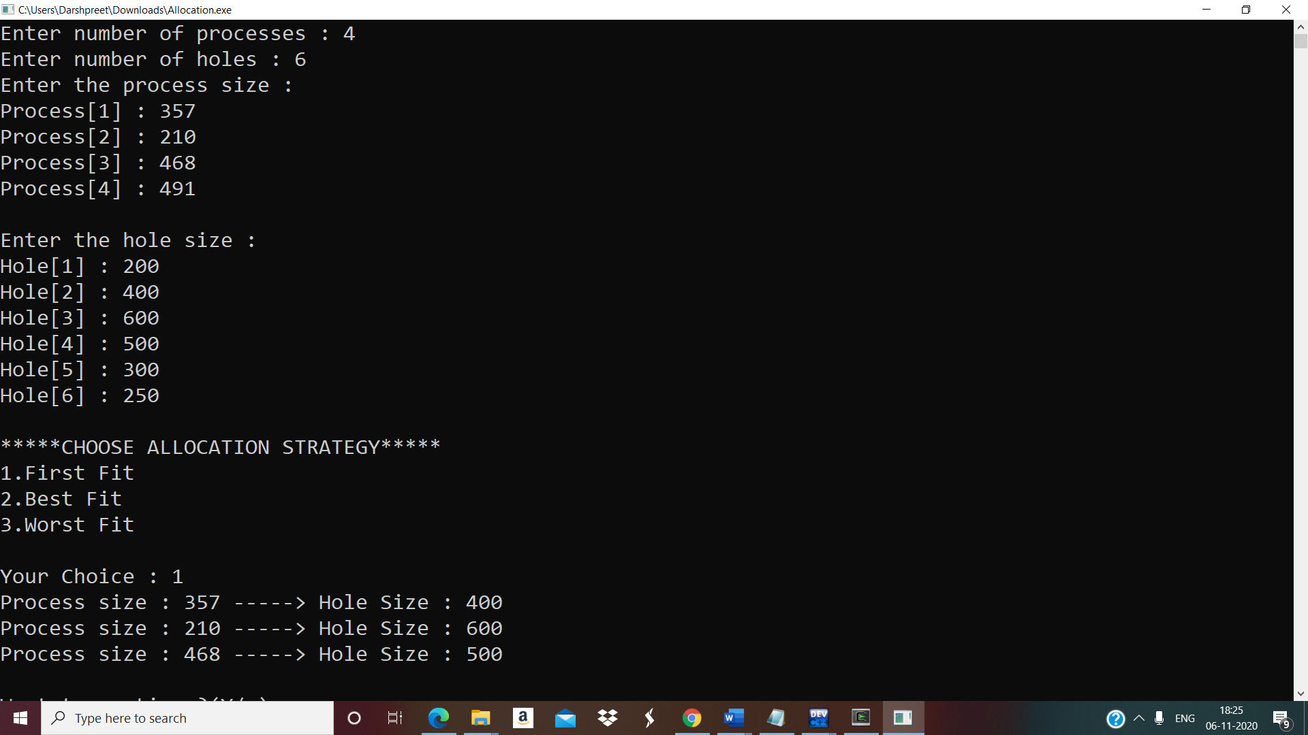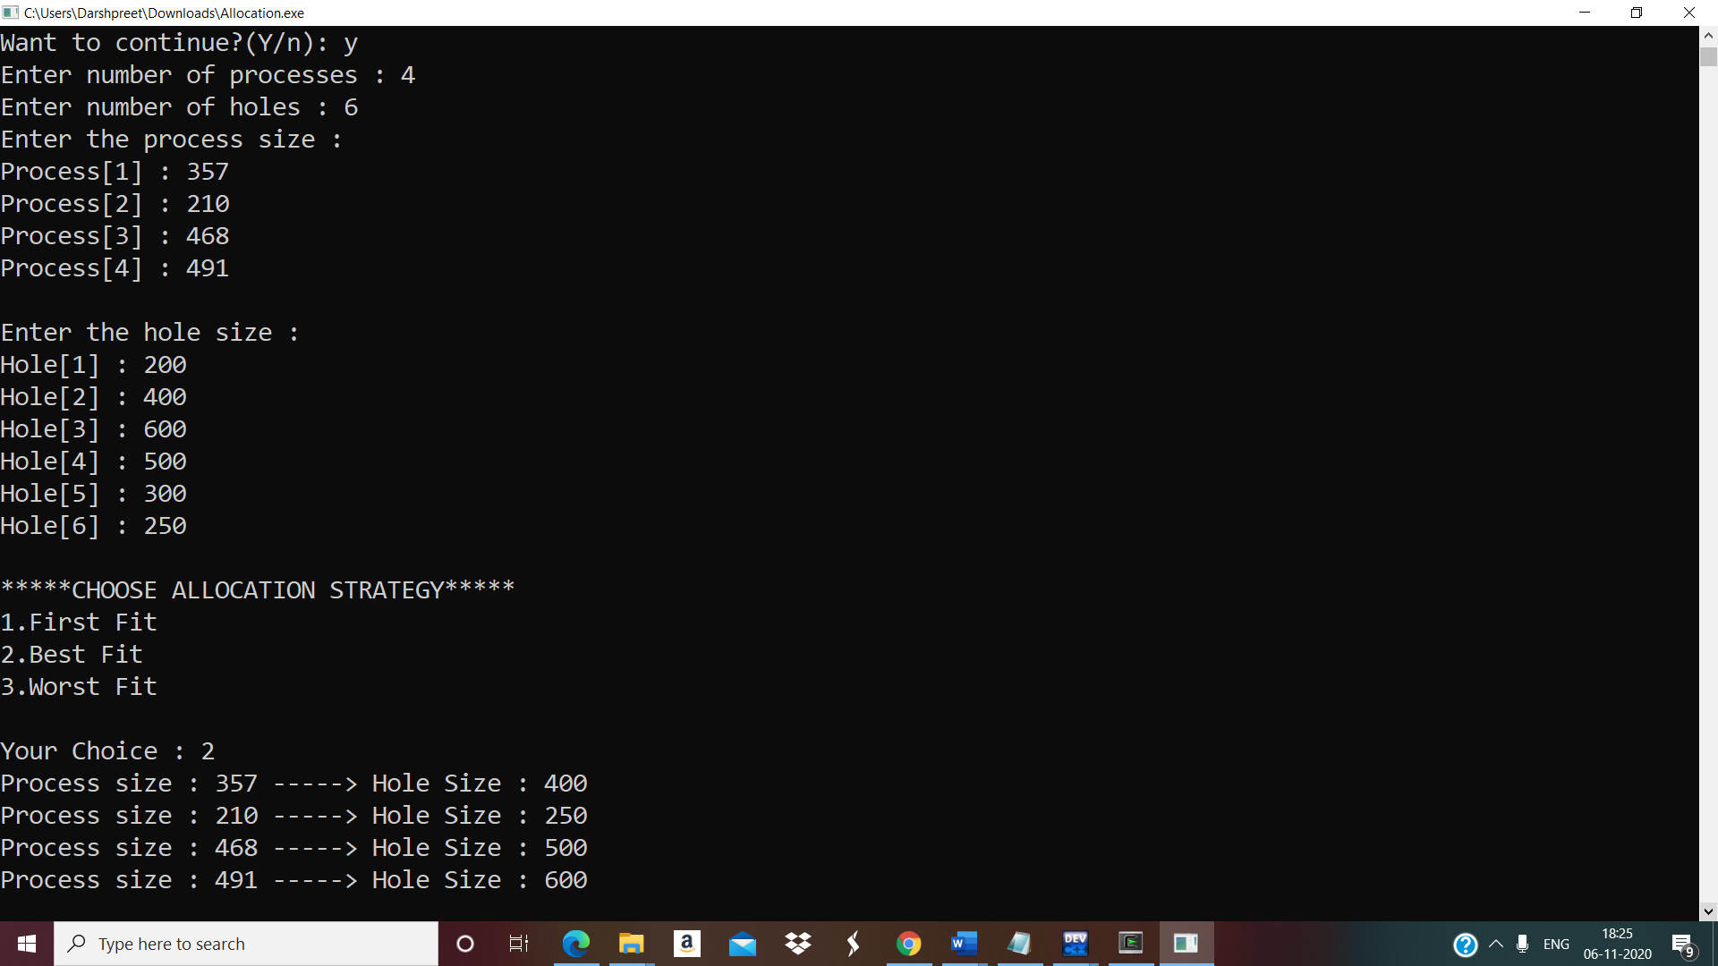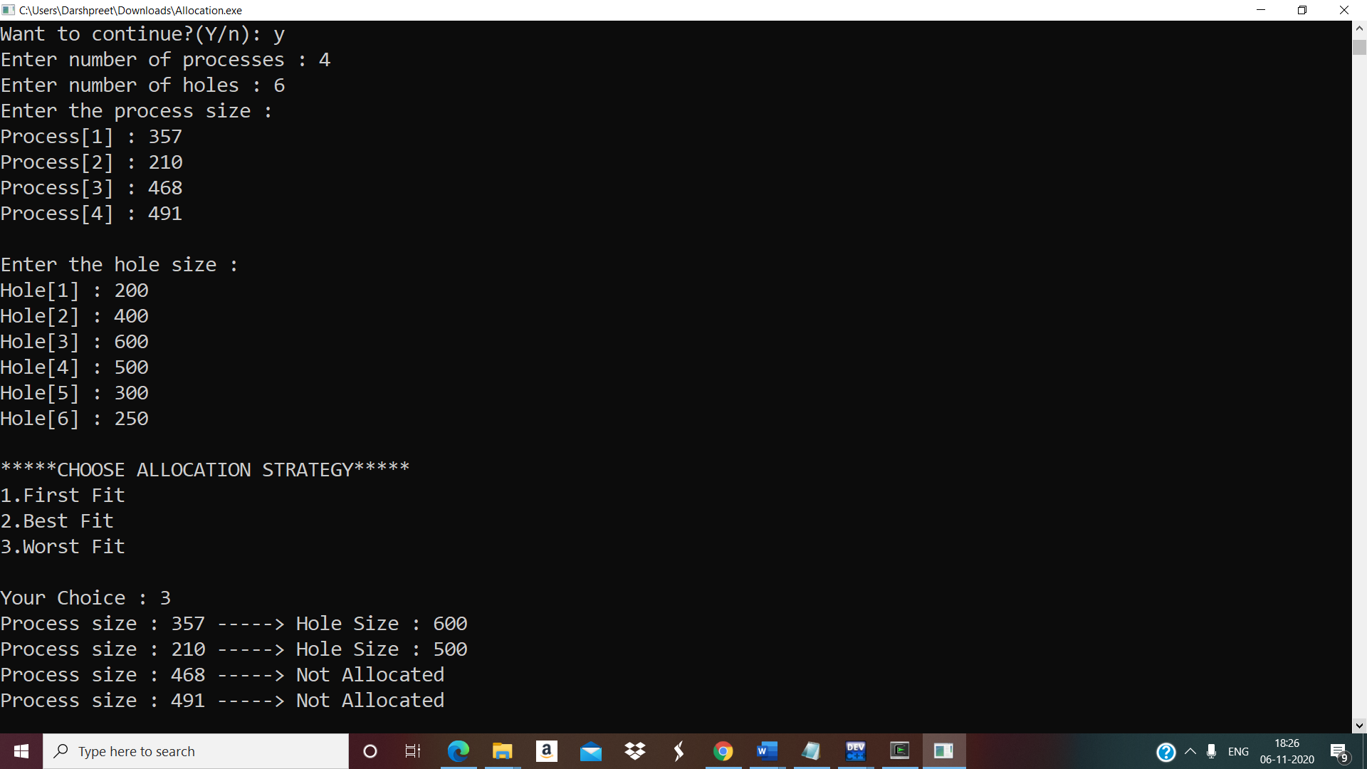………………………………. FINISH …………………………………

