Q1. Write a program to create a child process using fork() where parent and child process have same program but different codes.

CODE :
#include<iostream>
#include<unistd.h>
using namespace std;

int main()
{
int pid=fork();

if(pid<0)
{
cout<<"\n---------------------------------------\n";
cout<<"\n\t\t Unsuccessful\n";
cout<<"\n---------------------------------------\n";
return -1;
}
else if(pid==0)
{
cout<<"\n\t-------------------------------------------";
cout<<"\n\t\t I am child process ";
cout<<"\n\t-------------------------------------------";
}
else
{
sleep(1);
cout<<"\n\t-------------------------------------------";
cout<<"\n\t\t I am parent process ";
cout<<"\n\t-------------------------------------------\n";
}

return 0;
}

OUTPUT :
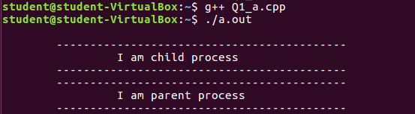

Q2. Write a program to create a child process using fork() where parent and child process have same program , different codes and parent wait for the child to finish.
CODE :
#include<iostream>
#include<sys/types.h>
#include<sys/wait.h>
#include<unistd.h>
#include<stdio.h>
using namespace std;
int main()
{
int status;
int pid= fork();
int x;

if(pid<0)
{
cout<<"\nChild process can not be created \n";
return -1;
}
else if(pid==0)
{
cout<<"\nI am child : "<<pid<<"\n";
cout<<"\nI am child. Child process id: "<<getpid()<<"\n";
execlp("/bin/ls", "ls", NULL);
}
else
{
x=wait(&status);
cout<<"\nChild complete \n";
cout<<"\nI am parent. Parent process id: "<<getpid()<<"\n";
cout<<"\nInfo returned by wait(&status): "<<x<<" which is = child process id\n";
}
return 0;
}
OUTPUT :

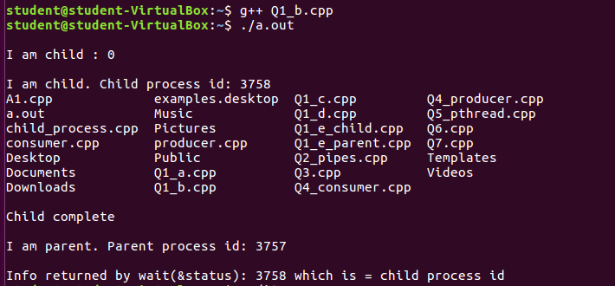

Q3. Write a program to create a child process using fork() where parent and child process have same program , same code running as concurrent processes :-

CODE :
#include<iostream>
#include<unistd.h>
#include<sys/types.h>
#include<sys/wait.h>
using namespace std;
int main()
{
int code=fork();
if(code<0)
{
cout<<"\nUnsuccessful \n";
}
else
{

cout<<"\n\t--------------------------------------------\n";
cout <<"\n\t\t Pid = " << getpid() << "\n\t\t Return code: "<< code<<"\n";
cout<<"\n\t--------------------------------------------\n";

}
return 0;
}

OUTPUT :

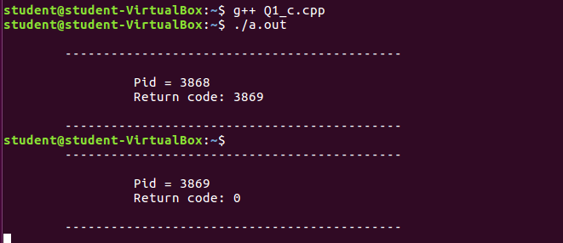

Q.4 Write a program to create a child process using fork() where parent and child process have same program , same code where parent wait for child to finish.

CODE :

#include<iostream>
#include<unistd.h>
#include<sys/types.h>
#include<sys/wait.h>
using namespace std;

int main()
{
int code=fork();
int status;
if(code<0)
{
cout<<"\nUnsuccessful \n";
}
else
{

wait(NULL);
cout<<"\n\t--------------------------------------";
cout <<"\n\t\t Pid = " << getpid();
cout <<"\n\t\t Return code: "<< code;
cout<<"\n\t--------------------------------------\n";
}
return 0;
}

OUTPUT :

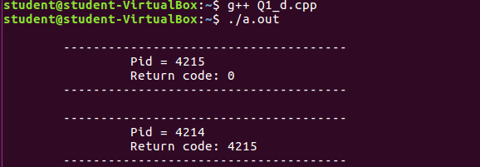

Q5. Write a program to create a child process using fork() where parent and child process have different program .

CODE :

PARENT CODE

#include <iostream>
#include <stdlib.h>
#include <string.h>
#include <sys/wait.h>
#include <sys/types.h>
#include <unistd.h>

using namespace std;

int main (int argc, char **argv)
{
int i = 0;
long sum;
int pid;
int status, ret;

cout<<"Parent: Hello, World!\n";

pid = fork ();

if (pid == 0) {

execvp ("./child", argv);
}

cout<<"Parent: Waiting for Child to complete.\n";

if ((ret = waitpid (pid, &status, 0)) == -1)
cout<<"parent:error\n";

if (ret == pid)
cout<<"Parent: Child process waited for.\n";

return 0;
}

CHILD PROCESS

#include <iostream>
#include <stdlib.h>
#include <string.h>

#define A 500
#define B 600
#define C 700

using namespace std;

int main (int argc, char **argv)
{
int i, j;
long sum;

cout<<"Child: Hello, World!\n";

for (j = 0; j < 30; j++ ) {
for (i =0; i < 900000; i++) {
sum = A * i + B * i * i + C;
sum %= 543;
}
}

cout<<"Child: Work completed!\n";
cout<<"Child: Bye now.\n";

exit (0);
}

OUTPUT :

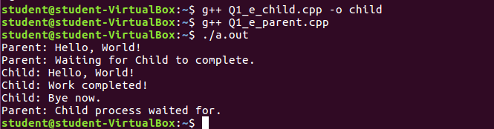

Q6. Demonstrate Inter-Process Communication (IPC) between parent
and child using pipe system call

CODE : #include<iostream>
#include<unistd.h>
#include<string.h>
#include<sys/types.h>

#define BUFFERSIZE 25
#define READEND 0
#define WRITEEND 1
using namespace std;
int main(void)
{
char writemsg[BUFFERSIZE] = "Greetings";
char readmsg[BUFFERSIZE];
int fd[2];
pid_t pid;
if (pipe(fd) == -1) {
cout<<"Pipe failed!";
return 1;
}
pid = fork();
if (pid < 0) {
cout<<"Fork Failed!";
return 1;
}
if (pid > 0) {
close(fd[READEND]);
write(fd[WRITEEND], writemsg, strlen(writemsg)+1);
close(fd[WRITEEND]);
}
else {
close(fd[WRITEEND]);
read(fd[READEND], readmsg, BUFFERSIZE);
cout<<"\n\t---------------------------------------";
cout<<"\n\t\t Read: "<<readmsg;
cout<<"\n\t---------------------------------------\n";
close(fd[READEND]);
}
return 0;
}

OUTPUT :

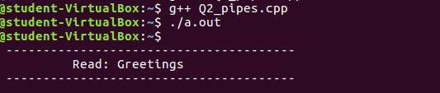

Q7. WAP to display the following :
a. kernel version
b. cpu type and model
c. information on configured memory,amount of free and used memory.

CODE :
#include<iostream>
#include<stdlib.h>
#include<stdio.h>
using namespace std;

int main()
{
cout<<"\n Kernel version is : \n";
system("cat/proc/sys/kernel/osrelease");
cout<<"\n CPU space :\n";
system("cat/proc/cpuinfo |awk 'NR==3,NR==4{print}' \n");
cout<<"\n Configured memory is :\n";
system("cat/proc/meminfo |awk 'NR==1{print $2}'\n");
cout<<"\n Amount of free space is :\n";
system("cat/proc/meminfo |awk 'NR==2{print $2}'\n");
cout<<"\n Amount of used memory is :\n";
system("cat/proc/meminfo |awk '{if(NR==1) a=$2; if(NR==2) b=$2} END{print a-b}'\n");

return 0;
}

OUTPUT :

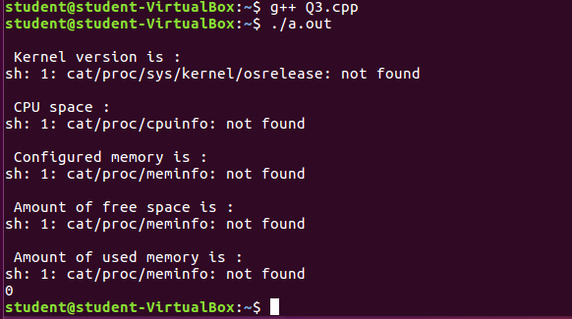

Q8. Demonstrate producer-consumer problem using shared memory.

CODE : PRODUCER

#include <stdio.h>
#include <stdlib.h>
#include <unistd.h>
#include <string.h>
#include <fcntl.h>
#include <sys/shm.h>
#include <sys/stat.h>
#include <sys/mman.h>
#include <sys/types.h>
#include <errno.h>
#include <iostream>
using namespace std;

int main()
{

const int SIZE = 4096;
const char* name = "/my_eg";
const char* message_0 = "\n Hello,";
const char* message_1 = " Nice day!\n";
int shm_fd;
void* ptr;
shm_fd = shm_open(name, O_CREAT | O_RDWR, 0666);

if (shm_fd < 0)
{
cout<<"In shm_open() of producer.";
exit(1);
}

ftruncate(shm_fd, SIZE);

ptr = mmap(0, SIZE, PROT_WRITE, MAP_SHARED, shm_fd, 0);

if (ptr == NULL)
{
cout<<"Error In mmap() requesting .";
exit(1);
}
char *cptr=(char*)ptr;

cptr=strcat(cptr,message_0);
cptr=strcat(cptr,message_1);

return 0;
}

CONSUMER

#include<iostream>
#include<stdlib.h> // used for shm_open
#include<string.h>
#include<fcntl.h>
#include<sys/shm.h>
#include<sys/stat.h>
#include<sys/mman.h>
#include<sys/unistd.h>
#include<sys/types.h>
#include<stdio.h>
using namespace std;

int main()
{
const int SIZE =4096;
const char *name ="/my_eg";
int shm_fd;
void* ptr;
shm_fd = shm_open(name, O_RDONLY, 0666);
if(shm_fd<0)
{
cout<<"\nERROR\n";
}

else
{
ptr = mmap(0, SIZE, PROT_READ, MAP_SHARED, shm_fd, 0);

cout<<(char*)ptr;
shm_unlink(name);

}
return 0;
}

OUTPUT :

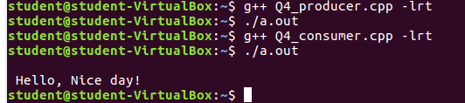

Q9. WAP to print file details including owner access permissions, file
access time, where file name is given as a command line argument.

CODE :

#include<iostream>
#include<stdlib.h>
#include<stdio.h>
#include<unistd.h>
#include <sys/stat.h>
#include <sys/types.h>
using namespace std;

int main(int argc, char** argv)
{
if(argc !=2)
{
cout<<"\nError ! ...Enter file name at runtime\n";
return 1;
}
struct stat fileStat;

if(stat(argv[1],&fileStat) < 0)
return 1;
cout<<"\nFile details for "<< argv[1]<<" are :\n";
cout<<"File Size: "<<fileStat.st_size<<" bytes\n";

printf(" time of last access: %ld : %s", fileStat.st_atime, ctime(&fileStat.st_atime));
printf(" time of last modification: %ld : %s", fileStat.st_mtime, ctime(&fileStat.st_mtime));
printf(" time of last change: %ld : %s", fileStat.st_ctime, ctime(&fileStat.st_ctime));

cout<<"File Permissions: \t";

printf( (S_ISDIR(fileStat.st_mode)) ? "d" : "-");
printf( (fileStat.st_mode & S_IRUSR) ? "r" : "-");
printf( (fileStat.st_mode & S_IWUSR) ? "w" : "-");
printf( (fileStat.st_mode & S_IXUSR) ? "x" : "-");
printf( (fileStat.st_mode & S_IRGRP) ? "r" : "-");
printf( (fileStat.st_mode & S_IWGRP) ? "w" : "-");
printf( (fileStat.st_mode & S_IXGRP) ? "x" : "-");
printf( (fileStat.st_mode & S_IROTH) ? "r" : "-");
printf( (fileStat.st_mode & S_IWOTH) ? "w" : "-");
printf( (fileStat.st_mode & S_IXOTH) ? "x" : "-");
cout<<endl;
return 0;
}

OUTPUT :

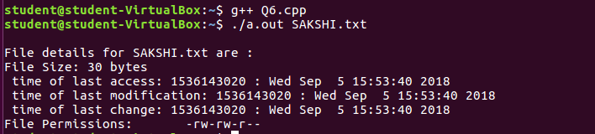

Q10. WAP to copy a source file into the target file and display the
target file using system calls.

CODE :
#include <iostream>
#include <stdlib.h>
#include <fcntl.h>
#include <errno.h>
#include<unistd.h>
#include<sys/types.h>

#define BUFF_SIZE 1024

using namespace std;

int main(int argc, char* argv[])
{
int srcFD,destFD,nbread,nbwrite;
char *buff[BUFF_SIZE];

/*Check if both src & dest files are received or --help is received to get usage*/
if(argc != 3 || argv[1] == "--help")
{
cout<<"\nUsage: cpcmd source_file destination_file\n";
exit(EXIT_FAILURE);
}

/*Open source file*/
srcFD = open(argv[1],O_RDONLY);

if(srcFD == -1)
{
cout<<"\nError opening file "<<argv[1]<<" errno = \n"<<errno;
exit(EXIT_FAILURE);
}

/*Open destination file with respective flags & modes
O_CREAT & O_TRUNC is to truncate existing file or create a new file
S_IXXXX are file permissions for the user,groups & others*/

destFD = open(argv[2],O_WRONLY | O_CREAT | O_TRUNC, S_IRUSR | S_IWUSR | S_IRGRP | S_IWGRP | S_IROTH | S_IWOTH);

if(destFD == -1)
{
cout<<"\nError opening file "<<argv[2]<<" errno = \n"<<errno;
exit(EXIT_FAILURE);
}

/*Start data transfer from src file to dest file till it reaches EOF*/
while((nbread = read(srcFD,buff,BUFF_SIZE)) > 0)
{
if(write(destFD,buff,nbread) != nbread)
cout<<"\nError in writing data to \n"<<argv[2];
}

if(nbread == -1)
cout<<"\nError in reading data from \n"<<argv[1];

if(close(srcFD) == -1)
cout<<"\nError in closing file \n"<<argv[1];

if(close(destFD) == -1)
cout<<"\nError in closing file \n"<<argv[2];

exit(EXIT_SUCCESS);
}

OUTPUT :

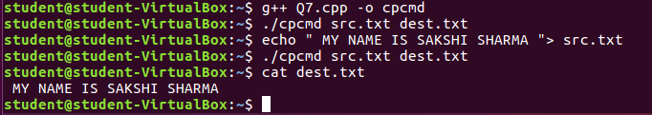

Q11. Solve the producer consumer problem using shared memory.

CODE : PRODUCER

#include<iostream>
#include<sys/types.h>
#include<unistd.h>
#include<fcntl.h>
#include<sys/stat.h>
#include<string.h>
#include<sys/shm.h>
#include<stdio.h>
#include<sys/mman.h>
#include<stdlib.h>

using namespace std;

int main()
{
const int SIZE = 4096 ;
const char *name = "/my-eg" ;
const char *msg_1 = "\n\t\t Hello" ;
const char *msg_2 = " World\n" ;

int shm_fd ;

void *ptr ;
shm_fd = shm_open(name, O_CREAT | O_RDWR, 0666);
if(shm_fd<0)
{
cout<<"Error in shm_open method!";
}
else
{
ftruncate(shm_fd, SIZE) ;
ptr = mmap(0, SIZE, PROT_WRITE,MAP_SHARED,shm_fd,0);

char *cptr = (char*)ptr ;
cptr = strcat(cptr,msg_1) ;
cptr = strcat(cptr,msg_2) ;
}
return 0 ;
}

CONSUMER

#include<iostream>
#include<sys/types.h>
#include<unistd.h>
#include<fcntl.h>
#include<sys/stat.h>
#include<string.h>
#include<sys/shm.h>
#include<stdio.h>
#include<sys/mman.h>
#include<stdlib.h>

using namespace std;

int main()
{
const int SIZE = 4096 ;
const char *name = "/my-eg" ;
int shm_fd ;

void *ptr ;
shm_fd = shm_open(name, O_RDONLY, 0666);
if(shm_fd<0)
{
cout<<"Error in READING shm OBJECT!"<< endl;
}
else
{
ptr = mmap(0, SIZE, PROT_READ,MAP_SHARED,shm_fd,0);
cout << (char*)ptr ;
shm_unlink(name) ;
}

return 0 ;
}

OUTPUT :

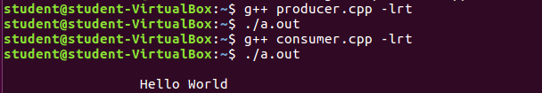

Q12. Write program to understand working of Pthread library.

CODE :
#include<pthread.h>
#include<stdio.h>
#include<stdlib.h>
#include<iostream>
using namespace std;
int sum;

void* runner(void* param)
{
int i,upper=atoi((const char*)param);
sum=0;
for(i=1;i<=upper;i++)
sum+=i;
pthread_exit(0);
}

int main(int argc,char *argv[])
{
pthread_t tid;
pthread_attr_t attr;
if(argc!=2)
{
cout<<"\nUsage :a.out<integer value>\n";
return -1;
}
if(atoi(argv[1])<0)
{
cout<<"\n%d must be >=0\n"<<atoi((const char*)(argv[1]));
return -1;
}
pthread_attr_init(&attr);
pthread_create(&tid,&attr,runner,argv[1]);
pthread_join(tid,NULL);

cout<<"\nSUM is: "<<sum<<endl;
return 0;
}

OUTPUT :
