ONLINE MOVIE TICKET SYSTEM

SOFTWARE ENGINEERING PROJECT REPORT
[Submitted in partial fulfillment]
As a part of the curriculum of
B.SC. (H) COMPUTER SCIENCE
From


Mata Sundri College for Women, New Delhi
University of Delhi

Submitted by:
Sweta Khatri (17044570027)
Radhika Gupta (17044570031)
B.Sc. (H) COMPUTER SCIENCE
IV SEMESTER
Mata Sundri College for Women
Mata Sundri Lane, New Delhi 110002
ACKNOWLEDGEMENT

Any project is incomplete without guidance and motivation. We are very much thankful to our mentor Ms. ASHEMA HASTI, who has provided us the opportunity and motivation to gain knowledge throughout the course of this project.

And last but not the least, we are thankful to all our friends, batchmates and other people who have directly or indirectly helped us during the preparation of this project.

Thank you.

Name - Sweta Khatri
Roll no. - 170443570027
Sign -

Name - Radhika Gupta
Roll no. - 170443570031
Sign -

CERTIFICATE

This is to certify that the project entitled Online Movie Ticket System i.e. “Movie Basket” is a bonafide work submitted by Ms. Sweta khatri and Ms. Radhika Gupta from Mata Sundri College for Women in partial fulfillment of the requirements of BSc (H) Computer Science, IV semester.

It has been completed under the supervision of Ms. Ashema Hasti, Assistant Professor, Department of Computer Science, Mata Sundri College for Women, Delhi University.

(ASHEMA HASTI)
Assistant Professor
Department of Computer Science
Mata Sundri College for Women
University of Delhi
TABLE OF CONTENTS

SNO. | TOPIC | Page No.
1 | PROBLEM STATEMENT
2 | PROCESS MODEL
3 | PROJECT SCHEDULING
4 | TIMELINE CHART
5. | SOFTWARE REQUIREMENTS SPECIFICATION
6. | CONTEXT LEVEL DIAGRAM
7. | DFD LEVEL 1
8. | DFD LEVEL 2
9. | DATA DICTIONARY
10. | USE CASE DIAGRAM
11. | USE CASE DESCRIPTION
12. | PROJECT METRICS
13. | COCOMO MODEL
14. | RISK ANALYSIS
15. | ER DIAGRAM
16. | DATA DESIGN
17 | COMPONENT LEVEL DESIGN
18 | TESTING
19 | References
20 | ANNEXURES

ABSTRACT

The online movie ticket system provides a website for a cinema hall where any internet user can access it. User is required to login to the system and needs a Credit / Debit card for booking the tickets. Watching movies with family and friends in theatres is one of the best medium of entertainment after having a hectic schedule. But all this excitement vanishes after standing in hours in long queues to get tickets booked.

The customer will need to enter the information related to film after which the system will provide complete information regarding currently running movies with details of show timings and available seats. The user can order his favorite snacks in app which will be served to them in the cinema hall. If seats are available, the customer can change the position of the seats while they will get an option to cancel of tickets .If cancellation request is before three hours of their movie timing then refund facility is also provided to that user.

Our online movie ticket system is one of the best opportunities for those who cannot afford enough time to get their tickets reserved standing in long queue.

In this system, the staff of the cinema hall won’t have to do anything for the ticket booking as the process will be done by the customer through the app which will reduce the amount of staff required in the booking counter.

PROBLEM STATEMENT

The main objective of “MOVIE BASKET” is to provide a convenient way to the users to book the tickets for cinema hall online, through which they can book tickets anytime and anywhere.

Our app will also give the facility to let the user select any timing slot and they have the authority to choose any seat according to their convenience . This app is basically made for providing customer an anytime and anywhere service for booking the seat in the cinema hall and to gather information about the movies online. The user can easily be able to know about the movies released and then make the choices.

User can wish to see the trailer of movie released and did not need to browse to other websites.

Features:
- Register – User have to create their account in our app .So that they get the notificationabout the latest movies released.
- Login – Both user and admin can login in app with their respective credentials .On Success Login, home page will be open.
- Change password – User can change his/her password by providing appropriate details.
- Book Ticket - User can book their favourite movie ticket.
- Order Snacks – Apart from buying movie ticket, User can also buy snacks at the time of ticket booking.
- Payment – User should pay the money after booking ticket and If user ordered snacks then its payment is also done together with ticket payment.
- Send Ticket- After successful payment, user get ticket together with QR Code, seat number and other essential information by email and sms.
- Cancel Ticket - In some situation, if user want to cancel the ticket then user can do this if and only if certain terms and conditions (such as cancellation should be before 3 hours of movie time and some other information) are fulfilled.

This app adopts a comprehensive approach to minimize the manual work and schedule resources, time in a cogent manner.

E-ticket is a brand new ticketing method that allows us to print tickets at home using your local printer connected to the computer. Internet customers will be presented with a custom ordering program that allows them to book tickets from a list of movies in the website.

Before they can order they have to provide their name and the mailing address. Each ticket will be displayed with its movie name, show timings, price and the seat numbers. The customers can book any number of tickets at a time.

The system computes the total price. The User has to enter the valid credit card information to confirm their booking.

After completing all the necessary criteria, the original information is added to the database and the ticket is confirmed for printing.

The ticket will be provided with the bar code for the security purposes. The staffs check the barcode on the ticket before the entry.

INCREMENTAL MODEL

What is Incremental Model?

Incremental Model is a process of software development where requirements are broken down into multiple standalone modules of software development cycle. Incremental development is done in steps from analysis design, implementation, testing/verification, maintenance.
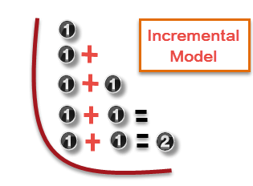
Each iteration passes through the requirements, design, coding and testing phases. And each subsequent release of the system adds function to the previous release until all designed functionality has been implemented.
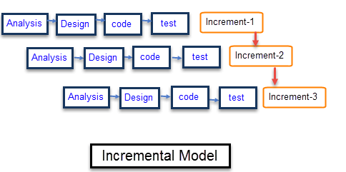

We have used Incremental Model because :-
- It is flexible and less expensive to change requirements and scope.
- Development stages changes can be done.
- This model is less costly compared to others.
- A customer can respond to each building.
- Errors are easy to be identified.
- The software will be generated quickly during the software life cycle.

PROJECT SCHEDULING
Time-Line Chart
Work Tasks | January |  |  |  | February |  |  |  | March |  |  |  | April
 | W1 | W2 | W3 | W4 | W1 | W2 | W3 | W4 | W1 | W2 | W3 | W4 | W1 | W2 | W3 | W4
Problem
Statement
Process Model
SRS
ERD
Data
Dictionary
Context
Level Diagram
DFD
(Level-1)
DFD
(Level-2)
Use Case
Diagram
Use Case
Description
Function
Point Metrics
COCOMO
Model
Risk
Analysis
Testing

PROJECT TABLE

Work | Planned  start | Actual  Start | Planned Complete | Actual complete | Assigned Person(s) | Effort Allocated
Problem Statement | Jan,w1 | Jan,w1 | Jan,w2 | Jan,w2 | Sweta Khatri,  Radhika Gupta | 2 pw
Process model | Jan,w2 | Jan,w3 | Jan,w3 | Jan,w3 | Sweta Khatri,  Radhika Gupta | 2 p-w
Project Scheduling | Jan,w4 | Jan,w4 | Jan,w4 | Jan,w4 | Sweta Khatri,  Radhika Gupta | 2 p-w
Software Requirement specification | Jan,w3 | Jan,w3 | Feb,w1 | Feb,w1 | Sweta Khatri,  Radhika Gupta | 2 p-w
Entity Relationship Diagram | Feb,w2 | Feb,w2 | Feb,w2 | Feb,w2 | Sweta Khatri,  Radhika Gupta | 2 p-w
DataDictionary | Feb,w2 | Feb,w2 | Feb, w3 | Feb,w3 | Sweta Khatri,  Radhika Gupta | 2 p-w
ContextLevel Diagram | Feb,w3 | Feb,w4 | Feb,w4 | Feb,w4 | Sweta Khatri,  Radhika Gupta | 2 p-w
Data Flow Diagram (level 1) | Feb, w4 | March,w1 | March,w1 | March,w2 | Sweta Khatri,  Radhika Gupta | 2 p-w
Data Flow Diagram  (Level 2) | March w2 | March,w3 | March,w4 | April,w1 | Sweta Khatri,  Radhika Gupta | 2 p-w
User caseDescription | March,  w4 | March,w4 | March,w4 | March,w4 | Sweta Khatri,  Radhika Gupta | 2 p-w
Functionalpoint Metrics | April,w1 | April,w1 | April,w1 | April,w1 | , Sweta Khatri ,  Radhika Gupta | 2 p-w
Effort estimation using COCOMO model | April,w2 | April,w2 | April,w2 | April,w2 | Sweta Khatri,  Radhika Gupta | 2 p-w
Testing | April,w2 | April,w3 | April,w3 | April,w3 | Sweta Khatri,  Radhika Gupta | 2 p-w

SYSTEM REQUIREMENTS SPECIFICATION

- Introduction
This document gives detailed functional and non-functional requirements for the Online Movie Ticket Booking System. This app is basically made for providing customer an anytime and anywhere service for booking the seat in the cinema hall and to gather information about the movies online.
1.1 Purpose and Scope
- The main purpose of our online ticket booking system is to provide another way for the user to buy cinema ticket. It is an automatic system.
- After inserting the data to database, staff need not to due with the order receive through the system. In fact, there is similar system on the internet, but there is no refund method found in the existing system.
- This system is basically aimed to provide the user the complete information of the movie, according to which the user can book the tickets and along with can order snacks and the refund facility provides more flexibility to the system.
- The goals of our system are:
1. To provide an anytime anyplace service for the user.
2. To minimize the number of staff at the ticket box.
3. To promote the film on the internet.
4. To increase the profit to obtain statistic information from the booking record.

1.2 ABBREVIATIONS AND ACRONYMS
- SRS-Software Requirement Specification
- DD-Data Dictionary
- DFD-Data Flow Diagram
- User- registered customer of the system.
- Admin- person who interacts with the system.

1.3 OVERVIEW
This app adopts a comprehensive approach to minimize the manual work and schedule resources, time in a cogent manner. The software controls redundancy so that no two users can access the same seat at the same time and transactions should be independent.

2, PROJECT DESCRIPTION

2.1 Product Perspective
  - If the actor has a role of an admin then he/she would have access to accept user’s request and make required updation in the database register, login, change password, payment and cancel ticket.
  - If the actor has a role of user then he/she would have access to register, login, change password, book movie ticket, order snack, payment and cancel ticket.
2.2 System Interfaces
This system does have one interface with online payment gateway of the existing systems.

2.2.1 System Specifications
- Hardware Requirements –
- Intel Pentium and Celeron class processor
- Processor Speed – 1.2 GHz or above
- RAM - 512 MB
- HDD - 40 GB
- Monitor-14”SVGA
- Printer
- Mouse- Normal
- Keyboard- Normal

- Software Requirements –
  - Front-end Tool: - Microsoft ASP.NET 2.0
- User friendly
- Low Cost Solution
- GUI feature
- Better designing aspects

  - Back-end Tool: - Microsoft SQL Server 2005
- Security
- Portability
- Quality
- Efficiency
- Maintainability

  - Platform: - Windows platform like: 2000 professional, XP & Vista // windows 10

2.2 Product Functions
- Register
Input – Name , email-id , contact No. , Password
Processing – User will be registered
Output – User’s account has been created successfully
- Login
Input – Id Name ,Password
Processing – credentials will be checked to verify the user or admin
Output – Go to Home page
- Book Ticket
Input – Movie name , date , time , seat type , No. of tickets
Processing – credentials of movie will be checked that desired seat is available or not .
Output – movie will be booked
- Order Snacks
Input – Food item ,No. of Item
Processing – snack will be check that it is available or not
Output – snack will be ordered
- Payment
Input – Card No. , CVV No.
Processing – details are verified
Output – payment done successfully
- Send Notification
Input – none
Processing – sends conformational message
- Cancel Ticket
Input – user Id , Password , Ticket Id
Processing – cancellation process is start by checking that it fulfill cancellation constraint
Output – Ticket will be cancelled with/without refund .

2.3 General Constraints

User interface is only in English. No other language option is available.

Our system is confined to only one particular cinema hall of a particular Delhi NCR.

Internet connection is required to use the system.

The files in which the information regarding user’s account should be secured against malicious deformations.

Data should not become corrupted incase of system crash or power failure.

User should carry their mobile phones with registered mobile number.

2.4 User Characteristics

User uses the system to fetch information about available movies, their price, duration, date and timings and majorly to book tickets.

Admin manages the system and keeps it up-to-date. Admin also looks over user requirements.

User can also give feedback of the movie watched, in the form of ratings.
- Central server of the system must be able to handle all the incoming requests simultaneously.
- Back up of the databases in case of hardware failure, disaster, natural calamities.

2.5 Assumptions and Dependencies
- Admin is created in the system already.
- Roles and tasks are predefined.
- There is a limit of booking a movie. If the hall is houseful then user cannot book the movie at that time.
- In general it has been assumed that the user has complete knowledge of the system that means user is not a naive user. Any data entered by him/her will be valid.
- It depends that the one should follow the international standards for the generating the User ID &should fill the related information in the proper format.
- Password must contain atleast 10 characters according to the rule.
- Internet is must.

3. SPECIFIC REQUIREMENTS.
3.1. EXTERNAL INTERFACES. - Payment Gateway is the external interface.

3.1.1 USER INTERFACE

It is a login window that requires user to enter correct ID and password, so that after authentication of data stored in the user database is approved as a valid user so that user enter into our application.

If the user does not exist, then the user must register in order to access the system functionalities. ID and password will be stored in the database for future login purpose.

User login to book movie tickets by selecting movie name, date, time, venue and number of tickets required.

3.1.2. HARDWARE INTERFACE
Various interfaces for the product could be
- Touch screen/Monitor
- Keypad
- Continuous battery backup

3.1.3. SOFTWARE INTERFACE
- Any operating system.
- JavaScript is required for highly interactive environment.

3.1.4. DATABASE INTERFACE

All databases for the software will be configured. These databases include movie’s details database, users’ details database and admin database.

The users’ details database includes user ID, password and previous and current booking details.

The events’ details database includes information about all listed events, their organizers, dates, timings, venue, price per ticket and available seats.

The organizers’ details database includes organizers’ ID, password and previous and current listed events’ details.

3.2 FUNCTIONAL REQUIREMENTS
- New users can see the movie details but cannot book it until they are registered in the system.
- Registered users should be able to login to the system through the first page of the Application.
- Registered users can change the password after logging into the system.
- No reservation for movie ticket, before 2 days can be done.
- See his/her current reservations on different movies along with the details.
- Able to choose the seats which are available for a certain class like silver, gold, platinum.
- Able to order snacks at the time of movie booking.
- Along with the snacks, user can apply coupons in order to avail discount.
- Give details about the credit card for the payment like account number, CVV number.
- A message and mail should be sent to the concerned person about the confirmation of the ticket to the specified mobile number.
- The login Id and password should be sent to the mentioned email address if a new account is created.
- The system should automatically show the fare for the corresponding movies and amount of money needs to be paid for selected seats.
- User can cancel the movie ticket anytime but with a limitation, if he/she cancels before 3 hours of show timing than 50% money is refunded back into his/her account otherwise only ticket will be cancelled without any refund.

3.3. PERFORMANCE REQUREMENTS
3.3.1 SECURITY:-
The Online Movie Ticket System is fully accessible to only authentic user. It requires username and password to become member of the app.
3.3.2. RELIABILITY:-
The application is highly reliable and it generates all the updated information in correct order.
3.3.3. AVAILABILITY:-
Any information should be quickly available from any computer to the authorized user.
3.3.4. MAINTAINABILITY:-
The application is maintainable in such a manner that if any new requirements occur then it should be easily incorporated in an individual module.
3.3.5. PORTABILITY:-
The application is not machine specific.
3.4 DESIGN CONSTRAINTS:
- Software Language Used-
The languages that can be used for coding Online Movie Ticket System are JavaScript and HTML.

- Database Design-
In our database design, we give names to data flows, processes and data stores. Although the names are descriptive of data, they do not give details. Our interest is to build some details of the contents of data flow, processes and data store. A data dictionary is a structured repository of data about data. It is a set of rigorous definitions of all DFD data elements and structures.

3.4.1 STANDARD COMPLIANCE
Report format: All the reports produced for this project are in compliance with the standard templates provided in the class by the advisor.
Naming Conventions: All the documents will be named using the standard naming conventions.

3.5 DATA FLOW DIAGRAMS

3.5.1 Context Level Diagram
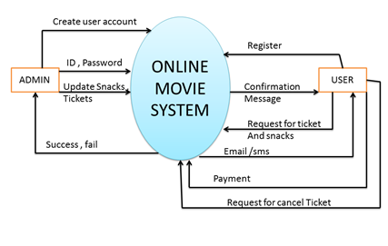
Figure No. 3.5.1 : Context Level Diagram

3.5.2 DFD Level 1 Diagram

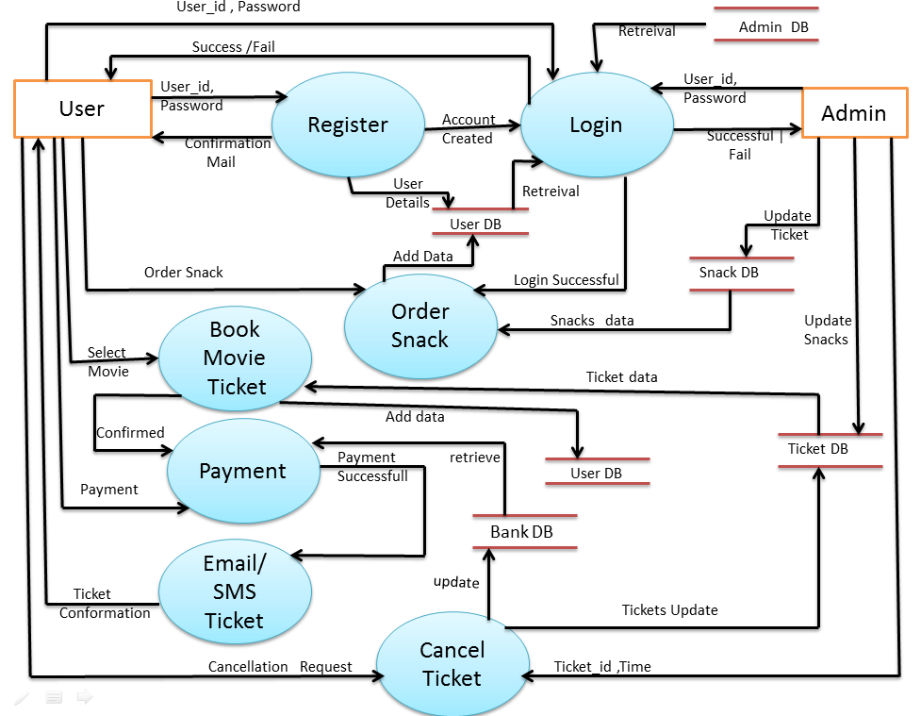

FigureNo, 3.5.2 : DFD Level 1 Diagram

3.5.3. DFD Level 2 Diagram

Register Module:
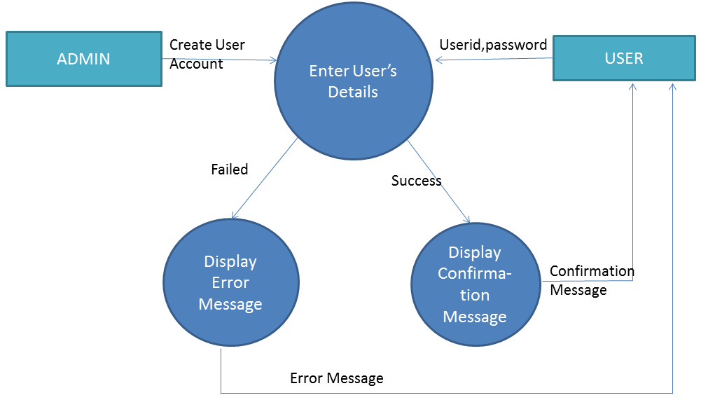
Login Module:
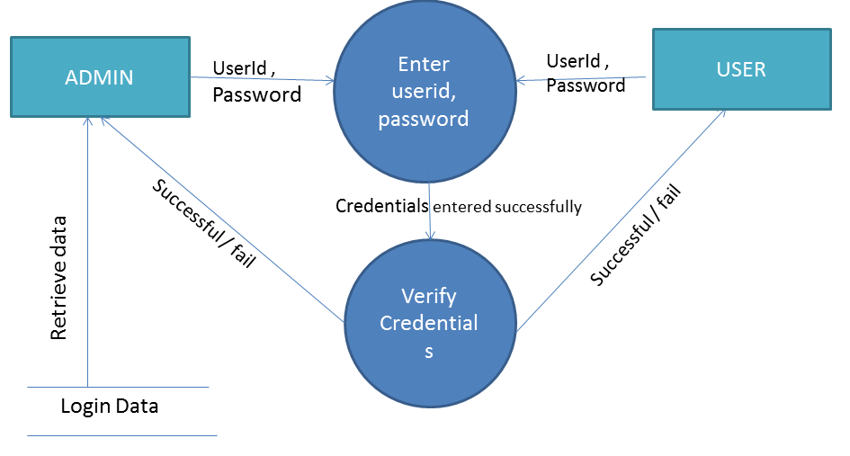
Book Movie Ticket Module:
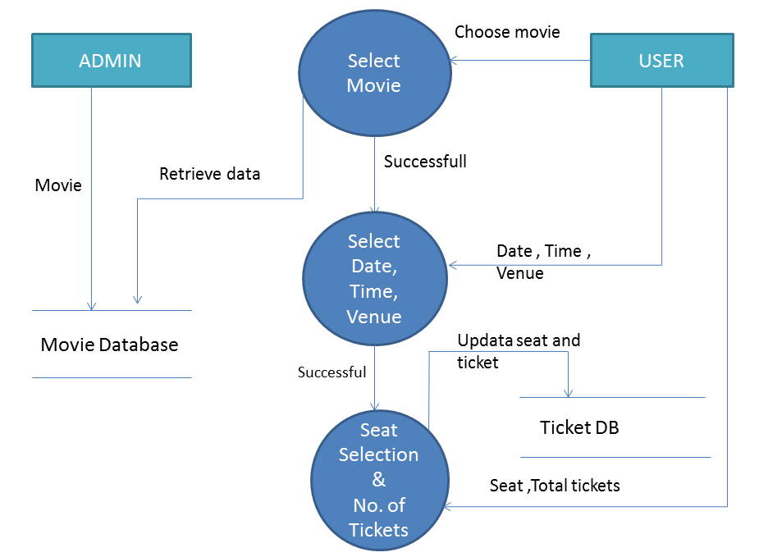
Order Snack Module:
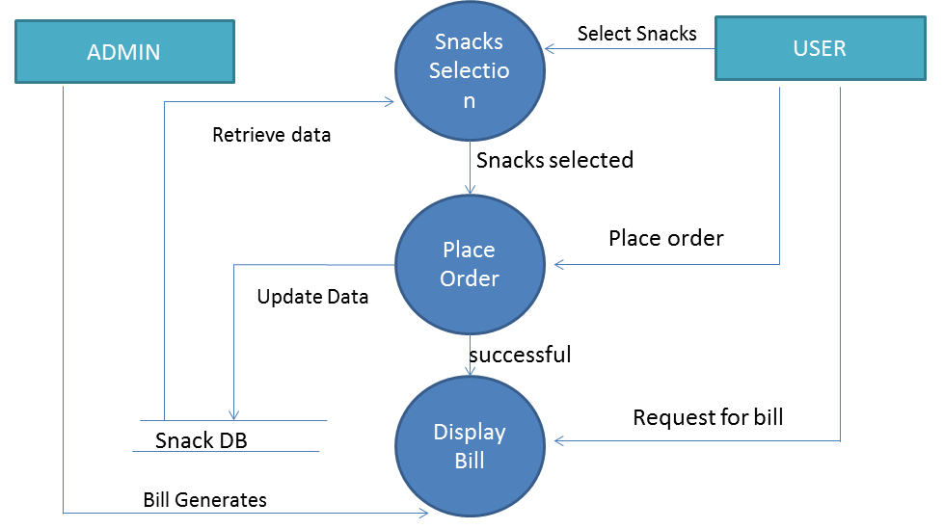
Payment Module: 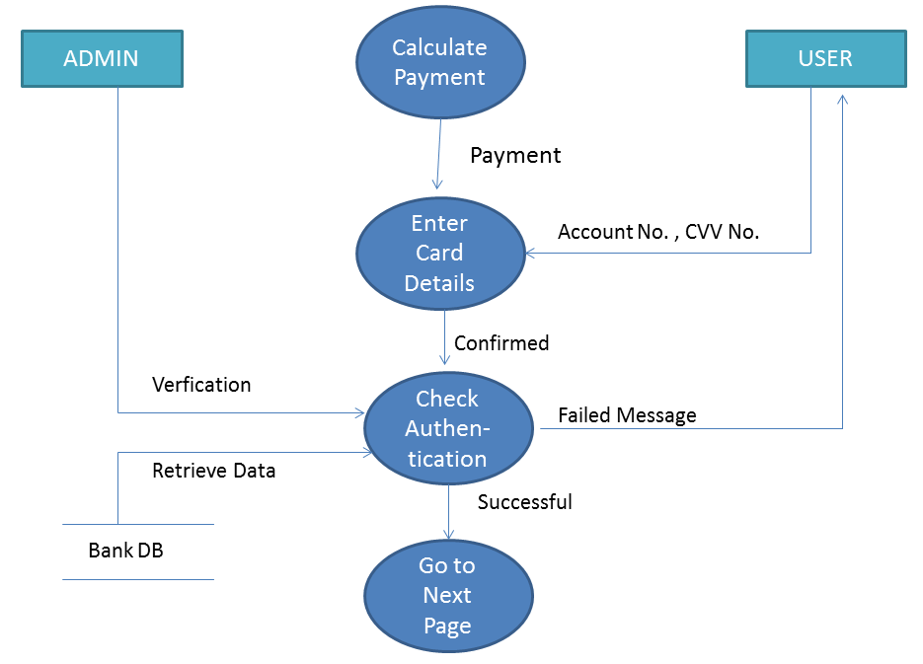Booking Confirmation Module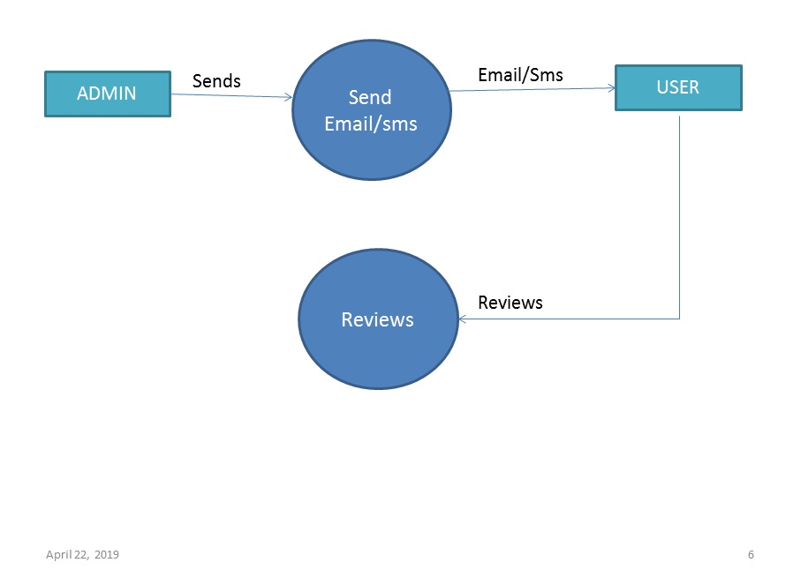

Cancel Ticket Module:
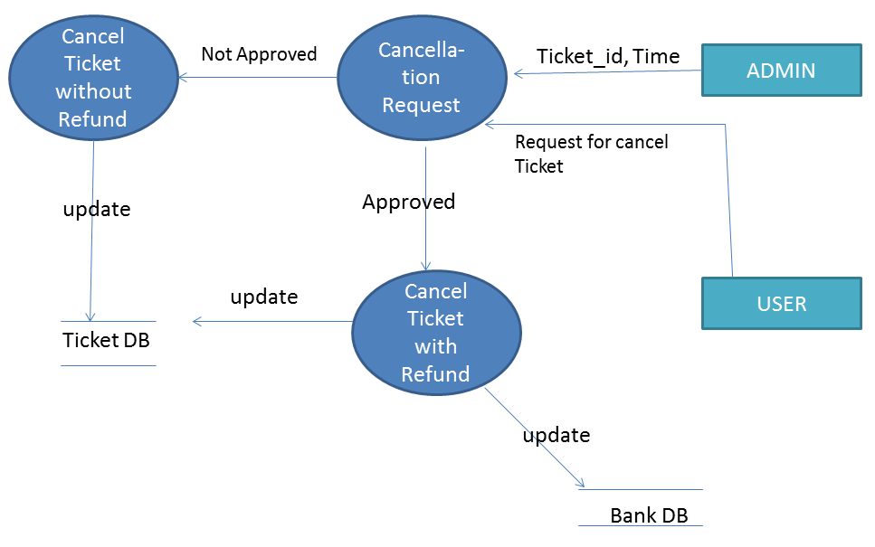

3.6 DATA DICTIONARY

- Precise structure of data is not specified by DFD.
- A catalog - repository of the elements in a system.
- A DD specifies structure of each data flow in DFD.
- A DD can specify:- 1. Data elements
2. Data Structures
3. Data Flow
4. Data Store
Why DD :-
- Manage details in large system.
- Documentation.
- Improved analyst/user communication.
- Maintain control information.
- Useful to locate errors and omissions.
- Important step in building a database.

Format used for specifying data structures :-
- Selection is represented by | and data items are enclosed in [ ].
- Composition sequence is represented by + ( both one and two).
- Repetition or iteration is represented by * and data items are enclosed in { }.
- Optional element is represented by ( ).
- Legal_characters – [a-z|A-Z]
- Digit – {0-9}
- Special characters – [@|$|*|#|]

1 | Name | {legal_characters}*
2. | Email id | {legal_characters + digit + special characters}*
3. | Password | {legal_characters + digit + special characters}*
4. | Phone number | digit +digit +digit +digit +digit +digit +digit +digit +digit +digit
5. | CVV no | digit + digit + digit
6. | Movie name | {legal_character}*
7. | SnackItem | {legal_character}*
8. | Seat_type | {legal_characters}*
9. | No. of tickets | {digits}*
10. | Card No. | {digit}*
11. | SnackQuantity | {digit}*

3.7 USECASES
3.7.1 UseCase Diagram

REGISTER
USER
LOGIN

BOOK MOVIE TICKET

ORDER SNACK
ADMIN

PAYMENT

CANCEL TICKET

3.7.2 UseCase Description
Register
- Purpose: It allows users to get registered i.e. to create a new account in the system.
- Actors involved: User
- Precondition: none
- Post condition: User successfully gets registered and the account has been created.
- Basic Flow:
  - System requests the user to login or register.
  - User clicks on register.
  - User enters his/her name, password, email id &phone number.
  - The system validates all the details entered by the user, if correct then it creates a new account of the user.
- Alternate Flow: If in the basic flow, the user does not enter any mandatory details or enters any invalid information, the system displays an error message asking the user to re-enter the information. User can either return to Home page or cancel the registering process altogether.
- Includes: None
- Extends: None
Login
- Purpose: It allows the user to use the online movie ticket booking system –“Movie Basket “, with the help of an already existing unique id.
- Actors involved: Admin, User
- Precondition: Users must have an already existing account in the system. In case of no prior account, user must first register themselves and then log into the system.
- Post condition:
  - On successful login, actor gets logged into the system.
  - If the actor has a role of an admin then he/she would have access to accept user’s request and make required updation in the database register, login, change password, payment and cancel ticket.
  - If the actor has a role of user then he/she would have access to register, login, change password, book movie ticket, order snack, payment and cancel ticket.
- Basic Flow: 1. User or admin enters his/her id and password.
2. Then their id and password will be checked for authentication.
- Alternate Flow: If the user enters an invalid id and password then the error message will be displayed asking the user to re-enter the details or cancel the login process.
If the user selects the latter option, the use case ends.
- Extends: None
- Includes: None
Book Movie Ticket
- Purpose: It allows user to book movie ticket online.
- Actors involved: User
- Precondition: User has to be successfully logged into the system.
- Post condition: Movie is booked for the user and all the booking details are displayed to him/her.
- Basic Flow: User selects the movie name, date, time, language, type of seat and number of tickets.
- Alternate Flow: if the user selects date or time or type of seat that is already booked then error message is displayed to the user and then user can check for that movie on the upcoming dates.
- Extends: None
- Includes: None

Order Snack
- Purpose: It allows the user to order snacks at the time of movie booking.
- Actors involved: User
- Precondition: User has to first book movie ticket.
- Post condition: Snacks has been ordered and user can get it at the time of movie screening in the cinema hall.
- Basic Flow: User selects the type of snacks. If there is any coupons/offers user can apply it on the total amount and then can make the payment.
- Alternate Flow: If the ordered snack is out of stock then error message is displayed to the user and user can select other item.
- Excludes: None
- Includes: None
Payment
- Purpose: Allows the user to pay the movie ticket bill and snacks bill.
- Actors involved: Admin, User
- Precondition: User has booked movie ticket and ordered some snacks.
- Post condition: After the bill is paid online then the user gets movie ticket and snacks payment confirmation on his/her registered mobile number as well as mail is sent on his/her registered email id.
- Basic Flow: User pays the total bill generated through credit card or debit card.
- Alternate Flow: If the user enters incorrect CVV no. or credit/debit card no. then error message is displayed to the user to re-enter all the details.
- Includes: None
- Excludes: None

Cancel Ticket
- Purpose: Allows user to cancel movie ticket.
- Precondition: Ticket should be booked and payment has been made.
- Post condition: If the user cancels the movie ticket before 3 hours of the movie time then only 50% refund is being transacted into user’s account and the ticket is cancelled otherwise only ticket is cancelled without any refund.
- Basic Flow: User raises the request for the movie ticket cancellation by providing details such as date, time and ticket id. Admin checks the details and confirms the request.
- Alternate Flow: If the user does not cancel his/her ticket before 3 hours of the movie time then the ticket will not get cancel.
- Excludes: None
- Includes: None

FUNCTION POINT METRIC
Project Metrics are used to control and coordinate software engineering process and to improve quality of the software to be produced. Project specific metrics provide indication of productivity and insight into the technical activities. Project metrics are used by a project manager and a software team to adapt project work flow and technical activities.
Function Oriented Metrics: Function Oriented Metrics use function point as normalization value. Function points are derived using an empirical relationship based on countable (direct) measure of software`s information domain and assessments of software complexity.

Calculation of Value Adjustment Factors (VAF) based on responses to the following:

Factor | Value
1. Does the system require reliable backup and recovery? | 5
2. Are specialized data communications required to transfer information to or from the application? | 2
3. Are there distributed processing functions? | 5
4. Is performance critical? | 2
5. Will the system run in an existing, heavily utilized operational environment? | 4
6. Does the system require online data entry? | 5
7. Does the online data entry require the input transaction to be built over multiple screens or operations? | 3
8. Are the ILFs updated online? | 5
9. Are the inputs, outputs, files, or inquiries complex? | 1
10. Is the internal processing complex? | 0
11. Is the code designed to be reusable? | 5
12. Are conversion and installation included in the design? | 3
13. Is the system designed for multiple installations in different organizations? | 0
14. Is the application designed to facilitate change and ease of use by the user? | 5
∑(fi) | 45

Measurement Parameter | Count | Weighting Factor | Weighting Count
Number of inputs | 52 | 3 | 156
Number of outputs | 18 | 4 | 72
Number of user enquires | 1 | 3 | 3
Number of internal files | 5 | 7 | 35
Number of external Interfaces | 1 | 5 | 5
TOTAL=271

Count total = 271
Function Point=Count Total x [0.65 + [0.01 x Σ (Fi)]
= 271 x (0.65 + 0.01 x45)
= 271 x (0.65 + 0.45)
= 271 x (1.1)
=302.5

EFFORT ESTIMATION USING COCOMO MODEL

Constructive Cost Model (COCOMO) Constructive cost model is a widely used hierarchy of software estimation models. It addresses the following areas:

- Application composition model. It was used during the early stages of software engineering, when prototyping of user interfaces, consideration of software and system interaction, assessment of performance, and evaluation of technology maturity are paramount.
- Early design stage model. Used once requirements have been stabilized and basic software architecture has been established.
- Post-architecture-stage model. Used during the construction of the software.

COCOMO II model requires sizing information for which three different sizing options are available as part of the model hierarchy: object points, lines of source code and function points. Like function points, the object point is an indirect software measure that is computed using counts of the number of
1. Screens (at the user interface),
2. Reports
3. Components likely to be required to build the application.
Each object instance (e.g., a screen or report) is classified into one of three complexity levels (i.e., simple, medium, or difficult) using criteria suggested by Boehm. In essence, complexity is a function of the number and source of the client and server data that are required to generate the screen or report and the number of views or sections presented as part of the screen or report. The object point count then determined by multiplying the original number of object instances by the weighting factor in the figure and summing to obtain a total object point count. When general software reuse is to be applied, the percent of reuse (%reuse) is estimated and the object point is adjusted:
NOP = (object points) * [(100- %reuse)/100]
Where, NOP = new object points
To derive an estimate of effort based on the computed NOP value, a “productivity rate” must be derived.
PROD= NOP\person-month
Where PROD = productivity, After productivity rate determination, an estimate of project effort is computes using,
Estimate Effort=NOP/PROD
Complexity weight for object types
OBJECT TYPES | COMPLEXITY WEIGHTS
 | Simple | Medium | Difficult
Screen | 1 | 2 | 3
Report | 2 | 5 | 8
3GL Component | - | - | 10

Cost Estimation of this Project
- Screens :- Total = 22
- Reports :- 1.Total Visitors on the site
2. Total Tickets Booked
- Total Snacks Ordered
- Total Payment & Profit
- Total Refund made
- Total Cancelled Tickets

- 3GL Components :- 0

Object points = 22*1 + 6*2
= 22+12
= 34
NOP= (object points)*[(100-%reuse)/100]
=32[(100-0)/100]
=34

Developers experience or capability | Very low | Low | Normal | High | Very High
Environmental maturity/ capability | Very low | Low | Normal | High | Very High
PROD | 4 | 7 | 13 | 25 | 50

Effort estimated= NOP/PROD
= 34/4
= 8.5 = 8person -month

RISK ANALYSIS

Risk always involves two characteristics -:

Uncertainty - The risk may or may not happen; that is, there are no 100 percent probable risks.
Loss - If the risk becomes a reality, unwanted consequences or losses will occur.

When risks are analyzed, it is important to quantify the level of uncertainty and the degree of loss associated with each risk.

The risk components are defined in the following manner :–

- Performance Risk – The degree of uncertainty that the product will meet its requirements and be fit for the intendeduse.
- Support Risk – The degree of uncertainty that the resultant software will be easy to correct, adapt, and enhance.
- Schedule Risk – The degree of uncertainty that the project schedule will be maintained and that the product will be delivered on time.
- Cost Risk – The degree of uncertainty that the product budget will be maintained.

ASSESSING OVERALL PROJECT RISKS
- Have top software and customer managers formally committed to support the project? YES
- Are end users enthusiastically committed to the project and the system product to be built? YES
- Are requirements fully understood by the software engineering team and its customers? YES
- Have customers been involved fully in the definition of requirements? YES
- Do end users have realistic expectations? YES
- Is the project scope stable? YES
- Does the software engineering team have the right mix of skills? YES
- Are project requirements stable? YES
- Does the project team have experience with the technology to be implemented? YES
- Is the number of people on the project team adequate to do the job? YES
- Do all customer/user constituencies agree on the importance of the project and on the requirements for the system/product to be built? YES

RISK TABLE
Risks | Category | Probability | Impact | Mitigation
Server breaks down | Project size risk | 40% | 2 | Past experience might be considered
Data loss | Project size risk | 30% | 2 | Take up steps to maintain backup and recovery
Security issues(payment must be secure) | Technical risk | 20% | 3 | External resources might help
Duplication of same seat while booking | Technical risk | 20% | 1 | Once a user has selected the seat & is about to initiate the payment the selected seat will be freezed & will be visible as booked for all the other users for a period of 10 mins. If the user has not made the payment within 10 mins then the selected seat gets unfreezed and will be available to all the other users.

ER DIAGRAM

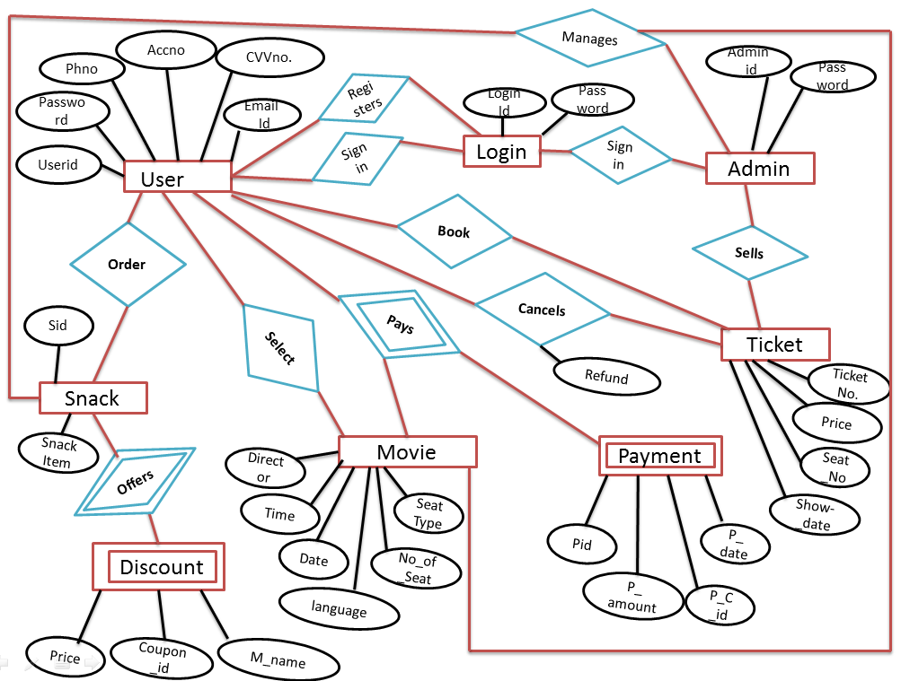

DATA DESIGN

A Data Design is a collection of names, definitions, and attributes about data elements that are being used or captured in this software project. It describes the meanings and purposes of data elements within the context of this project, and provides guidance on interpretation, accepted meanings and representation so that user and analyst will have a common understanding of inputs, outputs and other project components.
- Name :Register

S No. | Field  Name | Data Type | Field  Length | Constraints | Description | Example
1. | Name | Char | 50 | Not Null | To store name ofthe customer | Abc
2. | Email Id | Varchar | 30 | Not Null,  primary key | Login id for thecustomer | abc@gmail.com
3. | Password | Varchar | 10 | Not Null | Login password of user, must contain at least 8 characters including special ones | abc@123
4. | Phone No. | Integer | 10 | Not Null, unique | Must be 10 digits long | 9812467223

- Name :Admin

SNo. | Field  Name | Data Type | Field  Length | Constraints | Description | Example
1. | Adminid | Varchar | 30 | Not Null, primarykey | Any valid email id | adminMovieBasket@  gmail.com
2. | Password | Varchar | 10 | Not Null | Login password for admin, must contain at least a number or special character | Admin@123
- Name : Login

S No. | Field Name | Data Type | Field  Length | Constraints | Description | Example
1. | LoginId | Varchar | 30 | Not Null,primary key | Login id of the user | abc@gmail.com
2. | Password | Varchar | 10 | Not Null | Login password of the user, must contain at least a number or a specialcharacter | abc@123

- Name : Movie

S No. | Field  Name | Data Type | Field  Length | Constraints | Description | Example
1. | Movie name | Char | 30 | Primary key, not null | Name of movie | Simba , Kalank
2. | Date | Date | 10 | Not null | yyyy-mm-dd | 2019-04-17
3. | Time | Varchar | 10 | Not null | Specifies movie screening time | 12 pm
3. | Seat Type | Char | 10 | Not null | Different types of  seats | Silver, gold, platinum
4. | Number of Tickets | Integer | 20 | Not null | Specifies quantity | 2

- Name : Snacks

S No. | Field Name | Data Type | Field Length | Constraints | Description | Example
1. | Food Item | Char | 10 | Not null | Specifies type of food | Popcorn
2. | Number of Item | Integer | 10 | Not null | Specifies its quantity | 2
- Name : Payment
S No. | Field Name | Data Type | Field Length | Constraints | Description | Example
1 | Pid | Varchar | 20 | Primary key, not null | Unique id for particular payment | 1234
2 | pamt | Integer | 10 | Not null | Total amount | 500
3. | P_date | Date | 10 | yyyy-mm-dd | Date of payment | 21/3/2019
4. | P_cid | Varchar | 20 | Not null | Payment for a specific customer | 233

- Name : Cancel Ticket
S No. | Field Name | Data Type | Field Length | Constraints | Description | Example
1. | Userid | Varchar | 10 | Primary key , not null | User id | 1234
2 | Pid | Varchar | 10 | Primary key , not null | Payment id | 245
3. | Refund | Char | 10 | null | Refund amount | 300

- Name: Discount
S No. | Field Name | Data Type | Field Length | Constraints | Description | Example
1. | Price | Integer | 10 | Not null | amount | 50
2. | CouponId | varchar | 10 | Primary , not null | Coupon id for a specific discount | 3454
3. | M_name | varchar | 15 | Not null | Movie name | Abc

TESTING
Pseudo code
1
String foodItem , choice;
Int Tickets , num , movie;
While(Login_Is_Success)
2
{
cout<<” Enter movie details “;
cin>> movie _name;
cin>>date;
3
cin>>Time;
cin>>Seat_Type;
cin>>No_Of_Ticket;
movie = Is_Movie(movie _name , date , Time , Seat_Type , No_Of_Ticket);
4
If( ! HouseFull(movie) )
5
{ Book_Ticket( Seat_Type , No_Of_Ticket );
updateTickets(_name , date , Time , Seat_Type , No_Of_Ticket);

Cout<<”Along with you want to order snack (Y|N) “;
Cin>>choice;
6
While(choice ==”yes”)
{
Cout<<” Enter food item”;
7
Cin>>fooditem;
Cout<<”Enter quantity”;
Cin>>num;

9
8

If(check(foodItem) && quantity(num) )
{
Order_Snack(fooditem , num);
10
Update_foodstock(fooditem , num);
Check =”No” ;
}
Else
11
cout<<”Enter another food item “;
}// end of inner while loop
12
Go for payment
}
13
Else
Cout<<” Select any other movie”;
} // end of the outer while loop
14

//end of program

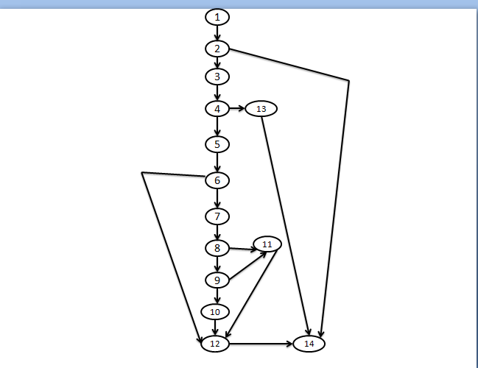
Test cases
- 1-2-14
- 1-2-3-4-13-14
- 1-2-3-4-5-6-12-14
- 1-2-3-4-5-6-7-8-11-12-14
- 1-2-3-4-5-6-7-8-9-11-12-14
- 1-2-3-4-5-6-7-8-9-10-11-12-14

Total edges in a graph (E) = 18
Total nodes in a graph (N) = 14
Total test cases = E – N + 2
= 18-14+2
= 6
Total number of regions = 6
Total number of predicate nodes = 5 {2,4,6,8,9}

REFERENCES

- “Software Engineering- A practitioner’s approach (7th edition,2010)” by Roger S. Pressman.
- P.Jalote ,An integrated approach to software engineering , Narosa Publishing house ,Ed. 3,2011
- https://www.guru99.com (Incremental Model)
- IEEE Software Engineering Standards committee, (IEEE recommended practice for software requirement specification ", 2011).

ANNEXURES



- Number of Inputs: 0

- Number of outputs: 1

- Files: 0

- Enquiries: 0

- External interfaces: 0


- Number of Inputs: 2

- Number of outputs: 1

- Files: 1

- Enquiries: 0

- External interfaces: 0
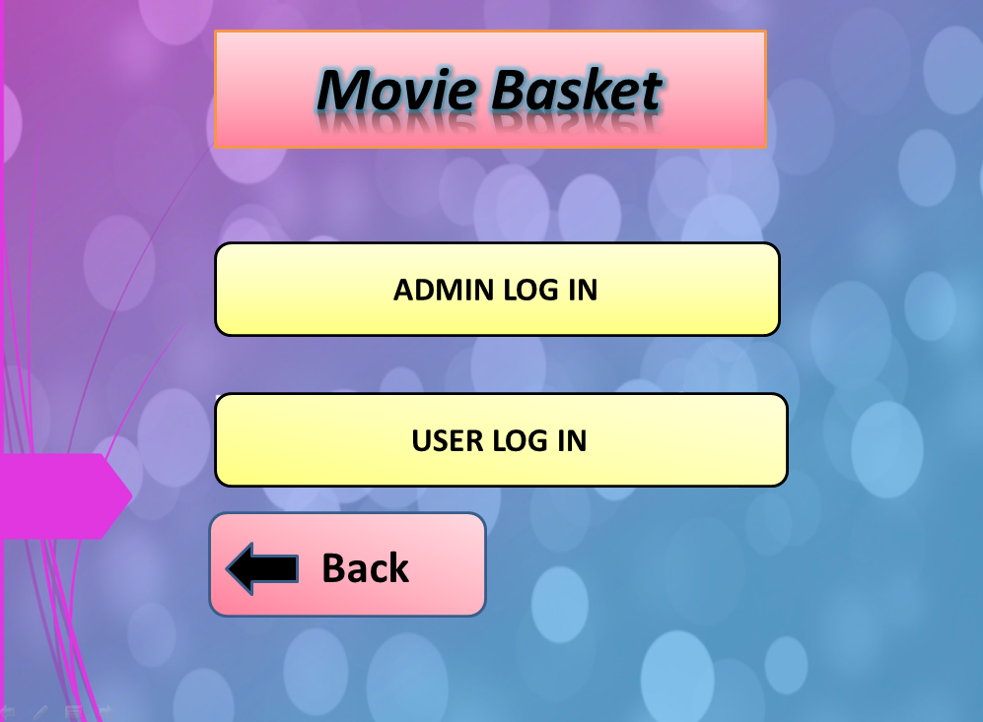
- Number of Inputs: 2

- Number of outputs: 1

- Files: 1

- Enquiries: 0

- External interfaces: 0

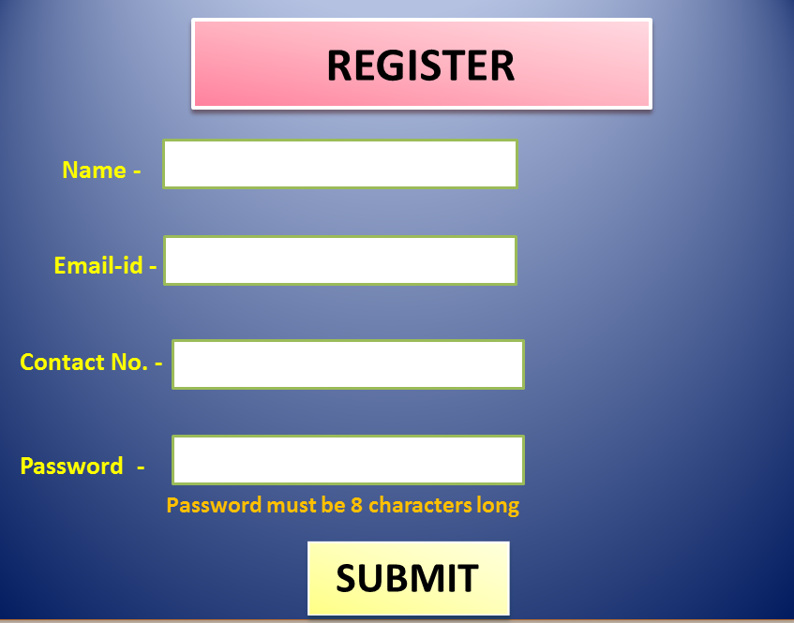

- Number of Inputs: 5

- Number of outputs: 1

- Files: 1

- Enquiries: 0

- External interfaces: 0

- Number of Inputs: 0

- Number of outputs: 1

- Files: 1

- Enquiries: 0

- External interfaces: 0
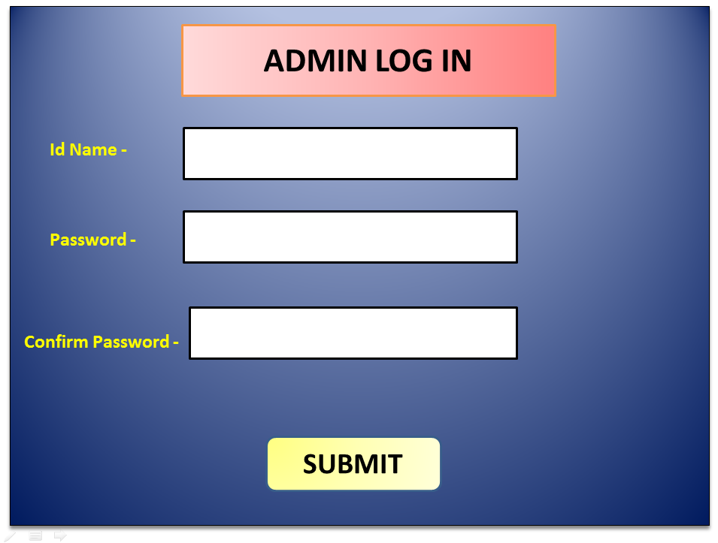
- Number of Inputs: 4

- Number of outputs: 1

- Files: 1

- Enquiries: 0

- External interfaces: 0
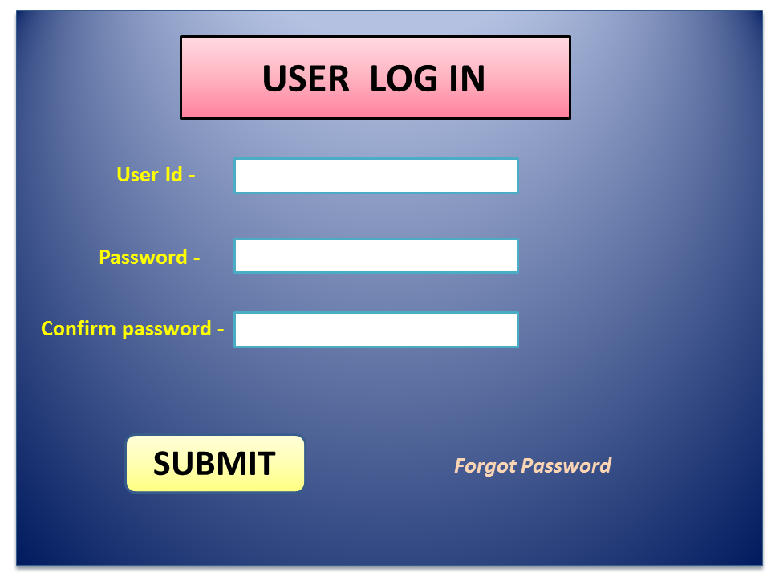
- Number of Inputs: 5

- Number of outputs: 1

- Files: 1

- Enquiries: 0

- External interfaces: 0

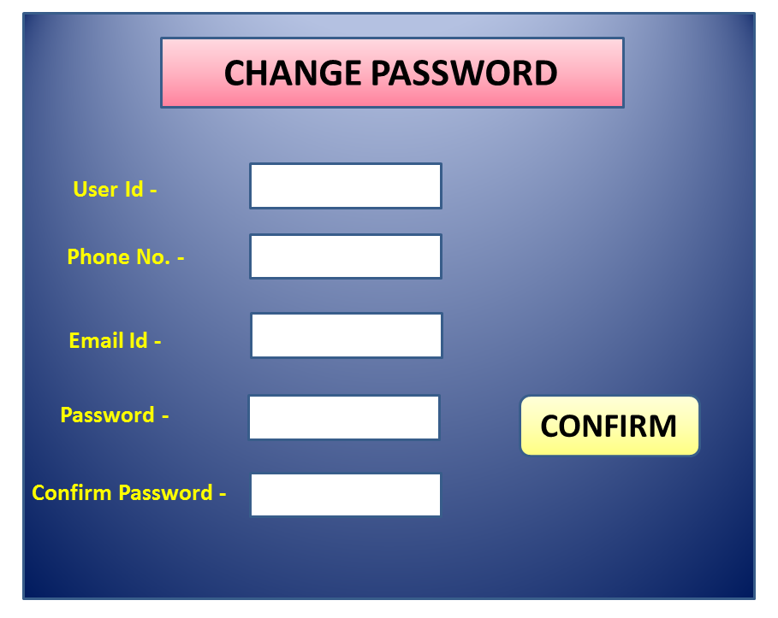
- Number of Inputs: 6

- Number of outputs: 1

- Files: 1

- Enquiries: 0

- External interfaces: 0
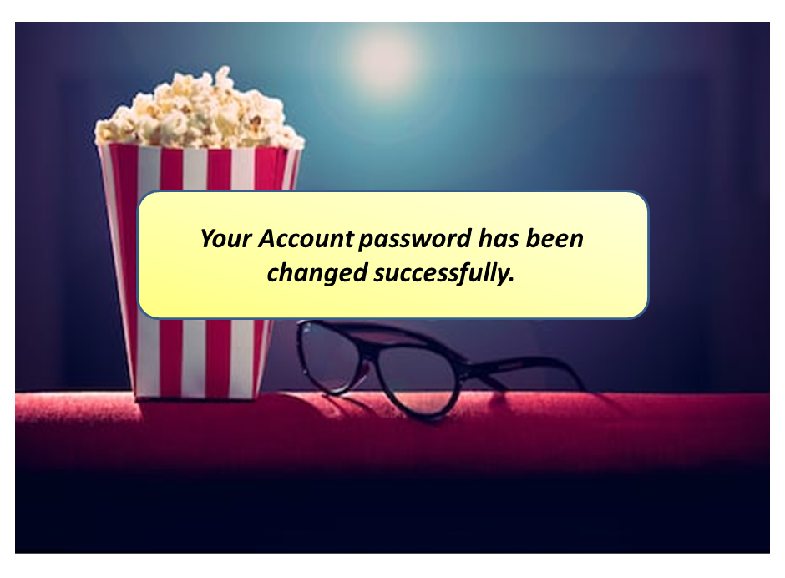
- Number of Inputs: 0

- Number of outputs: 1

- Files: 1

- Enquiries: 0

- External interfaces: 0
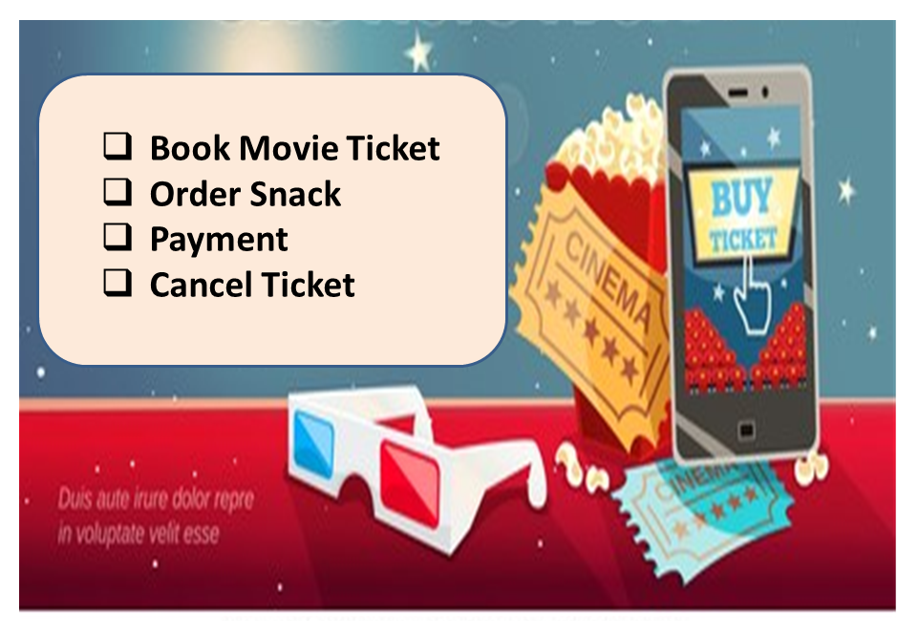

- Number of Inputs: 4
- Number of Outputs: 1
- Files: 1
- Enquiries: 0
- External Interfaces: 0

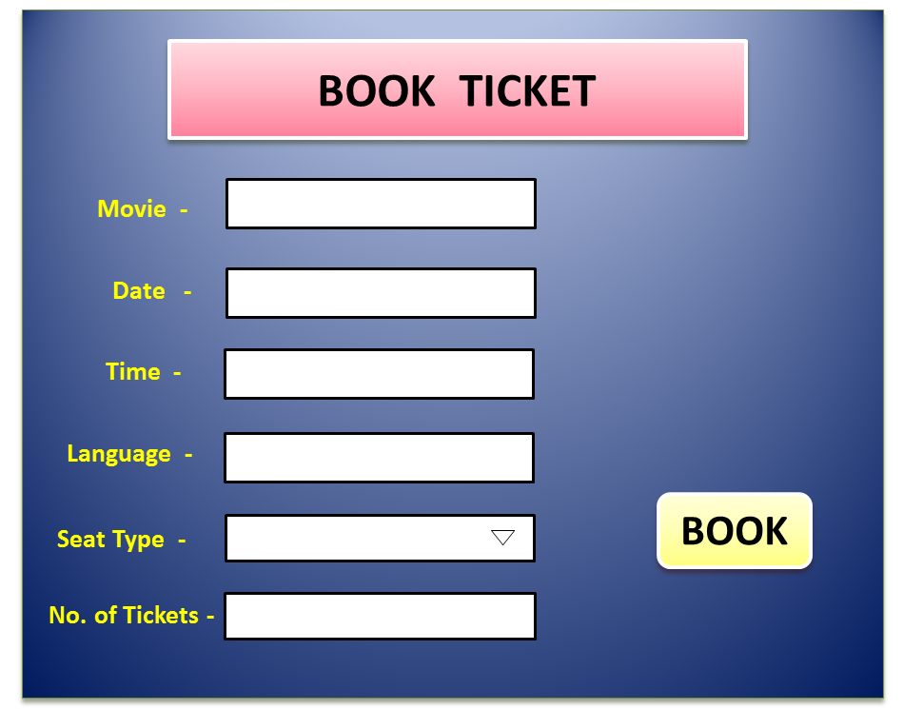

- Number of Inputs: 7
- Number of Outputs: 1
- Files: 1
- Enquiries: 0
- External Interfaces: 0

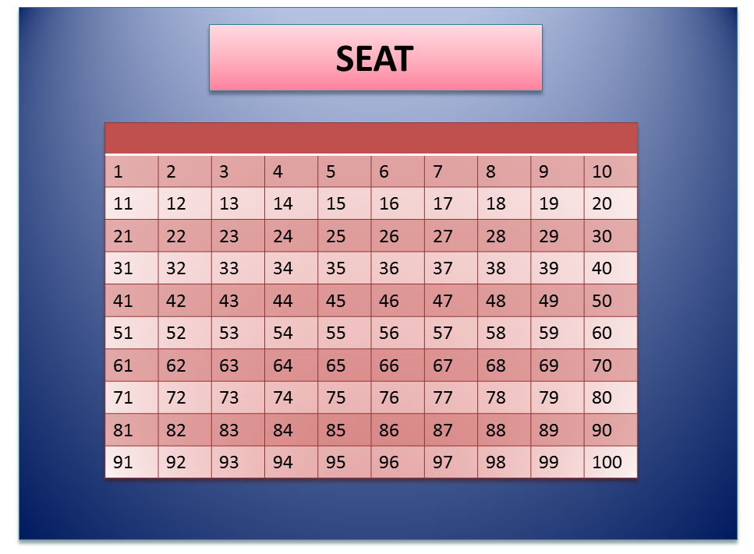
- Number of Inputs: 1
- Number of Outputs: 1
- Files: 1
- Enquiries: 0
- External Interfaces: 0

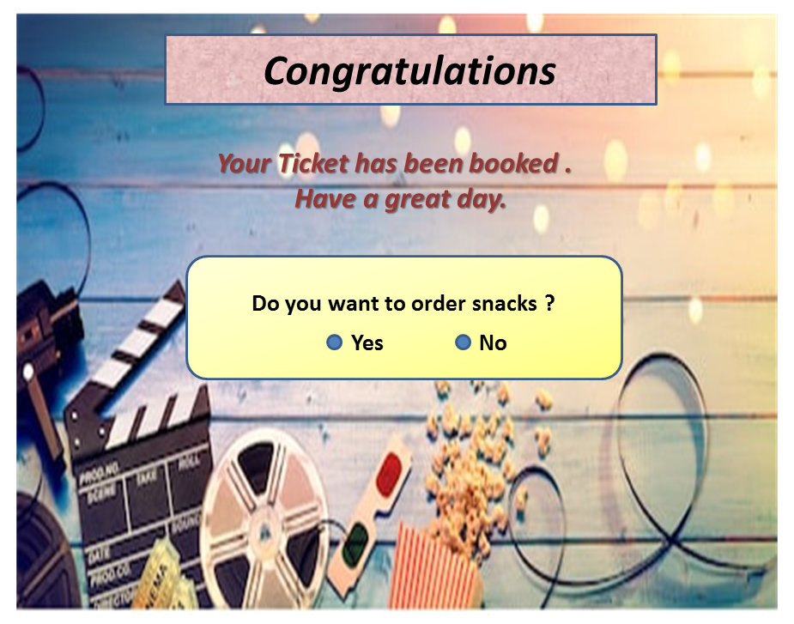
- Number of Inputs: 1
- Number of Outputs: 1
- Files: 1
- Enquiries: 0
- External Interfaces: 0

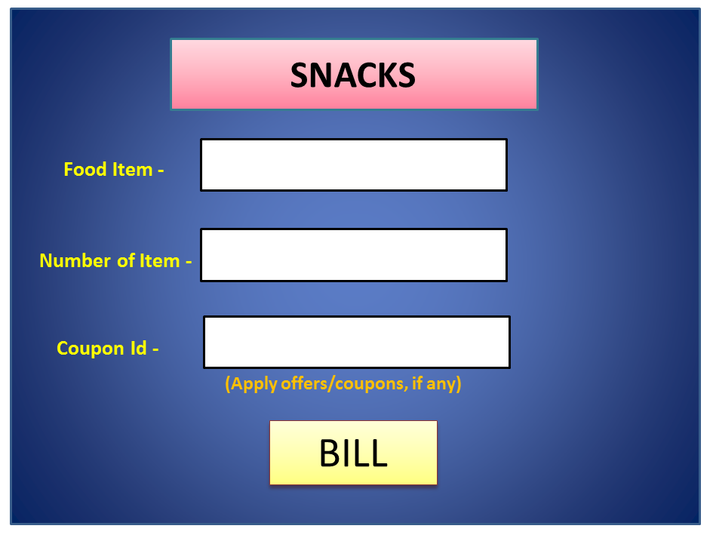
- Number of Inputs: 4
- Number of Outputs: 1
- Files: 1
- Enquiries: 0
- External Interfaces: 0

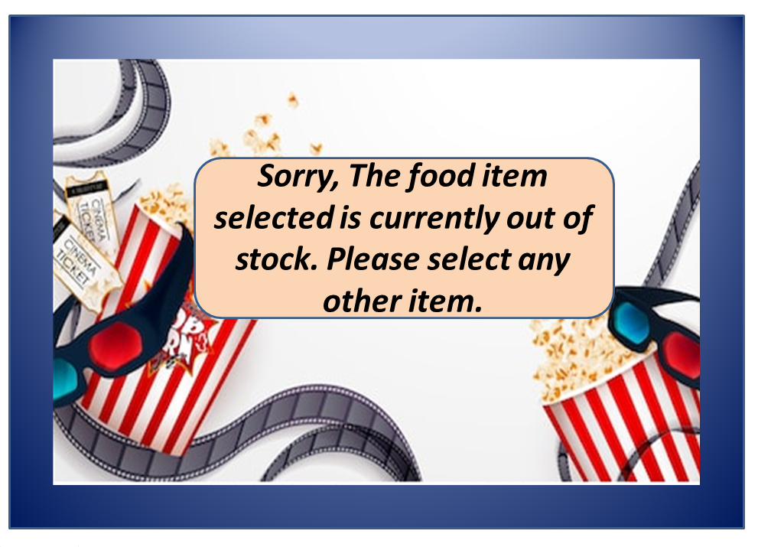
- Number of Inputs: 0
- Number of Outputs: 1
- Files: 1
- Enquiries: 0
- External Interfaces: 0

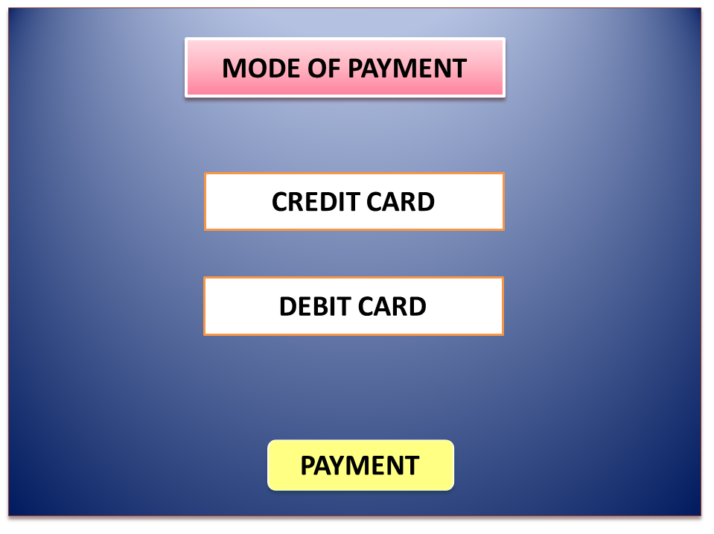
- Number of Inputs: 3
- Number of Outputs: 1
- Files: 1
- Enquiries: 0
- External Interfaces: 1

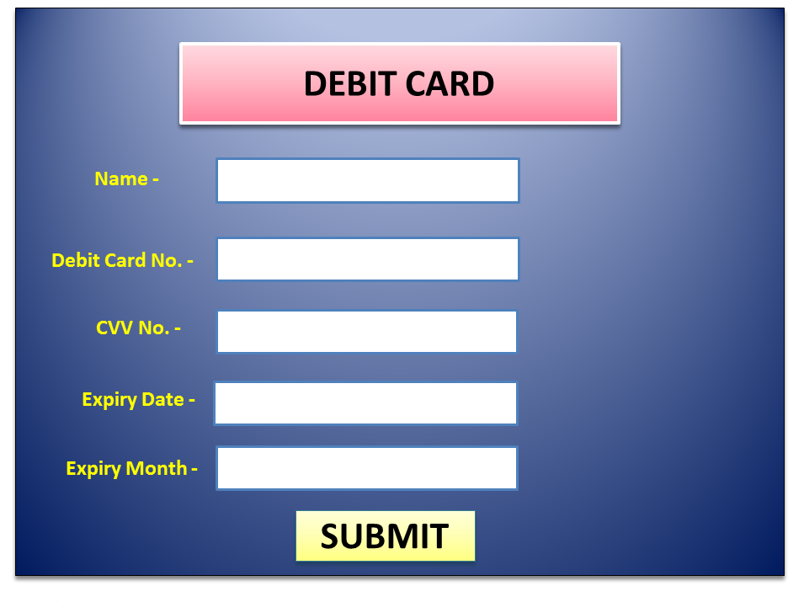
- Number of Inputs: 6
- Number of Outputs: 1
- Files: 1
- Enquiries: 0
- External Interfaces: 1

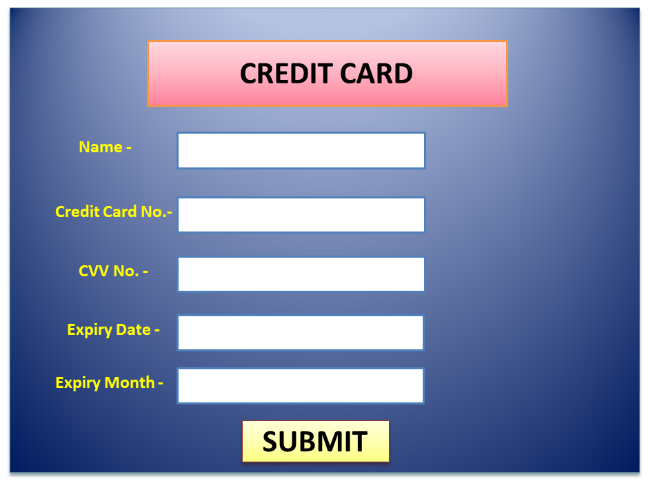
- Number of Inputs: 6
- Number of Outputs: 1
- Files: 1
- Enquiries: 0
- External Interfaces: 1

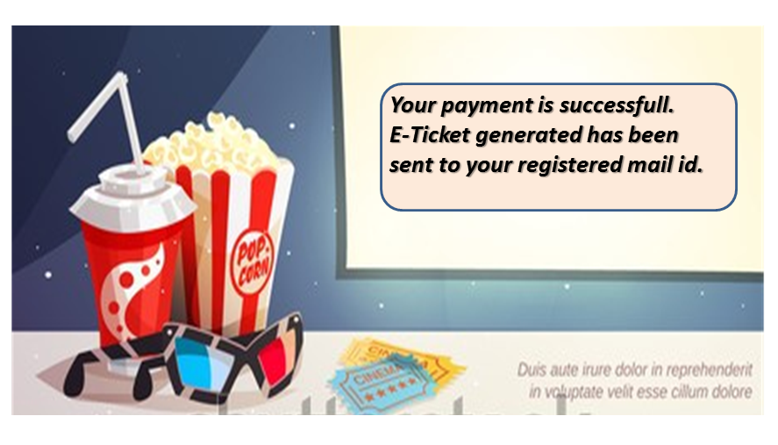
- Number of Inputs: 0
- Number of Outputs: 1
- Files: 1
- Enquiries: 0
- External Interfaces: 0

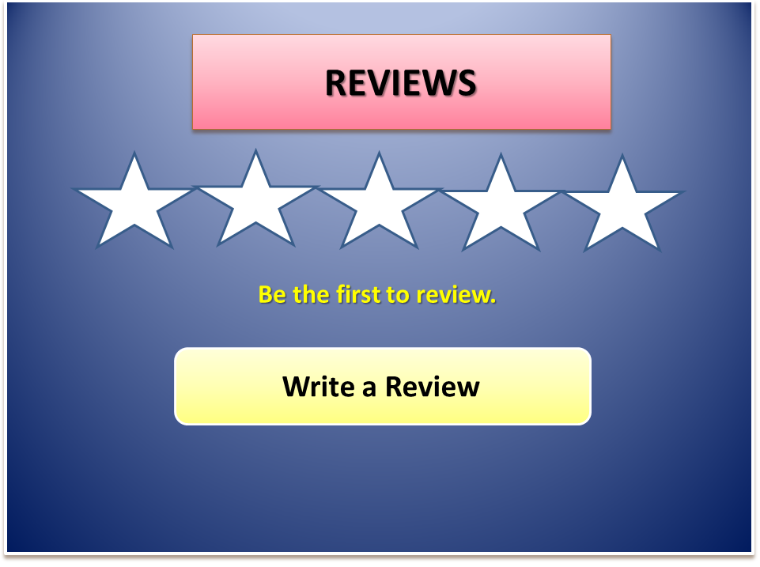
- Number of Inputs: 2
- Number of Outputs: 1
- Files: 0
- Enquiries: 0
- External Interfaces: 0

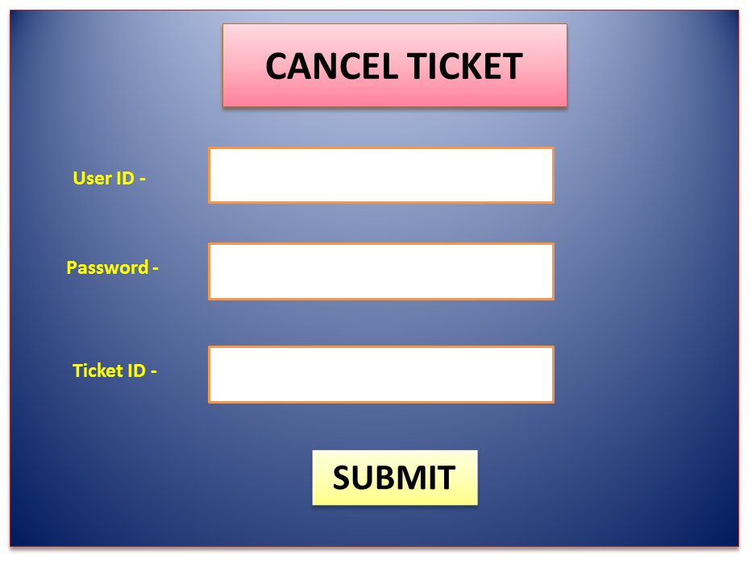
- Number of Inputs: 4
- Number of Outputs: 1
- Files: 1
- Enquiries: 0
- External Interfaces: 0

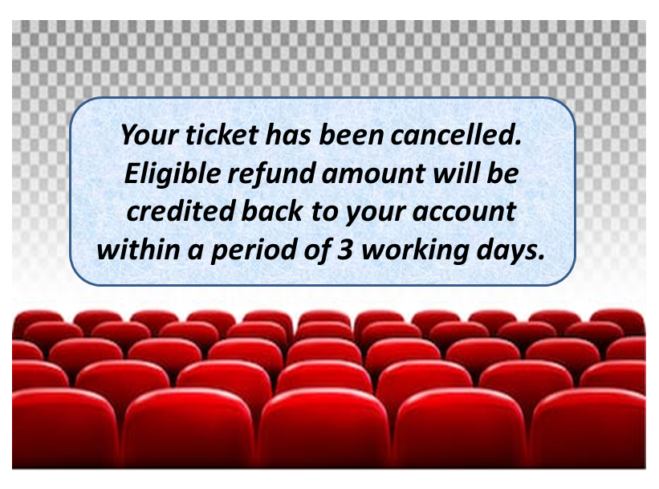
- Number of Inputs: 0
- Number of Outputs: 1
- Files: 1
- Enquiries: 0
- External Interfaces: 1

