M/S DMN LTD.
123 STUDENT ROAD , OLD UNIVERSITY CAMPUS.

Receiver Name:  Address: |  |  | Your order:  Reference:  Dated:  Invoice No:
Invoice
S. NO | PARTICULARS | QTY | PRICE PER UNIT  (RS.) | AMOUNT(RS.)
 | TOTAL
(Rupees:……………………………………………………..)
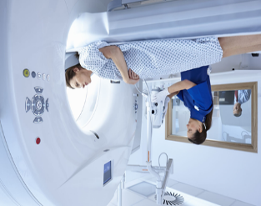
Terms and conditions:
- All disputes within jurisdiction of Delhi Courts
- Goods once sold shall not be returned
- All prices are inclusive of sales tax

For Alpha Ltd.

(Authorised Signature)

