Data and Proofs for 1.3.2

S.No. | STUDENTS | ROLL NUMBER | YEAR | SUPERVISORS
1. | Anusha Nair |  | 2017-18 | Dr. Sarabjit Kaur Sran
2 | Yastika Kamboj |  | 2017-18 | Dr. Sarabjit Kaur Sran
3 | Hargun Gill |  | 2017-18 | Dr. Sarabjit Kaur Sran
4 | Srishti Arora |  | 2017-18 | Dr. Pranita Gaur
5 | Rasika Panwar |  | 2017-18 | Dr. Pranita Gaur
6 | Sagrika Kukreja |  | 2017-18 | Dr. Pooja Wadhawan
7 | Ridhima Duggal |  | 2017-18 | Dr. Pooja Wadhawan
8 | Prashasti |  | 2017-18 | Dr. Garima Kumar
9 | Navdeep |  | 2018-19 | Dr. Sarabjit Kaur Sran
10 | Mehak Bawa |  | 2018-19 | Dr. Pranita Gaur
11 | Sagarika Mathur |  | 2018-19 | Dr. Garima Kumar
12 | Nandita Dhanda |  | 2019-2020 | Dr. Poonam Vats
13 | Zainab Salim |  | 2019-20 | Dr. Pranita Gaur
14 | Sampreeta Kaur |  | 2019-20 | Dr. Pranita Gaur
15 | Inderpreet kaur |  | 2019-20 | Dr. Dipika
16 | Shibani Chakraborty |  | 2019-20 | Dr. Jyoti Gupta
17 | Ms Shriyambara Bajpai |  | 2019-20 | Dr. Pooja Jaggi
18 | Anuja Rajdan |  | 2019-20 | Dr. Sarabjit Kaur Sran
19 | Japneet Kaur |  | 2019-20 | Dr. Sarabjit Kaur Sran
20 | Kamakshi |  | 2019-20 | Dr. Sarabjit Kaur Sran
21 | Oshin Rawat |  | 2019-20 | Dr. Garima KUmar
22 | Aseess Kaur | PSY/18/24 | 2020-21 | Dr. Sarbjit Kaur Sran
23 | Ashmita Singh | PSY/18/45 | 2020-21 | Dr. Pooja Wadhawan & Dr. Pranita Gaur
24 | Babanpreet Kaur | PSY/18/10 | 2020-21 | Dr. Sarbjit Kaur Sran & Dr. Pranita Gaur
25 | Bhavyaa Sehgal | PSY/18/23 | 2020-21 | Dr. Sarbjit Kaur Sran
26 | Bhumika Pareek | PSY/18/11 | 2020-21 | Dr. Dipika S. Dhanda
27 | Divyapreet Kaur | PSY/18/26 | 2020-21 | Dr. Pooja Jaggi
28 | Eshmehar Kaur Sahni | PSY/18/72 | 2020-21 | Dr. Sarbjit Kaur Sran
29 | Gul Khurana | PSY/18/38 | 2020-21 | Dr. Pooja Wadhawan & Dr. Pranita Gaur
30 | Harjyot Kaur | PSY/18/02 | 2020-21 | Dr. Pooja Jaggi
31 | Itti Mahajan | PSY/18/49 | 2020-21 | Dr. Pooja Wadhawan & Dr. Pranita Gaur
32 | Kirti Maheshwari | PSY/18/17 | 2020-21 | Dr. Garima Kumar
33 | Navkiran Kaur | PSY/18/71 | 2020-21 | Dr. Sarbjit Kaur Sran
34 | Savar Kaur | PSY/18/69 | 2020-21 | Dr. Pooja Wadhawan & Dr. Pranita Gaur
35 | Simarpreet Kaur | PSY/18/39 | 2020-21 | Dr. Poonam Vats
36 | Tanveen Kaur | PSY/18/43 | 2020-21 | Dr. Pooja Wadhawan & Dr. Pranita Gaur
37 | Tanya Bhalla | PSY/18/03 | 2020-21 | Dr. Pooja Wadhawan & Dr. Pranita Gaur
38 | Rajita |  | 2020-21 | Dr. Jyoti Gupta
2017-18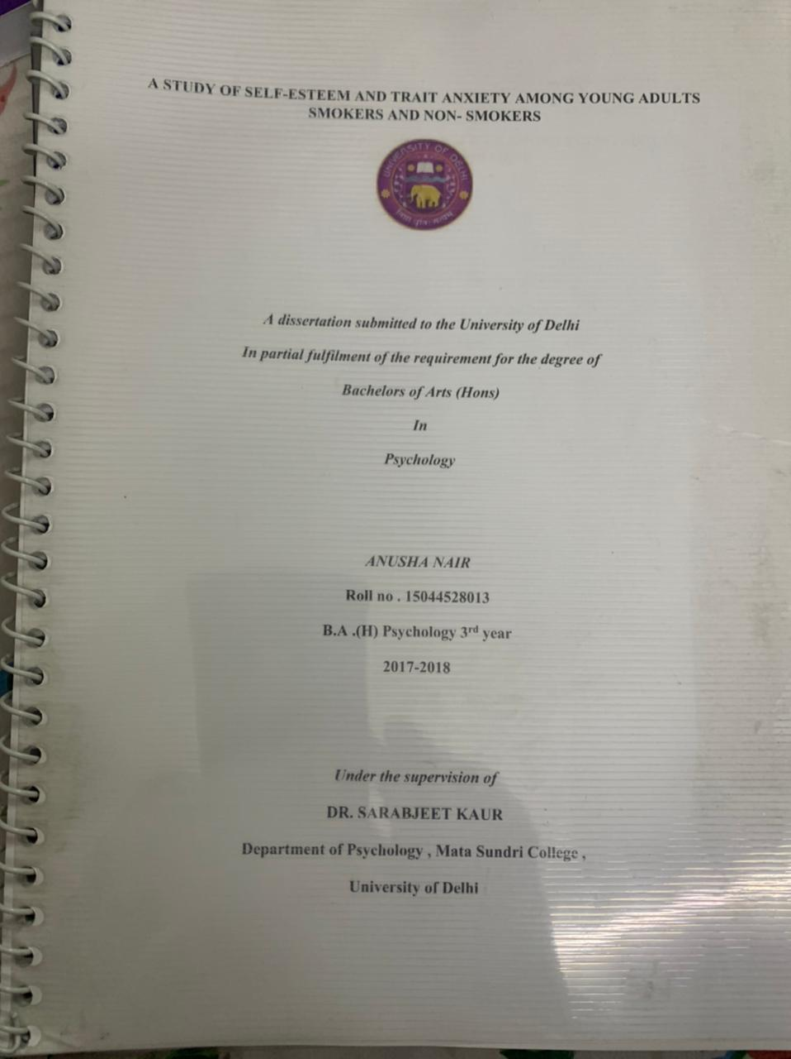

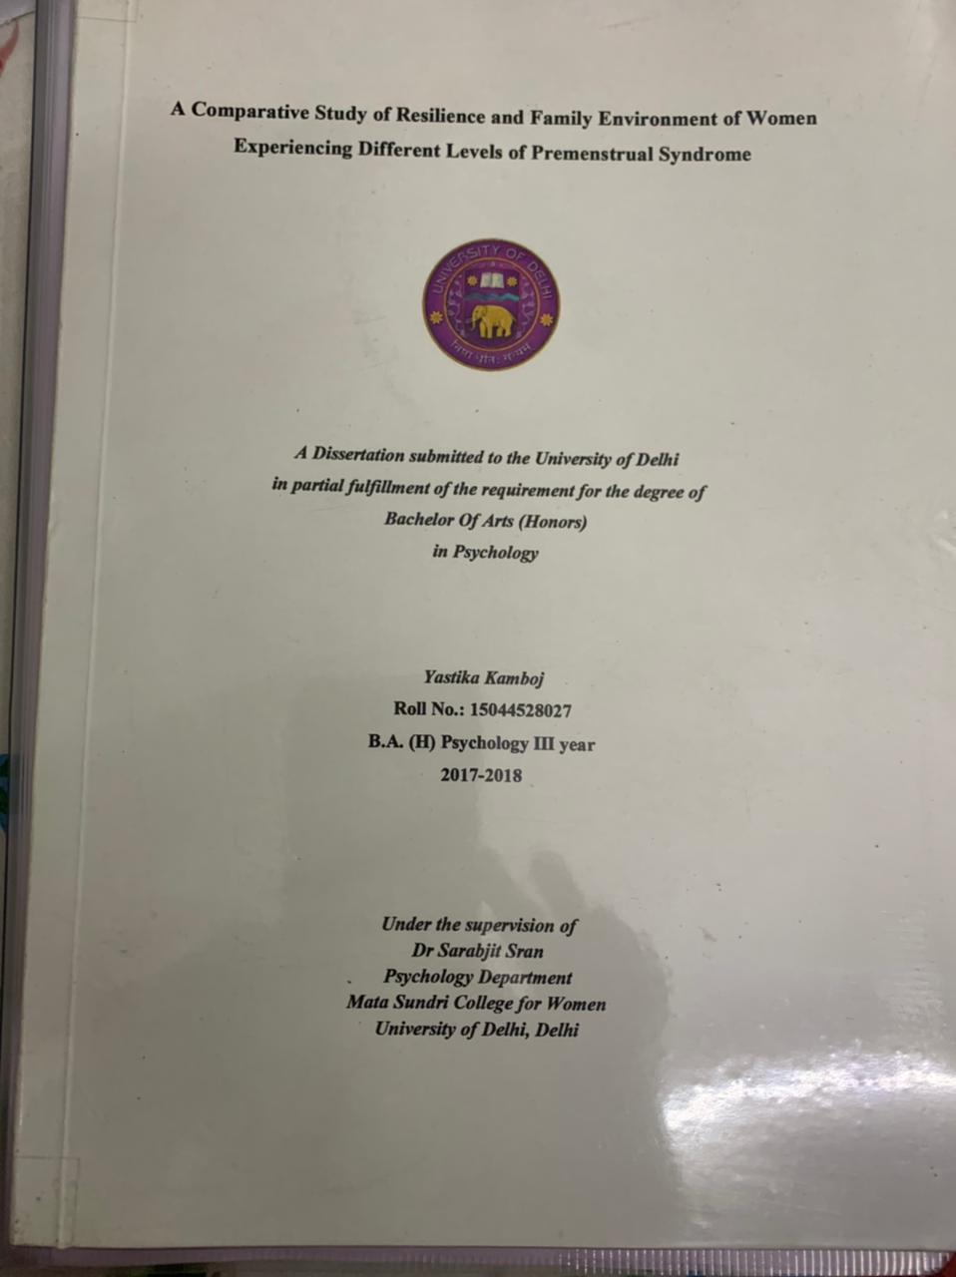

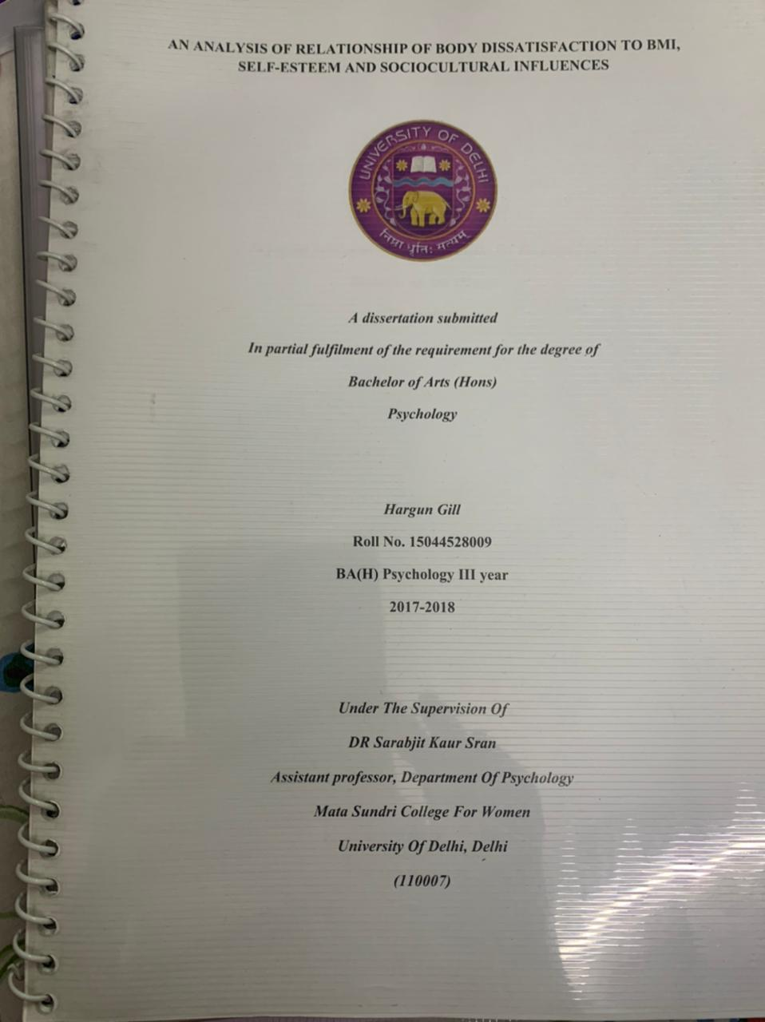
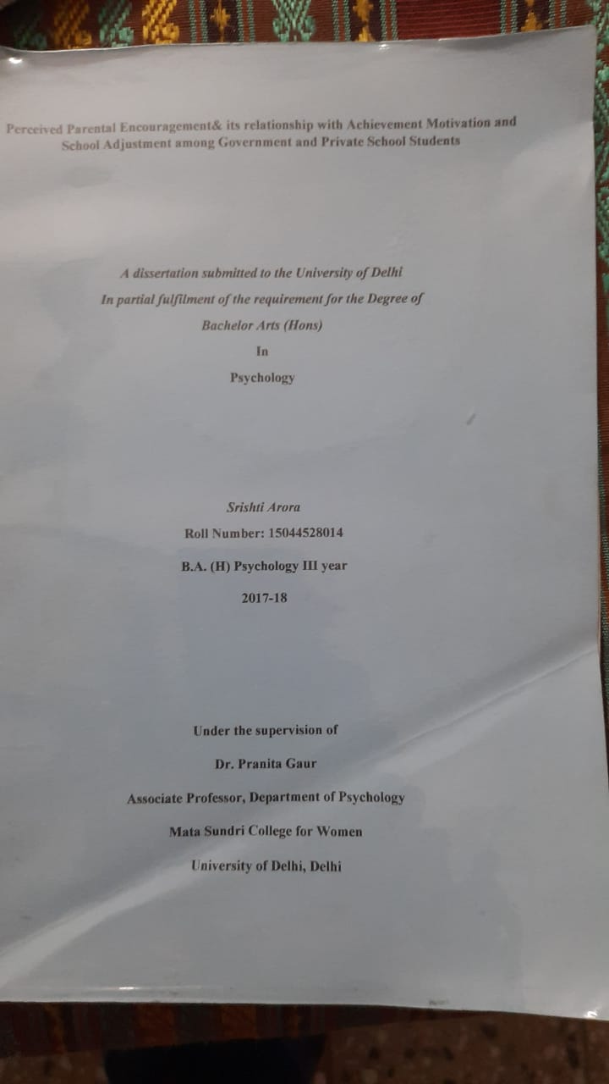

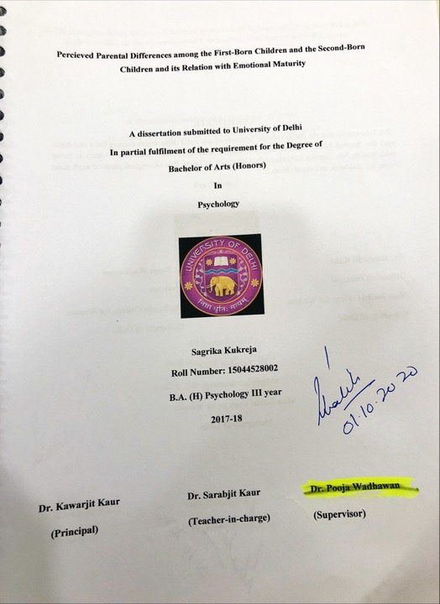

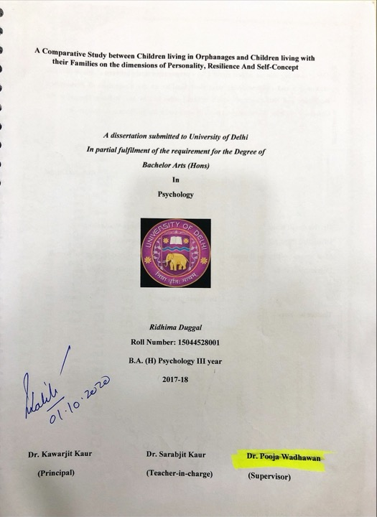

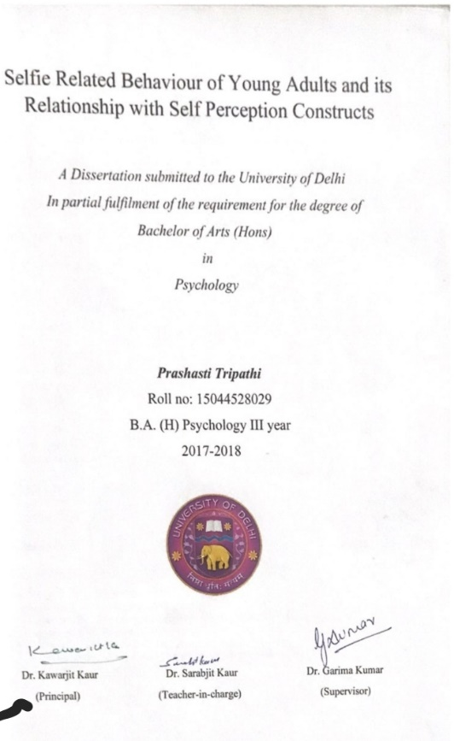
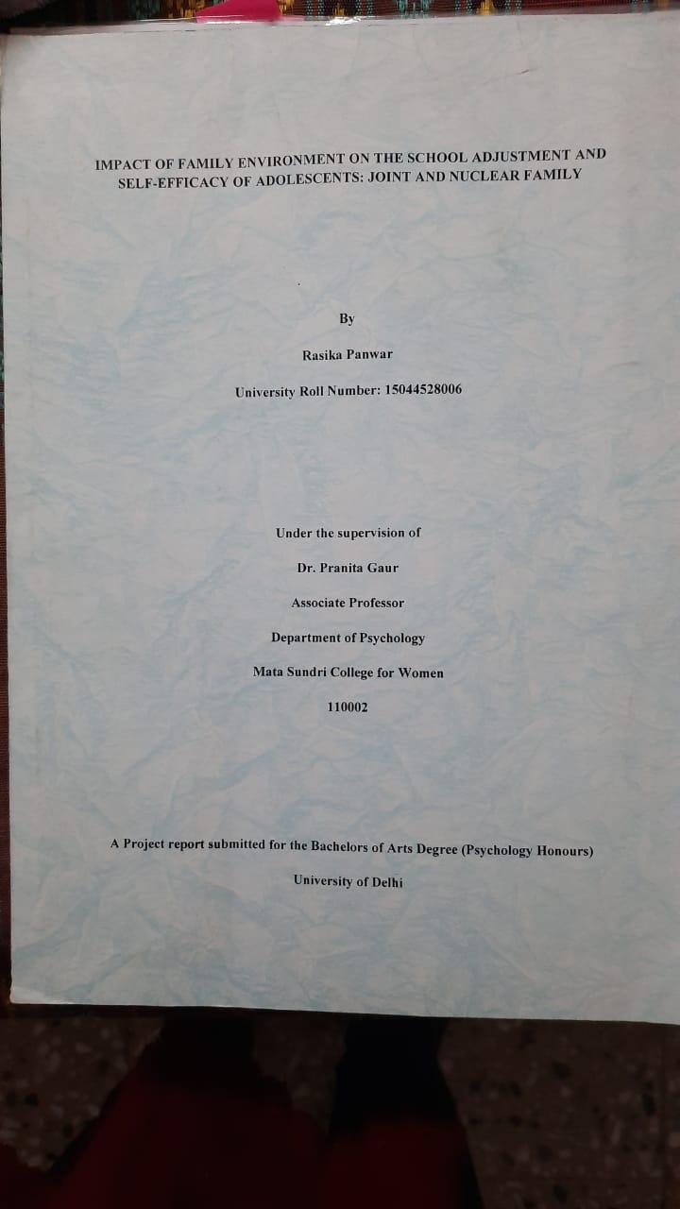
2018-19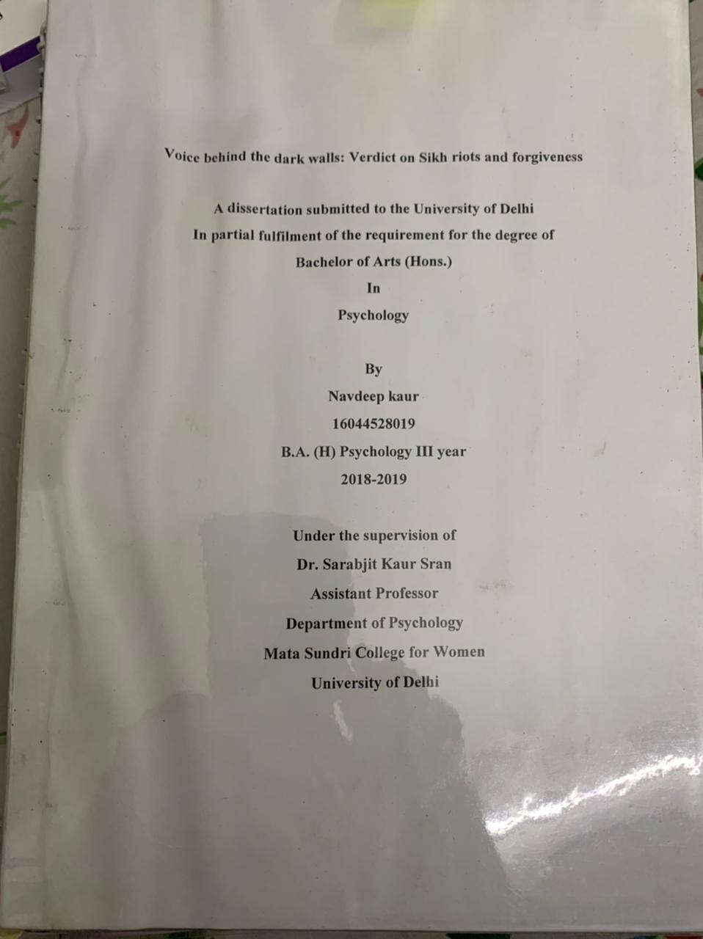

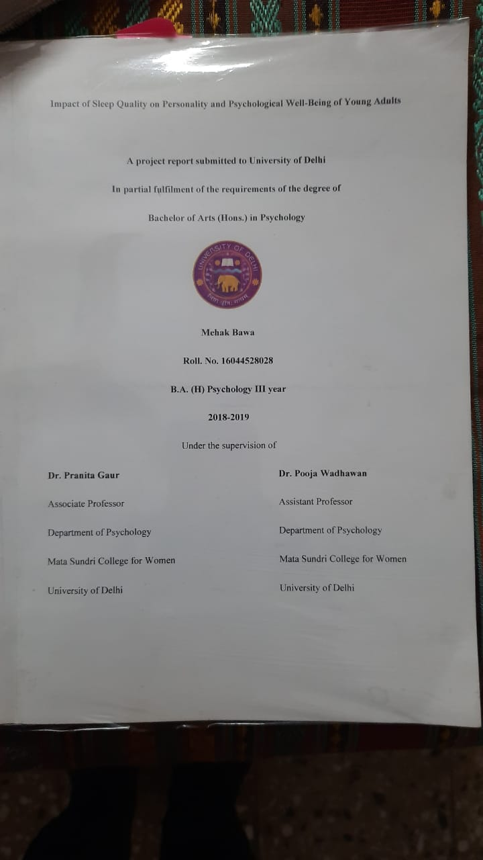
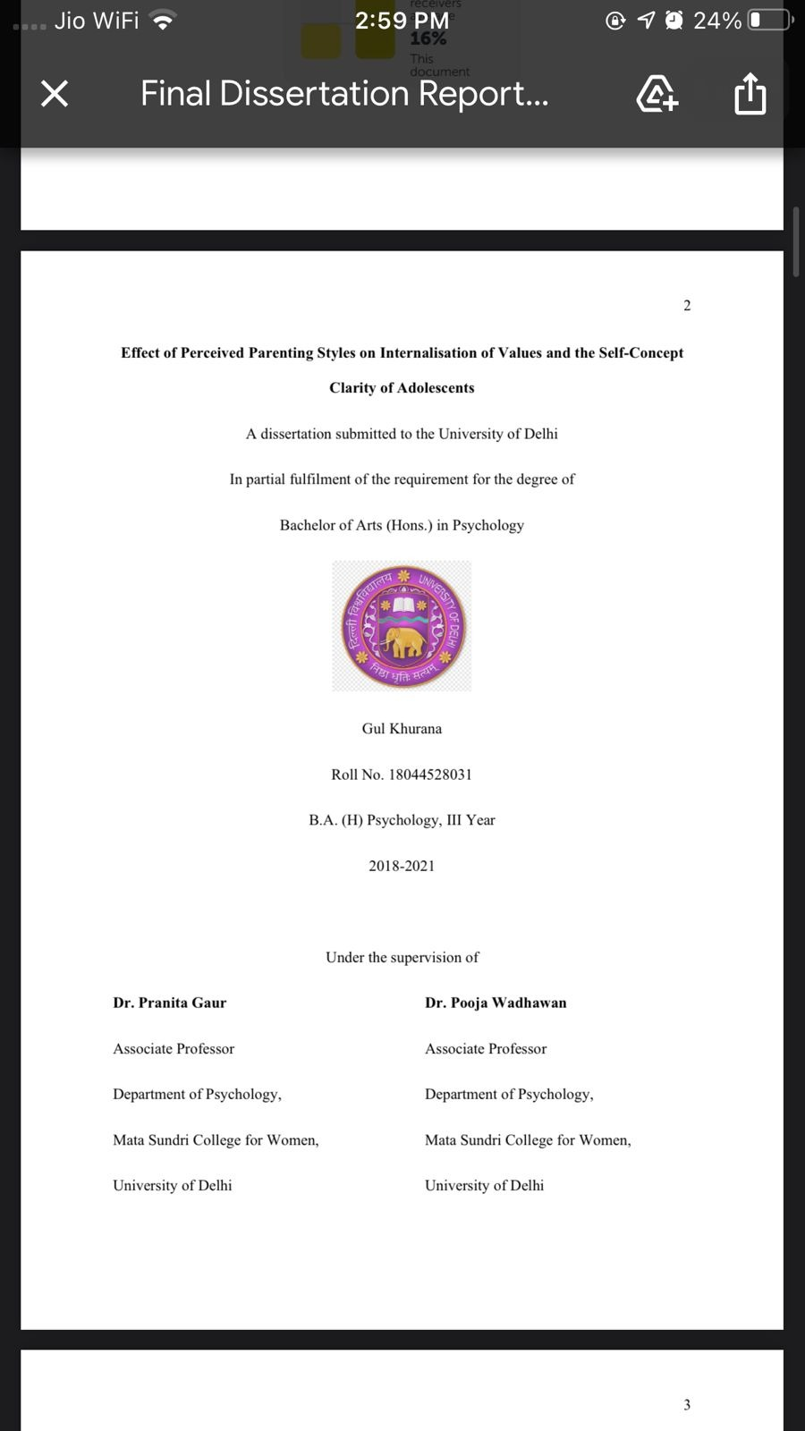

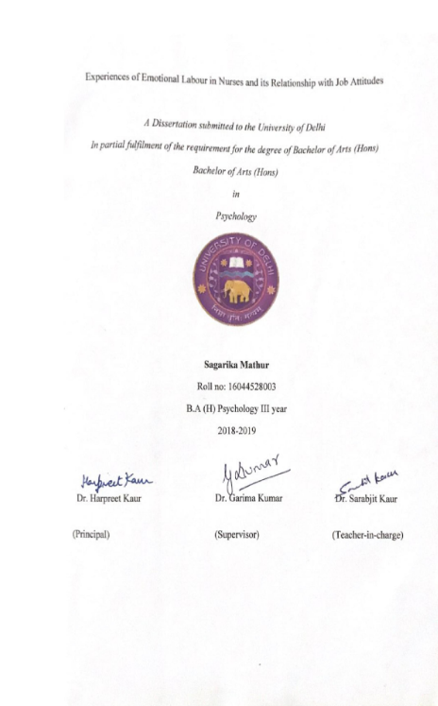

2019-20
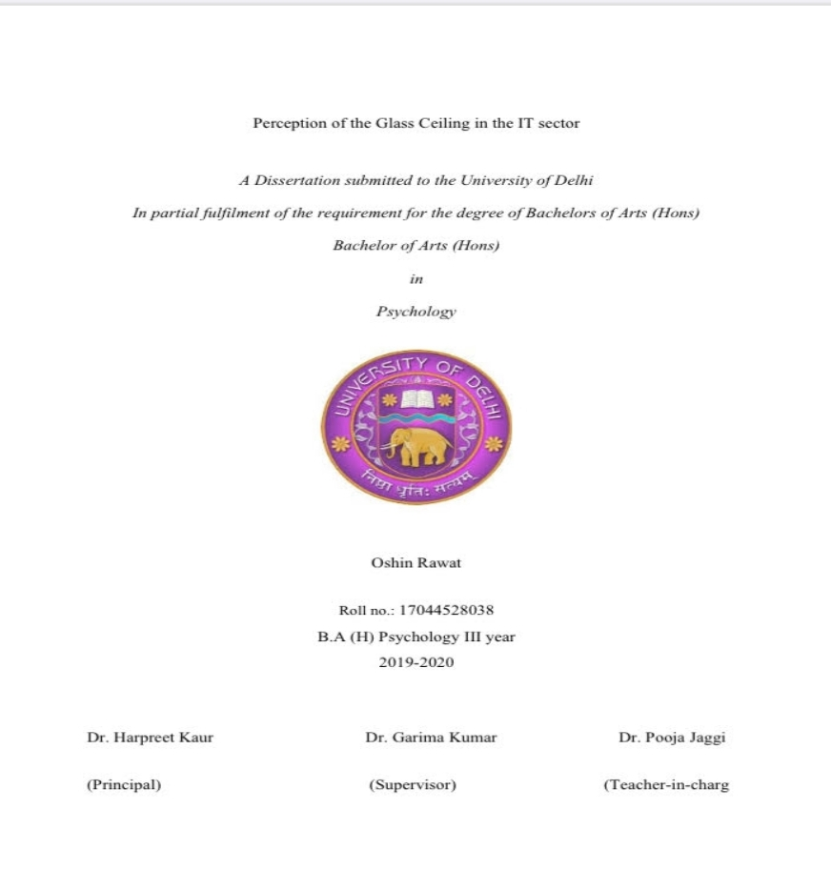
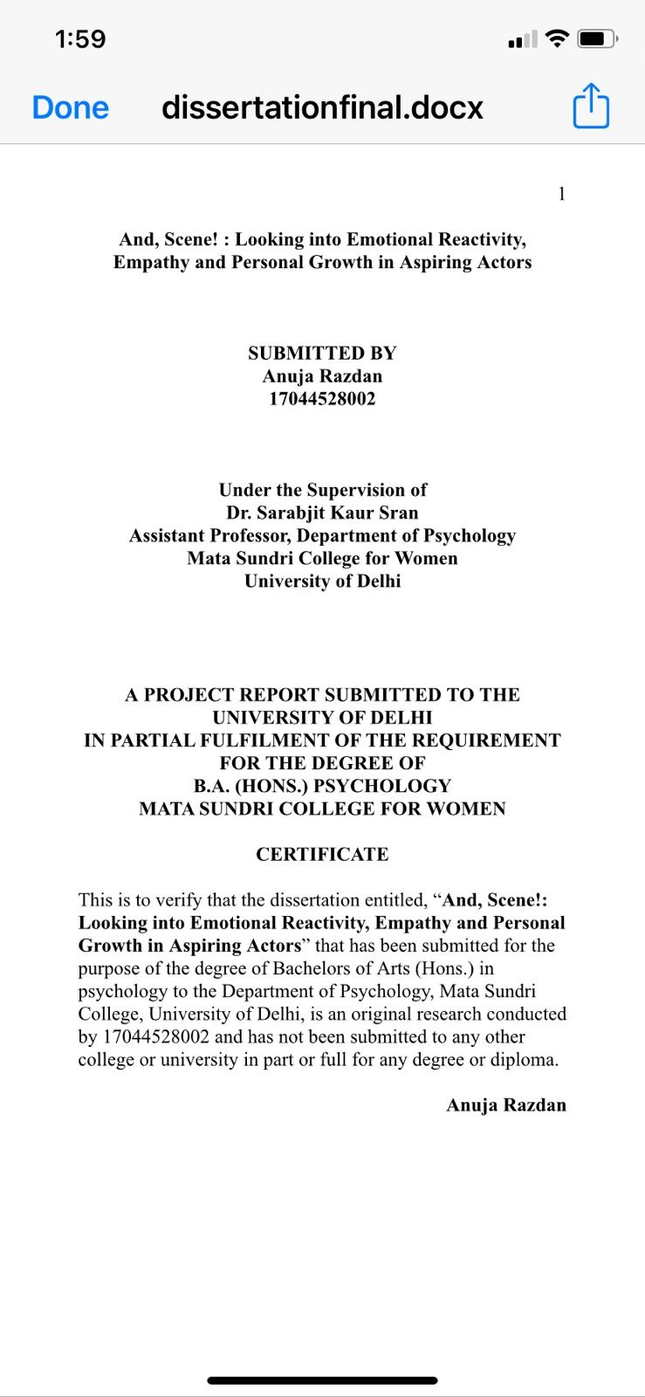
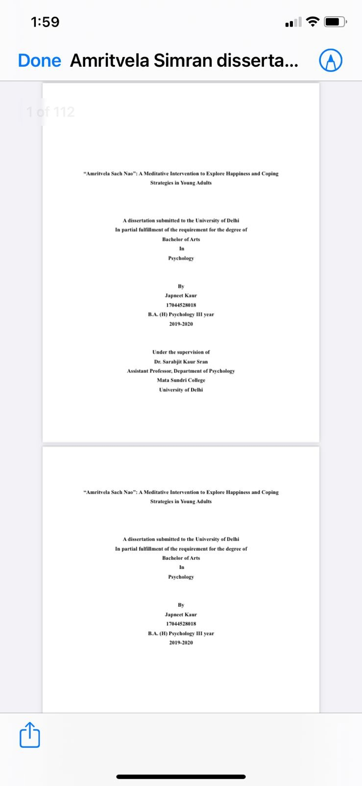

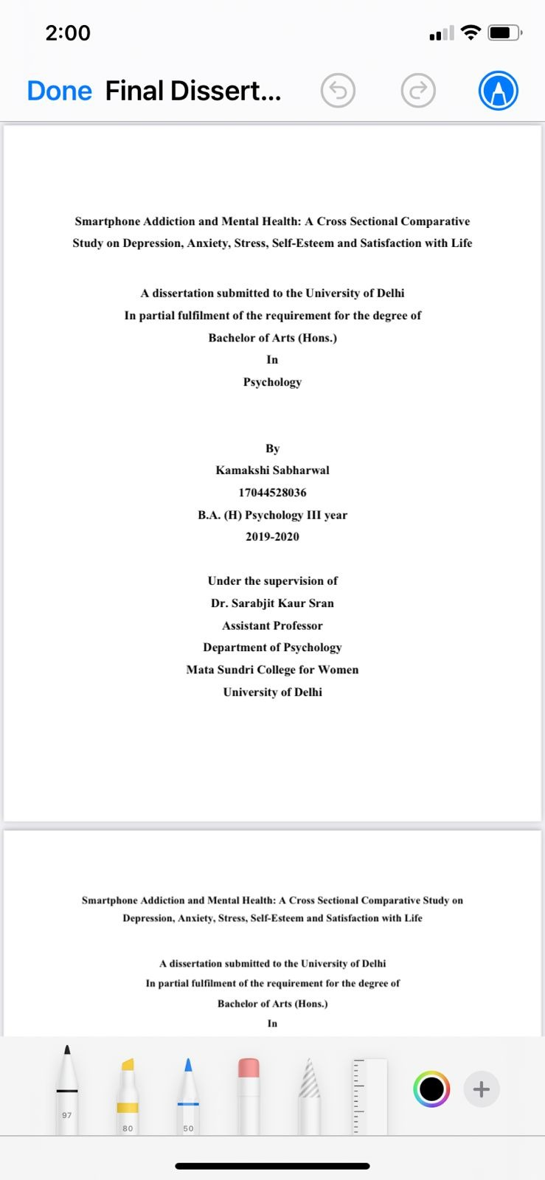
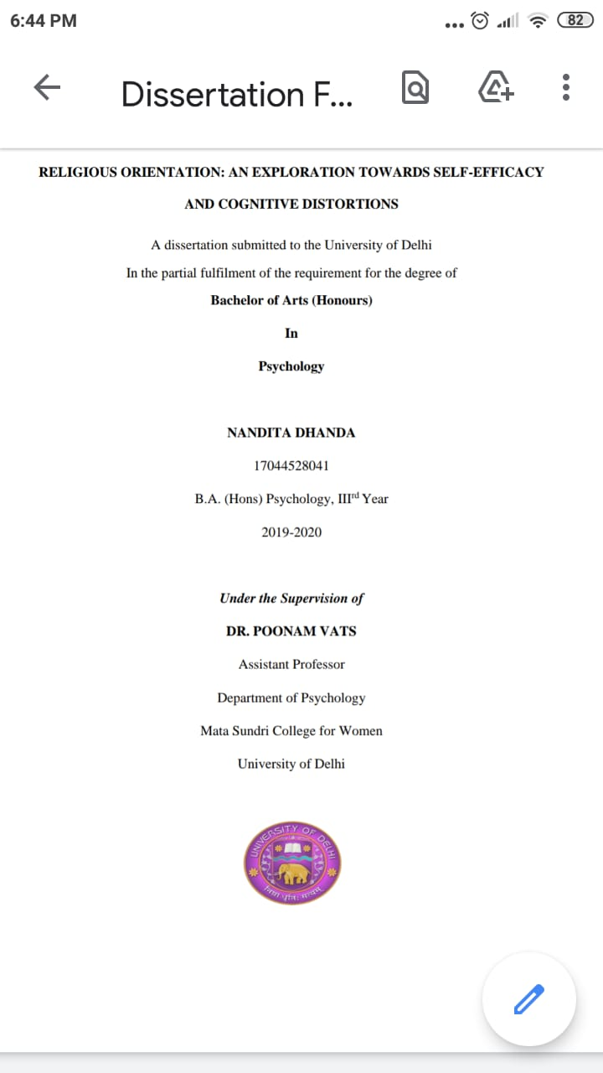
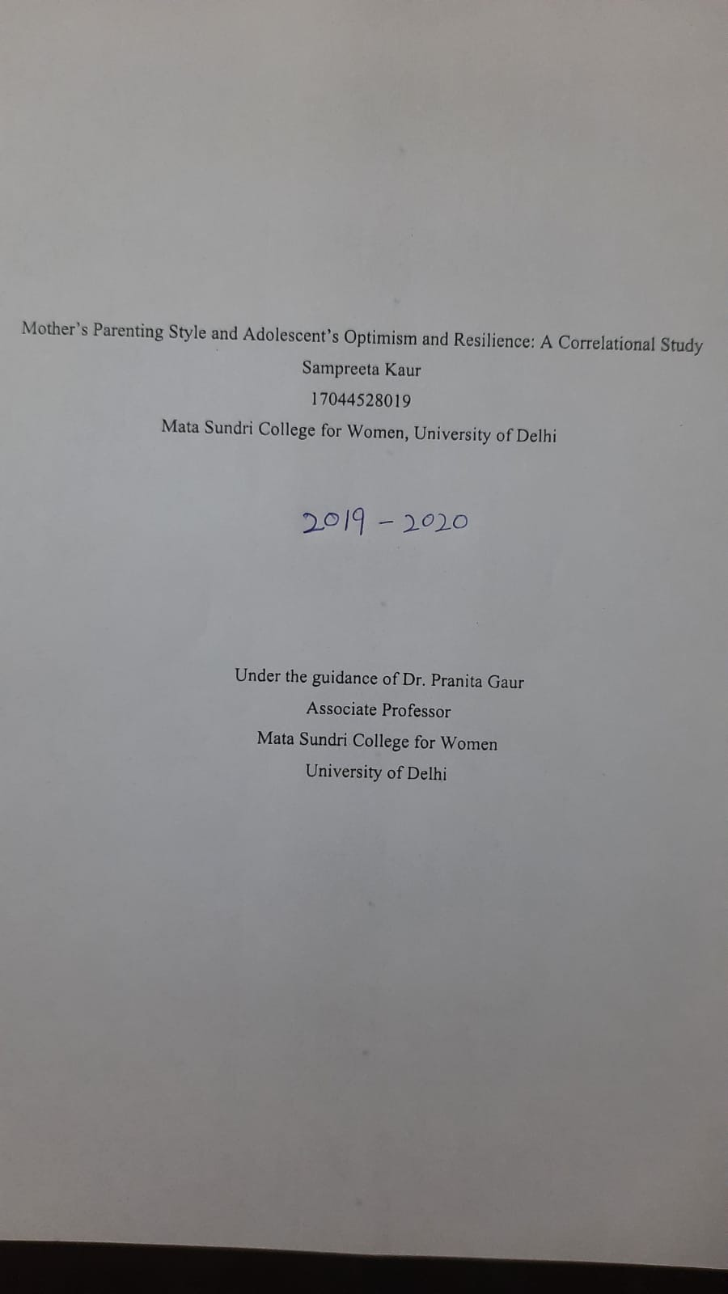
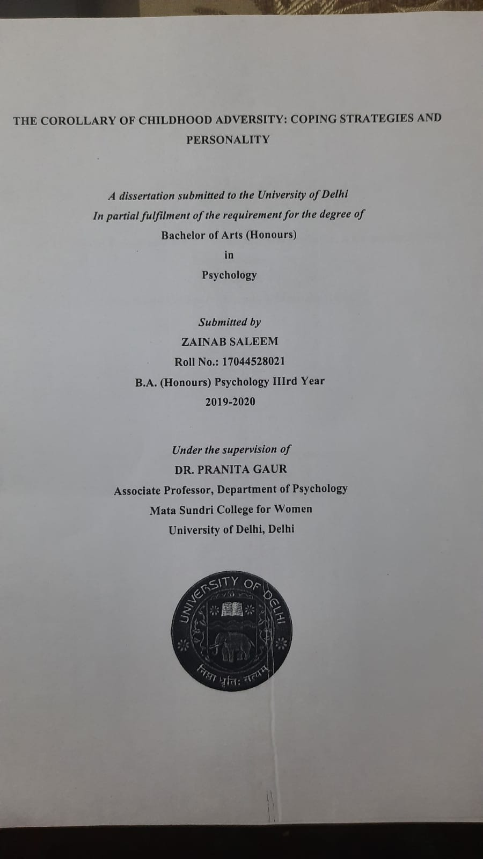
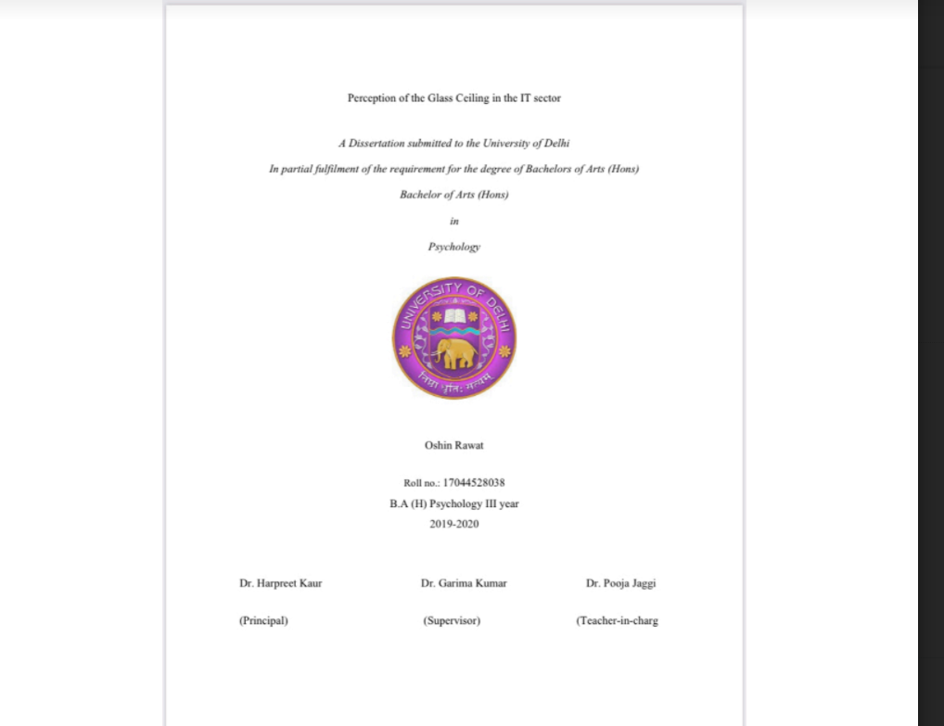

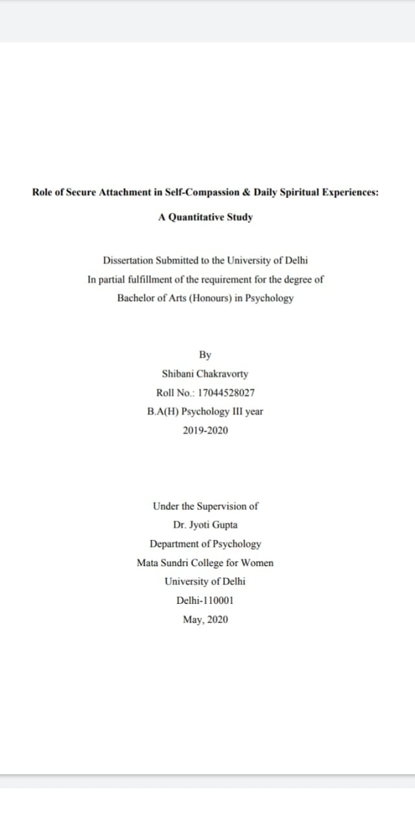
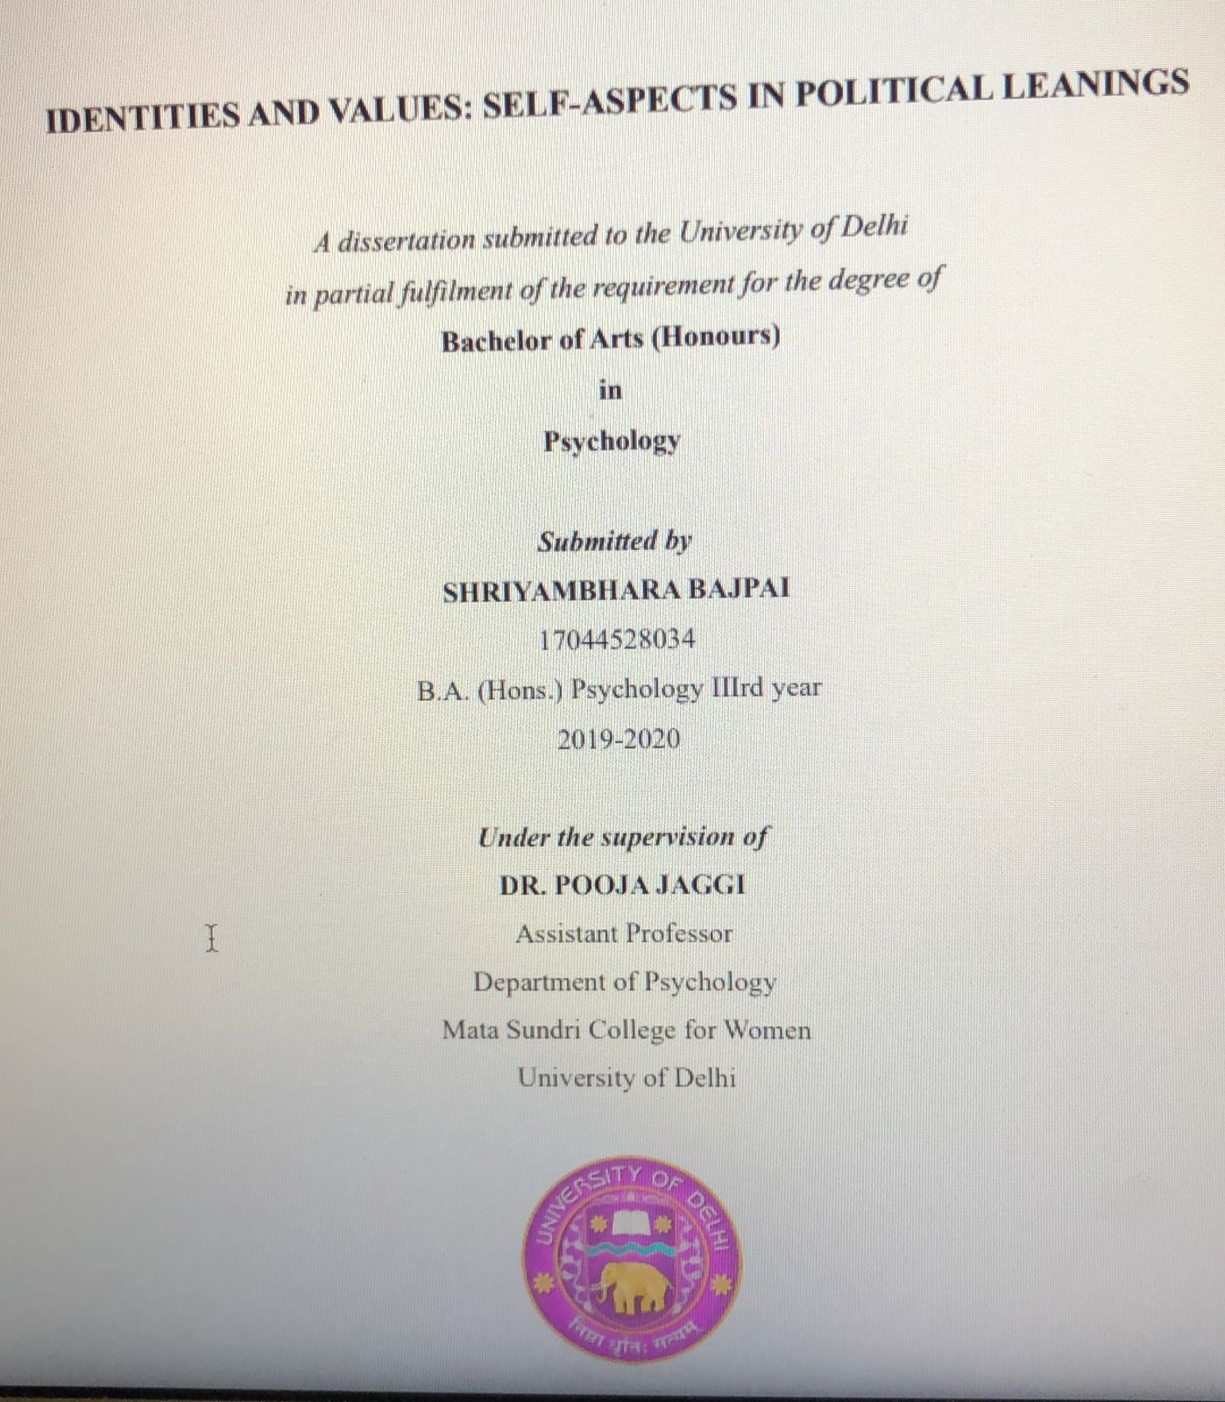
2020-21
